Agricultural Steering Committee Meeting
May 8, 2024
4:00 pm
Agenda
- Welcome
- LMG Update
- Funding Committee Update – May 17th event
- April 10th Community Input Meeting Follow-up
  - Over 85 in attendance
    - Survey Results (26 responses received: 21 support the initiative)
- Fundraiser Opportunities
  - April 20th York Rotary Beach Bash (Portion of proceeds to Ag Arena - $12,000)
  - May 3rd and 4th York Electric Hot Dogs (Donation to Ag Arena)
  - May 17th Modern Day Barn Raising Cocktail Event (Eden Farms)
- Publicity
  - May 23rd (Amy and Charlie will be on WRHI)
  - June 10th (Beth and Meg will be on Straight Talk)
- Signage at the Ag Arena Site
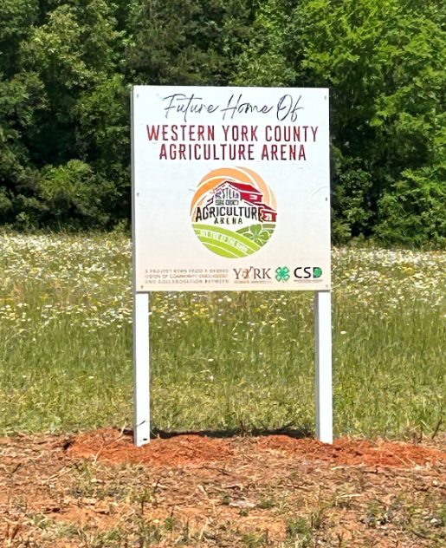
- Web Page (www.wycaa.org )
  - The Q & A Section has been updated based on feedback from the survey
- Next Meeting
  - June 12th at 4:00 PM

