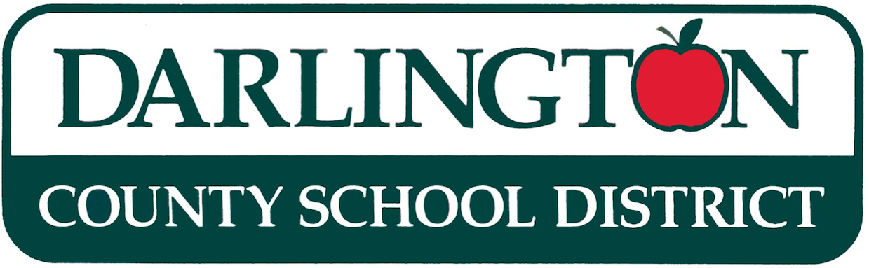

October 18, 2024

Dear Parent/Guardian:

The South Carolina Read to Succeed Act became law in 2014. The intent of Read to Succeed is to ensure all students have the reading skills necessary to become college and career ready. In March 2024, the Read to Succeed legislation was revised and included significant changes regarding the promotion and retention of third grade students.

Section 59-155-160 of S418 reads, “Beginning with the 2024-2025 School Year, a student must be retained in the third grade if the student fails to demonstrate reading proficiency at the end of the third grade as indicated by scoring Does Not Meet Expectations or at the lowest achievement level on the state summative reading assessment.”

Though there are a number of exceptions to this requirement in Read to Succeed, please be assured that our school district’s goal is that all students will be proficient readers by the end of third grade. Actions to improve student success include additional instructional time devoted to literacy, small group and individualized instruction, and classroom teachers receiving specialized literacy training and support from school-based literacy coaches.

If you have any questions or need additional information, please contact your school’s principal or your child’s teacher. You may also find information about the Read to Succeed Act on the South Carolina Department of Education website at http://ed.sc.gov/instruction/office-of-early-learning-and-literacy1/

Working in partnership with you, the district remains committed to seeing that your child successfully demonstrates proficiency on the end-of-year state reading assessment and advances to fourth grade. Please stay in communication with your child's teacher to monitor progress and identify additional ways that you can support your child's reading development at home.

Thank you,
Janice Dargan




Darlington County School District
This information is for parents of South Carolina’s third-grade students. It is designed to help parents understand what South Carolina’s Read to Succeed legislation says about reading requirements for third grade students and promotion to fourth grade. It also describes what the school will do to help children who are reading below grade level.

BACKGROUND
Reading and comprehension are the foundations for all academic learning. Walk into any kindergarten, first, second, or third grade classroom and you will find students learning to read. Students may be talking about the sounds letters make, listening to the teacher read a story, reading aloud together, or talking and writing about what they have read. Reading is the core of the school day for young children because students need strong reading skills to learn in all other school subjects, such as science, social studies, writing, and even math.

THE LAW
Section 59-155-160 of S418 reads, “Beginning with the 2024-2025 School Year, a student must be retained in the third grade if the student fails to demonstrate reading proficiency at the end of the third grade as indicated by scoring Does Not Meet Expectations or at the lowest achievement level on the state summative reading assessment.”

GOOD CAUSE EXEMPTIONS
Some students with disabilities, limited English proficiency, and those who have been previously retained can receive a “good cause exemption” and be promoted to the fourth grade even if they are not reading at the required level. Other good cause exemptions exist for students who demonstrate third grade reading proficiency by scoring the level above the lowest level on the statewide summative assessment or a norm-referenced alternative assessment approved by the board for use in summer reading camp.

EXPECTATIONS FOR THIRD GRADERS
In third grade, students shift from building foundational skills to understanding what they read. They start learning how to analyze stories and articles for setting, characters, and plot, as well as text features and structure, with teachers offering support as needed. Support could include one-on-one sessions, group activities, and tailored lessons. By year-end, students should complete these tasks independently. Third graders study authors' writing styles, understand their reasons for writing, and distinguish character perspectives from reader perspectives. They explore various types of writing, such as stories, nonfiction, literary nonfiction, poetry, and plays, both in print and digital formats, while learning to interpret visual aids. Throughout third grade, students practice writing skills, organize thoughts, use transitional words, improve research questioning, and discuss others' ideas. They write opinion pieces, narrative pieces, informational pieces, summaries, essays, text-dependent pieces, and creative stories. In addition, they start learning cursive writing.

WHY THIRD GRADE?
According to the 2013 National Assessment of Education Progress (NAEP), only thirty-five percent of the nation’s fourth grade students are reading on grade level. A substantial reading deficiency must be addressed before students can move on to the more difficult school work required in fourth grade and beyond when textbooks become more complex and reading passages are longer. Those who have trouble understanding what they read find it very difficult to keep up. Many students become frustrated when they try to tackle this schoolwork without independent reading skills. For some students, this leads to years of difficulty in school and limited opportunities in college and career.

DARLINGTON COUNTY SCHOOL DISTRICT’S EFFORTS

In an effort to ensure the success of all students in this area, the Darlington County School District currently supplies the following: reading coaches (one per elementary school), who provide professional development and instructional support to all English Language Arts teachers in the assigned elementary school; extended instructional time for English Language Arts in all elementary classrooms to support the development of strong literacy skills for all students. Additionally, targeted literacy support is provided differentiated instruction and targeted interventions as identified by assessment data to ensure that specific student needs are addressed.

Should you require additional information, please contact your child’s principal.

