GIVE YOUR TEACHER A TRIBUTE CARD

Scratching your head over that perfect holiday gift for your child's teacher? Do they really need another mug or scented candle?

Here's another option: Give your teacher a tribute card instead, through a donation to the Glendale-River Hills School District Foundation.

When you donate to the tribute card program, 100% of your gift is available to support your teacher -- along with tribute gifts from other families – so they can spend it on books, art supplies, globes, maps, music instruments, or anything else they decide their classroom needs.

No donation is too small to matter! And since your donation is being made to a non-profit organization, you might also be able to multiply your gift -- ask your employer if it has a matching gift program.

To give a tribute card to a teacher, staff member, or school program, just fill out the attached form and return it with your donation. We'll make sure that each teacher you designate receives a special card announcing your gift and providing instructions on how to use it.

Have questions? Contact:  Shawn McMahon  Treasurer, GRHSD Foundation  414-736-1632  McMahon.Shawn@Principal.com | 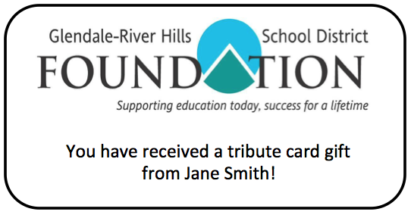

To learn more about the Foundation, visit our webpage www.grhfoundation.com/.

TRIBUTE CARD DONATION FORM

Please fill out this form and return it with your donation.
Name _____________________________________ Address __________________________________________
City ____________________________State ________________ ZIP _____________
Total Amount Enclosed: _____________________________

If you are a current parent or family member of a student:
Student name: _______________________________ Grade _________________

Please list each person or program to which you would like to give a tribute card. Your donation can be divided however you like. If you would like the Foundation to include a special message from you with your tribute gift card, include the message below.
Staff name or program | School | Special message? | Amount

If you would like us to notify anyone else of your contribution (such as your employer, for matching funds purposes), please provide contact information:
Name _____________________________________ Address __________________________________________
City ____________________________State ________________ ZIP _____________
Message: ____________________________________________________________

Please make checks payable to: Glendale-River Hills School District Foundation

Mail this form and your donation to:
Glendale-River Hills School District Foundation
2600 W. Mill Road
Glendale, WI 53209
Or you can drop your form and donation off at the Parkway Elementary School or Glen Hills Middle School main office for delivery to the Foundation mailbox.

