Saint Anthony Park Elementary School
Kindergarten Program

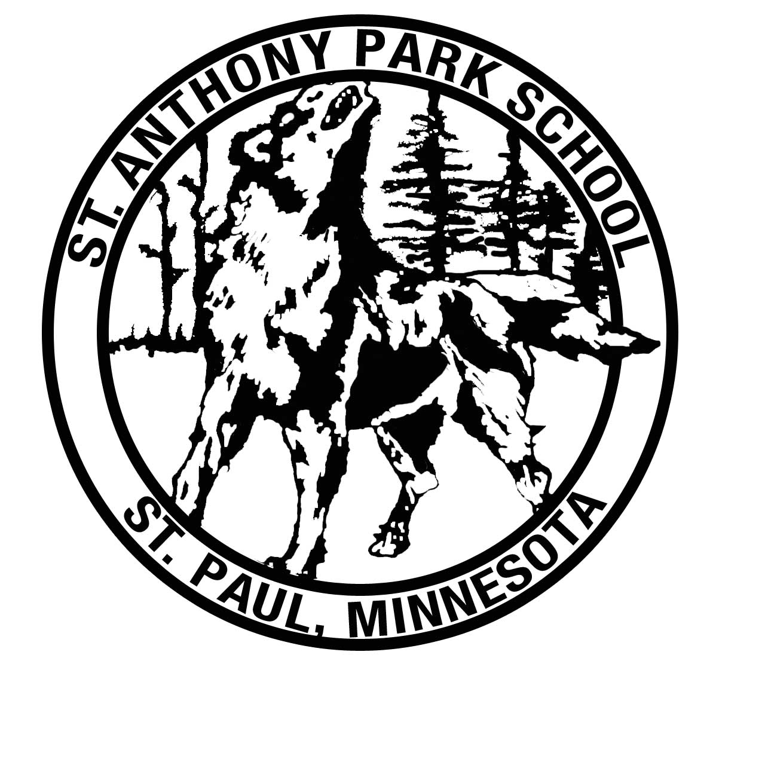



What are the class sizes in kindergarten?
Our maximum class size at this time is 26. We have four kindergarten classrooms.

What other special learning experiences do students have?
Students walk to the local public library regularly. They work with an artist-in-residence for one week; perform a vocal concert for parents and families; and do various special art projects. Students have the opportunity each day to attend either Performing Arts, Science, Math or Physical Education.

How can parent volunteers be involved?
After the first six weeks of school, parents are invited to volunteer in the classroom in many ways, from reading with students to preparing materials to helping out with special projects. There are many schoolwide opportunities for parents to be involved too – see www.sapsamn.org for more information!

Are there teaching assistants?
We have one teaching assistant who is assigned along four kindergarten teachers. Other support staff include the following: multi-lingual, special education, speech/language, counselor and social worker.

What is your philosophy on social-emotional support?
We believe that all students want to be successful and have positive learning experiences. Our counselors teach lessons in every classroom in social skills, self-esteem, and successful school behaviors. Every classroom begins the year by explicitly teaching all children the rituals and routines they will need to know in order to participate successfully at school. We teach Zones of Regulation building-wide to help students identify and cope with their moods and emotions.

Each day begins with a morning meeting, in which the focus is sharing and community building. Some children need more time or assistance to learn those routines, and we provide extra support as needed from counselors, support staff and teachers. If children are not demonstrating expected behaviors, they are provided with tools to help them change their behavior, fix a problem they have created, or help themselves be ready to learn again. We hold all children to very high standards of positive behavior, but we are committed to providing all children with the support they need to meet those standards.

What specialist classes do kindergarteners have?
Kindergarteners participate in physical education, performing arts and science. All classes are taught by licensed teachers and rotate approximately every three days.

Do students have recess?
Students go outside for recess every day for 30 minutes, unless the temperature and/or wind chill are -10° or colder.

What technology do students use?
All students in St Paul Public School are issued an iPad for use at school. Students use the iPads to build a portfolio of their work, play games that reinforce basic skills, read books online, learn basic technology skills, and many other things. iPads are available to take home in case of weather-related or other planned digital learning days.

How do you teach gifted or advanced children?
Teachers at St. Anthony Park infuse rigor and challenge throughout the curriculum for all children. All students are tested in kindergarten on the Cognitive Abilities Test (CogAT), and we have a very high percentage of students who are officially identified as “gifted and talented.” Our teachers are skilled at enriching or deepening the curriculum for children who need it. The Saint Paul Public Schools curriculum in general is designed to meet the needs of learners with diverse needs in every class, at every level.

What is the kindergarten day like?
Our school day is 7:15-2:00. This is a sample kindergarten day schedule:

7:15-7:40 Arrival
7:40-7:55 Morning Meeting
7:55-8:10 Writer’s Workshop mini-lesson
8:10-8:20 Independent writing
8:20-9:10 Centers
9:10-9:20 Read-Aloud
9:20-10:10 Specialists (Science, Active Inquiry, Music, Physical Education)
10:10-10:20 Break
10:20-10:50 Lunch
10:55-11:30 Recess
11:30-11:45 Independent reading
11:45-11:55 Math Review
11:55-12:10 Math mini-lesson
12:10-12:20 Math Task Board (Independent Activities)
12:20-12:50 Centers
12:50-1:20 Phonics and Phonemic Awareness
1:20-1:35 Reader’s Workshop
1:35-1:50 Clean-up
1:50-2:00 Dismissal

For more information, or to tour our school, call
651-293-8735, or visit our website at www.spps.org/stanthony

St Anthony Park Elementary School
2180 Knapp Street, St Paul MN 55108
651-293-8735

Updated December 2024

