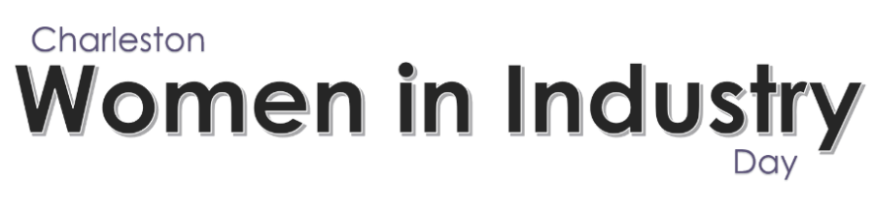
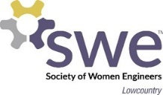
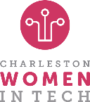
Thank you for applying to the Women in Industry Scholarship. We want to learn more about you and the future you have planned in the Science, Technology, Engineering and Mathematics (STEM) field. Please answer the questions below and return to wiidscholarship@swelowcountry.org by March 21st, 2025.

Winners will be notified by April 18th and announced at the Women in Industry Conference on May 9th, 2025.

Eligibility:

Applicant Must:
- Be currently enrolled as a high school senior in one of the following South Carolina Counties: Dorchester, Berkeley, or Charleston.
- Identify as a woman.
- Be attending an ABET-accredited program in a STEM related field.
- Plan to attend full-time.
- Not be fully funded.
- Be able to provide proof of enrollment (if chosen as a scholarship recipient) for the upcoming academic year of 2025-26 starting in the Fall.
- Submit application by March 21st, 2025.

Application Questions:

Name:
First Name:
Last Name:
Email Address:
Phone Number:
Gender Identity:
High School attended in 2024-2025 Academic Year
Current GPA – Out of Possible (example 4.1/5.0 or 4.0/4.0)
School County (Charleston, Berkeley, Dorchester) *Must attend a school in one of these counties to be eligible | Choose an item.
Transcript | Please Upload
Headshot | Please Upload
Letter of Recommendation | Please Upload
Short Answer/Short Essay Questions: | Please Upload – see questions below
Essay Question 1: | List the activities you were involved in during your high school career and any leadership roles held in those activities
Essay Question 2: | What fields do you plan to study in college? What led you to choose these fields?
Essay Question 3: | After college what are your aspirations and goals?
Essay Question 4: | What does STEM mean to you?

About the Women in Industry Conference: Women in Industry began in 2019 through the leadership and vision of the Lowcountry Society of Women Engineers. Now in its seventh year, this dynamic conference is designed to connect professionals from industries across the Lowcountry.
​

