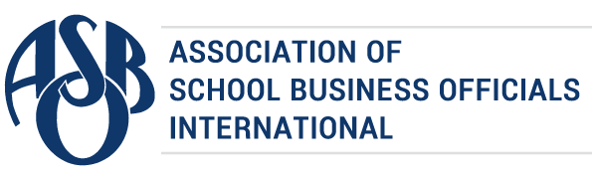

The Certificate of Excellence in Financial Reporting
is presented to

J O Combs Unified School District No 44

for its Annual Comprehensive Financial Report
for the Fiscal Year Ended June 30, 2023.
The district report meets the criteria established for
ASBO International’s Certificate of Excellence in Financial Reporting.
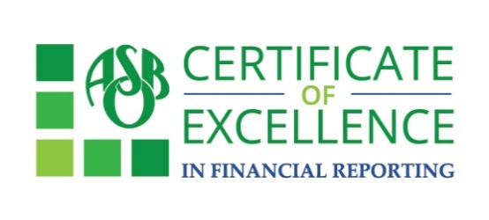

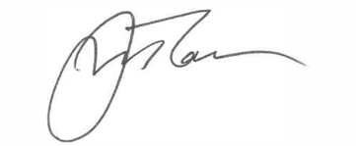
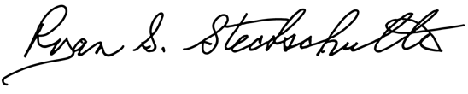

Ryan S. Stechschulte James M. Rowan, CAE, SFO
President CEO/Executive Director

April 9, 2024

Julie Cook
Director of Business Services
J O Combs Unified School District No 44
43371 N. Kenworthy Road
San Tan Valley, AZ 85140

Dear Julie,

Congratulations! On behalf of the Association of School Business Officials International (ASBO), I am pleased to inform you that J O Combs Unified School District No 44 has received ASBO’s Certificate of Excellence in Financial Reporting for the fiscal year ended 2023. This award represents a significant achievement and reflects your commitment to transparency and high-quality financial reporting. We encourage you to use the COE recipient’s logo to share your achievement in emails and marketing materials.

The Certificate of Excellence (COE) Review Team has provided their comments for the improvement of your Annual Comprehensive Financial Report. It is important to review the comments and address them before you prepare next year’s report. Your district must include a copy of the original comments and the district’s written responses to the comments in next year’s application packet.

We hope you will use the attached press release to share this important achievement with
your community. Your award certificate is also attached.

Congratulations to you and the members of your staff who worked so hard to earn the COE this year. We look forward to your continued participation in the COE program.

Sincerely,

James M. Rowan, CAE, SFO
CEO/Executive Director
FOR IMMEDIATE RELEASE
Contact: Allison Barton-Kramer
abarton-kramer@asbointl.org

School District Awarded for Outstanding Financial Reporting

Ashburn, VA – April 9, 2024 – The Association of School Business Officials International (ASBO) is pleased to award J O Combs Unified School District No 44 the Certificate of Excellence in Financial Reporting (COE). ASBO International’s COE recognizes districts that have met the program’s high standards for financial reporting and transparency. The school district earned the Certificate of Excellence for its Annual Comprehensive Financial Report (ACFR) for the fiscal year ended 2023.

“For over half a century, ASBO International’s Certificate of Excellence in Financial Reporting has been the gold standard in promoting and recognizing excellence in financial reporting,” according to ASBO International Executive Director Jim Rowan, CAE, SFO. “Communicating the financial and economic state of a district is so important when engaging with the school community and building their trust. Districts that receive the COE Award have demonstrated their ability to do that at the highest level.”

By participating in the COE program, school districts demonstrate their commitment to financial transparency. Applicants submit their ACFR for review by a team of financial professionals who provide feedback to improve future documents. If the report meets the requirements of the program, it may receive the Certificate of Excellence. A district’s participation in the COE program can facilitate bond rating and continuing bond disclosure processes.

The COE is proudly sponsored by ASBO International Strategic Partner American Fidelity.

# # #

About ASBO International
Founded in 1910, the Association of School Business Officials International (ASBO) is a nonprofit organization that, through its members and affiliates, represents approximately 30,000 school business professionals worldwide. ASBO International is committed to providing programs, services, and a global network that promotes the highest standards in school business. Its members support student achievement through effective resource management in various areas ranging from finance and operations to food services and transportation. Learn more at asbointl.org.

About American Fidelity
American Fidelity provides employer cost-savings solutions and supplemental insurance benefits to specific industries. Acting as an extension of the HR department, we educate, enroll, and support the development of robust, competitive insurance packages—all while ensuring seamless administration and employee satisfaction. As experts in employer benefit solutions, our salaried account managers deliver year-round support, help employers overcome benefit administrative challenges, and always offer a different perspective – a different opinion.

