Pasadena Unified School District



PasadenaLEARNs Expanded Learning Program
2022-23 Program Plan
Grant ID Number: 19-23939-6488-EZ
CDS Code: 1964881

Authorized Signatory: Dr. Brian McDonald, Superintendent
Phone: (626) 396-3600
E-mail: mcdonald.brian@pusd.us

Program Plan Submitted By:
Maria Toliver, M.Ed.
Director/Grant Manager, Expanded Learning Programs

ASES Programs
School | Projected Daily Attendance | Target Population | % of School Population
Altadena Elementary | 84 | LCFF-Eligible Students | 63.2
Blair Middle | 69 | LCFF-Eligible Students | 31.5
Charles Eliot Middle | 111 | LCFF-Eligible Students | 32.3
Field Elementary | 84 | LCFF-Eligible Students | 28.8
Hamilton Elementary | 160 | LCFF-Eligible Students | 47.1
Jackson Elementary | 133 | LCFF-Eligible Students | 66.6
Longfellow Elementary | 149 | LCFF-Eligible Students | 85.6
Madison Elementary | 154 | LCFF-Eligible Students | 85.0
Marshall | 90 | LCFF-Eligible Students | 25.2
McKinley | 84 | LCFF-Eligible Students | 65.8
Norma Coombs Elementary | 71 | LCFF-Eligible Students | 63.8
San Rafael | 93 | LCFF-Eligible Students | 33.4
Washington Elementary | 144 | LCFF-Eligible Students | 63.5
Octavia E. Butler Magnet | 111 | LCFF-Eligible Students | 40.5
Webster Elementary | 111 | LCFF-Eligible Students | 46.0
Willard Elementary | 196 | LCFF-Eligible Students | 71.1

1- Safe and Supportive Environment:
Describe the initiatives and measures that will be taken by the program to create safety procedures that are aligned with the instructional day, including regular staff training and practice drills with students and staff.
- Emergency Plans and Procedures
PasadenaLEARNs sites submit annual disaster plans, which include evacuation procedures, maps, students/staff accounting documents, staff roles and responsibilities, and emergency procedures. Plans are aligned to the school day disaster plans and are approved by the program Director/Grant Manager and school principal.
All schools have emergency bins, which contain supplies to be used in case of disaster such as first aid supplies, blankets, food, and water. PasadenaLEARNs Site Coordinators and supervisors have keys to access emergency bins. In addition to keys to emergency bins, Site Coordinators are also assigned master keys from the District Director of Maintenance and Operations, which provide access to the entire campus and allows Site Coordinators to secure students and campus in case of a Shelter In Place or other emergency.
PasadenaLEARNs sites hold mandatory monthly emergency drills for earthquake, fire, and shelter in place situations such as active shooter. PasadenaLEARNs collaborates with other after school service providers on campus to coordinate drills. Site Coordinators are required to submit written feedback regarding proper execution of procedures during emergency drills. Written reports include the amount of time it took staff and students to arrive at the designated safe zone, the number of staff and students present, information regarding unaccounted for/missing students, and comments regarding any needs or areas of concern identified during drills.
- Student Safety
PasadenaLEARNs staff is required to wear staff shirts that are adorned with the program name and logo in highly visible letters and graphics along with name badges during work hours. Uniforms ensure that program staff are visible and identifiable. PasadenaLEARNs also provides first aid packs and back packs for portable emergency first aid supplies. In addition, staff is required to maintain updated First Aid/CPR certification and TB clearance, which is kept on file in the district’s Human Resources Department and LEARNs central administrative office. PasadenaLEARNs offers CPR/First Aid certification courses twice per year for staff at no cost, which enables staff to obtain free certification.
PasadenaLEARNs provides program block schedules to parents of participating students at the beginning of each new session that includes the names of frontline staff persons in charge of each group, classroom location, and the Site Coordinator’s name and contact information. Line staff, called Youth Leaders, maintain updated emergency contact information and authorized pick up lists for all program participants. Students may only be released to a parent/guardian or adult over the age of 18 who has been authorized by a parent/guardian. Adults signing out program participants are required to provide a valid form of identification before students are released.
Incidents and injuries are documented via the district’s Incident and Injury Report forms, which must be submitted to the Director/Grant Manager within 24 hours for review and follow up. All reports are then submitted to the appropriate department (Human Resources; Special Education; Child Welfare, Attendance and Safety, etc.) for review and follow up. Parents are contacted via telephone and receive written head injury and/or first aid notices when appropriate.
Describe how the program will provide a safe and supportive environment that provides for the developmental, social-emotional, and physical needs of students.
PasadenaLEARNs uses Growth Heartset Skills® and Second Step curriculum to incorporate social-emotional learning into the program. Activities are designed to support students’ social and emotional health and the development of social-emotional competencies. In addition, LEARNs Site Coordinators and Youth Leaders receive annual training in Mental Health First Aid from the Student Welfare and Support Services Department. Staff are trained how to identify students in emotional distress and are provided with important information, strategies, and resources.

2- Active and Engaged Learning:
Provide examples of best practices, including research or evidence-based practices that were used to guide the planning of educational literacy and educational enrichment activities that will align with the regular school day to enhance academic performance achievement and positive youth development.
To provide academic support, PasadenaLEARNs uses Imagine Learning Language and Literacy, Imagine Math, and Imagine Math Facts for students in grades K-5, which are research-based online programs designed to provide individualized English Language Arts and math support for students. Students complete diagnostic tests that are used to create individual learning plans. Plans include benchmark assessments to track progress. School day teachers and program staff are able to review and track students’ progress and download supplemental activities to provide students with more opportunities to practice and review learned skills.
PasadenaLEARNs also employs credentialed teachers at each school to provide afterschool tutoring and homework assistance for students in grades K-8. Teachers work with groups of 8-10 students for 60-90 minutes a minimum of two days per week. Students engage in hands-on, interactive learning centers that focus on skill development and receive homework help. Students in primary grades receive additional instruction in phonics skills, phonemic awareness, and beginning reading and writing skills.
Enrichment classes, known as “clubs,” vary each session and are based on session themes. Session themes support the school’s academic and social emotional learning goals for the year and are derived via school day and after school collaboration. Site Coordinators meet with principals monthly to review program offerings and plan upcoming clubs based on student survey feedback, scheduled school events, and academic support needs. Each program also creates a LEARNs Student Advisory Group comprised of student representatives from grades 2-5 at elementary sites and 6-8 at middle school sites. With the support of the Site Coordinator, groups meet to plan student surveys, program events, and club activities.
Describe the planned program activities and how they will:
- Provide positive youth development;
- Provide hands-on, project-based learning that will result in culminating products or events.
To ensure high quality enrichment offerings, PasadenaLEARNs contracts with ~30 consultants to provide specialized enrichment classes for students. Students participate in a variety of clubs such as karate, tennis, ceramics, robotics, coding, video production, cartooning, scrapbooking, sewing, graphic design, culinary arts, sports, cheerleading, dance, rock/jazz band, orchestra, beginning strings, guitar, and electronic keyboarding. Clubs are offered on a rotating basis and are designed to broaden students’ horizons and maximize their exposure to a variety of activities and interests.
In addition to academic and enrichment opportunities, students have the opportunity to participate in PasadenaLEARNs Sports, or PLS. PLS coordinators organize friendly, semi-competitive sports contests. LEARNs participants play against LEARNs students from other PUSD sites. PLS offers three sport seasons: fall, winter, and spring. During the fall season, elementary and middle school students compete in co-ed flag football. Middle school students also compete in girls volleyball. Elementary and middle school students participate in boys’ and girls’ basketball during the winter season and boys’ and girls’ soccer during the spring season. Each sports season lasts approximately 6 weeks and includes play-off and championship games. Winners are awarded medals and trophies. Students learn fundamental skills, how to work as a team, and develop self-discipline and good sportsmanship.
PasadenaLEARNs hosts two program showcases each year (winter and spring), which are open to PUSD families, district staff, and community members. Winter showcases are held individually at each school site and include student performances and student project exhibits. The spring showcase is a comprehensive, district-wide event held at a district-approved venue. All PasadenaLEARNs programs provide display booths, interactive games and activities for students and families, and student performances. Showcases provide opportunities for students to exhibit skills learned, showcase projects created, and share their afterschool experiences.
If applicable, explain how the planned program activities are based on school and community needs for a summer supplemental program.

PUSD serves a diverse community sharply divided along socio-economic and geographic lines. Neighborhoods of great wealth contrast starkly with high-density neighborhoods of extreme poverty. Northwest Pasadena, for example, has a large low-income population, including many immigrant families, and is home to more than half of the city’s children and youth. Approximately 30% of school-age children in the PUSD service area attend private schools, about three times the national average. About 70% of PUSD’s total student population qualifies for the federal reduced price meals program.
PasadenaLEARNs program activities are planned based on a number of assessments of school and community needs. Working closely with PUSD departments, PasadenaLEARNs analyzes attendance; truancy and drop-out rates; test scores; student health indicators; the availability of enrichment activities at each school; the Local Control Accountability Plan; each school’s Single Plan for Student Achievement; and parent/student survey feedback.
In the community, PasadenaLEARNs consults with the City of Pasadena Human Services and Recreation Department and other public and private community-based providers of after school programs and is a member of the Partnership for Children, Youth, and Families, which is an organization that brings together local community service providers to work together to support area youth and their families. Despite the existence of a number of organizations that provide after school care and enrichment programs, there are still a significant number of children and youth left unserved, especially those who are from low-income families, live in underserved neighborhoods, are English learners, or have a disability.
Stakeholder feedback is used to inform decisions regarding PasadenaLEARNs’ summer program structure. PasadenaLEARNs offers 6-hour per day summer programs that operate six weeks for students in grades TK-8. As a result of the parent feedback, PasadenaLEARNs transitioned from offering 5-week summer programs for 4 hours each day Monday-Thursday to offering 6-week summer programs for 6-8 hours each day Monday-Friday.
PasadenaLEARNs hires credentialed teachers to teach the English Language Arts, literacy, and math during the summer. Teachers use an accelerated learning model to prepare students for the upcoming school year. Students are introduced to concepts they will learn during the school year while addressing learning gaps using grade-level content. TK-K students participate in Intro to Kindergarten and Intro to First Grade programs that focus on phonics development, phonemic awareness, beginning reading, and numeracy skills.
PasadenaLEARNs partners with community organizations such as Harambee Ministries, Lake Avenue STARS, Day One, Young and Healthy, Harmony Project, Darden Leadership Academy, and Pasadena Educational Foundation to provide additional summer enrichment opportunities for PUSD students that focus on academic support, leadership development, social-emotional learning, and performing arts.
PasadenaLEARNs also offers a Children’s Defense Fund’s (CDF) Freedom Schools Summer Program® to PUSD students from communities that are the furthest away from opportunity. CDF Freedom Schools Summer Programs® empower youth to excel and believe they can make a difference in their lives and the lives of others. The six-week program focuses on literacy, self-esteem building, and civic responsibility. The program uses a research-based, multicultural Integrated Reading Curriculum (IRC) that supports students and families through 5 essential components:
- High quality academic enrichment
- Parent and family development
- Civic engagement and social action
- Intergenerational servant leadership development
- Nutrition, health and mental health

3-Skill Building:
Describe how the program educational literacy and educational enrichment activities are expected to contribute to the improvement of student academic achievement as well as overall student success.
During the 2022 summer program, PasadenaLEARNs partnered with PUSD credentialed teachers to provide accelerated learning for English Language Arts, literacy, and math for students in grades K-6. Students participated in a 6-hour program Mondays through Fridays for approximately six weeks where they received instruction in key learning concepts for the upcoming school year and participated in theme-based enrichment activities. Subsequent data showed that students who participated in the 2022 summer program had a mean target growth of 62.8% on the mid-year i-Ready assessment, which was higher than that of students who participated in other programs or who did not participate in a summer program.
During the 2022-23 school year, PasadenaLEARNs expanded homework assistance to include tutoring facilitated by certificated teachers. Students receive intervention and support through interactive games and activities designed to reinforce academic concepts and close learning gaps.
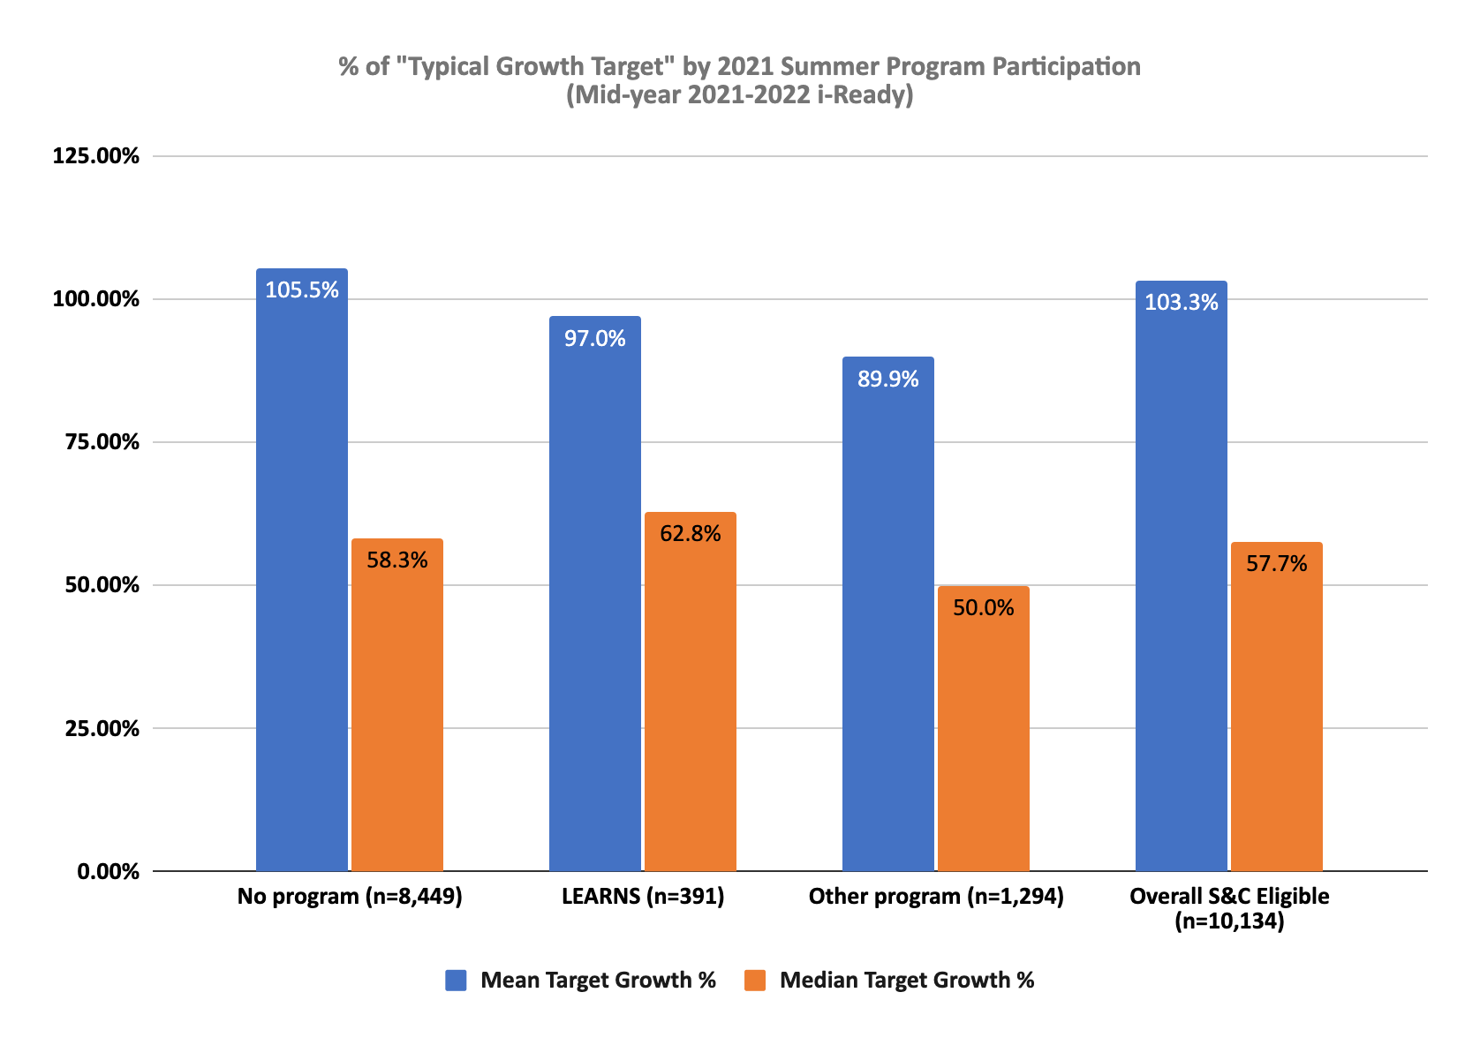
iReady benchmark assessments and attendance data are used to evaluate the effectiveness of the program. Site Coordinators meet with school site principals monthly to review school and programs goals to ensure alignment and cohesion and to plan program activities that support students’ needs as identified by school day staff. Instructional coaches and school counselors work with LEARNs staff to contact families of non-participants to encourage program participation to meet academic and social-emotional learning needs. Teachers recruit students during Parent-Teacher conferences who need additional academic support.

Explain how the planned program activities are based on the school and community needs for a before school, after school and/or supplemental program.
On the 2021-22 parent survey, parents were asked to provide the reasons why their children attend the after school program and to select all reasons that apply.
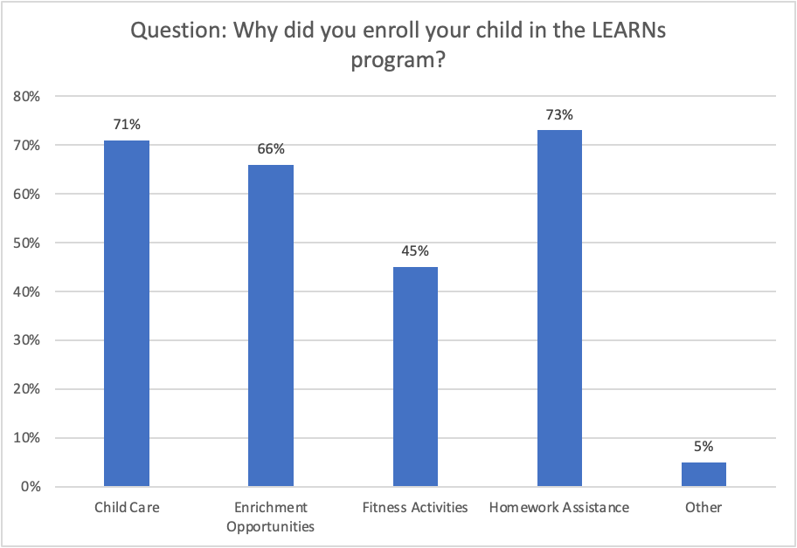
PasadenaLEARNs provides academic support by offering structured homework time Mondays-Thursdays for a minimum of 30 minutes per day. Students receive homework assistance and support. Youth Leaders provide supplemental skill building activities and online resources for students who finish homework early. In addition to structured homework time, credentialed teachers provide small group tutoring and intervention, which includes reteaching concepts taught during the school day and homework assistance.
Program partners provide specialized enrichment classes such as graphic design, entrepreneurship, sewing, robotics, coding, STEM, and more. Program staff members design theme-based enrichment classes based on students’ interests and trending topics. Fitness activities not only include structured games and activities every day but also include organized sports, cheer, dance, and wrestling.

4-Youth Voice and Leadership:
Describe how student feedback, assessments, evaluations, and integration with the instructional day will be used to guide the development of training, curricula, and projects that will meet students’ needs and interests.
Students complete annual program surveys to capture their feedback regarding program offerings and program quality. Student feedback is analyzed as part of the continuous quality improvement cycle to assess the quality of the program and inform future program planning. Academic performance measures and attendance data are used to gauge the effectiveness of academic intervention strategies. Pasadena LEARNs collaborates with school day staff for events, extracurricular activities, and sports. LEARNs staff attend coaching clinics to prepare for upcoming sports seasons and specialized professional development opportunities such implementation of STEM-based enrichment activities, Arts Attack curriculum training, and Thrively Strengths Exploration training.
Describe the opportunities provided to students where they can share their viewpoints, concerns, or interests (i.e. student advisory group) that will impact program practices, curricula, or policies, including opportunities for student leadership.
PasadenaLEARNs elementary and middle school sites are required to create LEARNs Student Advisory Councils (L-SACs) each semester to provide students with leadership opportunities. L-SACs are comprised of students in grades 2-5 at the elementary level and grades 6-8 at the middle school level. Students are elected by their peers to serve on the L-SAC. Under the supervision of the Site Coordinator or designated Youth Leader, the L-SAC is tasked with conducting student surveys to gather student input regarding enrichment offerings and to capture students’ ideas and suggestions. The L-SAC also plans field trips and program events such as dances and, showcase events, and school spirit days.
In addition to the formation of L-SAC groups, PasadenaLEARNs also encourages student voice, choice, and leadership in the creation of classroom contracts or group agreements that govern students’ behavior. As an element of the classroom community, Youth Leaders are required to work with students to create classroom agreements. As part of the process, students work together, with support and feedback from the Youth Leader, to create an agreement that all students adhere to. Empowering students to create their own “rules” enables them to take responsibility for their after school environment and their interactions with peers and program staff.
Describe how students in lower grades will be able to make choices when participating in program activities, and how students in higher grades will actively exercise their leadership skills by addressing real world problems that they identify in their communities (e.g. service learning).
PasadenaLEARNs enrichment classes operate as self-selected student “clubs.” Prior to the beginning of each new session, students in grades 2-5 at the elementary sites and grades 6-8 at the middle school sites select their club preferences in order from greatest to least preferred. At the beginning of each session, Youth Leaders share the name of the club they will be teaching, what students will do/learn in the club, and provide a work product sample for students to view or information regarding student takeaways. Students then complete a club selection form. Based on available space and grade level appropriateness, students are placed in clubs according to their preferences. Extremely popular clubs like culinary arts and video production may be offered for more than one session to accommodate high student interest and allow more students an opportunity to participate.
PasadenaLEARNs participants in grades 3-8 complete one program-wide service learning project each year. Service learning project requirements are:
- The project must address a need in the community.
- In the case of donated items, the organization receiving the donations must provide the program with a letter verifying that the donated items were received. Letter must be written on organization letterhead and signed.
- Programs must provide evidence of completed projects such as pictures or other memorabilia (except in the case of donations that have a verification letter).
- Students write a one-page reflection about their experience that explains their project, the importance of giving back to the community, and how participating in the project made them feel.
Some service learning projects completed include:
- Donation of toiletries to local homeless shelters
- Donation of socks to Families In Transition
- Collection of canned foods to deliver to food pantries
- Christmas toy drives for schools
- Adopting families for Thanksgiving and providing meals

5-Healthy Choices and Behaviors:
Describe the types of healthy practices and program activities that will be aligned with the school wellness plan.
PasadenaLEARNs adheres to the District Student Wellness Policy (BP 5030, adopted by the Board of Education in 2006 and revised in 2012 and 2014; the complete document can be viewed and downloaded on the PUSD Health Programs webpage http://www.pusd.us/Page/777).
The policy states, “The Governing Board recognizes the link between student health and learning and desires to provide a comprehensive program promoting healthy eating and physical activity for district students. The Superintendent or designee shall coordinate and align district efforts to support student wellness through health education, physical education and activity, health services, nutrition services, psychological and counseling services, and a safe and healthy school environment. In addition, the Superintendent or designee shall develop strategies for promoting staff wellness and for involving parents/guardians and the community in reinforcing students’ understanding and appreciation of the importance of a healthy lifestyle.”
The Student Wellness Policy includes specific guidelines for providing healthy food options in school meals and snacks, encouraging healthier eating habits, health and nutritional education, creating and maintaining a safe and supportive environment at all schools, and recommendations for the length and rigor of daily physical activity. Each PUSD school and all departments are required to adhere to the Student Wellness Policy. All PasadenaLEARNs sites participate in the district’s supper program provided by the Food and Nutrition Services Department. Meals adhere to the Student Wellness Policy and meet nutritional guidelines.
In addition to providing a safe and supportive environment as described in Question 1, healthy meals, and organized physical activity, PasadenaLEARNs uses Second Step curriculum to promote students’ development of social emotional competencies. Students also participate in mindfulness activities at the beginning of program each day and throughout program time to practice self-care. Youth Leaders create calm and nurturing environments by posting affirmations around classrooms, using positive reinforcement, and providing soothing music during independent work time.
Describe how the program will incorporate healthy nutritional practices, and the types of daily developmentally appropriate and/or research-based physical activities the program will conduct. Include any collaborative partnership with wellness organizations.
PasadenaLEARNs, in collaboration with PUSD’s Food and Nutrition Services Department, provides students in the after school program with a well-balanced supper each day during the regular school year, and with a nutritional breakfast and lunch during the summer. All meals comply with State standards and meet both nutritional guidelines and the District’s Student Wellness Policy.
PasadenaLEARNs is integral to the district’s goal that students participate in at least 30 minutes of rigorous exercise every day. Activities such as PasadenaLEARNs Sports, PasadenaLEARNs Cheer, yoga, dance, zumba, tennis, Online Physical Education Network (OPEN), and Sports, Play, and Active Recreation for Kids (SPARK) curriculum enable the program to offer a variety of movement opportunities to students.
PasadenaLEARNs uses two research-based movement curricula: Online Physical Education Network (OPEN) and Sports, Play, and Active Recreation for Kids. Both provide a variety of rigorous and highly engaging movement activities for students of all grade levels based on available space, equipment, and physical activity goals.
PasadenaLEARNs partners with wellness organizations such as Youth and Healthy to provide classes on healthy eating, bike safety, and marijuana usage. Students participate in classes where they learn to create healthy snacks that are also delicious, safe routes to school for bike riders, and the laws and dangers of marijuana use. PasadenaLEARNs also partners with Common Threads to offer Small Bites Cooking Classes. The Common Threads Small Bites Grant Program provides funding for Small Bites cooking lessons that combine nutrition and knife-free cooking. Programs receive eight, 1-hour lessons on nutrition education and healthy snacking, onsite and online staff training, access to digital curriculum, and dollars to purchase supplies for cooking classes.
PasadenaLEARNs also collaborates with organizations that specialize in fitness and sports activities such as Beat the Streets, Pasadena Tennis Association, California Youth Karate Club, and Girls On the Run.
Give 3-5 examples of nutritious snacks or meals that follow the California Nutritional Guidelines that are served in your after school program.
Some meals provided to PasadenaLEARNs participants who participate in the Supper Program are:
- Pepperoni Pinwheel, Broccoli Florets, Juice Box
- Beef Chimichanga, Celery Sticks, Applesauce Cups
- Anytimer’s Protein Pack, Celery Sticks, Applesauce Cups
- Bean & Cheese Quesadilla, Cucumber Slices, Juice Box
- Turkey & Cheese Sub Sandwich, Zucchini Sticks, Frozen Diced Peaches

6-Diversity, Access, and Equity:
Describe how the program will create an environment that promotes diversity and provides activities and opportunities to celebrate students’ cultural and unique backgrounds.
At all of its program sites as well as its administrative offices at PUSD headquarters, PasadenaLEARNs creates and maintains an environment that promotes diversity in staffing, participation, and programming. Each site provides opportunities to celebrate students’ cultural and unique backgrounds. PasadenaLEARNs maintains staff diversity that is representative of the students served in the program.
PasadenaLEARNs also offers enrichment opportunities such as language classes for Spanish, French, and Mandarin, Folklorico Dance, Hip-Hop Dance, and African Drumming to promote cultural awareness, celebrate diversity, and educate students about the cultures and traditions of Pasadena residents. In addition, PasadenaLEARNs seeks out opportunities to celebrate diversity by participating in public events such as the Latino/Jamaican Heritage Parade, Black History Parade, Dia de los Muertos, and Chinese New Year.
PasadenaLEARNs sponsors a CDF Freedom Schools Summer Program® at Altadena Elementary School during summer program and Harambee Ministries programs at McKinley School and Octavia E. Butler Magnet during the school year. Both programs support students from low socioeconomic backgrounds from marginalized communities who are furthest away from opportunity.
Describe how the program will reach out and provide support to students with disabilities, English Language Learners, and other students who have potential barriers to participate in the program.
PUSD and PasadenaLEARNs are committed to making programs and activities equitably accessible to all students. PasadenaLEARNs prohibits discrimination on the basis of gender, race, national origin, religion, color, disability, sexual orientation, native language, age, or physical appearance. Promising practices to ensure that all activities are accessible to those with special needs such as physical disabilities, learning disabilities, or limited English proficiency include: providing communications in English as well as students’ primary languages; maintaining bilingual staff and staff representative of the school’s demographics at all sites; providing inclusion training for all staff, which includes training on how to support students with behavior challenges; and providing behavior intervention and support for students who need additional emotional support. PasadenaLEARNs works closely with the Special Education Office, school site principals, and classroom teachers to identify students with disabilities who might benefit from participation in the after school program. PasadenaLEARNs works with families who need additional support for their children after school to request support from the Regional Center. The Special Education Department provides training for PasadenaLEARNs staff on how to support students with special needs in the after school environment. Hands-on and collaborative group activities allow students to learn by using their hands while collaborating with their peers. The Director/Grant Manager attends IEP meetings to discuss ways the after school program can support students with disabilities in the program including additional time to complete homework, alternative activities, behavior incentives, and calming areas.
School day teachers recommend enrollment in PasadenaLEARNs to parents of English Language Learners for additional support and assistance with homework and language mastery. PasadenaLEARNs also hires credentialed PUSD teachers to provide academic support after school.

7-Quality Staff:
PasadenaLEARNs Organizational Chart
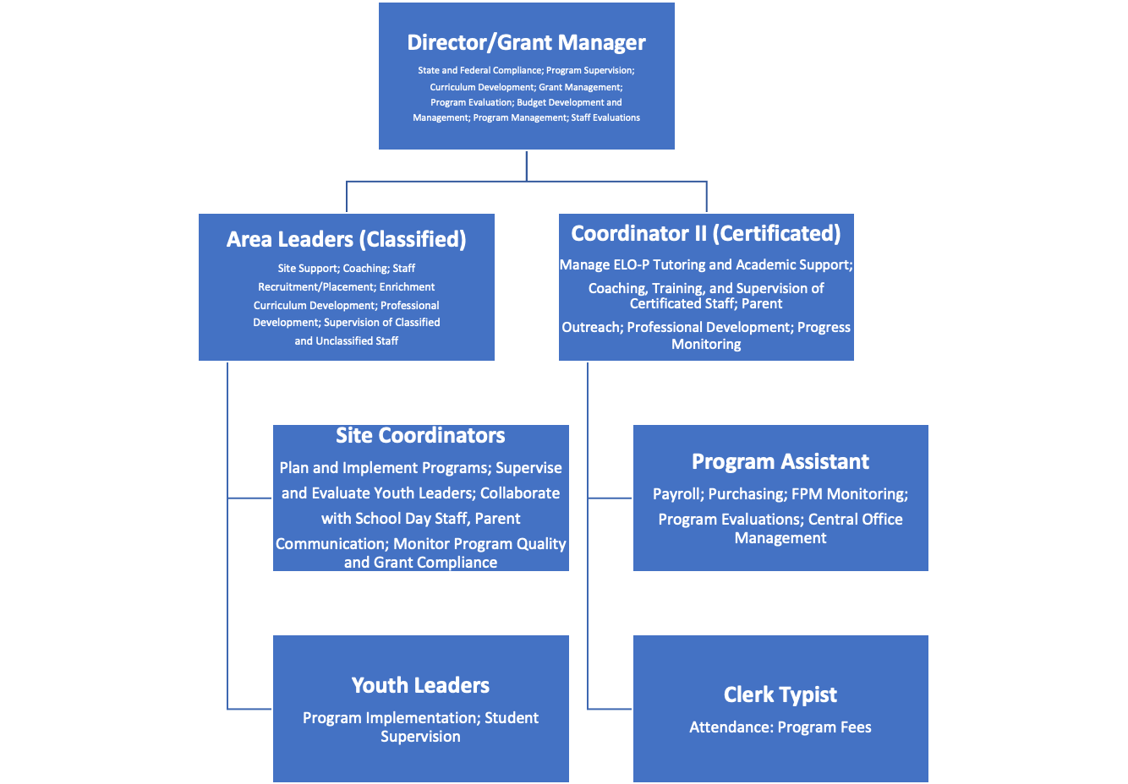

Describe how the program’s administrators will ensure that all staff who directly supervise pupils meet the minimum requirements of an instructional aide.
Program staff is comprised of Youth Leaders and PUSD credentialed teachers.
Youth Leaders must meet the district’s minimum job qualifications for Instructional Aides. Applicants must have a minimum of 48 semester or 73 quarter hours from an accredited college or university or take and pass the Youth Leader exam. In addition, PasadenaLEARNs requires a minimum of six months experience working with students in a school setting.

Describe the planned recruitment and hiring process for staff and how their experience, knowledge, and interests will be considered.
PasadenaLEARNs’ employment opportunities are posted on the district’s Human Resources website and EdJoin. Recruitment information is also uploaded to job search engines such as Indeed, Handshake, and LinkedIn. Staff attend recruitment fairs at local colleges/universities and post information on campus job boards.
Applicants may apply online or in person at the Pasadena Unified School District Office. Once an applicant’s minimum qualifications and previous employment experience are verified, candidates are invited to interview with a panel of 2-3 interviewers comprised of Site Coordinators and Area Leaders. Candidates who pass the interview process are referred to the Human Resources Office to complete the clearance process, which includes:
FBI/DOJ fingerprint background clearance
- TB Clearance
- First Aid/CPR Certification
Previous work experience and grade level preferences are taken into consideration when assigning new employees to schools. Level of education and degrees conferred are taken into consideration when determining compensation rates.
Describe the type and schedule for the continuous professional development that will be provided to staff.
PasadenaLEARNs staff participate in a 2-day professional development conference prior to the beginning of each school year. Staff receive ongoing training through monthly professional development workshops hosted the last Friday of each month, onsite training provided by Area Leaders and Site Coordinators during bimonthly staff meetings, and individualized classroom support. Training topics include but are not limited to:
- Supporting Foster and Homeless Youth After School
- Trauma-Informed Care Education and Promising Practices
- Understanding the Quality Standards for Expanded Learning in California
- Promoting Student Leadership
- Supporting English Language Learners
- Creating An Effective Classroom Community
- Including Students with Behaviors In the Classroom
- Mental First Aid Training
- Second Step Implementation Support

8-Clear Vision, Mission, And Purpose:
Describe how the needs of the community, students, parents, and school were identified (i.e. assessment scores, number of students performing academically below grade level, school and community safety data, attendance and truancy rates, and juvenile criminal rates, etc.), the resources available, and how those needs will be addressed.
SBAC data, iReady benchmark assessments, and attendance data are used to identify the academic support needs of PUSD students.
Spring 2022 Summative SBAC Data
Student Group | 2018-19 % meeting grade level standard  ELA | 2018-19 % meeting grade level standard  Math | 2021-22 % meeting grade level standard  ELA | 2021-22 % meeting grade level standard  Math
All Students | 45.5 | 35.3 | 45.3 | 32.9
English Learners | 4.5 | 6.5 | 6.0 | 5.3
Socio-Econ Disadv. | 33.6 | 23.1 | 34.0 | 21.3
Foster Youth | 14.1 | 8.1 | 16.7 | 13.5
Homeless | 26.7 | 17.3 | 22.6 | 11.4
Special Ed | 16.8 | 12.9 | 16.8 | 13.3
Based on 2022 Summative SBAC Data, PasadenaLEARNs implemented target intervention support for English Language Learners (ELLs) and foster/homeless youth. LEARNs provides ELD support for ELLs after school with certificated teachers and math tutoring and homework assistance. Tutors also help students work towards reclassification by providing LPAC test prep and instruction. PasadenaLEARNs works with school counselors and group home counselors to enroll foster/homeless students in the program where they receive academic support and develop the tools to build positive relationships with peers and adults.
According to national crime statistics, Pasadena’s crime rate is higher than approximately 70% of California’s cities, which underscores to need to create safe places for students between the hours of 3-6pm every day. With additional funding provided by the Expanded Learning Opportunities Program, PasadenaLEARNs has expanded the program to serve more than 1,000 additional students before and after school.
Describe 3-5 program goals developed from the results of the needs assessment and how will data be collected to evaluate whether program goals are being met.
Director/Grant Manager meets with Site Coordinators to review evaluation data from principal, student, and parent surveys and District SBAC and attendance data. Focus standards from the Quality Standards for Expanded Learning in California are selected for 2022-23 and S.M.A.R.T. goals created. Site Coordinators work with frontline staff to develop activities for their individual programs to support program goals. Goals are reviewed quarterly to track progress and revise if needed.
2022-23 Continuous Quality Improvement Goals
Quality Standard | Goal | Measure
Youth Voice and Leadership | Programs implement LEARNs Student Advisory Groups (L-SACs) by December 22, 2022 | L-PAC student rosters submitted to Director
Youth Voice and Leadership | L-SACs meet monthly to plan enrichment clubs, program spirit days, events, and field trips from January 9-May 26, 2023. | Monthly meeting agendas and meeting outcomes submitted to Director
Quality Staff | Site Coordinators engage in monthly staff recruitment activities from November 2022 through March 2023. | -Recruitment events scheduled on LEARNs calendar  -Site Coordinators submit monthly recruitment evidence (screenshots of search engine posts, confirmation emails for job fair sign-ups, etc.)
Quality Staff | Site Coordinators and Youth Leaders complete two Cypherworx online professional development modules per month beginning November 2022 through May 2023. | Monthly review of Cypherworx training module management system

Describe how the program has engaged or will engage stakeholders (i.e. Principal, instructional day teachers and other instructional day staff, families, students, program staff, community members, and other community partners) in the creation of the program’s mission, vision, goals, and expected outcomes based on the needs of the specific community.
PasadenaLEARNs’ program vision aligns to the district’s strategic vision. The program engages school day staff, program staff, students, parents, and community partners in the development of the program mission and goals through a variety of activities.
Program Mission

Our program provides safe, nurturing, and innovative learning communities where students can:
❖ expand their learning
❖ create new relationships
❖ enjoy new experiences
❖ develop life skills
Surveys
PasadenaLEARNs administer annual surveys for principals, students, and parents. Student surveys are designed to capture students’ attitudes about the program design, quality of program offerings, feelings of connectedness with peers and staff, and suggestions for future program planning. Parent surveys solicit feedback regarding the reasons for program participation, perceptions of program quality and effectiveness, and suggestions for program improvement. Principal surveys capture the principal’s goals for the program, alignment to school day needs, and perceptions of program quality. Survey information is used to inform program planning and offerings.

Advisory Group Meetings
PasadenaLEARNs hosts advisory committee meetings twice per year. PasadenaLEARNs Advisory Committee consists of LEARNs staff, school day staff, parents, and community members. The advisory committee discusses upcoming events, shares feedback from the sites, reviews evaluation data, and plans program-wide activities.
District Meetings
The Director/Grant Manager attends bi-monthly leadership meetings to share updated program information, receive feedback from other district departments, and identify opportunities for collaboration.
Parent Groups and Community Engagement
To engage and communicate with educational partners, PasadenaLEARNs staff participate in meetings with the following groups:
- The LCAP Workgroup comprised of parents, teachers, principals, counselors, nurses, administrators from district departments, and representatives from community arts partners and foster youth agencies.
- The District English Language Learner Advisory Committee (DELAC) consists of parents of English Language Learners and district personnel.
- The Parent Advisory Committee (PAC) consists of 11 parents and guardians who represent the targeted sub-groups of students and families, leaders from PUSD parent groups, district personnel, and representative from community agencies that support foster youth.
- District Leadership Network (DLN) consists of Chiefs, Assistant Superintendents, Directors, Program Coordinators, and union representatives
- African-American Parent Council (AAPC) consists of parents and caregivers of African-American students and district personnel.

9-Collaborative Partnerships:
Describe the collaborative partners that will be involved in the process used to plan, implement, and update the after school program plan.
The partners involved in the planning and implementation of the program plan are the Superintendent, Deputy Superintendent, Assistant Superintendent of Academic Services, and Director/Grant Manager of Expanded Learning Programs.
Director/Grant Manager of Expanded Learning Programs meets with community partners such as Partnership for Children, Youth, and Families, Day One, Young and Healthy, Boys and Girls Clubs of Pasadena, City of Pasadena’s Human Services Department annually to revisit collaboration efforts and determine if changes/updates are needed.
PasadenaLEARNs Director/Grant Manager meets with program partners annually to review contracts, discuss possible renewals, and identify in-kind services to be provided.
List and describe at least 3-5 collaborative members, including any specific duties/responsibilities or contributions (e.g., Memorandums of Understanding, service providers, in-kind, etc.).
- College Access Plan (CAP) is a contracted service provider that also provides in-kind services as outlined in a Memorandum of Understanding. Organization provides college and career exploration classes and assists middle school students in conducting research on fields of interest.
- Young and Healthy provides in-kind services in the form of student workshops that focus on healthy choices and behaviors and safety.
- Partnership for Children, Youth, and Families provides in-kind services that connect PasadenaLEARNs to community resources in order to support the needs of the whole student by providing wraparound services.

10-Continuous Quality Improvement:
Describe what measures of student success (e.g., school attendance, students and parents satisfaction, academic improvement, feedback from instruction day teachers) will be collected to help the program(s) assess and improve the quality of academic enrichment opportunities. Explain how the measures are coherent with the instructional day and the goals of the program.
Students who participate in PasadenaLEARNs are identified in the district’s Aeries Data Collection System, which collects data on PUSD students including attendance, grades, test scores, demographic information, and program participation information.
Student achievement data from Aeries (e.g. grades, SBAC scores, iReady benchmark assessments, and English Language Learner reclassification rates) is used by the District and PasadenaLEARNs to determine academic enrichment needs at each site. The disaggregated outcome results are shared with program staff and stakeholders in order to inform the public about student achievement and program quality and effectiveness.
District Instructional Coaches design and refine curriculum for the after school program geared towards addressing student needs identified in the data. Research-based online literacy and math intervention program such as Imagine Learning are also used to improve students’ academic achievement.
Principal feedback is also important in determining if program activities support student achievement and align to school day goals. Site Coordinators hold monthly meetings with principals to discuss program effectiveness, review program alignment with school day goals, and identify any areas of opportunity.
Parent surveys allow PasadenaLEARNs to determine if the program meets the needs of the families served. An analysis of the 2021-22 Parent Survey data found that over 80% of parents surveyed were satisfied with the program and agreed that the program met its intended outcomes.

2021-22 Parent Survey Data
Program Satisfaction
% of parents who reported feeling very satisfied/satisfied
Homework Assistance | 81.5
Enrichment Activities | 89.56
Relationship Building | 92.31

2021-22 Parent Survey Data
Service Outcomes
% of parents who agreed or strongly agreed
Safe space for my child | 93.09
Motivates students to learn | 87.84
Supportive learning environment | 92.9
Encourage me to be an active partner in the school | 85.64

Describe how (i.e., methods and frequency) the program will engage in a data-driven CQI process (i.e. assess program quality, plan, improve program quality) based on the Quality Standards for Expanded Learning in California. Include timelines, roles of staff and stakeholders, and how the results of the assessment(s) will help refine, improve, and strengthen the program.
PasadenaLEARNs engages in a continuous quality improvement cycle that includes ongoing assessment in the form of stakeholder surveys and site observations. Principals, parents, and students are surveyed in fall and spring each year. Attendance and SBAC performance data is made available at the conclusion of the school year and is available for review during the summer months. Information is used to identify on Point-of-Service and one Programmatic Standard from the Quality Standards for Expanded Learning in California to focus on each school year. Site Coordinators complete Program Quality Improvement Plans including S.M.A.R.T. goals with feedback from Youth Leaders. Plans are reviewed throughout the school year to assess movement towards goals. Improvement plans are updated as needed throughout the school year.

11-Program Management:
Describe how the program funding will relate to the program vision, mission, and goals for each site or group of sites.
The grant addresses identified needs at each site by dedicating 95% of the funding to direct services for students, as follows:
- Provide additional paid work hours for Site Coordinators and Youth Leaders to participate in more professional development opportunities provided at the County and District levels.
- Onboard more full-time staff to support program expansion.
- Hire certificated teachers to provide tutoring and homework assistance at each school site.
- Hire after school behavior intervention specialists to support students with mental health needs.
- Provide English Language Learners with additional academic support, tutoring facilitated by credentialed PUSD teachers, and English Language Development resources.
- Expanded scope of service agreements with program partners at each site to provide a wider variety of specialized classes such as robotics, video production, etc.
- Allocate additional funding to onboard more program partners to provide specialized services such as guitar, video game animation, etc.
- Hire additional Youth Leaders to create smaller student/staff ratios.
- Increased hourly rates for Youth Leaders to attract higher quality staff.
Provide the program organizational structure including succinct description of staff roles (e.g., “Staff responsible for homework support for grade three and science activities for grades three through five.”), lines of supervision for each site or groups of sites, frequency of meetings, and methods of communication.
- Director/Grant Manager is responsible for program development; grant management and compliance; reporting requirements; program budgets; CQI process; grant applications; Program Plan updates; meetings with program stakeholders; staff supervision; Area Leader and Site Coordinator evaluations; program-wide professional development; weekly meetings with direct supervisor, Chief Human Resources Officer; weekly meetings with Area Leaders and Site Coordinators
- Area Leaders supervise, support, and coach Site Coordinators; conduct daily site visits and classroom observations; meet with school site principals monthly; report to Director/Grant Manager daily; conduct monthly cluster meetings with assigned Site Coordinators; participates in weekly Site Coordinator meetings
- Site Coordinators manage program sites and budgets; support, coach, train, supervise, and evaluate Youth Leaders; oversee implementation of program components; input daily attendance; collaborate with school day; communicate with program parents; plan program activities; participate in monthly cluster meetings and weekly Site Coordinator meetings
- Youth Leaders supervise groups of approximately 20 students; implement program components; communicate with program parents; attend monthly professional development workshops; attend bi-weekly staff meetings
- Administrative Assistant monitors site budgets and tracks expenditures; submits Payroll; collects FPM documents; oversees program purchases; maintains equipment
- Clerk Typist collects, processes, and submits fee payments to Accounting Department; collects and reviews weekly program attendance for accuracy

Organizational chart provided in 7-Quality Staff.
Describe the process and time frames for periodic review of the program plan and how community partners and other external stakeholders were involved in the process.
PasadenaLEARNs Program Plan is reviewed and updated annually. The process, which involves community partners and external stakeholders, is outlined in Question 9.
Describe the system in place to address the following program administration requirements:
Fiscal accounting and reporting requirements:
Director/Grant Manager works with the grant’s Fiscal Analyst, Hector Baeza, to monitor grant spending and site allocations, track expenditures, maintain balanced site budgets, and submit reports in a timely manner.
Obtaining local match (cash or in-kind services) of one-third of the state grant amount:
Director/Grant Manager and Fiscal Analyst meet annually with principals, Director of Maintenance and Operations, Chief of Facilities, and Superintendent to identify match and in-kind services provided to PasadenaLEARNs.
Attendance tracking, including sign-in and sign-out procedures:
Site Coordinators track daily attendance for programs. Youth Leaders ensure that students are signed in and out properly each day. Site Coordinators check attendance sheets for accuracy daily and enter daily attendance information in Aeries. Attendance sheets are delivered to the PasadenaLEARNs Central Office weekly and are reviewed for accuracy by the Clerk Typist. The Clerk Typist also checks attendance data inputted into Aeries to ensure accuracy before attendance is filed.

12-Sustainability:
Describe the possible partnerships and funding sources, a schedule for revisiting the sustainability plan, and who is responsible for resource development.
Beginning in 2016-17, PasadenaLEARNs began offering fee-based programs at PUSD schools that did not qualify to receive ASES funds due to an inability to meet the minimum threshold requirement for percentage of students who are eligible to receive free or reduced price meals. Scholarships were made available for students who qualify to receive free or reduced price meals. Fee-based programs have been self-sustaining, and students are able to participate in a quality after school program at low/no cost. Fees collected supplement existing PasadenaLEARNs programs and provide additional revenue.
Beginning 2019-20, PasadenaLEARNs families were asked to pay a one-time registration fee to cover the cost of program supplies and materials with fee waivers available for families that qualified. The additional revenue was used to purchase much needed program supplies and materials for sites.
Pasadena Educational Foundation, a District partner, continues to research and solicit private sources of funding (foundations, corporations, civic groups, and individuals) and in-kind support to supplement and sustain the vision, mission, and goals of PasadenaLEARNs. Potential funding sources include the California Community Foundation, the Pasadena Community Foundation, and the foundations associated with banks and financial institutions that are required by law to support program that benefit low and moderate-income families.
Ongoing partnerships with non-profit organizations and/or organizations that have their own grant funding also helps sustain the program. Partners are encouraged to raise funds from public and private sources to help support their participation in PasadenaLEARNs, particularly from funding sources that focus on specific areas such as visual and performing arts, STEM/STEAM education, sports, and athletics.
PasadenaLEARNs’ sustainability plan is reviewed and updated annually based on data from the annual review of the LCAP, revenue from fee-based programs, and private donations. The updated sustainability plan is reviewed and approved by the Authorized Agent.

