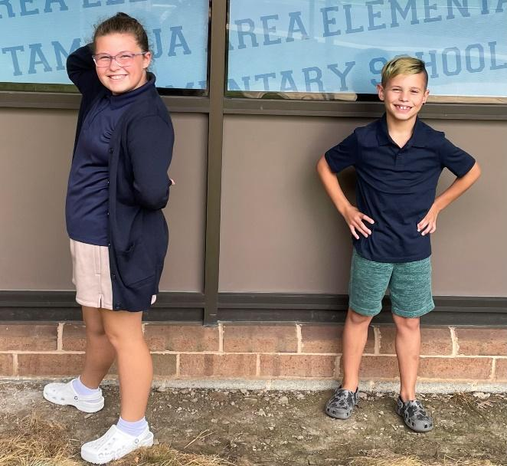

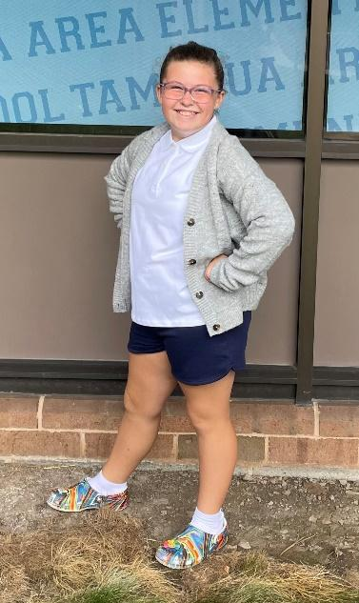
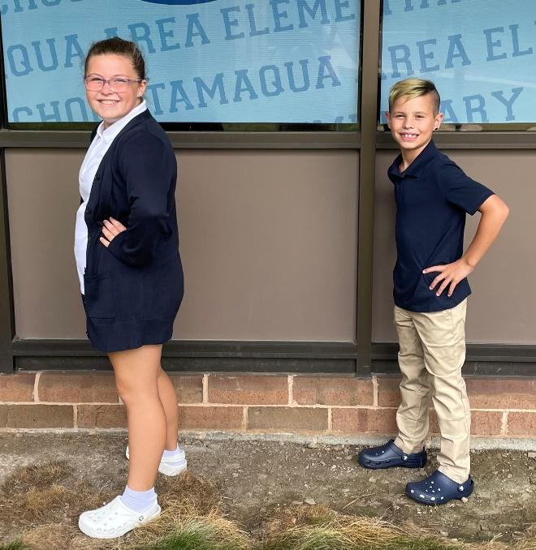
Elementary School Dress Code Examples
Sweater color
Shoe color
Shoe color

Hoodie

Hoodie
Cargo pants
Shorts color
Shoe color

Ready for school
*The arrows give examples of items that are not representative of the approved Tamaqua Area School District dress-code.

