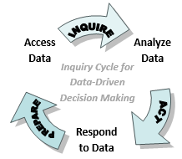
I-Tracker Pro Data Protocols for Teams
admin level access

Objectives:
- Identify students to target for improved outcomes
- Create action plans for identified students

Protocol Reports: via admin access to I-Tracker Pro
- Benchmark Assessment Correlation
- Summary of results of one test grouped by another test (e.g. movement from fall to winter)
- Growth Summary Reports
- Growth Summary by Grade (DIBELS Next, MI, RI)
- Triangle Reports
  - Academic Triangle (Academic Index)
    - Identify students at risk and contributing factors in student success or lack of success
  - Assessment Triangle
    - Intervention planning and/or reteaching strategies based on risk categories
  - For Elementary- Curriculum Triangle
    - Measure instructional outcomes, used to determine next steps
  - For high schools-College Planning School Dashboard
    - Measure instructional outcomes, used to determine next steps

Protocol Activities:
- Student Action plan (Academic dashboard and general)
- Here’s What, So What, Now What
- Data to Instruction Framework
- PLC/Collaborative Team Reflection on Cycles of Inquiry

Appendices
- Assessment Literacy: More Information on Assessment
- Cut Scores for Performance Levels and Cut Scores for Growth

Additional Resources
- Red Clay Analysis Protocols for I-Tracker Pro for Teachers
- Red Clay Online Test Scoring and Item Analysis Protocols
- Red Clay Analysis Protocols for Scholastic Achievement Manager (SAM)

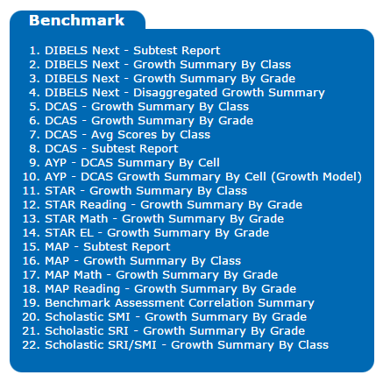
Protocol 1: Benchmark Assessment Correlation

Step 1: PREPARE- Access the Data
- Log into DSC http://www.dataservice.org/ and select I-Tracker Pro
- Under the Benchmark folder, click on “Benchmark Assessment Correlation Summary”
- Select the grade, the primary assessment for grouping (such as BOY DIBELS composite, Fall RI, or Fall MI), and another assessment (such as MOY DIBELS composite, Winter RI, or Winter MI. Run the report.
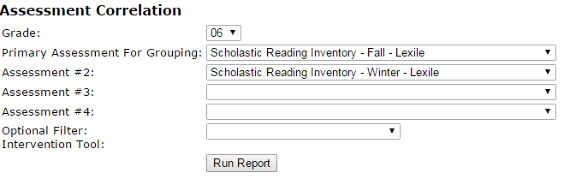

Step 2: INQUIRE-Analyze the Data
Among students identified in Red BOY/Fall, what percentage:
- Remained red?
- Grew to yellow?
- Grew to green?
Among students identified in Yellow BOY/Fall, what percentage:
- Declined to red?
- Stayed yellow?
- Grew to green?
Among students identified in Green BOY/Fall, what percentage:
- Declined to red?
- Declined to yellow?
- Stayed green?

Step 3: ACT-Respond to the Data
Dig deeper into the Growth Summary (Protocol 2) reports to identify students in each category

Product(s):
Print the table

Revisit (Cycle of Inquiry):
Monitor student progress on interim and benchmark assessments.
Check this report after the next screening assessment cycle.

Protocol 2: Growth Summary by Grade

Step 1: PREPARE- Access the Data
- Log into DSC http://www.dataservice.org/ and select I-Tracker Pro
- Under the Benchmark folder, click on “DIBELS Next” or “MI” or “RI” “Growth Summary by Grade”
- Select the grade, and choose view “Grouped by Beginning of Year Composite” (for DIBELS) or “Grouped by Fall Score” (for RI, MI). Run Report.
If a column heading is underlined, you can sort by that column.

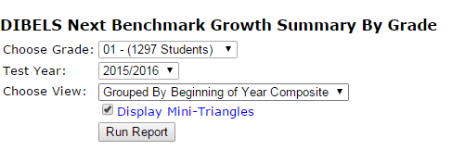
Step 2: INQUIRE- Analyze the Data
- Sort by Middle of Year (DIBELS) or Winter score (RI-Lexile/MI-quantile) column
at the end of the year sort by EOY (DIBELS) or Spring Score (RI/MI)
- Look at changes from Beginning of Year (DIBELS) or Fall score (RI-Lexile/MI-quantile)
  - Who are the students who have improved?
    - What do you think is working for the students who are improving?

  - Who are the students who have not improved or have declined?
    - Why do you think the students who haven’t improved, aren’t doing so?

  - Who are the students who have declined?
    - Why do you think the students who have declined did so?

  - (RI/MI) Which students met their growth target? Which students did not meet their growth target (how many points are they away from their target)?

Step 3. ACT: Responding to the Data
Identify targeted students and create action plans to address individual needs.
- What are the next steps for the students who have not improved?
- What other sources of data can help you determine next steps?
Have you looked at the academic index?
Have you examined interim/benchmark data at the item analysis level?
For RI/MI, have you accessed SAM (Scholastic) for additional reports if needed?
Product(s): Document next steps in one or more of the products provided, or in a similar document
Note: there is one student action plan specific to the Academic Dashboard. Teachers have student goal setting products.
Revisit (Cycle of Inquiry): Monitoring student progress. By the determined check in date, review success or lack of success of the action plan. What was the impact of previous actions?
- What went well and why? What would you change and why?

Adjust accordingly. Check the report after the next screening assessment cycle.

Protocol 3: Triangle Reports
related teacher level reports found in Class Data Dashboards

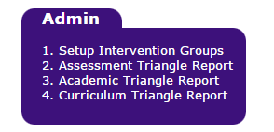
Step 1: PREPARE- Access the Data
- Log into DSC http://www.dataservice.org/ and select I-Tracker Pro
- Under the Admin folder, click on the triangle report you want to review.
- Select a grade or select all grades.
If a column heading is underlined, you can sort by that column.

Step 2: INQUIRE-Analyze the Data
- For the “Assessment” triangle report, select the assessments to review. More recent assessments will report similar assessments given in the same school year (e.g. fall RI data in the Winter RI report).
This data is most likely accessed for RtI intervention planning and/or reteaching.
- For the “Academic” triangle report, select the last marking period when grades were submitted
(Note: For more information on the Academic Index, click on the “View Academic Index Information” link in the upper right corner of the screen)
- For the “Curriculum” link, select the assessment to review. Data is provided for all related assessments (ones teachers entered or DSC entered (Grades 2-5 unit benchmarks). Attendance data is provided to determine if it is a contributing factor to lack of student success. (Note: Elementary Fresh Read levels: A-above level, OL-on level, SI-strategic intervention)

- *High Schools only* (not triangle, but similar report)
In the “Data Monitoring Reports” folder, access the “College Planning School Dashboard”. Columns will populate based on data available, including PSAT, SAT, AP scores, and GPA weighted and not weighted (current and cumulative).

When viewing each triangle report, click in a portion of the triangle to review that subset of students (red, yellow, or green). Consider the following questions:
- How does data compare across data points for each student?
- Are there any trends for the class or particular students?
- Are students progressing? If so, celebrate. If not, what other data sources can provide actionable data? Determine what is necessary to help your students improve. Focus on causes that are within your control. Brainstorm strategies to improve student outcomes in the identified area of need.

Step 3. ACT: Responding to the Data
Identify targeted students and create action plans to address individual needs. Document next steps in the product provided or in a similar document.
Product(s): Select one or more of the products provided to address needs identified in Step 2: Analysis.
Note: there is one student action plan specific to the Academic Dashboard. Teachers have student goal setting products.
Revisit (Cycle of Inquiry): Monitoring student progress. By the determined check in date, review success or lack of success of the action plan. What was the impact of previous actions?
- What went well and why? What would you change and why?

Adjust accordingly. Check the report after the next screening assessment cycle.

Product: Student Action Plans
Area of Concern | List Students | Next Steps Action Plan  (additional data to review or collect,  intervention/instructional strategy) | Met Target? (RI/MI),  if no, how many points are needed | Timeline | Recheck  status  (declining, improving,  neither)
Red
Staying
Red

Yellow Declining to Red

Green Declining to Red

Green Declining to Yellow

Yellow remaining Yellow

Product: Student Action Plans Using Academic Triangle for Protocol 3

Red Students Marking Period:_________
Key Area of Concern | List Students | Action Plan to address need | Person Responsible | Check in Date
All
Attendance

Discipline

Grades

Product: Student Action Plans Using Academic Dashboard for Protocol 3 (continued)

Yellow Students Marking Period:_________
Key Area of Concern | List Students | Action Plan to address need | Person Responsible | Check in Date
All
Attendance

Discipline

Grades

Product: Here’s What-So What-Now What
How to use this sheet: This part is best done in a group – after all, we learn more from working together than from doing things alone. After taking time to consider the data, we are ready to use our ideas to build knowledge about our students, instruction, our classrooms, and, importantly, what is and isn’t working. In the first column, “here’s what!”, we put clear accurate statements about the data (e.g. 24% of our 8th grade student are not ready for algebra). Some of these may come from our own “notice” columns or may emerge from collaborative work around data. Next we focus on “so what?” – this is an opportunity to interpret the data. What does it mean? What are possible causes? Why do we think this is? No “here’s what?” should ever have just one hypothesized cause or meaning – be open about possibilities that can be explored later. Last, we move to “now what?”, where we come up with action steps. Keep in mind “action” doesn’t mean “solution”. It may mean revisiting the issue using other data sources to explore causes, collecting more data (e.g. diagnostic assessments, surveys, etc.) to better understand the issue, or researching a strategy to address the issue. All columns should reflect the consensus and collaboration of the group or team and all “now what?” items should be planned to be addressed by team members.

Here’s What! | So What? | Now What?
Dr. Elizabeth Farley‐Ripple, University of Delaware

Product: DATA TO INSTRUCTION FRAMEWORK

Identified Need

Needs Groups
At Risk/ Deficit |  | Some Risk/ Emerging |  | Benchmark/ Established

Skill/Strategy Selected

Standards/ Learning Progressions:

EQ:
At Risk/  I-Tracker Red Group | Student Activities/Instructional Strategies:  Assessment:
Some Risk/  I-Tracker Yellow Group | Student Activities/Instructional Strategies:  Assessment:
Low Risk/  I-Tracker Green Group | Student Activities/Instructional Strategies:  Assessment:
Adapted from DTI Framework, Red Clay Instructional Technology Coaches & Dotty Johnson version
Product: PLC Team Reflection on Cycles of Inquiry
Team/ Department/Grade Level/ Content Area:
Group Leaders:
Names of Group Members:

Guiding Questions/ Reflections…

- What are the team’s SMART Goals?

- What instructional strategies have been used to address the SMART Goals?

- How has your team measured success towards your SMART Goals?

- How do your SMART Goals relate to the summative or interim/benchmark measures (i.e. DCAS, DIBELS, RI/MI)?

- What factors have contributed to your team’s success towards reaching your SMART Goals?

- What factors have contributed to your team not reaching your SMART Goals?

- What will your team do differently in the next few weeks (for mid-year reflection) or next year (for end-of-year reflection) to improve your Cycle of Inquiry and help your team reach your SMART Goals?

Appendix: Assessment Literacy
More information on assessment
Assessment is a valuable part of Red Clay’s educational program. This important component allows teachers to plan, document and evaluate student learning in an ongoing cycle. This teaching process is crucial to promote student achievement. Tests and other assessments provide evidence of student learning and help teachers identify next steps in their instruction.
Classroom assessments are determined by individual teachers. Some examples are pre-tests, end of unit or chapter tests, quizzes, and informal assessments to gauge students’ understanding, provide grades, and inform teaching.

Schoolwide assessments are determined at the school level. Teachers across a grade level or department give the same assessment. Common assessments provide information to identify students who may need additional assistance and to identify strengths and needs in the instructional program.

Districtwide assessments are determined at the district level. These assessments are given to all students across the district. Certain assessments are selected based on district need and other assessments are given to meet state or federal requirements, such as Response to Intervention (RTI) to identify students who need additional assistance. These common assessments show what students learned, monitor progress, and determine what professional development might be helpful for teachers.

State and National assessments are determined by the Delaware or U.S. Departments of Education. Delaware System of Student Assessment (DeSSA) includes Smarter testing in reading and mathematics (grades 3-8), DCAS Science (grades 5, 8, 10), DCAS Social Studies (grades 4, 7), DCAS U.S. History (high school), PSAT (grade 10, Red Clay also tests grades 9 and 11), and SAT (grade 11). It also includes tests for specific groups: DCAS Alt-1 (alternative test) for students with severe cognitive disabilities, ACCESS (Assessing Comprehension and Communication in English State-to-State) for English Language Learners (taken until demonstrate proficiency in English). Students enrolled in Advanced Placement (AP) or International Baccalaureate (IB) courses have an opportunity to take AP or IB exams. Every few years a sample of 4th, 8th, and 12th grade students take the National Assessment of Educational Progress (NAEP).

TYPES OF ASSESSMENTS
FORMATIVE assessments are used during instruction and provide feedback to adjust ongoing teaching and learning. An example is a class quiz where students explain their thinking.
SUMMATIVE assessments are generally given after instruction (end of a unit, course, or grade) to evaluate students’ performance against a set of standards. Examples are the state SMARTER and DCAS tests, and class unit tests.
INTERIM or BENCHMARK assessments fall between formative and summative and are given to evaluate students’ knowledge and skills relative to a specific set of standards. They are designed to inform decisions at the classroom level and school or district level. An example is a unit test from our reading or math series given to all students in the district at that grade level.
Source: Achieve http://www.achieve.org/files/Achieve_StudentAssessmentInventory_ListeningtoParents.pdf

Appendix: Cut Scores

DIBELS Next https://dibels.uoregon.edu/docs/DIBELSNextFormerBenchmarkGoals.pdf (page 4)

RI

Average growth chart of RI for grades 2 – 8
Note each students target is specific to their fall Lexile
(click to visit link, starts on page 15)
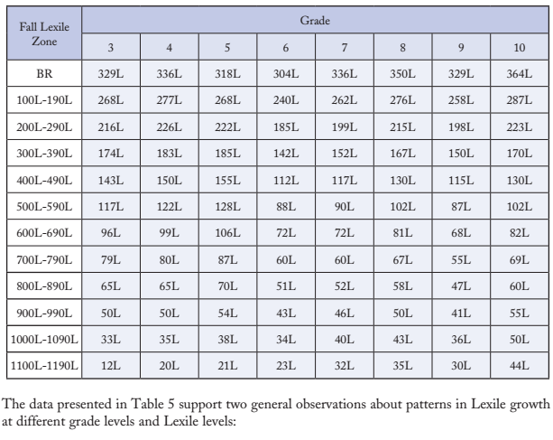

MI

Expected growth chart of MI for grades 2 – 8
Fall Quantile | Grade Level
Fall Quantile | 2 | 3 | 4 | 5 | 6 | 7 | 8
EM-99 | 215 | 270 | 290 | 295 | 210 | 190 | 180
100-199 | 180 | 245 | 260 | 270 | 200 | 200 | 175
200-299 | 145 | 225 | 230 | 240 | 190 | 185 | 180
300-399 | 100 | 195 | 195 | 200 | 165 | 165 | 165
400-499 | 60 | 170 | 160 | 165 | 145 | 140 | 150
500-599 | 0 | 140 | 120 | 130 | 120 | 120 | 130
600-699 | N/A | 110 | 85 | 95 | 95 | 95 | 110
700-799 | N/A | 75 | 45 | 60 | 65 | 70 | 90
800-899 | N/A | N/A | 0 | 25 | 40 | 45 | 70
900-999 | N/A | N/A | N/A | 0 | 10 | 20 | 50
1000-1099 | N/A | N/A | N/A | N/A | 0 | 0 | 25
1100-1199 | N/A | N/A | N/A | N/A | N/A | 0 | 0
1200-1299 | N/A | N/A | N/A | N/A | N/A | N/A | 0

RI Performance Grade Bands
(click to visit link, view page 44)

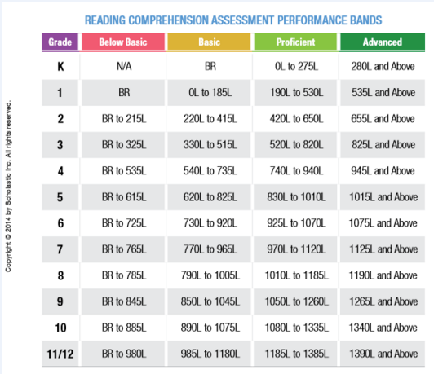

MI Performance Grade Bands
