School-Based Health Center’s Wellness Wednesday!

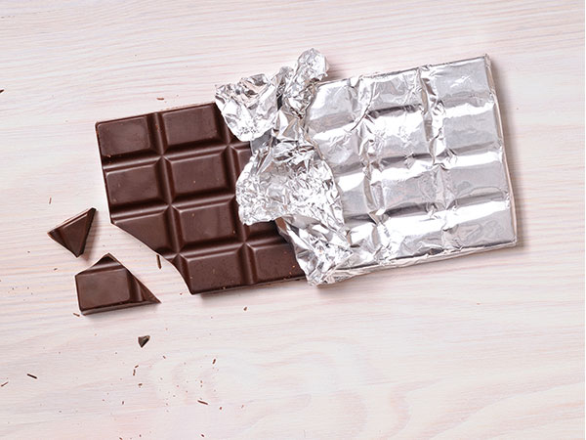

Since many of you have been home all day, you may find yourself eating more snacks. If you are trying to follow a very strict diet or completely cut out groups of foods, you may get overly hungry and find yourself eating unplanned, random snacks. Strict diets can cause food cravings to become intense and lead to overeating and guilt. It is better to plan balanced meals and healthy snacks to help you get the energy you need, to stay focused on your school work and to prevent food cravings. It is okay to plan some high-calorie snacks once in a while. So if you sometimes crave chocolate, keep some on hand and plan to enjoy a small portion and then put it away. Chocolate should be a snack and not a “sneak”.
For more ideas on how to handle food cravings and plan healthy snacks, check out this website:

https://www.eatright.org/food/planning-and-prep/snack-and-meal-ideas

If you have any questions about food or nutrition for our dietitians, call or text the School-Based Health Center at # 302-285-9661. Eating healthy can help you stay healthy.

