Nutrition and Physical Activity Fall 2024

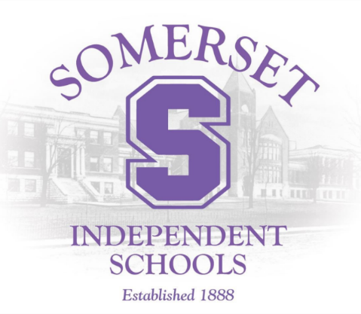
SIS CHILD/SCHOOL NUTRITION Program is administered through the United States Department of Agriculture (USDA), the Kentucky Department of Education (KDE), the Kentucky Department of Agriculture (KDA), and the SIS Board of Education. Comprehensive regulations must be followed in order to receive federal funding to operate the program.

The following USDA programs are provided in the SIS:
National School Breakfast and Lunch (NSBLP) = school meals
Summer Food Service Program (SFSP) = summer meals
Child and Adult Care Food Program (CACFP) = dinner meals

During the 2023-2024 school year, Somerset Independent Schools served 80,955 breakfasts and 199,125 lunches. During the Summer feeding program that ran for six weeks, Somerset Independent Schools served 346 breakfasts and 752 lunches.

Somerset Independent Schools Wellness Summary

- SHS installed 3 new vape detectors and Meece Middle School installed 4 new vape detectors to help reduce teen vape use

  - A full-time nurse is assigned to Hopkins, Meece Middle School, and SHS

  - Trainings for emergency and daily medication dispensing continued

  - Somerset Aquatic and Alumni Center therapy pool and lap pool officially opened

  - LCMA Mobile Health Bus comes on Thursdays to provide physicals, immunizations, sick and well child visits as needed

  - July 1, 2021, Hopkins Elementary, Meece Middle, and SHS created Trauma Informed Teams to identify and assist students whose learning, behavior, and relationships have been impacted by trauma

  - Hopkins Elementary, Meece Middle, and SHS administered the Terrace Metrics survey to assess students’ social/emotional learning

  - July 1, 2022, Somerset Independent Schools partnered with Care Solace to provide access to mental health resources to students, families, and employees.

  - December 2022, Somerset Independent Schools purchased 2 new Vape detectors for the student restrooms at Central Office.

- Spring of 2023, LCDHD provided 6 Narcan kits to Somerset Independent Schools. SHS, MMS, and HES have two Narcan kits per school.

- Summer of 2023, Life Vac manufacturing provided 3 anti-choking devices to Somerset Independent Schools. SHS, MMS, and HES have one anti-choking device per school.

- July 2023, Somerset Independent Schools implemented a Cardiac Emergency Response plan for athletics and at SHS, MMS, and HES.

- Spring of 2024, LCDHD provided 6 Stop the Bleed kits to Somerset Independent Schools. SHS, MMS, and HES have two Stop the Bleed kits per school.

- Summer of 2024, Somerset Independent Schools purchased three additional AEDs with one specifically to be used to send on off campus field trips.

