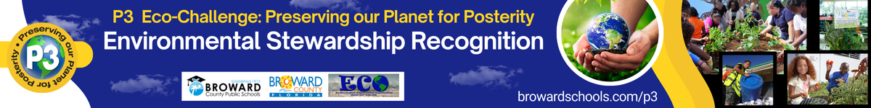

2024-25 NON-INSTRUCTIONAL STAFF APPLICATION

Non-instructional staff can be your school volunteers, secretaries, bookkeepers, cafeteria staff, and others who assist your school in your environmental initiatives.

First Name of Nominee
Last Name of Nominee
BCPS School Name Affiliation of Nominee
Email Address of Nominee
Phone Number of Nominee
Name of person completing this application
Email address of above
Relationship of person above to the nominee

Summary of Nominee – This brief summary will be used as the biographical information for the nominee in the Awards Ceremony program. To see previous P3 Winners and Nominees’ Bio, visit https://www.browardschools.com/cms/lib/FL01803656/Centricity/Domain/13621/STEM_CS/P3%20EcoChallenge/Documents/2018_P3_Bios.pdf Maximum of 1/3 page printed.
Summary here

Picture of Nominee (1 pt – part of the Documentation and Photos) – insert your picture below. Submit a high-quality picture for printing. We use this picture for the awards ceremony program and slides.

Picture here

For the following narratives, insert the pictures with descriptions and any supporting documentation where applicable. You can use other indicators not listed to support your narrative.

Awareness & Involvement (30 points max)
Fosters awareness of the natural and built environments
Promotes an understanding of concepts, issues, feelings, values, attitudes and perceptions at the heart of environmental issues
Advocates civic responsibility, encouraging others to use their knowledge, personal skills, and assessments of issues as a basis for problem-solving and action
Helps provide the ability for educators to utilize the outdoors and/or alternative sites and methods in his/her environmental stewardship practices
Utilizes eco-friendly materials to do their job
Encourages lifelong skills that enable others to prevent and address environmental issues

Narrative here

Current Professional Development (30 points max)
Attends professional development opportunities such as workshops, seminars and conferences to learn best practices and the latest eco-friendly techniques for their position
Supports, provides and/or promotes additional training for other staff in environmental issues and best practices
Encourages collaboration with teachers, students, and others in their field
Motivates and inspires others to conserve water, recycle, and practice environmental sustainability

Narrative here

Creativity (30 points max)
Supports the use of community resources
Emphasizes and promotes the use of different environmental friendly techniques and materials
Integrates current environmental issues into their job
Aids and/or provides opportunities for educators to promote and foster critical thinking and problem-solving activities, programs, and experiments

Narrative here

Documentation and Photos (10 points)
Provides letter(s) of recommendation(s), other documentation to support application (3 points) – use the Assignments upload or take a picture and add at the end of this document.
Provides at least one high quality image of just the nominee (1 point)
Provides pictures and documentation to support the narratives (6 points)

