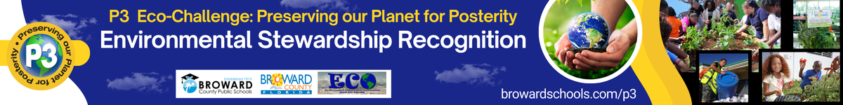

2024-25 CUSTODIAL STAFF APPLICATION

First Name
Last Name
School Name
Email Address of nominee
Phone Number of nominee
Name of person completing this application if not the nominee
Email address of above

Summary of Nominee – This brief summary will be used as the biographical information for the nominee in the Awards Ceremony program. To see previous P3 Winners and Nominees’ Bio, visit https://www.browardschools.com/cms/lib/FL01803656/Centricity/Domain/13621/STEM_CS/P3%20EcoChallenge/Documents/2018_P3_Bios.pdf Maximum of 1/3 page printed.
Summary here

Picture of Nominee (3 pts – part of the Documentation and Photos) – insert your picture below. Submit a high-quality picture for printing.

Picture here

For the following narratives, insert the pictures with descriptions and any supporting documentation where applicable. You can use other indicators not listed to support your narrative.

Awareness & Involvement (40 points max)
Works to create a sustainable environment at the school by promoting eco-friendly practices. These practices include improving energy efficiency, reducing waste, reducing water use, conserving habitat, responsible resource management, proper disposal techniques, reducing stormwater runoff, improving water or air quality, incorporating sustainability practices on the campus, such as assisting with school gardens, mulching, or promoting native/Florida-friendly drought tolerant plants.
Demonstrates leadership qualities; provides a good example for others to follow.
Works to motivate and/or educate others to use eco-friendly methods.

Narrative here

Current Professional Development (40 points max)
Demonstrates personal commitment to environmental principles. Can include attending environmental/green trainings, such as custodial trainings, and those taken outside of work.
Promotes others’ (community, students, staff) involvement in the school’s green programs.
Fosters cooperative relationships with colleagues in the green activities at the school.
Seeks out trainings, expert advice or other ways to improve knowledge on best management practices for the campus.

Narrative here

Creativity (10 points max)
Utilizes instructional techniques that create an effective learning environment
Uses community resources
Motivates connections to real-life
Emphasizes the use of techniques for different learning styles
Develops interdisciplinary instruction, learner centered instruction, and a variety of assessment strategies
Integrates current environmental issues into learning opportunities and activities

Narrative here

Documentation and Photos (10 points)
Provides letter(s) of recommendation(s), other documentation to support application (4pts) – use the Assignments upload.
Provides at least one high quality image of just the nominee (3 pts)
Provides at least one high quality image of the nominee in action (environmentally related) or a picture that the custodian was involved in its success (a garden, fixed or new facilities upgrades, recycling etc.) with caption explaining picture. (3 pts)

