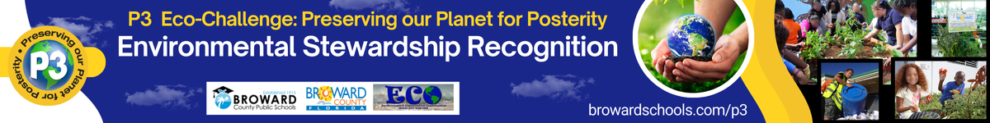

2024-25 EDUCATOR APPLICATION

School Level: ________________

(Enter one level only: Elementary, Middle, or High)
First Name
Last Name
School Name
Email Address
Phone Number
Grade Level(s)/Subject(s) You Teach

Summary of Nominee – This brief summary will be used as the biographical information for the nominee in the Awards Ceremony program. To see previous P3 Winners and Nominees’ Bio, visit https://www.browardschools.com/cms/lib/FL01803656/Centricity/Domain/13621/STEM_CS/P3%20EcoChallenge/Documents/2018_P3_Bios.pdf Maximum of 1/3 page printed.
Summary here

Picture of Nominee (5 pts) – insert your picture below. Submit a high-quality picture for printing.

Picture here

For the following narratives, insert the pictures with descriptions and any supporting documentation where applicable. You can use other indicators not listed to support your narrative.

Awareness & Involvement (22 points max)
Fosters awareness of the natural and built environments
Promotes an understanding of concepts, issues, feelings, values, attitudes and perceptions at the heart of environmental issues
Advocates civic responsibility, encouraging learners to use their knowledge, personal skills, and assessments of issues as a basis for problem-solving and action
Forges relationships between the environment, school and community
Utilizes the outdoors and/or alternative sites in his/her environmental stewardship practices
Employs alternative methods for teaching tools
High school: Team competes at the regional Envirothon competition

Narrative here

Current Professional Development (22 points max)
Attends professional development opportunities such as workshops and conferences
Arranges for additional teaching and learning development
Seeks additional training in environmental education and issues
Collaborates with other educators

Narrative here

Instructional Soundness/Creativity (22 points max)
Utilizes instructional techniques that create an effective learning environment
Uses community resources
Motivates connections to real-life
Emphasizes the use of techniques for different learning styles
Develops interdisciplinary instruction, learner centered instruction, and a variety of assessment strategies
Integrates current environmental issues into learning opportunities and activities

Narrative here

Skill Building (22 points max)
Teaches lifelong skills that enable students to prevent and address environmental issues
Fosters critical thinking and problem-solving activities, programs, and experiments
Motivates students to seek environment-related courses and fields in higher education and/or careers

Narrative here

Documentation and Photos (7 points)
Provides letter(s) of recommendation(s), other documentation to support application – use the Assignments upload or you can take a picture of it and add to the bottom of this application
Provides pictures and documentation to support the narratives

