What is a School-Parent Compact? Activities to Build Partnerships

A School-Parent Compact for Achievement is an agreement that parents, students, and teachers develop together. It explains how parents and teachers will work together to make sure all our students reach grade-level standards.
Effective Compacts:

- Link to goals of the School Improvement Plan
- Focus on student learning skills
- Describe how teachers will help students develop those skills using high-quality instruction
- Share strategies parents can use at home
- Explain how teachers and parents will communicate about student progress
- Describe opportunities for parents to volunteer and participate in classroom

Jointly Developed
The parents, students, and staff of Pate’s Creek Elementary developed this School-Parent Compact for Achievement. Teachers suggested home learning strategies, parents added ideas to make them more specific and students told us what would help them learn. Meetings are held each year to review the Compact and make changes based on student needs.

Parents are welcome to contribute input/comments at any time.
If you would like to volunteer or participate, please contact: Tiffany.Tucker@henry.k12.ga.us or call 770-389-8819. For classroom observations contact your student’s teacher to schedule. All classroom observations will be virtual this school year.

Family Resource Center (FRC)

Parents are welcomed and encouraged to check-out resources to assist their child with learning at home. Some of these learning aids include manipulatives, books, games, flashcards, and much more. The Family Resource Center is located in Room 106. If you wish to check out materials, please contact Ms. Tucker or your child’s teacher.

Parent Workshops

Workshops are held throughout the school year. For the 2023-2024 school year, these meetings will alternate virtually and in-person. The focus of the workshops is to provide parents the tools and support to help their child academically at home.

Student Facilitated Conferences

Your student will be well versed and have an appreciative understanding of their grade standards. With this knowledge your student will conduct a parent student teacher conference to share work samples and display their growth.

Communication about Student Learning
Pate’s Creek Elementary is committed to frequent two-way communications with families about
children’s learning. Some of the ways you can expect us to reach you are:
- Weekly communication folders
- Phone calls
- Email
- Campus Messenger
- Report Cards
- School website
- Class DoJo

Pate’s Creek Elementary

School-Parent Compact for Student Achievement 2024-2025

Revised September 23, 2024

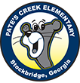

Jennifer McCrary, Principal

Toi McLaughlin, Assistant Principal

1309 Jodeco Road

Stockbridge, GA 30281

770-389-8819

https://schoolwires.henry.k12.ga.us/Page/12605

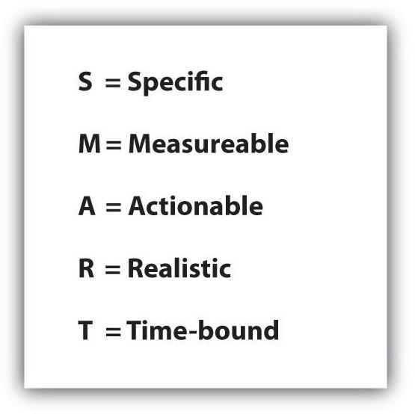

Our Goals for Student Achievement

Henry County District Goals:
PRIORITY STUDENT OUTCOMES to measure success:
1. We will advance opportunities, access, and outcomes for every student group in Literacy Proficiency at every grade.
2. We will advance opportunities, access, and outcomes for every student group in Readiness to Learn at every level.
3. We will advance opportunities, access, and outcomes for every student group in College, Career, and Life Ready skills - post graduation.

Pate’s Creek Elementary Goals:

Student Performance Goal #1:Increase the percentage of 1st grade students reading on or above grade level from 42.5% to 50% according to Amira benchmark data.

Student Performance Goal #2: Increase the percentage of 3rd grade students reading on or above grade level from 48% to 53% according to GA milestones.

Student Performance Goal #3: Increase the percentage of students present more than 90% of enrolled days from 77% to 80%.

Focus Areas: Literacy and Attendance

Teacher/School Responsibilities
As a school, we will………
- Share teachers’ web pages and email address on our website for parents to access study guides and other learning resources.
- Provide parents with information on the Family Resource Center and its resources available for checkout to assist their child in areas of academic need
- Conduct parent workshops to support ELA, science, social studies, and math

Student Responsibilities
As students, we will…
- Use the ELA, math, science, and social studies websites my teachers share with me to complete notes, practice tests, use study guides for reinforcement, and activities to make learning fun
- Complete the homework assignments with my parents and highlight math problems, ELA directions that I do not understand, and note science and social studies questions to review with my teachers the next school day
- Take home weekly communication folder and invitations about meetings, conferences and workshops and share it with my parent

Parent and Family Responsibilities
As parents, we will……………
- Visit the school website and teacher’s homepage with my child for shared math notes and practice tests, use study guides for reinforcement, and activities to make learning fun
- Utilize the Family Resource Center for additional home academic support
- Be an active participant of the Pate’s Creek Elementary Community by participating in PTO meetings and Academic Workshops for parents to learn about school curriculum and academic strategies to support my child’s learning at home

Teachers, Parents, and Students Together for Success

