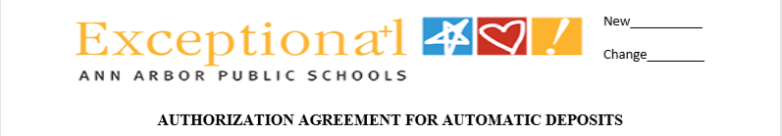
QUESTIONS:
finpayroll@aaps.k12.mi.us
Schedule IN PERSON APPT:
finpayroll@aaps.k12.mi.us

I hereby authorize AAPS via JPMORGAN CHASE BANK to initiate deposit entries and when necessary, initiate correction entries to my checking and/or savings account indicated below and the financial institution (s) named below to credit and/or debit the same such account. PLEASE ATTACH A VOIDED CHECK or PRINTOUT from financial institution. MUST contain ROUTING & ACCOUNT NUMBER.
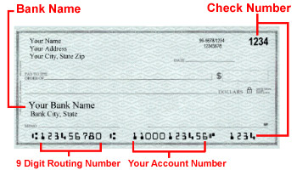
PRIMARY DIRECT DEPOSIT ACCOUNT (for BALANCE OF NET PAY)
Bank Name: __________________________________ Checking (OR) Savings
Routing Number: _______________________ Account Number: __________________________
CHANGE ACCOUNT:
1
PLEASE STAPLE CHECK HERE:
**NOTE: Electing NOT to provide supporting documentation may result in the need for a correction entry and DELAY in receipt of funds.
VOID

Entering NEW account information, AUTOMATICALLY overrides current information in system for PRIMARY account ONLY***
2
ADDITIONAL ACCOUNT (DOLLAR AMOUNT or PERCENTAGE OF INCOME)
Bank Name: ____________________________________ Checking (OR) Savings
Routing Number: _________________________ Account Number: _________________________
Amount: $ _________________ OR % ___________________
_______________________________

ADD DELETE
EDIT

MARK ONLY IF REMOVING ACCOUNT

ACCNT.

3
ADDITIONAL ACCOUNT (DOLLAR AMOUNT or PERCENTAGE OF INCOME)
Bank Name: ____________________________________ Checking (OR) Savings
Routing Number: _________________________ Account Number: _________________________
Amount: $ ____________________ OR % ___________________

ADD DELETE
EDIT

MARK ONLY IF REMOVING ACCOUNT

This authority is to remain in full force and effect until the Ann Arbor Public Schools Finance Department has received a REVISED, UPDATED, SIGNED form from me (AAPS EMPLOYEE) -IN PERSON/VERIFIED BY PAYROLL.

EMPLOYEE NAME (PRINT ONLY): __________________________________________________________
SSN (LAST 4 DIGITS ONLY): __________________ EMPLOYEE ID: _______________________
EMPLOYEE SIGNATURE: __________________________________________ DATE: _________________
Rev: 8/6/24
16/2022
.19
IDENTITY VERIFIED BY: ___________

