27 20 00
Note to Editor: this is a master specification and needs to be edited to become project SPECIFIC. please remove all COMMENTS, highlights and text boxes and make all text black once editing is complete.

DATA COMMUNICATIONS ACTIVE INFRASTRUCTURE
PART 1 – GENERAL
1.01 SUMMARY
- This section describes the data communications network infrastructure including electronics and software needed to support Local Area Networks and network management.
- Contractor and Integrator shall verify all equipment models with the District prior to purchase.
- Contractor and Integrator shall be responsible for coordinating and providing Network Design to the District for review and approval.
- Products Installed Under this Section: Only new equipment and material, produced by manufacturers that are recognized nationally by the telecommunications industry and approved by Underwriters Laboratory shall be used as specified in this Section or on the Drawings.
1. All mounting hardware
2. All mounting brackets
3. All power cords
Note to Editor: Revise related specification section as APPROPRIATE for specific project requirEments.

- Related Sections
1. Division 01
2. 11 40 00: Food Service Equipment
3. 11 51 19: Book Theft Protection Equipment
4. 23 09 00: Instrumentation Controls for HVAC
5. 26 05 00: Common Work Results for Electrical
6. 26 50 00: Lighting
7. 27 10 00: Structured Cabling
8. 27 30 00: Voice Communications
9. 27 41 16: Audio Visual Systems
10. 27 41 33: Master Antenna & TV Systems
11. 27 50 00: Digital Intercom Clock & Bell
12. 27 51 26: Assistive Listening System
13. 28 16 00: Intrusion Detection System
14. 28 23 00: Digital Video Surveillance System
1.02 References
- NEMA – National Electrical Manufacturer’s Association
- ANSI – American National Standards Institute
- NEC – National Electric Code
- RSEF – Relevant State Electrical and Fire Codes
- IEEE – Institute of Electrical and Electronic Engineers
- UL – Underwriters Laboratories, Inc.
- ANSI/EIA/TIA – 568-C.0, Generic Telecommunications Cabling for Customer Premises
- ANSI/EIA/TIA – 568-C.1, Commercial Building Telecommunications Cabling Standard
- ANSI/EIA/TIA – 568-C.2, Balanced Twisted-Pair Telecommunications Cabling and Components Standard
- ANSI/TIA – 568-C.2-1 Transmission Performance Category 6 Cabling Specifications for 4-Pair 100 Ω Category 6 Cabling, provided they meet accuracy requirements for level III field testers; Category 6
- ANSI/TIA – 568-C.3, Optical Fiber Cabling Components Standard
- ANSI/TIA – 569A Commercial Building Standard for Telecommunications Pathways and Spaces
- ANSI/EIA/TIA – 606 The Administration Standard for the Telecommunications Pathways and Spaces
- ANSI/EIA/TIA – 607 Commercial Building Grounding and Bonding Requirements for Telecommunications
- ANSI/EIA/TIA – 598 Color Coding of Optical Fiber Cables
- EIA/TIATSB – 67 Transmission Performance Specifications for Field Testing of Unshielded Twisted-Pair Cabling Systems
- BICSI – Building Industry Consulting Service International publications:
  - Telecommunications Distribution Methods Manual
  - LAN and Internetworking Design Manual
  - Telecommunications Cabling Installation Manual
  - Customer Owned Outside Plant Design Manual
  - Manufacturer’s recommendations and installation guidelines
- All cabling shall comply with all appropriate requirements of NEC Articles 770 and 800 and shall comply with the State Fire Codes as interpreted by the State Fire Marshall’s Department.
- All publications referred to in this document shall be the latest publicized edition.
1.03 Definitions
- Contractor – The entity responsible for performing or overseeing the installation and configuration of the system.
- District – Long Beach Unified School District
- District Approved Equal – A product that the Contractor submitted as equal to or greater than the product specified, which subsequently received District approval for use on the intended project. Refer to Division 01s for additional information
- District Standard – a design or brand selected by the District Board as the acceptable product.
- District Technology Representative – An individual from the District’s Facilities Technology Group. They should possess an official @lbschools.net email address.
- District Representative – An authorized individual representing the District, for example a project manager or construction manager.
- Hard Lid – A fixed ceiling where the ceiling material is affixed directly to the underside of roof framing.
- Integrator – The entity performing the physical installation and configuration of the system, who may be a sub-contractor of the Contractor.
- Owner – The District’s, Technology Information Services Branch (TISB), who will oversee the system after turnover.
- Prime Period of Maintenance (PPM) - regular hours of operation the Contractor is to provide for maintenance services.
- WAP(s) - Wireless Access Point(s)
- Core Switch – The central switch for a site. This switch feeds all IDF switches and is located at the MDF. It also serves as the router for the site.
- IDF – Intermediate Distribution Frame – Location where access layer switches reside.
- MDF – Main Distribution Frame – Location where the Core switch resides, often also has access layer switches as well.
1.04 Submittals
- Product Data
- Provide a list of complete current part numbers and confirm with District during submittal phase.
- Contractor and Integrator shall verify all equipment models with the District prior to purchase.
- Refer to sections 01 11 00 Summary of Work and 01 33 00 Submittals for full details.
- If additional equipment is required to meet performance specifications of the system the Contractor shall provide the equipment with District written approval prior to installation.
- Certificates
- Contractor shall hold and maintain, through the completion, commissioning, closeout, and warranty period of the project,the following certification for the Data Communications:
- Cisco Certified Partner
- Advanced Wireless LAN Specialist with Cisco Certified Network Associate (CCNA).
- Contractor shall hold and maintain, through the completion, commissioning, closeout, and warranty period of the project, the following certification for the Wireless Equipment:
  - Select Tier or greater partnership level.
  - JNCIA-MistAI - Juniper Networks Certified Internet Associate.
  - AirMagnet WiFi Pro or AirMagnet Survey Pro or District approved equal.
- Contractor shall provide proof of certification to the District during bid time.
- Qualifications
- The Installing Contractor shall provide proof of certification to the District during bid time. The installing Contractor must be certified with the manufacturer for at least twelve (12) months prior to the bid.
- Contractor shall assign a competent person as project manager who has demonstrated the ability to supervise a project of similar size and scope. Submit a resume of the proposed Project Manager for the District’s review and acceptance. The Project Manager must attend meetings as required.
- Contractor shall provide documentation to the District to demonstrate that it has been in the telecommunications contracting business for a minimum of five (5) years under the same name and is located within a four (4) hour response time of the District.
- Refer to Section 01 33 00 for additional requirements.
1.05 CLOSEOUT SUBMITTALS
- The Contractor shall provide published escalation and priority handling procedures. This shall include the names and phone numbers, in organizational chart format, of the technicians and management (up to the CEO of the company) responsible for supporting the District.
- The Contractor shall describe its policies and plans to assist the District in the event of a catastrophic disaster to the facilities mentioned in this section.
- Contractor shall provide a report noting the following:
- Initial set-up and configuration.
- Configuration management for additions and changes. (Including emergency board replacement.)
- Problem solving and resolution procedures
1.06 Quality Assurance
- Use adequate numbers of skilled workers thoroughly trained and experienced on the necessary crafts and completely familiar with the specified requirements and methods needed for the proper performance of the work of this Section.
1.07 Delivery, Storage and Handling
- Deliver materials (except bulk materials) in manufacturer's unopened containers fully identified with manufacturer's name, trade name, type, class, grade, size and color.
- Store materials in unopened containers. Store off ground and under cover, protected from damage.
1.08 Warranty
- MDF core switch electronics: LAN electronics and associated software shall be warranted for one (1) year with full-service materials and labor. Contractor shall be available 24-hour/7-day-per-week PPM for on-site service to correct defects in installation, workmanship, product failure, or material without charge for labor, materials or parts.
- IDF switch locations: LAN electronics and associated software shall be warranted for one (1) year with full service materials and labor. Contractor shall be available Monday through Friday 8am-5pm PPM for on-site service to correct defects in installation, workmanship, product failure, or material without charge for labor, materials or parts.
- The Contractor shall provide one (1) year Smartnet warranty on all Cisco equipment and software provided under this contract. In addition, the Contractor shall provide a manufacturer limited lifetime hardware and software warranty on all products supplied. The Contractor will warrant the system to perform in the intended use as indicated in this section.
- All major component failures must be replaced within a four-hour period. A major component shall be considered any hub or switch component that affects fifty or more user devices.
- The Contractor must provide a four-hour response time to problem calls during the Prime Period of Maintenance (PPM). For problems reported outside of PPM, response time can occur no later than the beginning of PPM for the next day. Response time is defined as on-site presence of authorized maintenance personnel equipped with appropriate spare parts and diagnostic tools.
- Once work has begun on repair of a critical problem, a technician shall remain on-site until the problem has been repaired. The Contractor shall be allowed to change technicians at shift changes, however, the first technician shall not leave the site until the second has arrived and has been briefed on the problem.
- The Contractor shall provide the District with the manufacturer toll-free hotline and support center to assist the District personnel in the installation, tuning, maintenance and updating of the systems hardware and software.
- During the warranty period, the Contractor shall maintain an inventory of critical spare parts that shall be available locally, in a location approved by the District, to ensure the repair response times required in this section.
- If parts are required to fix a critical problem that is not available locally, they shall be shipped by the fastest possible means at no cost to the District.
- During the warranty period, the Contractor shall keep on-site detailed maintenance and repair records of all calls made to the facility.
PART 2 – PRODUCTS
NOTE TO EDITOR: DRAWINGS MUST INDICATE ALL QUANTITIES OF PARTS LISTED BELOW VIA SINGLE LINE DRAWING(S). PROVIDE RACK ELEVATIONS FOR ALL MDFs AND IDFs.

2.01 LAN ELECTRONICS
- Contractor and Integrator shall verify all equipment models with the District prior to purchase.
- All Cisco equipment is to be new and certified by Cisco for SmartNet. No manufacturer substitutions allowed.
- No refurbished, used, after-market or gray-market components will be accepted.
- Material must be rack mountable in the equipment racks as specified in Section 27 10 00 Structured Cabling.
- The system must be able to be remotely managed by existing District Cisco Prime, DNA or other approved management system at the discretion of the District.
- The system is required to operate 24 hours/day, 7 days/week. At a minimum, the system is required to have an uptime of 99 percent for any single switch component during the hours of 7:00 a.m. to 7:00 p.m. (and 98 percent uptime when calculated over a 24-hour day).
G. MDF Cisco 9500X Series “Core” Switch
1. Redundant power supplies are required for each of the core switches. For 24 port switches: Part number (C9K-PWR-650WAC-R/2) for larger High school switches: 9500x Catalyst 9500X 950 W AC Config 4 Power Supply front to back cooling. PWR-C4-950WAC-R or PWR-C4-950WAC-R/2.
A. U.S. Power Cord, 250 VAC 13 A NEMA 6-15 Plug, North America AC Type A Power Cable. CAB-TA-NA
2. For Elementary, Middle and small high schools with less than 18 fiber connections: r
9500X core switch, part number C9500-24YAC-EDU.
A. Provide Cisco Catalyst 9500 DNA Advantage 3 Year License: C9500-DNA-L-A-3Y License for Enterprise services, must support BGP, Advanced IP Routing and QOS.
B. Cisco CAB-9K12A-NA U.S. Power Cord, 125VAC 13A NEMA 5-15 Plug, 8.2-Ft.,, North America.
3. For large high schools (or sites with more than 18 fiber connections): 9500X core switch, part number C9500-40X-EDU
A. SNTC-8X5XNBD Catalyst 89500 40-port 10G, K12: CON-SNT-C9500-4X.
B. C9500 Network Advantage, high-density license K12: C9500-NW-A-EDU.
C. CAT9500 Universal Image: S9500UK9-166.
4. Contractor to verify fiber run distance and select SFP to accommodate 10G connectivity. Use 10GBASE-SR SFP Module for OM3, OM4 and where it will support 10G. Part number SFP-10G-SR. For older fiber use 10GBASE-LRM SFP Module. Part number SFP-10G-LRM. Fiber-Optic cable in support of data transmission between MDF and IDF, at or over 400 meters must be installed with Singlemode cable and appropriate long haul transceivers.
5. License for Enterprise services, must support BGP, Advanced IP Routing and QOS.
6. The Contractor and Integrator shall verify all equipment models, components and correct amount of components with the District prior to purchase.
H. I. IDF Switches
1. Redundant power is required for each switch. For stacked switches power redundancy may be achieved through the stacking cables: STACK-T1-50CM and CAB-SPWR-150CM. For non-stacked switches (i.e. 1 switch IDFs) use Catalyst 9300 1100W AC Power Supply, part number PWR-C1-1100WAC-P/2
A. A maximum of four switches can be power stacked in a configuration
2. IDF’s that contain more than six (6) switches in a cabinet shall be broken down into two (2) smaller cabinets. This does not apply to large IDFs using full length floor standing racks. Large IDFs with more than six (6) switches will create two distinct switch stacks. One switch stack will consist of the first Four (4) switches and the other stack shall be the remainder. Stacks are not able to exceed 4 switches per stack due to stacking cable limitations. Provide additional SFP interconnect cables as required.
3. 48 port access layer switch is as follows:
a. 48 x 5Gbps Multigigabit ports (5G/2.5G/1G/100M), Modular Uplinks, UPOE, K12, part number C9300-48UN-EDUb. AC Power Cord for Catalyst 9300 (North America), part number CAB-TA-NA
b. AC Power Cord for Catalyst 9300 (North America), part number CAB-3KX-AC.
c. Catalyst 9300 10GE Network, Module option PID, part number C9300-NM-8X. A minimum of one network modules is required in an IDF. Stand alone, non-stacked switches will all require a network module.
d. Catalyst 9300 1100W AC Power Supply, part number PWR-C1-1100WAC-P/2
e. Catalyst 9300 Power Supply Blank, part number PWR-C1-Blank=
f. Contractor to verify fiber run distance and select SFP to accommodate 10G connectivity. Use 10GBASE-SR SFP Module for OM3, OM4 and where it will support 10G. Part number SFP-10G-SR. For older fiber use 10GBASE-LRM SFP Module. Part number SFP-10G-LRM. Fiber-Optic cable in support of data transmission between MDF and IDF, at or over 400 meters must be installed with Singlemode cable and appropriate long haul transceivers.
g. The Contractor and Integrator shall verify all equipment models, components and correct amount of components with the District prior to purchase.
h. All switches that are to be stacked shall be purchased with data stack cables. Any unused stack cables shall be turned over to District at project close-out. Part number: STACK-T1-50CM or STACK-T1-1M. Contractor is advised that larger stacks of switches (3+) will require the longer stack cables. Contractor shall order accordingly.i. All switches that are to be stacked shall also be purchased with power stack cables. Any unused stack cables shall be turned over to District at project close-out. Part number: CAB-SPWR-30CM or CAB-SPWR-150CM. Contractor is advised that larger stacks of switches (3+) will require the longer stack cables. Contractor shall order accordingly.
J. Provide a UPS system at MDF per the following:
- High school MDF – Tripp Lite 3000VA, part number SU3000LCD2UHV, with UPS – shall be rack mountable with management module, and external battery pack, part number BP72V18-US.
- Elementary and middle school MDF - Tripp Lite SmartOnline 2200VA, part number SU2200RTXLCD2U, with UPS shall be rack mountable with management module, and external battery pack, part number BP486V60RT3U.
- All UPS must be configured with Tripp Lite SNMP Management card for remote monitoring, part number WEBCARDLX.
- Tripp-Lite Enviro-sense Module, part number ENVIROSENSE.
- The Contractor and Integrator shall verify all equipment models, components and correct amount of components for the MDF with the District prior to purchase
- Contractor shall verify the number of Uninterruptible Power Supply and number of Battery Packs needed to acquire the Baseline Run Time for all the switches. Baseline Run Time requirement is to be coordinated with the District prior to purchase.
- PDU Specifications:
1. Objectives:
- Network-grade surge protection with Lifetime Insurance protection for connected devices*.
- Traditional 1U or 2U height for standard EIA 19 inch racks.
- Resettable circuit breaker.
- Outward facing power ON/OFF switch with cover plate to accidental tripping protection.
- Min. 12 AC outlets available for equipment.
- Min. 10 foot input power cord length.
- 12, 20 and 30 amp installation solutions depending on cabinet density and supply power configurations.
*Lifetime Insurance Protection requires proactive registration of PDU and connected components.
2. 120vAC 15 AMP Installations – 1-3 switches (Replaces SU1000RTXLCD2U or SU1500RTXLCD2U)
ISOBAR12ULTRA PDU – Tripp-Lite
- Input: QTY. 1 NEMA 5-15 120V AC power cord
- Outlets: QTY. 2 front 5-15R receptacle
- Outlets: QTY. 10 rear NEMA 5-15R receptacles

3. 120vAV 20 AMP Installation – 1-3 switches (Replaces SU2200RTXLCD2U)
ISOBAR20ULTRA PDU – Tripp-Lite
- Input: QTY. 1 NEMA 5-20P 120V AC power cord
- Outlets: QTY. 2 front NEMA 5-15R receptacles
- Outlets: QTY. 10 rear NEMA 5-20R receptacles
4. 120vAC 30 AMP Installations – 4-6 switches (replaces SU3000RTXLCD2U)
PDUMNH30 Monitored PDU - Tripp-Lite
- Input: QTY. 1 NEMA 5-30P 120V AC power cord
- Outlets: QTY. 16 rear NEMA 5-20R receptacles
- 120V AC single phase
- Built In LX platform Network Management Interface
- Digital front panel Display with load status
- *No Surge protection available
5. 208/240vAC 30 AMP installation – 4-6 switches with C type receptacles
PDUMNH30V Monitored PDU – Tripp-Lite
- Input: QTY. 1 NEMA L6-30P AC power cord
- Outlets: QTY. 12 rear C13 receptacles
- Outlets: QTY. 4 rear C19 receptacles
- 240V AC single phase
- Built In LX platform Network Management Interface
- Digital front panel Display with load status
- *No Surge protection available
2.02 RACK ELEVATION EXAMPLES
Rack elevation examples are based on District’s specification stated in section 2. Below, are examples of small to medium IDFs racks and MDF racks.
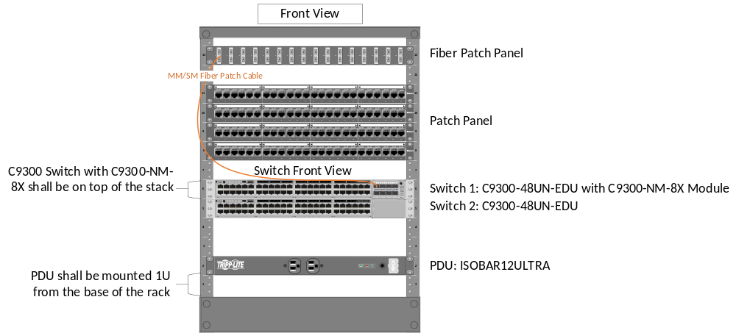
Figure 1: Small IDF Rack Elevation – Front View
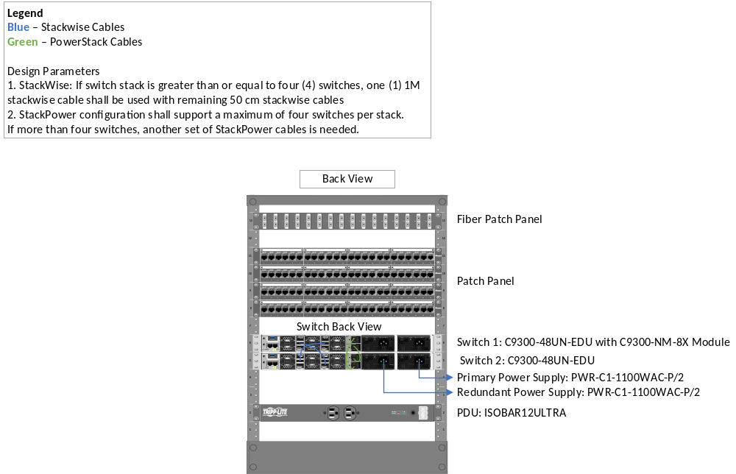
Figure 2: Small IDF Rack Elevation – Front View
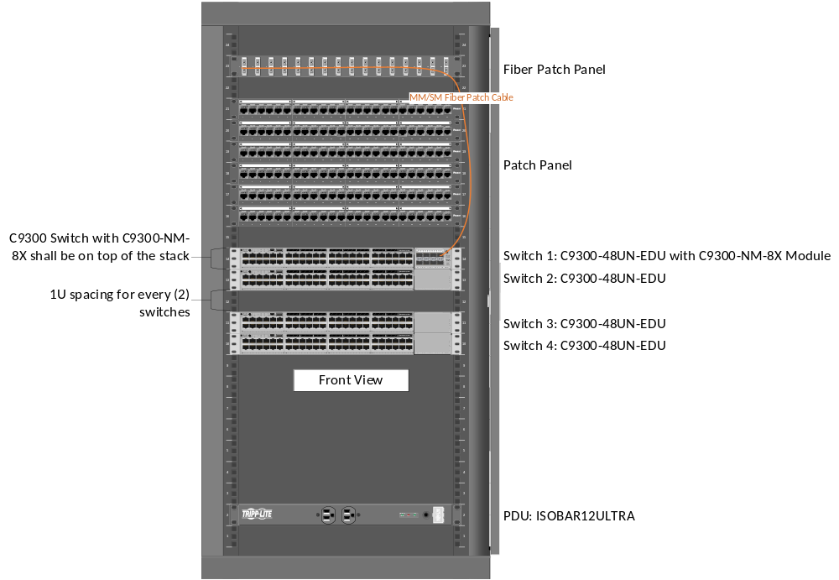
Figure 3: Medium IDF Rack Elevation – Front View
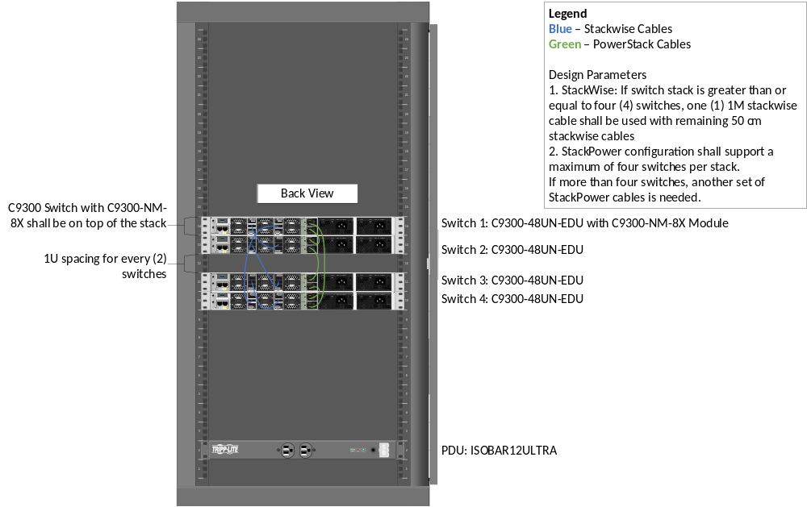
Figure 4: Medium IDF Rack Elevation – Back View

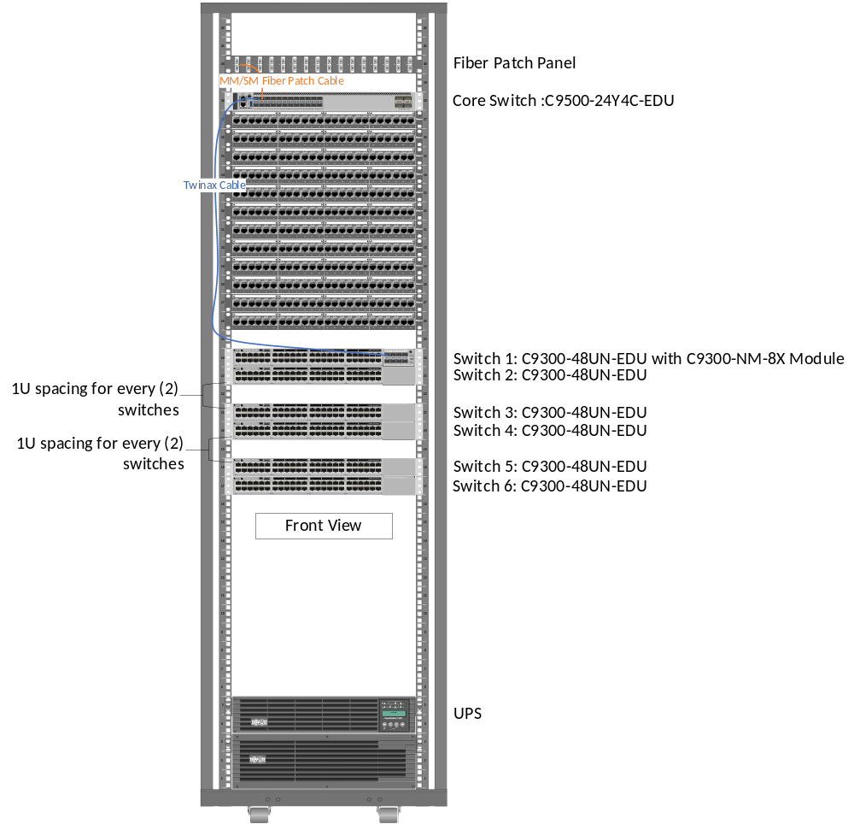
Figure 5: MDF Rack Elevation – Front View

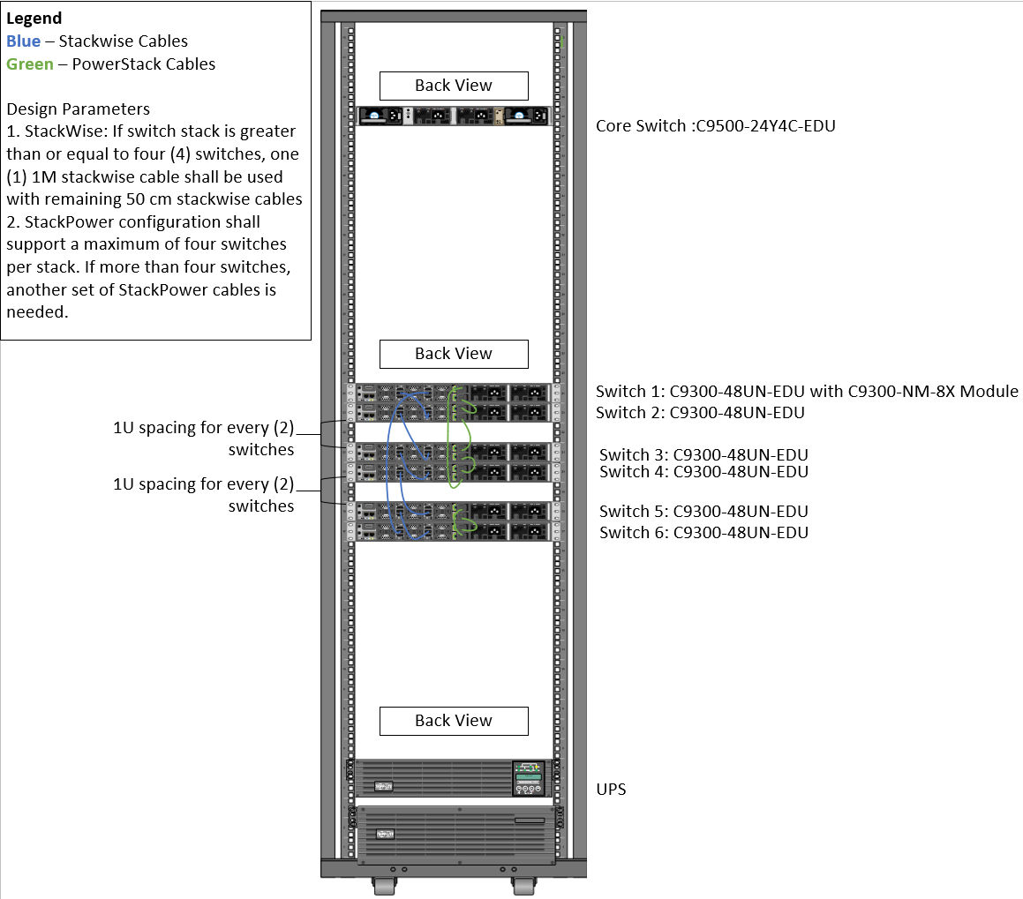
Figure 6: MDF Rack Elevation – Back View

2.03 WIRELESS ACCESS POINTS AND ACCESSORIES
- 802.11ax (Wi-Fi 6), including support for OFDMA, 1024-QAM, MU-MIMO, Target Wake Time (TWT),Spatial Frequency Reuse (BSS Coloring). Backwards compatibility with 802.11a/b/g/n/ac
- Model: Juniper Mist AP43 for interior and AP43e for exterior/antenna installations.
- Interior part number Juniper Mist AP43. Bundle with 5 year Licensing: Ordering number: B-AP43-2S-5Y-E
- Exterior Part number Juniper Mist AP43E
  - Exterior Antenna: 2.4/5 GHZ 4/2 DBI 6 ELEMENT INDOOR/OUTDOOR 90×90 PATCH ANTENNA WITH RPSMA - Part Number: ATS-OHDP-245-42-6RPSP-36
- For wireless installations requiring additional protection (i.e. outdoors or in gyms) use the following protective enclosure: 12X10X6 POLYCARBONATE ENCLOSURE WITH CLEAR DOOR, KEY LOCK & 6 RPSMA HOLES Part Number: ATS-12106P-C-K-6S-CG-UBPTB

- Juniper Universal AP bracket as required..Part number APBR-U (Note AP package typically comes with 1 bracket) This bracket does not require additional hardware to mount to most ceiling types.
- .
- Brand shall be Juniper for compatibility with existing dashboard software, substitutions are not acceptable.
PART 3 - EXECUTION
3.01 EXAMINATION
A. Examine the areas and conditions under which the work of this Section is to be performed. Correct conditions detrimental to timely and proper completion of the Work. Do not proceed until unsatisfactory conditions are corrected.
3.02 INSTALLATION
A. Property damage caused by the Contractor during the installation and testing process shall be replaced at no cost to the District.
B. The Contractor shall be responsible for all mounting kits and brackets for the LAN electronics and Wireless equipment.
C. The Contractor shall be responsible for providing and patching ALL fiber and copper data cables into LAN electronics and Wireless equipment per the specifications.
3.03 LOCATIONS
A. Coordinate with other trades to assure proper and adequate provision in the work of those trades for interface with the work of this Section.
B. Install the work of this Section in strict accordance with the original design, the approved Shop Drawings, pertinent requirements of governmental agencies having jurisdiction, and the manufacturer’s recommended installation procedures as approved by LBUSD representative, anchoring all components firmly into position for long life under hard use.
3.04 GENERAL INSTALLATION REQUIREMENTS
A. The Contractor shall provide a turnkey solution. Turnkey installation is defined as having all networking components including cabling, LAN electronics, and LAN servers working as individual components as well as a homogenous system.
NOTE TO EDITOR: DELETE IF THERE ARE NO OCCUPANTS ON SITE DURING CONSTRUCTION

3. The Contractor will coordinate installation schedules with the District Representative so as to minimize the impact on day-to-day operation for the campus.
3.05 LAN ELECTRONICS INSTALLATION
  - The District will provide IP addresses and switch port numbers as necessary to the Contractor. The Contractor shall test and confirm correct port placement, functionality for the appropriate VLAN and overall system functionality.
- The Target System Configuration shall be a collapsed backbone topology. A high capacity 10 Gigabit Ethernet (10GBaseSR/LR) switch located in the MDF of each school site shall be the focal point of the backbone. WAN connectivity is via MetroEthernet Transparent LAN Service.
- The switch will connect client workstations with servers and applications throughout the school campus as well as to applications available through the WAN, and shall have IP base routing capabilities with secure shell console management.
- The Contractor shall configure each switch with the appropriate District provided TCP/IP address and District configuration. The console and management software is currently installed at LBUSD offices. Coordinate with District Representative for TCP/IP address and configuration.
- The Contractor shall follow the District’s naming convention for switches.
- The Contractor shall complete IP sheet assignment tracking of address and host name assignments for any new infrastructure placed on the network.
- The Contractor shall include switch port assignments on to the appropriate VLAN for all new installed infrastructures, including replacement switches and WAPs.
- The Contractor shall include topology of switches/stacks in each MDF/IDF.
- The Contractor shall show VLAN Trunking Protocol
- The Contractor shall provide “runs and shows” for each switch. Runs and shows in this case refers to the show run command on Cisco switches.
- All core switches shall be configured with all necessary control and management modules for complete and operational system.
- The MDF switch shall be configured with redundant load sharing power supplies.
- The MDF switch shall be supported by an in-line Tripp-Lite UPS and appropriate extended run battery(s) capable of supplying 60 minutes of power to the MDF switch at full load.
- The UPS shall also be equipped with an SNMP agent such as a Tripp-Lite SNMP Web Card part number WEBCARDLX so that the management station is notified if the UPS is operating in battery mode.
- MDF UPS power supply shall be capable of interfacing with the core switch so MDF is aware of when it is using battery backup.
- Access layer Ethernet (100BaseTX/1000BaseTX/10GBaseTX) PoE Switches are to be located in each closet supporting interfaces.
- Unshielded Category 6 Twisted Pair (UTP) wiring will connect access layer switches to the station devices (PC’s, printers, etc.) All 1000BaseTX/10GBaseTX interfaces are to be 8-pin modular (RJ-45) type.
- All interfaces to the core switch shall be fiber optic
- Each MDF UPS will include the appropriate extended run battery(s) capable of supplying 60 minutes of power.
- For new installations Singlemode fiber optic cable (laser optimized OS2) shall connect the IDF LAN Electronics to the high capacity Ethernet switch. For existing conditions, verify fiber types and connectors in field.
- The goal of the network is to allow any workstation (PC) access to any application that the user is authorized for on the LAN or WAN.
- One Pluggable SFP interface is required for each stack of Catalyst 9300 switches.
- Provide a PDU at each IDF installed at the bottom, leaving one rack unit open.
- All switch components must be manageable by the existing District Cisco DNA centralized system management console.
3.06 FILE STORAGE SERVERS INSTALLATION
  - Prior to ordering and installing files storage server, Contractor shall coordinate with the District, the specific configuration requirements of file storage server.
- Due to the many versions and releases of file storage servers, Contractor shall not purchase server more than 90 days prior to installation.
- The Contractor shall not purchase or install file storage server without written approval from the District.
3.07 WIRELESS INSTALLATION
- Wireless controllers are existing and cloud based. All new wireless must be tied into existing deployment.
- Follow best practices from Juniper for installation and configuration of wireless.
- No power injectors allowed unless otherwise noted.
- Configure new wireless and BYOD VLANs. Verify DHCP setup with District IT personnel
- Install new WAPs per drawings. Label WAPs with MAC address and a plastic label that is printed large enough to be visible from floor level. Plug in only eth0. Do not use other rj45 ports.
- WAP configuration: Coordinate with District IT personnel for installer account access. Log into mist application or webUI to add new WAPs. Contractor may scan QR codes on WAP boxes to add, or use MAC addresses.
- Requires DHCP on a specific VLAN, each switch port attached to a WAP must be configured for trunking and a specific VLAN native. Verify specifics by looking at existing configuration port settings or request from District Representative. Access points do not auto configure on switches.
- Configure WAPs on Mist app or Mist web dashboard, including renaming them, configuring orientation and placing on maps. Provide and upload new maps as necessary for new buildings.
- Configure SSIDs. Contractor is advised to look at existing SSIDs at other locations or request confirmation from District Representative what SSIDs are needed. Note: There may be hidden non-broadcast SSIDs. For new sites Contractor will need to build out a new site template. Coordinate with District IT as necessary. District IT is a consult only, Contractor to ultimately identify and perform all required configuration.
- Test Wireless access SSID connectivity.
- Verify in dashboard that all new devices are online and healthy. Provide final spreadsheet indicating install locations (device names), serial numbers, mac addresses, connectivity status (should all be connected) and warranty information.
3.08 ACCEPTANCE TESTING
A. All LAN electronics specified in this document must meet manufacturer’s standard tests. Testing must include the ability to successfully “ping” from one device to another and to and from PC end stations and servers. PC’s must be able to connect to their appropriate servers.
B. Device configurations must be reviewed and approved by the District before deployment in production environment to allow for changes and acceptance.
C. Predictive surveys are not acceptable. Physical surveys are required.
D. The Contractor shall prepare detailed coverage heat maps, after the installation of the WAP’s, using AirMagnet Wi-Fi Pro, AirMagnet Survey Pro or equal approved by the District. Predictive site surveys are not acceptable such as utilizing Cisco Prime software. Provide current certifications for the site surveyor for AirMagnet or District approved equal. Provide a copy of the physical survey to District Technology Representative prior to installation of Wireless Access Points). Heat maps shall identify:
1. Access point quantity
2. Access point locations (room & building)
3. Access point protocol 802.11 a/b/g/n/ac/ax
4. Access point channel and signal strength
5. Common access point configuration
6. Seamless subnet roaming
7. Non 802.11 interference in 2.4GHz and 5GHz bands
8. Special antenna
9. Physical end environmental requirements for access point placement
10. Upgrades to existing access points (including hardware and/or software)
3.09 PROJECT RECORD DOCUMENTATION
A. The Contractor shall submit a daily report to the District Project Team. This report should contain the following information:
1. Summary of work completed for the week concluded. Including personnel onsite and hours of work.
2. Summary of work anticipated for the following week.
3. Any action items requested of the District personnel.
4. Any deviations from the implementation schedule.
B. Prepare and submit copies of configurations, as-builts and logical network diagrams updated to reflect the new work completed for each campus project <DELETE “for each campus project” IF THERE IS ONLY ONE SITE INCLUDED IN THE PROJECT> (i.e. site plans, cable, pathways, MDF/IDF cabinet elevations, equipment configuration spreadsheets, etc.).
C. These documents must be delivered to the District upon completion of work and before Final Inspection.

End of Section 27 20 00

