CaliforniaColleges.edu
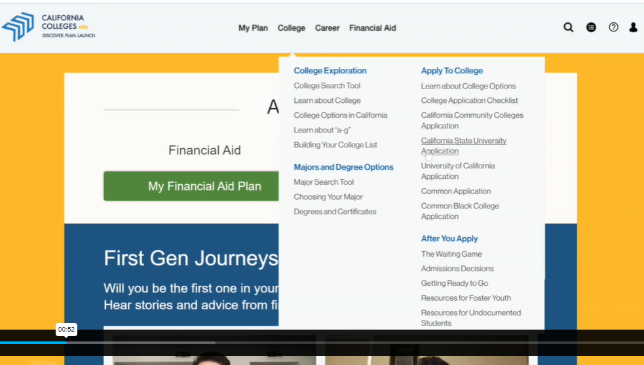
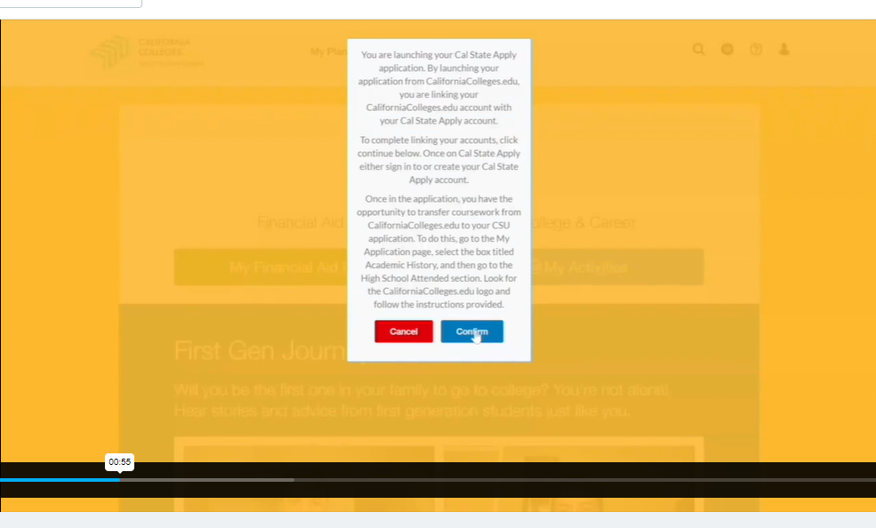

Sign In to existing Cal State account or Create an account
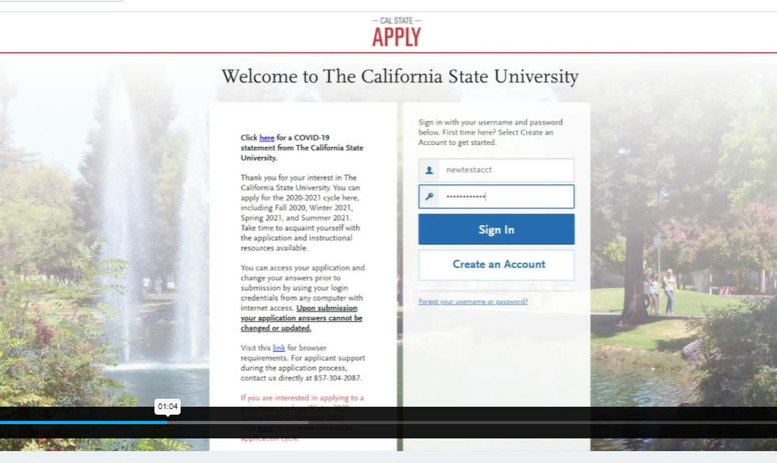
Now the accounts should be linked. Next Import Coursework. Click on Academic History.
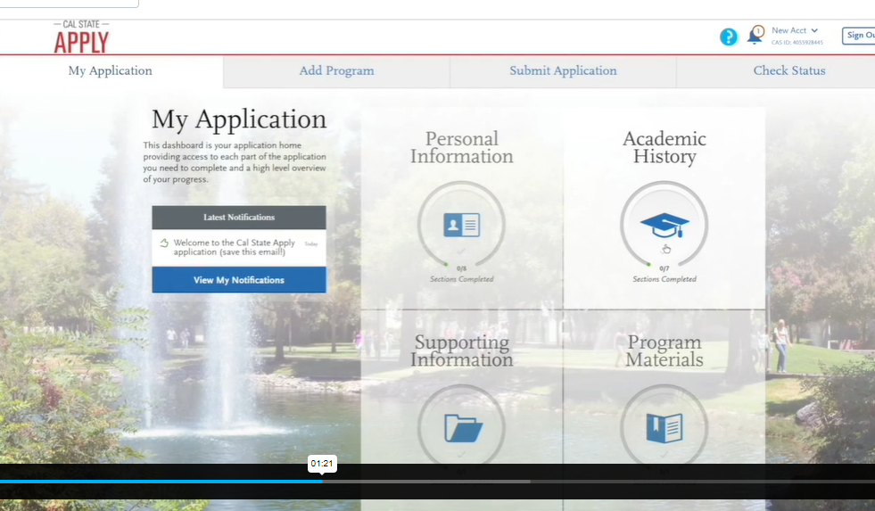
Click High Schools Attended, then Click Show Me How
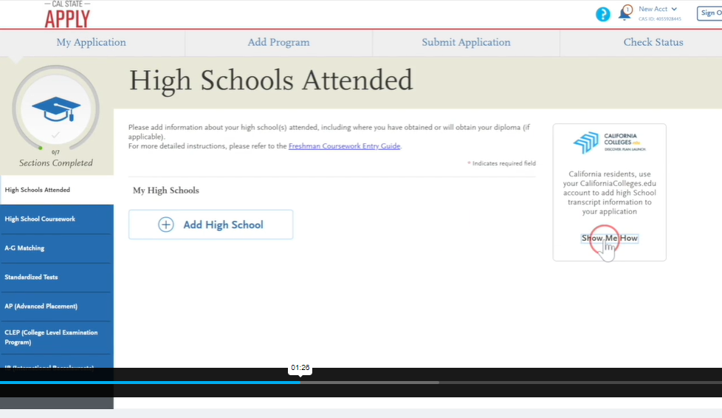
Click Import
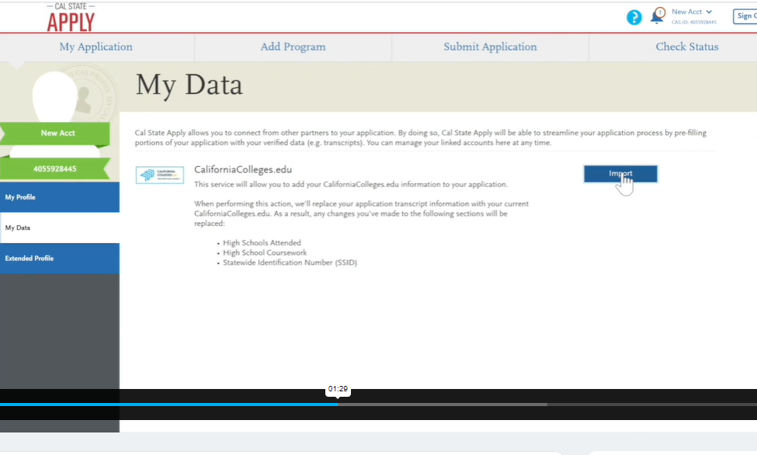
Click Connect and Continue
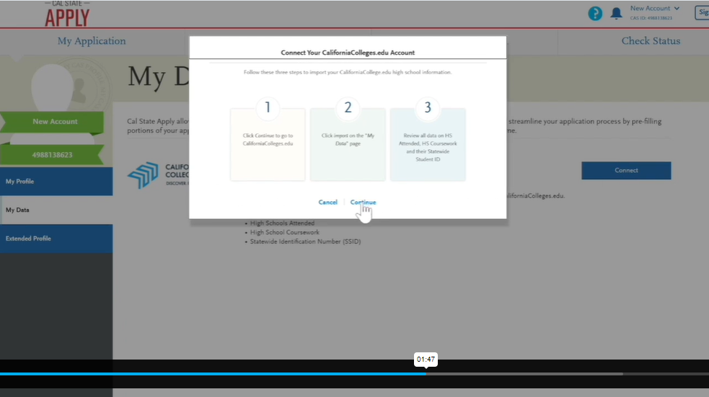

Sign in to California Colleges
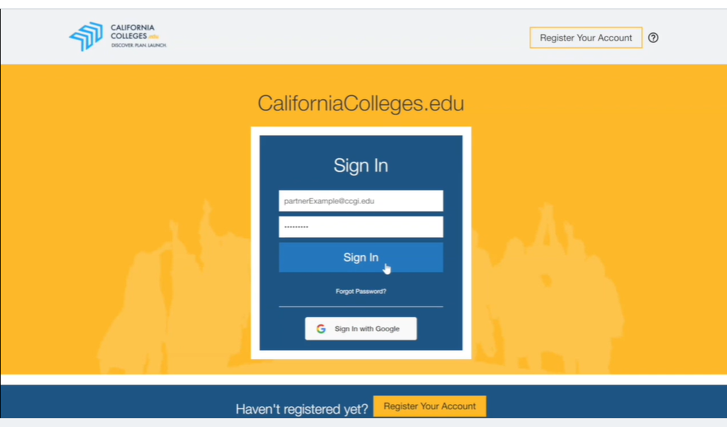

Link your accounts and then Import your coursework
Review your Coursework that has been imported
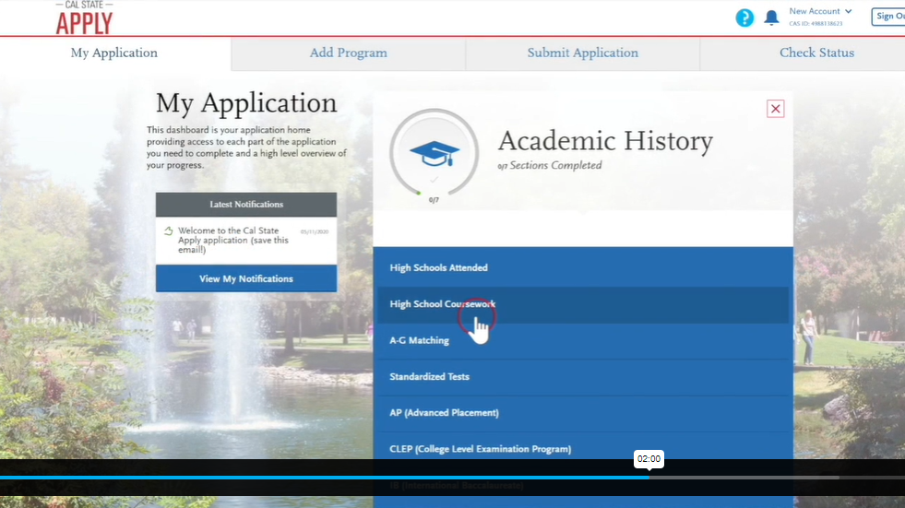

Check for accuracy
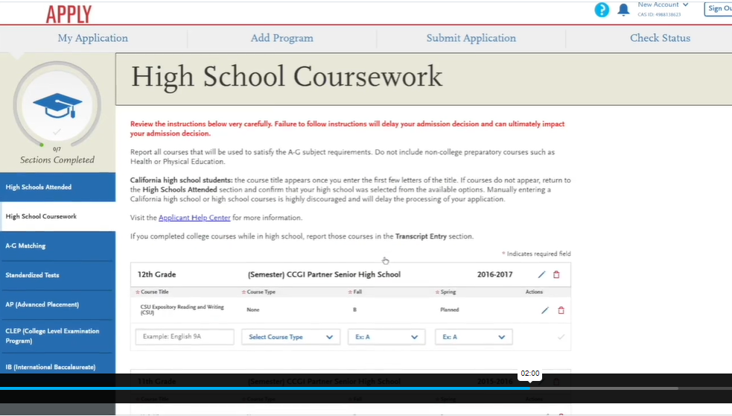

Use the A-G Matching Tool
Click Update A-G Courses if you need to make any changes and Click Save and Continue
