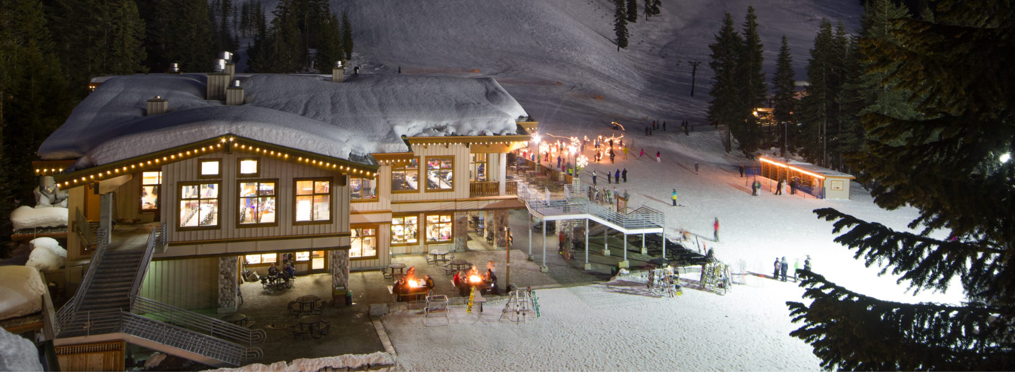
Wednesday Ski and Ride Bus |
2025

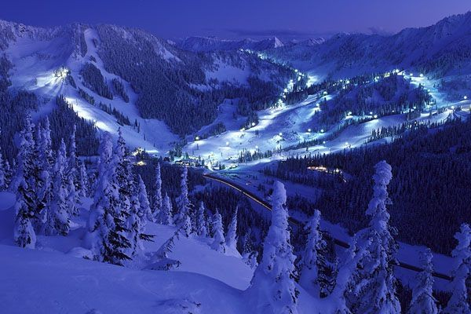
Welcome to the Ski and Ride program! The purpose of this document is to provide all necessary information about NorthStar’s Ski and Ride Program.

Veronica Knight- 206-412-7211 vbruffy@hotmail.com

How Does it Work?

- Register for the Ski and Ride Bus (Waiver and Seat Paid)
- Directly Purchase Discounted Lessons & Lift Tickets from Stevens Pass (Stevens Pass Website or CALL 206-812-4510)
- Gear up at the local ski shop OR Gear Rental at Stevens

Overview
  - The Ski and Ride Bus Program will provide charter bus transportation, Journey Line, and chaperones to and from Stevens Pass on Wednesday, early release days.
  - This 6-week program runs January 8, 15, 22, 29, February 5, 12, 2025
  - Bus will arrive at NorthStar at 12:30pm and we will depart as soon as everyone is loaded with gear, ideally between 12:45-1:00pm
  - Bus will arrive back at NorthStar ~8:30pm

Ski Day Schedule
12:30 - ~12:45 | Collect gear and load the bus- Bring your snow gear to school in the morning!
~12:45 - 2:30 | Drive to Stevens Pass, up Highway 2 - Takes about 1.5 hours depending on conditions.
2:30 - 4:00 | Unload and don gear, make your way to the hill, visit the ticket booth if needed, free skiers and riders can ski/ride. Beginners can practice on the rope-tow hill.
4:00 - 6:45 | Group Lessons and/or free ski/ride
6:45 - 7:00 | Load up the bus (everyone must be back on the bus at 6:45 sharp). Movie may be shown on the ride home. If you have a “G” or “PG” movie to loan, please do!
7:00 - ~8:45 | Return to NorthStar for parent pick-up. Please be on time to pick up your child! I will try to send a group message out when we are 25 minutes from NorthStar.

  - I think it is easiest to bring a duffel bag for all the smaller equipment (boots, jacket, snow pants, goggles, extra fleece, helmet, extra socks). Then carry your skis/snowboard and poles. LABEL GEAR!!
  - PLEASE bring all your gear to the covered courtyard area at NorthStar Middle School in the mornings of our program. Gear will be protected from rain and will be secure.

Payment Info: PLEASE READ CAREFULLY
Step 1: Sign the NorthStar Waiver AND Pay $235.00 for a seat on the bus. First 40 students PAID go. Seats do fill up! We work with Community School, so there will be 4th/5th graders on the bus.
REGISTRATION Starts September 20, 2024. Closes October 20, 2024.
- Waiver Link: https://acrobat.adobe.com/id/urn:aaid:sc:US:767f582f-3a38-4302-a06b-93212a5a6127

  - Payment made by Zelle (NorthStar NAC) or by Check, made out to NAC. Drop off with Harriet at the NorthStar office. Payment is REQUIRED for registration!
  - If space is still available after N* sign-up, we’ll be working to fill the bus with friends and family.
  - The more seats we have filled, the lower the price. We MUST have 30 seats filled to run the bus.

Step 2: YOU Purchase a Stevens Pass Lift Pass- *Options

You can WAIT on this purchase until you KNOW the bus will be full and our NorthStar ski/ride program is a “GO”. You WILL NOT GET A REFUND FOR A PURCHASED PASS!
- Epic Pass: Purchase Online: $397 for Child Pass 6-12, $616 for Teen Pass 13-17
- Stevens Only Season Pass- Purchase Online or Call Stevens: $315.00 for all ages
- Special Discounted 6-Week Pass for our Ski Program- Call Stevens Pass 206-812-4510: $126.00

Step 3: OPTIONAL YOU purchase Stevens Pass Group Lessons- $324 for 6-week program
- PLEASE purchase lessons if your child is a beginner! Chaperones DO NOT teach lessons.
- Lessons WILL SELL OUT! Last year lessons sold out by October 15. Don’t wait!
  - Stevens does have a cancellation and refund policy that is good, if for some reason, our ski/ride program is canceled. So, it is ok to book early.
- Link for Lesson Sign-ups: Make sure you use the dropdown to select “Wednesday Nights”
  - Evening Ski Participant Link
  - Evening Snowboard Participant Link
  - Problems or Information Call Stevens Pass: 206-812-4510
  - If you purchase lessons, you can select a full bundle of lift pass, gear rental, lessons
  - You will receive a waiver and direct communication from Stevens Pass Group Lessons Center after registering for lessons.
  - I WILL NOT BE YOUR CONTACT FOR LESSONS OR QUESTIONS ABOUT LESSONS!

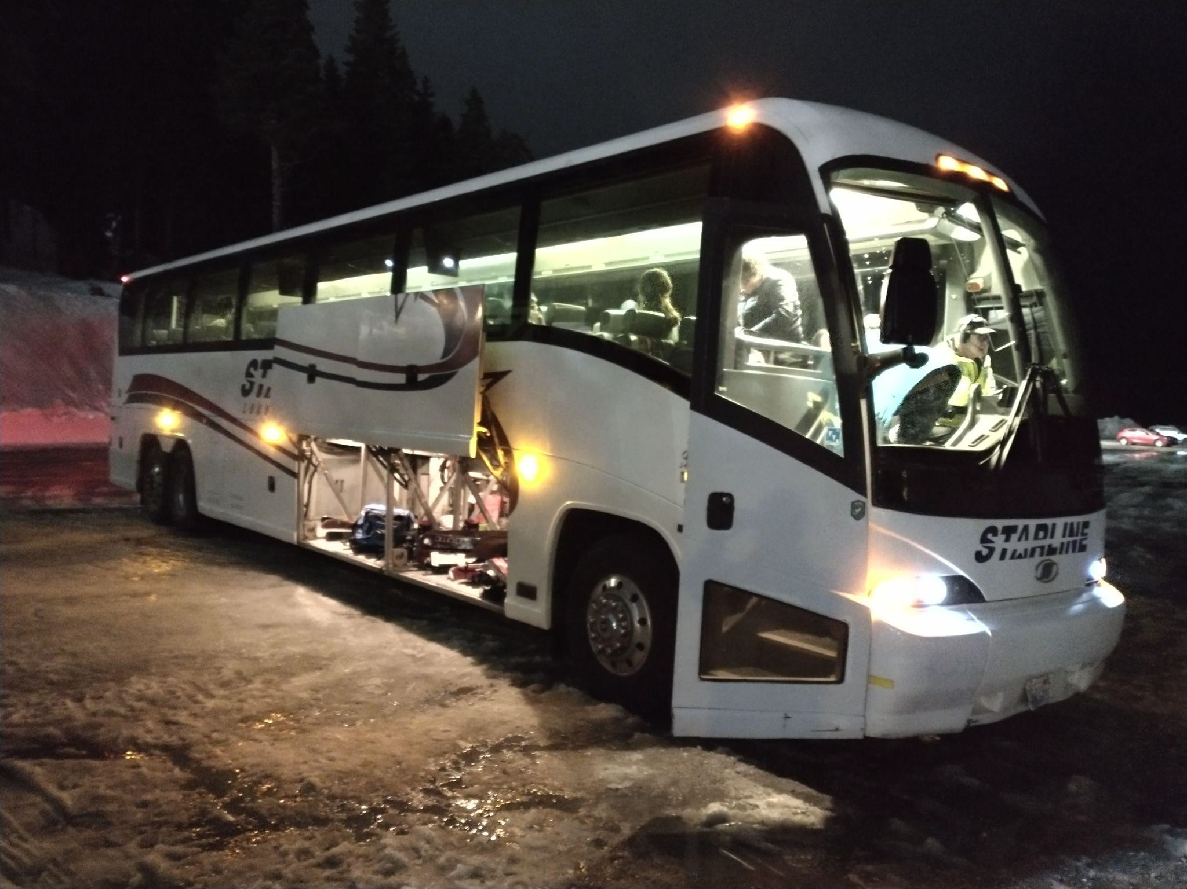
Bus Sign-Up:
- Your child’s seat is RESERVED with a payment of $235.00
- If for some reason the ENTIRE ski program is canceled, you will receive a refund. JUST FOR THE BUS!! Stevens Pass Purchases and refunds are not dependent on our cancellation!

Unfortunately, due to shared costs, we CAN NOT issue weekly refunds for illness, vacations, injuries, etc.
- I will try to create a “sub-lease” sign up. If you know you will be gone for a week, we can reach out to NorthStar family and friends to see if someone would like to purchase your seat for that week.

Lessons:
- Sign-up via the links above for Wednesday Nights, 4pm – 6pm. Chaperones will help all lesson participants to the lesson area and review check-in and check-out on the first day.
- Lessons are available for all level skiers/snowboarders.
- Lessons are REQUIRED for beginners!
- If lessons appear to be full, or you need assistance with sign-up, contact Stevens Pass at 206-812-4510.
  - There is also a link for LESSON WAITLIST
    - SCHOOL Groups Waitlist
  - Let Stevens Pass know you are part of the “NorthStar Middle School Wednesday night Program”. Related questions can be directed to SPSchoolTeams@vailresorts.com.
  - Alicia is a great contact!

Free-Ski/Snowboard:
- Many of our ski program participants are intermediate to advanced skiers. If you decide NOT to purchase lessons for your child, they will be considered a “Free Skier/Snowboarder”.
  - Free Skiing/Boarding means students will have the freedom to ski/ride without lessons.
  - However, we REQUIRE everyone to follow the “buddy system”. Every student will always ski/ride with at least one other student.
  - Chaperones will be on the mountain but will not necessarily be skiing with students.
  - If we find that your child is riding by herself, even after being reminded to find a buddy, your child will be asked to stay in the lodge for the remainder of the evening.
  - This is a SAFETY ISSUE, and we take it very seriously!

Lift Tickets: Required purchase or you can’t ski/ride!
There are a few options for lift tickets: (Note: I have not done a detailed price comparison of these options)
- The 6-day pass sold through the Stevens School Program site appears to be the best price.
$126.00. Mention you are with the NorthStar Wednesday Night Ski Program. Must call in for this.
  - Important! This discounted pass is available to everyone, not just those in lessons, but you’ll have to call to purchase (not available online): 206-812-4510
- Epic Pass - *Limited Availability!
- Stevens Pass Only Season Pass

Emergency Contacts
- Walkie-talkie Frequency: 9
- Stevens Pass: 206-812-4510 For ski patrol you would dial 9
  - To Report an Accident - Mark the site by placing skis in an “X” or snowboard vertically above the injured person. Inform the nearest Skier, Lift Operator, Patroller, or other Stevens Pass employee of the location, run name, lift tower number, etc.
- Norberto Villanueva will be the on-mountain emergency contact. 214-263-0937
- Other Lead Contacts:
  - Veronica Knight: 206-412-7211
  - Yana Cher: 425-503-7831
  - Scott Macy: 206-390-2858

Chaperones:

After registration, I will do a separate call for chaperones. I do not know how many chaperones I will need until I know the number of skiers. If you are interested now, please send me an email at vbruffy@hotmail.com or text 206-412-7211.
Chaperones receive a free lift pass and a free seat on the bus, 1 per 10 students.

Rules & Responsibilities
By choosing adventure up into the snow and mountains, you are accepting some very important responsibilities. Both for yourself, and for the rest of us. By joining us, you agree to adhere to the following.

Illness Precautions:
- Please stay home if you have any symptoms of cold or flu

On the bus:
- No tobacco, drugs or alcohol
  - No smoking/vaping of anything!
- No Firearms
- Garbage belongs in the trash, please pick up after yourself!
- Students
  - BE NICE AND RESPECTFUL, please
  - Listen to the bus driver and follow all directions given
  - Avoid loud or disruptive behavior. The bus driver needs to be able to hear other vehicles on the road.
  - Find a seat and stay seated, facing forward, for the entire trip
  - Buckle up if seat belts are available
  - Keep legs and feet in front of you and never stick your arms or head out of the bus window
  - Keep the aisles clear
  - Place backpacks and other items under the seat
  - Do not throw anything in the bus or out of a bus window.
- Chaperones
  - I know it can be hard to know what type of behavior crosses the line. Please come see me and we’ll figure it out together.
  - A chaperone or two to sit in the back of the bus.

On the ski hill:
https://www.stevenspass.com/the-mountain/more-options/mountain-safety.aspx
- Everyone is responsible for their own equipment.
  - I’m not counting equipment or carrying anyone’s stuff, so please don’t expect us to know where your clothes or equipment is!
- Everyone is responsible for their own Schedule!
  - I suggest you set an alarm on your phone/watch 15 minutes before you need to be back.
  - Please be back to the bus at 6:45 sharp!
- Please ski responsibly! - Always stay in control and on terrain for your skill level
- Stay on a lighted ski run
- No skiing alone! Always have a buddy. Larger groups are encouraged
  - We’ll note who’s skiing together
- Keep your phone or walkie-talkie close
- Chaperones
  - Skiing Chaperones will announce what run they’ll be skiing on via text or walkie talkie

  - Any chaperones staying in the lodge will handle a walkie-talkie and phone

Required Ski Clothing
Here’s a high-level overview of what you’ll need to stay warm on the slopes. Since we’re skiing at night, the temperatures do get low!

- Base Layer - Long johns (pants and shirt).
- Mid Layer - A fleece pullover (unless the ski jacket is heavily insulated).
- Ski Jacket and Pants - Dedicated ski outerwear is a must. It gets very wet sometimes, the more waterproof the outer layer, the warmer you’ll stay.
- Ski Gloves - Again, dedicated ski gloves are a must due to their increased waterproofing and length
- Goggles - Ski goggles with light lenses for night skiing are preferred.
  - These at $30 from Amazon with clear or yellow lenses would be great.
  - There are also good quality and good priced SPY Goggles at Costco
- Helmet - Snow can be quite hard, please wear a helmet! And it stays dry and covers the ears. Also good quality and good priced SPY helmets at Costco
- Ski Boots or Snowboard Boots
- Poles for skiers

What else to Bring
- Food and Snacks!!! For the ride up, and something more substantial for the ride home. Don’t forget a drink.
  - Note that hot food is available in the lodge. Several students choose to eat at the mountain, in the lodge, or buy food for the ride home. Hot water is also available for hot chocolate or cup-o-noodles soup.
- To save time getting on the bus, please have kids wear their base-layer to school.
- Head-lamps or other lights are great for seeing, and for being seen.
- We will provide arm-band lights for all kids and adults. These should be worn while on the mountain and charged via USB in the bus.
- Parents, let me know what else to add!

Gear Rental
Renting gear locally, then carrying it on the bus will be best. Since our time on the hill is limited, I would hate for people to spend it in the rental shop!

- Sturtevant’s Ski Mart (Bellevue) - Offers both rentals or purchase and trade-ins of used gear. Our family has been buying used and trading in for several years now, we’ll do that again this year.
- Edge & Spoke (Redmond) - Renting can be a great option for these fast growing kids!

Thanks for your interest in the program! Please let us know via email or on Konstella if you have any questions.

Questions & Answers

Q: How long does the ski bus run?

The total program is 6 weeks long. However, total calendar time is somewhat dependent on weather. For example, last year Stevens closed for a couple weeks due a snowstorm. So, the program was extended to be sure that students were able to go a total of 6 times.

Q: Do students need to be there every week?

Yes and No. We understand if a child gets sick or injured and cannot attend the ski bus for the week. However, it’s important we have enough people sign up for the bus at the beginning of the program to run the bus. We will NOT be able to issue refunds or reimbursements for days missed. Please understand that the bus can only run if we have enough “sold seats”. If we issue refunds, then the other families will have to pay more, or we won’t have enough money for the bus rental. That is why we cannot issue any type of “refund”.

*If it happens that your child will miss multiple days due to an illness or injury, we can try to re-sell the seats to another student, parent or family member as a single rider. Please contact me, Veronica Knight, as soon as possible if this issue comes up.

Q: When is the deadline to sign up?

The most time critical thing to sign-up for are:
- Lessons - These will fill up very quickly! Please register through Stevens Pass before October!
- Epic Passes - These will sell-out before the ski season starts.
- Rentals - I would suggest getting your gear sorted out well before the season starts. Rental shops will sell out when the season starts. Like NOW! September or October.

Regarding the bus, it will hold 56 people max. NorthStar students and chaperones have 45 of those seats. Community School has 8 of those seats. We reserve 3 spots in case of an injury.

Q: Can a parent accompany their kid for one or two days. Or maybe the whole program?

More the merrier, until the bus is full that is! I especially welcome having more parents on the bus where things can get a little crazy! I will create a list of “on-call” chaperones who would like to go up a few days. In this case, we will ask you to do a few “chaperone” duties. But on the upside, you will get a free ride on the bus and a free list ticket for the afternoon/evening. These “on call” chaperones will not necessarily have much notice, possibly just the morning of our trip. But hopefully you will be asked to join us well in advance.

On the other hand, if you want to accompany your child on the mountain, but don’t really want to “chaperone”, there may be seats that come up on a “sub-lease” basis where you pay to take the seat of someone out sick or on vacation.

Q: Are there options to just join the ski bus a few times for non-NorthStar kids or siblings of NS students? Or do they have to be committed for the whole 6 trips?

If there’s space remaining on the bus, we may open “one-off” seats. But this will be determined closer to the season.

