Scholarship Information for Seniors

See Scholarships Below! If a letter of recommendation and/or transcript is needed from your counselor, please request this at least 3 weeks prior to the scholarship deadline. When requesting a letter of recommendation, always share an updated resume’. Please show the same courtesy to teachers, other school personnel, or individuals of which you are requesting a recommendation.

Note: Scholarship agencies reserve the right to change website, deadline, award amounts, and any other scholarship-related information or requirements. Research scholarships early as changes may occur.
SCHOLARSHIP | TYPICAL APPLICATION DEADLINE | AWARD AMOUNT
QuestBridge Scholarship | September | Award Amount: Varies  www.questbridge.org
Gates Millennium Scholarship | September | Award Amount Varies  www.gmsp.org
Horatio Alger Scholarship | October | Award Amount: $6,000 - $12,000  www.horatioalger.org
Coca Cola Scholarship | October | Award Amount: Varies  www.coca-colascholarsfoundation.org
Rhythm Nation Janet Jackson Scholarship | October (see website for specifics) | Amount: Up to $5,000  https://scholarships.uncf.org
American Association of Colleges of Nursing | TBD – see website for the more info | http://www.aacn.nche.edu/students/scholarships/bednash-scholarship
Voice of Democracy | October | Award Amount: Varies  www.vfw.org/community/programs
Elks National Foundation | November | Award Amount: $4,000 - $50,000  www.elks.org/enf/scholars
UNCF/Michael Jackson and Rhythm Nation Scholarships | TBD-See website for more info | https://scholarships.uncf.org/Program/Details/3ad39cc5-8774-467b-91b9-567d4aaa7e6f
Scholastic Art & Writing Awards | December | http://www.artandwriting.org/Affiliate/GA001W
AXA Achievement Scholarship | December | Award Amount: $10,000  https://us.axa.com/axa-foundation/AXA-achievement-scholarship.html
NRA Civil Rights Defense Fund  Youth Essay Contest | TBD- typically, December deadline | Award Amount: $1,000  www.nradefensefund.org/contests-scholarships
Colored Rocks Scholarship | TBD – typically, December deadline | Award Amount: Varies  www.coloredrocks.org
US Navy & Marines Scholarship Program | TBD – typically, December deadline | Award Amount: Varies  http://www.military.com/join-armed-forces/rotc-scholarships-navy.html
Kentucky Fried Chicken  (For KFC Employees Only) | TBD -See website | Award Amount: Varies  https://www.kfc.com/foundation
Ron Brown Scholarships | January | Award Amount: Varies  www.ronbrown.org
United States Airforce Scholarship | January | Award Amount: Varies  https://www.afrotc.com/scholarships
Dell Corporate Scholarship | January | Award Amount: $4,500  https://scholarships.uncf.org
Ronald McDonald House Scholarship | January | Award Amount: Varies  www.rmhc.org
Daughters of the American Revolution | January | Award Amount: Varies  www.dar.org/national-society/scholarships
United Federation of Teachers | TBD- typically, January deadline | http://www.uft.org/parents/scholarship-fund
Jackie Robinson Scholarship | February | Award Amount: Varies  http://www.jackierobinson.org
Hispanic Scholarship Fund | February | Award Amount: Varies  www.hsf.net
Microsoft Scholarships | March | Award Amount: Up to $5,000  www.microsoft.com/about/diversity/en/us/programs/blacks-scholarships.aspx
Peyton Anderson Scholarship | TBD – typically, March deadline | Award Amount: Varies (Renewable)  www.peytonanderson.org
United States Marines | TBD – typically, March deadline | Award Amount: Varies  www.mcsf.org
American Fire Sprinkler Association | April | Award Amount: Varies  https://www.afsascholarship.org
Signet Essay Contest | TBD- typically, April deadline | Award Amount: Varies  http://www.penguin.com/services-academic/essayhome
Dr. Pepper Tuition Program | May | Award Amount: $5,000 – 100,000
Tom Bentley Memorial Scholarship – MidSouth Community Federal Credit | TBD- typically, May deadline | Award Amount: Varies  https://www.midsouthfcu.org/other-services
Steps For Change Scholarship | May | Amount: $2,000 (scholarships.com)
Abbott & Fenner Business Consultants | June | Award Amount: $1,000  http://www.abbottandfenner.com/scholarships.htm
College Steps – Wells Fargo | TBD- typically a June deadline | Award Amount: Varies  www.wellsfargo.com/collegesteps
These scholarships will be available in October or later.
Google in Education | *Typically Available in the Fall | Amount: Varies  https://www.google.com/edu/scholarships/the-generation-google-scholarship/
Edison Scholars Program | *Typically Available in the Fall | Award Amount: $10,000 Renewable  https://www.scholarshipamerica.org/edisonscholars
Military Commanders’ Scholarship Fund | *Typically Available in the Fall | Award Amount: Varies  http://sms.scholarsapply.org/militarycommanders/
Reagan Foundation Scholarship Program | *Typically Available in the Fall | Award Amount: Up to $10,000  www.reaganfoundation.org/scholarships
Jack Kent Cooke Scholarship | November | Award Amount: Up to $30,000 per year  www.jkcf.org/scholarships
Young Patriots Essay Contest | *Check site | Award Amount: Up to $5,000  www.debate-central.ncpa.org/yp14
The Dream Scholarship  (Specific to certain colleges) | *Typically available  In November | Scholarship Amount: Up to $25,000  http://www.thedream.us/opportunityscholarship
Herbert Lehman Education Fund Scholarship | *Typically Available in the Fall | http://www.naacpldf.org/herbert-lehman-education-fund-scholarship
Robins Federal Credit Union | *Typically available in January | Amount: $2,000  https://www.robinsfcu.org
General Mills Scholarship | *Typically available in January | http://sms.scholarsapply.org/cbcfgeneralmillshealth
Rent-A-Center Make A Difference Scholarship | *Typically available in February | Amount: Varies  http://www6.rentacenter.com/racommunity/make-a-difference-scholarship
State Farm Good Neighbor Scholarship | *Typically available in the Fall | Award Amount: Varies  https://www.scholarshipamerica.org/statefarmgoodneighborscholarship/
 | When applying for scholarships….. DON’T PROCRASTINATE!! | 
The following scholarships are offered through the Community Foundation of Central Georgia. These scholarships are typically available online through their website from mid-December - mid March. See website for specifics and any changes.
Al Lucas Memorial Scholarship | Typically, the deadline is March 15 | Award Amount: $1,000  www.cfcga.org/page.aspx?pid=504
Joyce Brown Memorial Scholarship Fund | Typically, the deadline is March 15 | Award Amount: $500 (Renewable)  www.cfcga.org/page.aspx?pid=504
Miller-Lanier-Central Foundation Scholarship Fund | Typically, the deadline is March 15 | Award Amount: $750 (Renewable)  www.cfcga.org/page.aspx?pid=504
P. Allen Golson Scholarship Fund | Typically, the deadline is March 15 | Award Amount: $500 (Renewable)  www.cfcga.org/page.aspx?pid=504
Sgt. Rodney M. Davis, USMC (MOH) Memorial Scholarship | Typically, the deadline is March 15 | Award Amount: $1,000 (Renewable)  www.cfcga.org/page.aspx?pid=504
The Billy & Bobby Stevens Scholarship Fund | Typically, the deadline is March 15 | Award Amount: $2,000 - $4,000  www.cfcga.org/page.aspx?pid=504
The Sarah & George William Grier, Jr. Scholarship Fund | Typically, the deadline is March 15 | Award Amount: $1,000  www.cfcga.org/page.aspx?pid=504
Charles H. Williamson Memorial Scholarship Fund | Typically, the deadline is March 15 | Award Amount: $3,000 (Renewable)  www.cfcga.org/page.aspx?pid=504
Clifton Whitehead Scholarship Fund | Typically, the deadline is March 15 | Award Amount: $1,000 (Renewable)  www.cfcga.org/page.aspx?pid=504
GIGA Inc. Scholarship Fund | Typically, the deadline is March 15 | Award Amount: Varies  www.cfcga.org/page.aspx?pid=504
The Shield Club Scholarship Fund | Typically, the deadline is March 15 | Award Amount: $2,000 (Renewable)  www.cfcga.org/page.aspx?pid=504

Helpful Essay Links:
http://www.usnews.com/education/blogs/the-scholarship-coach/2013/01/31/4-ways-to-make-your
scholarship-essay-stand-out
https://www.scholarships.com/financial-aid/college-scholarships/scholarship-application

Other sites to search for scholarships:

http://www.fedmoney.org

http://www.finaid.org

http://www.college-scholarships.com/free_scholarship_searches.htm

http://www.fastweb.com

www.GAfutures.org

www.gsfc.org

www.brokescholar.com

http://apps.collegeboard.com/cbsearch.ss/welcome.jsp

www.fafsa.ed.gov

www.collegedata.com

www.CollegeAnswer.com/scholarships

www.ed.gov
www.scholarships.com
www.bls.gov/oco
www.gcic.peachnet.edu
www.kaptest.com
www.myfuture.com
www.eduinconline.com
www.usnews.com
www.petersons.com
www.usg.edu
https://www.goingmerry.com

Search Engines and Scholarship Programs
- Scholar Snapp - A free, simple to use data standard that allows students to reuse their application information - including contact information, essays, transcripts, etc. - from one scholarship application to another thereby streamlining the college scholarship application process.
- Scholly – A mobile app that provides students with a fast and simple way to find scholarships for college. (Created by Christopher Gray, a Coca-Cola Scholar!)
- Peerlift - Proven scholarships, internships, summer programs, and more gathered by fellow students like you. (Founded by a team of 2017 Coca-Cola Scholars!) Learn more about the creation of Peerlift.
- Fastweb – Create a profile and let fastweb do the research on scholarships, internships colleges and more for you.
- CashCourse – Information that helps college students stay financially informed.
- Common Knowledge Scholarship Foundation – Educational and scholarship opportunities for students of all levels.
- Cappex – A free website where you can learn which colleges want you, before you apply and learn about more than $11 billion in merit aid scholarships.
- Scholarships.com– A free college scholarship search and financial aid information.
- Scholarship America – Provides information and resources for your scholarship search.
- KnowHow2GO – Complete information on college prep, whether in middle school or seniors.
- HS Finder (Hispanic Scholarship Fund) – Scholarship information for Latino students.
- Thurgood Marshall College Fund – Provides scholarships, programmatic and capacity building support to the 47 public Historically Black Colleges and Universities (HBCUs).
- Gates Millennium Scholars – Provides outstanding low income African American, American Indian/Alaska Native, Asian Pacific Islander American, and Hispanic American students with an opportunity to complete an undergraduate college education in any discipline they choose.
- Asian & Pacific Islander American Scholarship Fund – The nation’s largest non-profit organization devoted to providing college scholarships for Asian Americans and Pacific Islanders (AAPI).
- American Indian College Fund – Provides Native American students with scholarships and financial support for the nation’s 33 accredited tribal colleges and universities.
- Dell Scholars Program – Recognizes academic potential and determination in students that have a definite need for financial assistance.
- UNCF – Awards 10,000 students each year through 400 scholarship and internship programs so that students from low- and moderate-income families can afford college tuition, books and room and board.
- Chegg – A place to connect with scholarships and learn about colleges.
- Reagan Foundation Scholarships - Scholarship opportunities for outstanding student leaders.
- Goizueta Legacy Scholarship - Provides scholarships for the children of Coca-Cola employees.
- American Indian Graduate Center & AIGCS - The largest scholarship providers to Native students in the United States, awarding $15 million in scholarships annually and more than $200 million since inception. For almost 50 years, AIGC has funded students pursing undergraduate, graduate, and professional degrees in any field of study at any accredited institution of choice, working with over 500 tribes in all 50 states.
- National Society of High School Scholars - NSHSS and its partners offer more than $2,000,000 in scholarships annually. All students are eligible to apply for high school and college scholarships in the areas of academic excellence, entrepreneurship, leadership, literature, medicine, music, STEM, sustainability, visual arts, and more.
Scholarship Apps & Resources
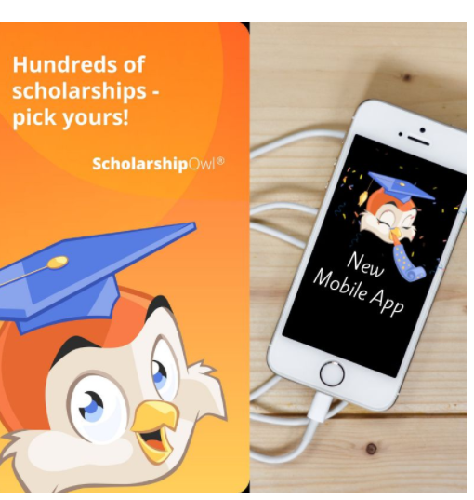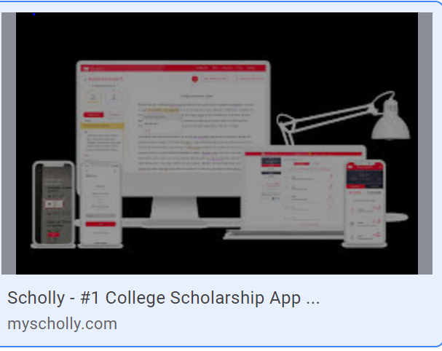
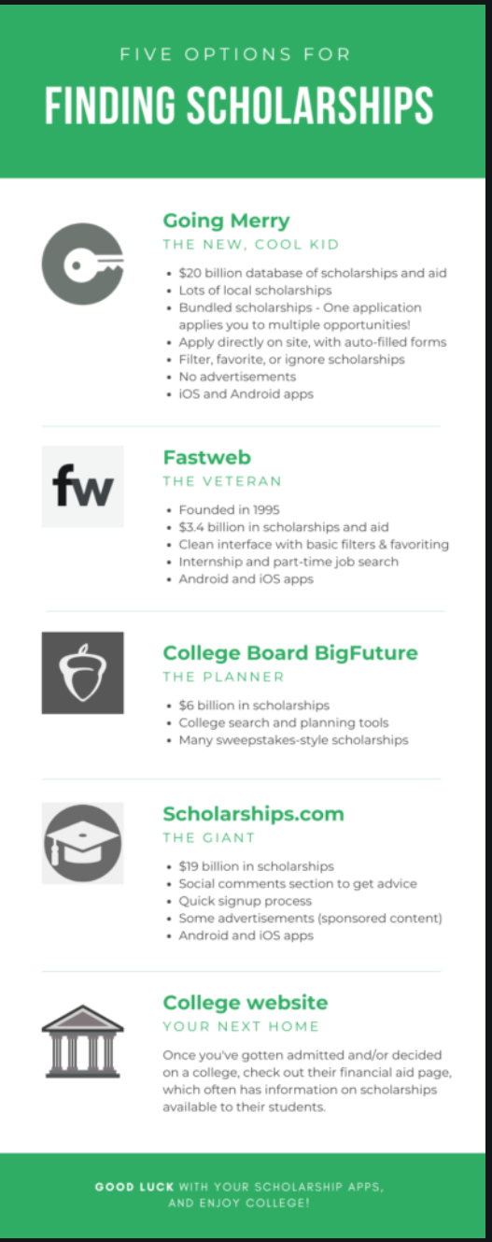
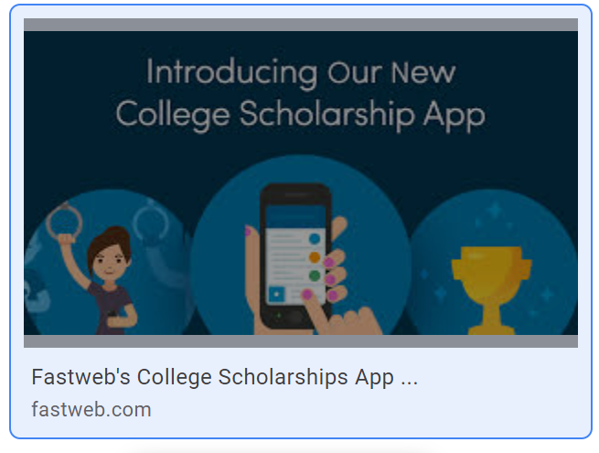
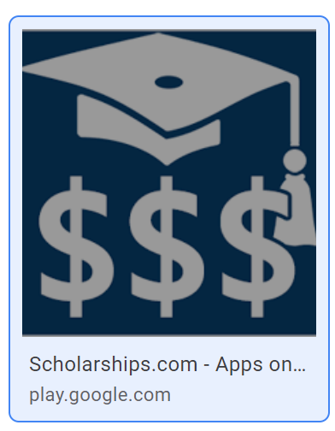
$$$
Do not forget to check college websites to see what scholarships the college offers! $$$

