Ronnie Hearne
Class of 1966

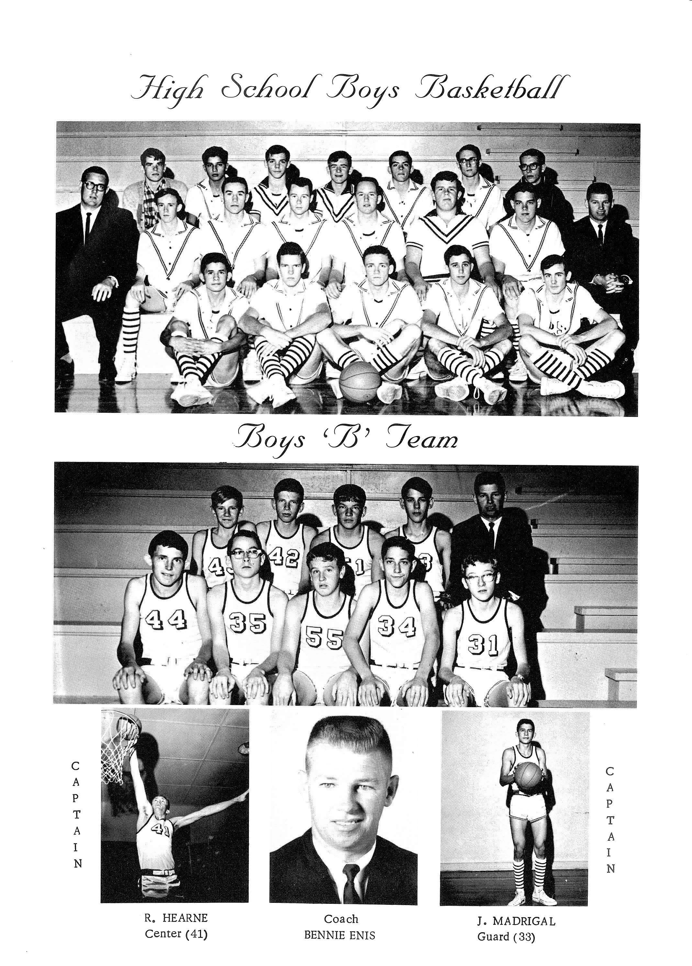

Ronnie Hearne is a 1966 graduate of Millsap High School and attended MISD all his life beginning in 1954 as a first grade student. He was a member of the FFA and was chosen by his peers as the Halloween King.

Ronnie was an all-around athlete but was best known for his great basketball skills and shooting ability. He lettered in basketball 4 years, track 3 years, as well as baseball and football 3 years. Millsap just began football on the varsity level his sophomore year and in 1964, he was the very first quarterback to ever set foot on the field as a varsity player for MHS. Hearne was also the first varsity pitcher for the MHS baseball team.

Hearne began his varsity basketball career as a freshman in 1963. As a freshman, he was the only player that came into the game off the bench at the state tournament. The state team lost their first game and played for third, ultimately bringing home the first and only State Basketball appearance in school history. The team finished 3rd place defeating Stratford 46-43. He continued his illustrious basketball career at Millsap High School as a starting center for the next three seasons, earning eight all-tournament honors, member of the District Team, all while he and was an integral part of the success of the 1965 & 1966 Basketball Regional Finalist teams. Hearne also served as the captain of the basketball team. In addition to his basketball success, Ronnie found success in track finishing 4th in the mile at the State Track Meet his Sr year.

After his ? career at MHS, Hearne took the college realm by storm as he became known as one of the greatest scorers in Abilene Christian University basketball history. During his tenure as a college basketball player, Ronnie ranks 2nd in career scoring average at 20.6 points per game, three times first team All-Southland Conference, (1969, 1970 and 1971), scored 30 or more point eight times in 75 games and a career high of 36 points. Hearne is one of only six players in ACU history to lead in scoring three straight seasons.

Ronnie married his high school sweetheart, Darleen, in 1970. They came back to Millsap where he was a very successful coach for 4 years. In addition to high school coaching, Hearne also coached at two colleges including Cisco and Tarleton State University. On the college level, Hearne was inducted into the ACU Hall of Fame as a player and TSU as a coach with over 1,000 wins.

Ronnie and Darleen have 1 son and 1 daughter, 6 grandchildren, and 1 great grandson. After 43 years of a successful coaching career, Ronnie and his wife now reside in Stephenville, Texas. They enjoy spending their time watching their grandchildren being successful in sports as well.

