Coach Terry Hamilton

Boys Cross Country Team
1986

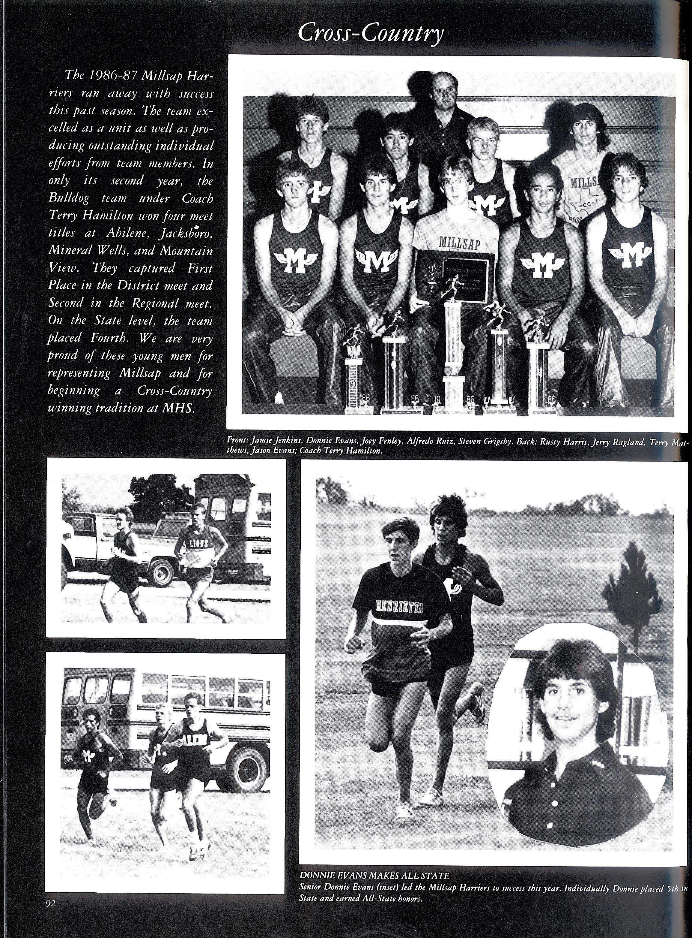

Back – Coach Terry Hamilton, Middle row: left to right – R. Harris, J. Ragland, T. Matthew, J. Evans
Front row: left to right – J. Jenkins, D. Evans, J. Finley - JV, A. Ruiz, S. Grigsby.

In 1986, the Millsap Harriers embarked upon an exceptional Cross-Country season not only as a team but also as individual performers. In only their second year, the Bulldog team won four meet titles at Abilene, Jacksboro, Mineral Wells and Mountain View under the direction of Coach Terry Hamilton.

Capturing First Place in the District meet and Second in the Regional meet as a team, the Bulldogs found themselves in a position to vie for a state title. At the state level, these young men suffered an injury with their #2 runner, Jamie Jenkins. However, Jenkins fought through and competed at the state meet helping the team to a 4th place finish. This team could have very well been a medalist with all runners healthy.

Not only did the team have success but the level of individual success was superb as well. Donnie Evans and Terry Matthews both finished in the top 15 at 5th and 14th respectively. Both young men were named to the All-State Cross Country Team. Other individuals who contributed to the 4th place finish included Jamie Jenkins, Jerry Ragland, Alfredo Ruiz, Steven Grigsby, Rusty Harris and Jason Evans.

This banner year set the tone for future success in Millsap High School Cross Country for both the boys’ and girls’ programs for many years to come. The 1986 team was filled with eight young men that had a strong work ethic and a deserve to achieve a goal.

Coach Hamilton instilled an outstanding work ethic in each one of the young men and each one responded well. Their hard work carried over into other sports in which they competed and allowed them to be successful in all sports at Millsap High School.

