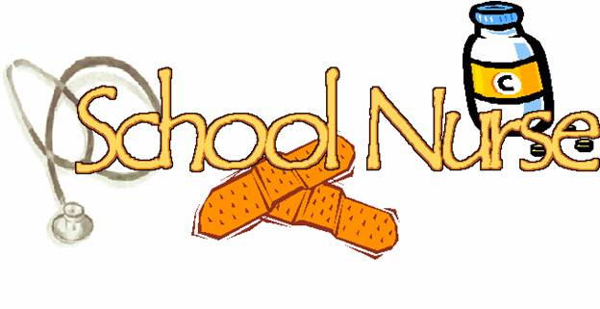
Dear Cooper Families,
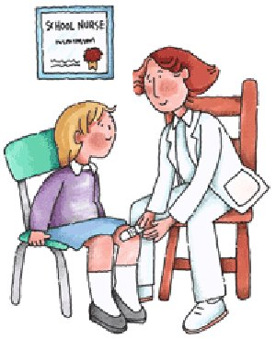
Welcome back to the new school year! My name is Jennifer Fleischmann and I am the nurse at Cooper School. I have met many of you already, but if not, please stop by my office between 8:45am and 3:45pm so we can become acquainted.

I would like to take this opportunity to review important information related to school health services and policies for Cooper School.

Children are not permitted in school until they have been 24 hours free of:
- Fever greater than 100 degrees Fahrenheit (without use of fever reducing medication)
- Diarrhea or vomit

- Excessively runny nose, sore throat, and/or cough

Children are not permitted in school until they have been on an antibiotic for 24 hours for:
- Conjunctivitis (pink eye)
- Impetigo (skin condition)
- Strep throat

All prescription or over-the-counter medications must be reported to the nurse.
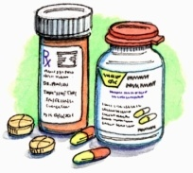
Medications (prescription and over- the-counter) that need to be given during the school day:
- Must be administered in nurse’s office
- Must be brought to nurse by an adult in original prescription or manufacturer’s labeled bottle
- Must not be past expiration date
- Require a signed form with physician order and parental permission (new order each year)

- Ibuprofen and Acetaminophen can be given with a signed parental permission form

All orthopedic injuries - casts, immobilizers, or crutches- must be reported to the nurse
- A physician’s note must be brought to the nurse with the diagnosis and any restrictions or limitations
- Accommodations need to be arranged for:
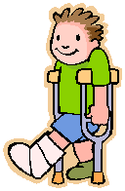
  - Physical education and recess
  - Class activities, writing and testing

Notify nurse of any changes in child’s health or emergency contact information:
- Notify nurse if your child has any new:
  - Allergies, medications, medical conditions
  - Accidents, operations
- Send documentation of immunizations or physical exams (required by State of New Jersey)
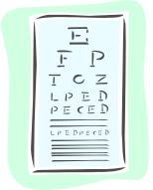
Health Screenings:
- Performed throughout the year and include:
  - Height, weight, blood pressure, vision, hearing
  - Scoliosis (5th grade only)
- Referral for follow up with physician sent home if any atypical results are found

If you have any special concerns, questions or information to share about your child, please stop by my office or contact me by telephone or email. I look forward to taking care of your child’s health care needs.

Jennifer Fleischmann, RN, BSN, CSN
Sharp School Nurse
(856) 424-4554, extension 2
jfleischmann@chclc.org

