LINQ V6 HR

OUT OF DISTRICT WORKSHOPS

LINQ V6 HR
Out of District Workshop Processing

Time Keeper | Employee Portal

Out of District Workshop Requests
- After logging into Time Keeper, select Out of District Workshop Requests from the left side menu.

Adding a New Request
- Click the Add New button . The Add New Out of District Workshop Request for Approval form will open.
- The form can be saved at any point by clicking the “Save Progress” button.
- After saving, the form and each tab in the form can be added to or edited by clicking the pencil icons .
- Once the Request is submitted and review by Human Resources, the General information and Credit Breakdown values can no longer be changed.
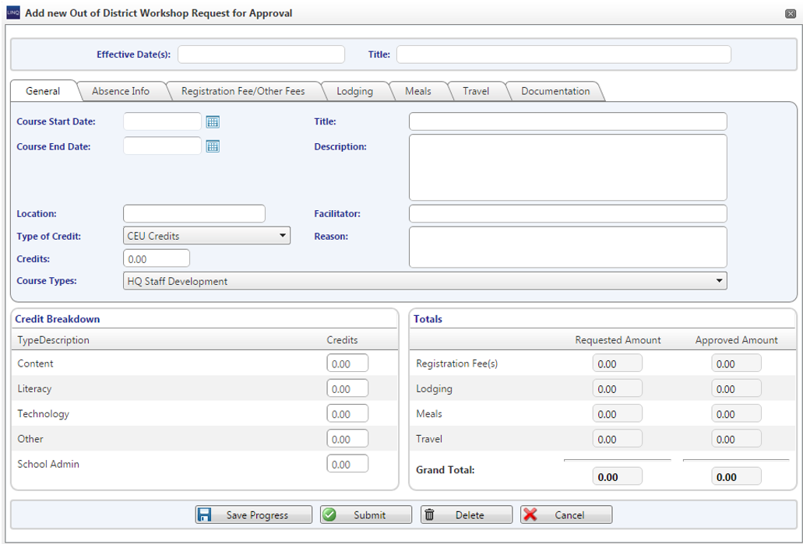

General Tab
- Course Start Date, Title, Description, Location or Facilitator, and a total for Credits is required before saving or submitting.

Absence Info Tab
- Absences entered here are treated like an Absence Request. Payroll will receive the request if approved by Human Resources personnel.
- Click the green plus button to add an absence.
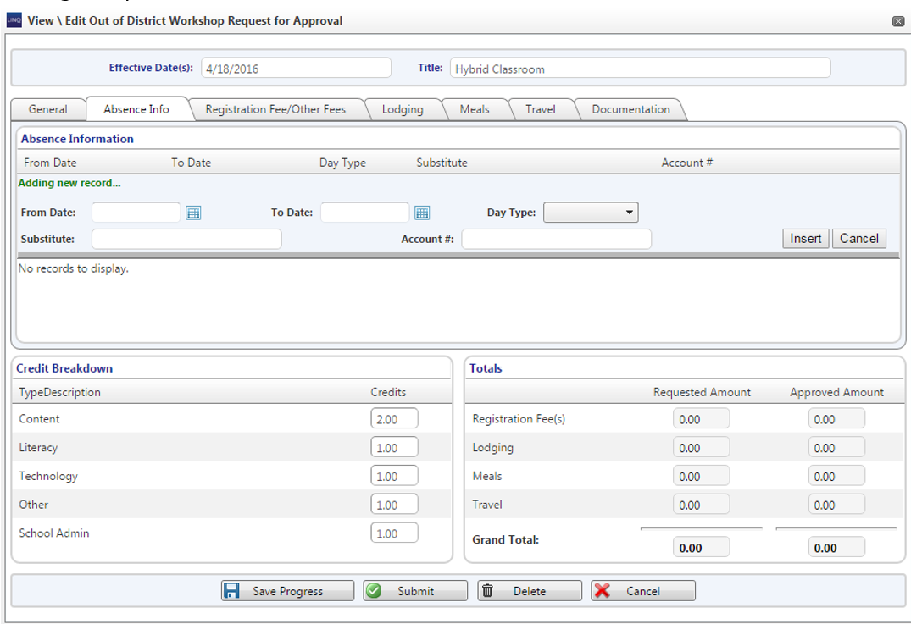
- Fill in the From and To Dates.
- The Day Type, Substitute name, and Account # fields are optional. A list of account codes and substitute names can be accessed by clicking the search icon.
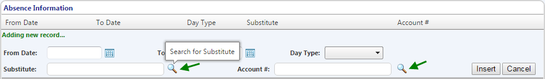
- Click Insert to add the absence request.

Registration Fees/Other Fee Tab
- Click the green plus button to add fee reimbursement requests.
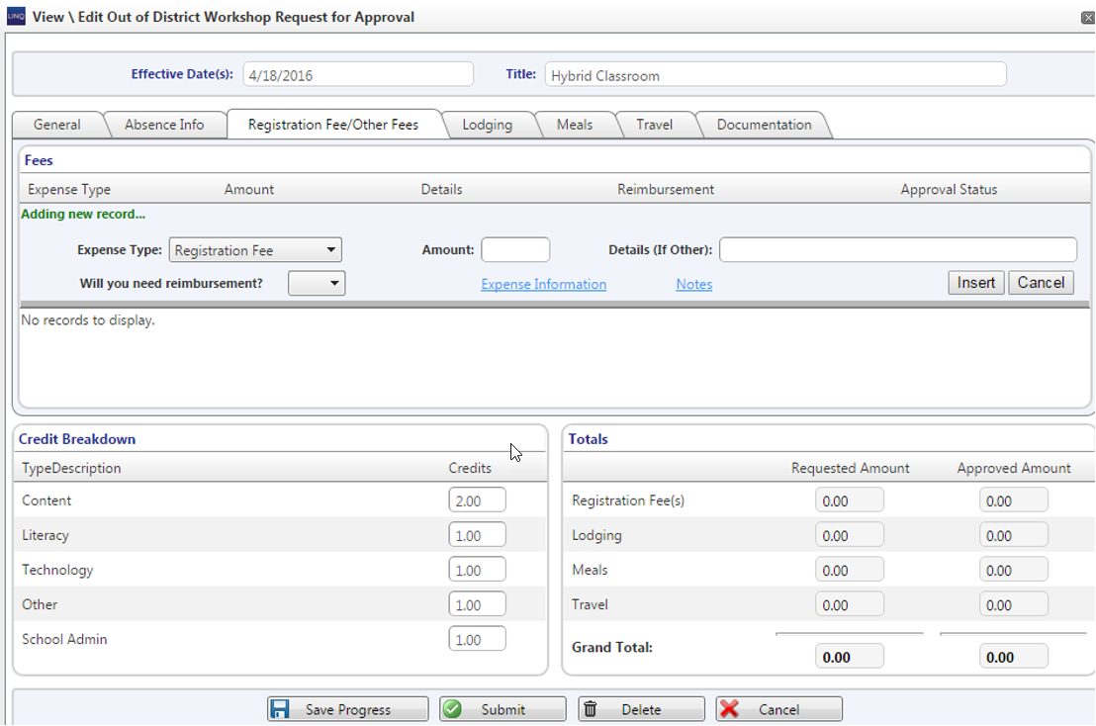
- Enter the Expense Type, the Amount, and Details (if the Expense Type is not a Registration Fee).
- Answering YES to the “Will you need reimbursement?” dropdown will generate an invoice for the employee in Fund Management.
- Answering NO to the “Will you need reimbursement?” dropdown will cause a box to pop up for entering information about the vendor that is owed payment. Note: The Expense Information link will perform the same function.
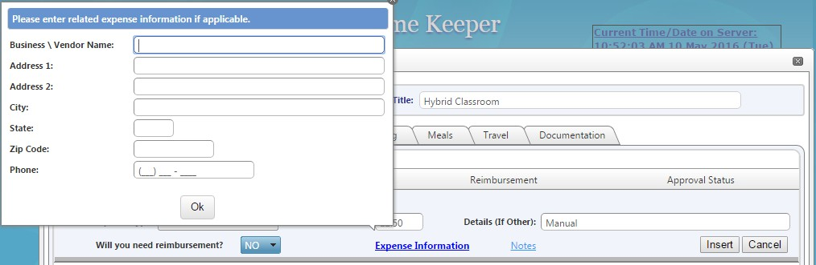
- The employee will type in what information they have for the vendor, but Business\Vendor Name is required. Click ‘Ok’ when finished.
- Click Insert when the information is complete.

Lodging Tab
- Click the green plus sign to add a new lodging request.
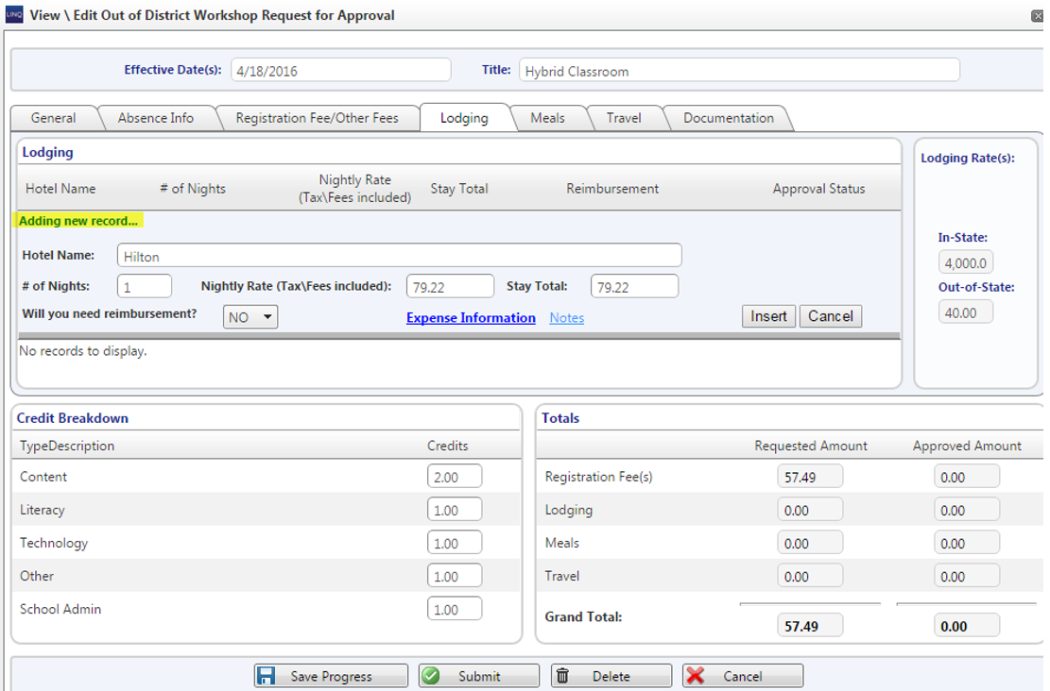
- Enter the Hotel Name, # of Nights, and Nightly Rate.
- Answering YES to the “Will you need reimbursement?” dropdown will generate an invoice for the employee in Fund Management.
- Answering NO to the “Will you need reimbursement?” dropdown will cause a box to pop up for entering information about the vendor that is owed payment. Note: The Expense Information link will perform the same function.
- The employee will type in what information they have for the vendor, but Business\Vendor Name is
required. Click ‘Ok’ when finished.
- Click Insert when the information is complete.

Meals Tab
- Rates for Meals are set up in the Control File of the Human Resources module.
- Enter the number of meals for each section. The amount can be changed, if desired.
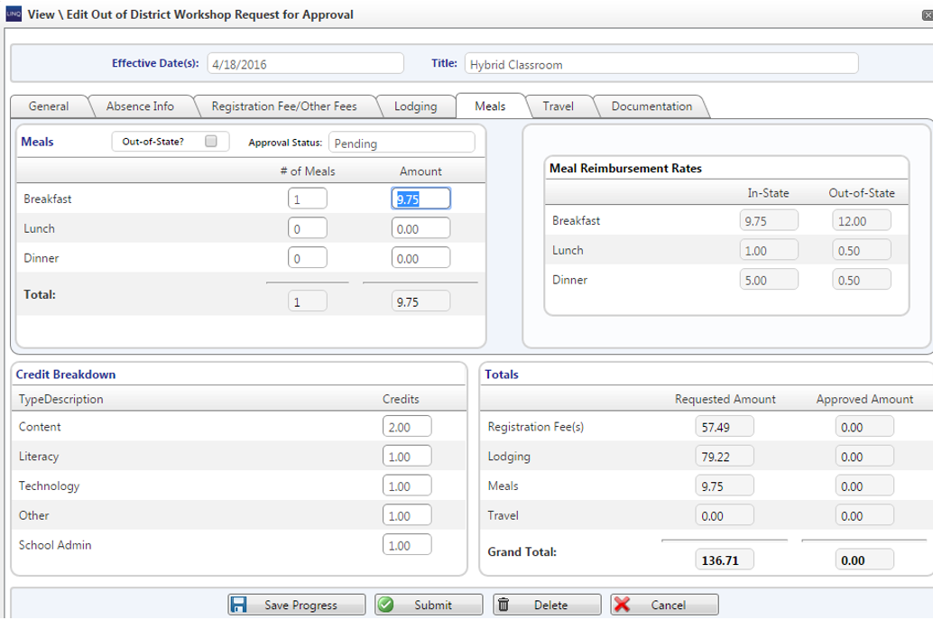

Travel Tab
- Click the green plus sign to add the request(s).
- Select a Travel Type.
Note for Admin: Travel Type options are entered in Travel Type Setup of the
CEU’s/Workshops menu option in the Human Resources module.
- Enter the Mileage. Note for Admin: The Mileage Reimbursement Rate is entered in the Control File of the Human Resources module.
- The Total Cost can be modified.
- Click Insert.
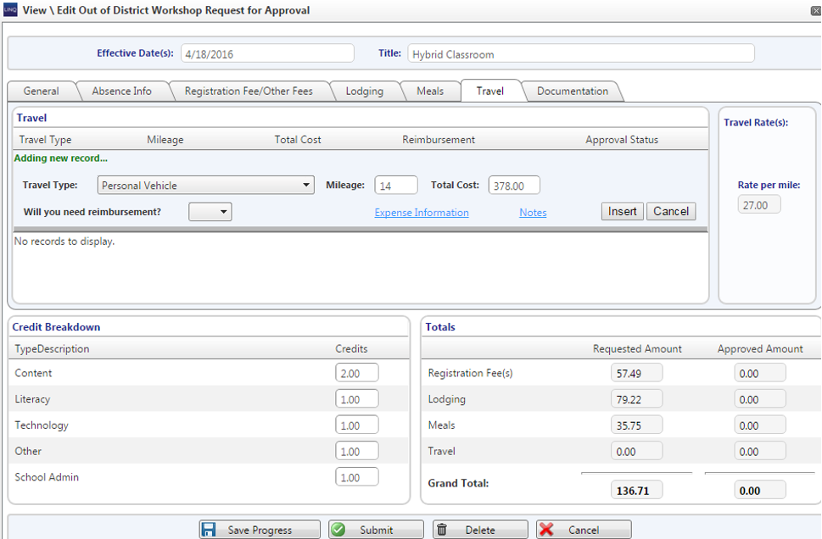

The reimbursement requests for fees, Lodging, Meals, and Travel will go to Fund Management after approval from Human Resources personnel. Invoices will be created there for employees and vendors.

Travel Tab
- Click the green plus button to add documents.
- Click the Upload File button to browse for documents to upload. They can be .jpeg, .jpg, .png, .doc, .docx, .xls, .xlsx, .pdf, .txt, .bmp, .rtf.
- Once the document has uploaded, enter a Description.
- Click the Insert button to add to the Request.

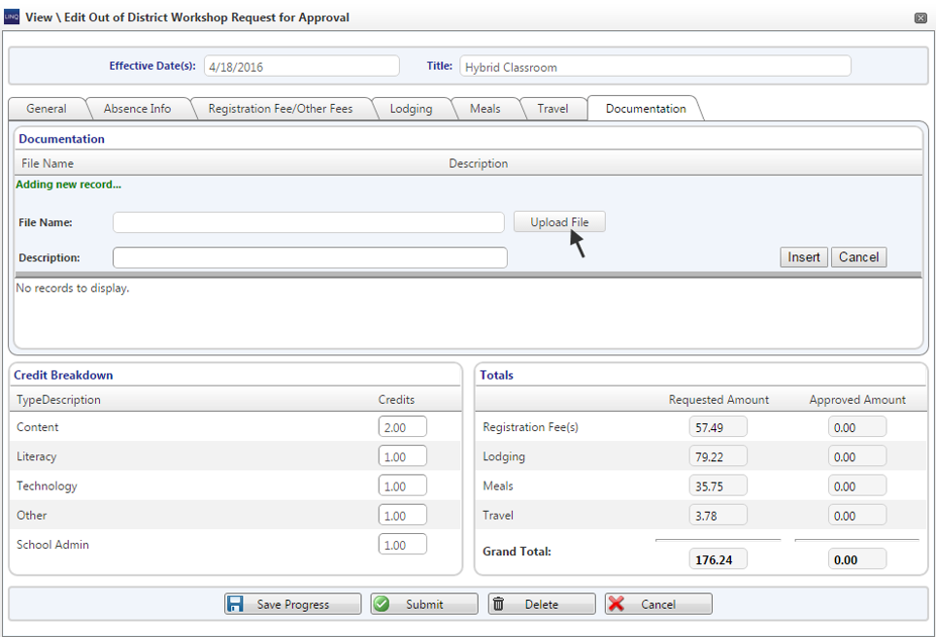

Submitting the Request to Human Resources
- After everything has been completed by the employee, they will need to submit their request to HR. Click the Submit button and answer Yes if the request is complete.
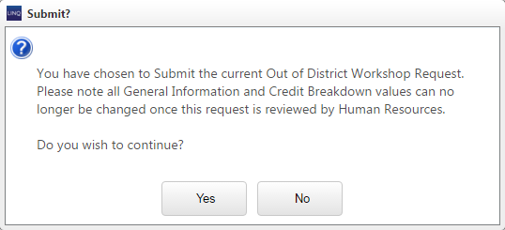

Human Resources

CEUs/Workshops

Workshop Requests
- After Filter the grid of Workshop Requests as desired.
- Select the Request by double clicking on the row or click View/Edit. The request itself has to be approved by a level 5 user before each absence and fee reimbursement request can be approved.

General Tab
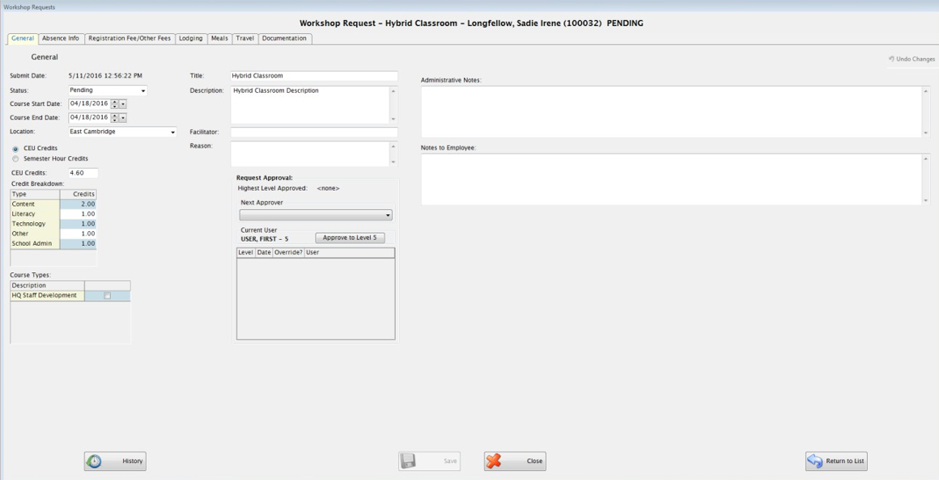
- Make modifications if needed.
- Select a Next Approver and click Approve to Level 1, 2, 3, 4, or 5. As a level 5, the Request can be changed to the “Approved” status.
- After the request is in the “Approved” status, the absence requests and each of the fee reimbursement
requests can be approved. Users with lower approval levels can still approve all requests in each tab.
- Any data submitted by employees can be modified, added to, or deleted for each request.
- Change each request’s Approval Status to “Approved”.

Absence Info Tab
- Marking the Absence Info request as approved will send the request to Manage Requests in Payroll (The “Approve All” button will approve all requests in this tab).
- Click Save.
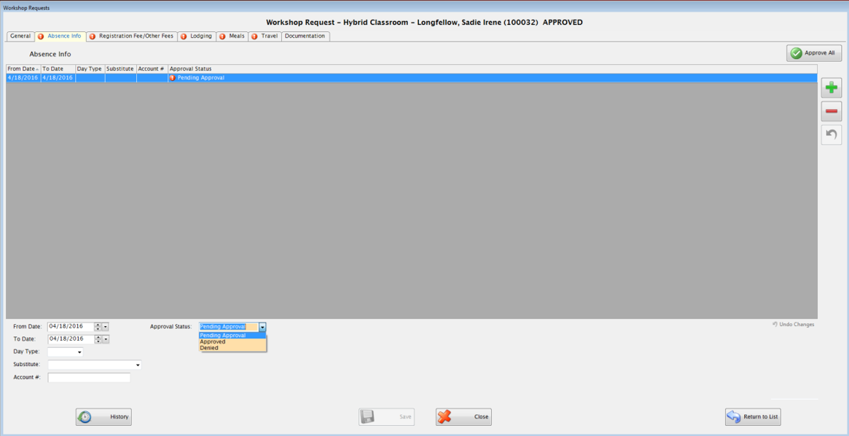

Registration Fee/Other Fees Tab
- Enter the approved amount for each expense. Change the Approval Status to “Approved”. If all of the amounts are entered, the “Approve All” button can be used to approve all requests in this tab.
- Updating the status, will send the requests to Fund Management to start the reimbursement process.
- Click Save.
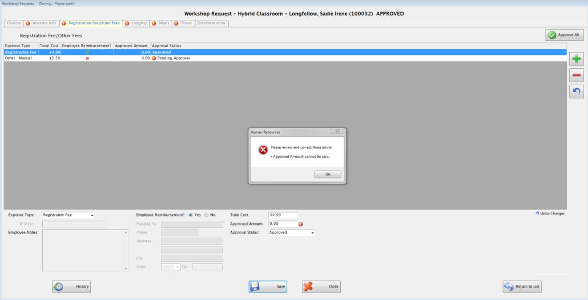

Lodging Tab
- Make any changes necessary to what was submitted.
- Enter the approved amount for each expense. Change the Approval Status to “Approved”. If all of the amounts are entered, the “Approve All” button can be used to approve all requests in this tab.
- Updating the status, will send the requests to Fund Management to start the reimbursement process.
- Click Save.

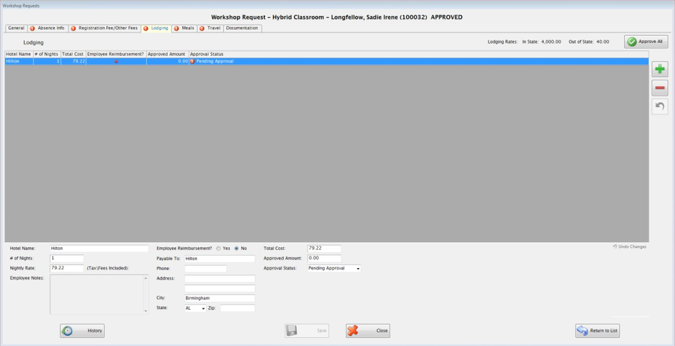

Meals Tab
- Make adjustments to amounts if needed.
- Enter the total Approved Amount and change the Approval Status to “Approved”.
- Updating the status, will send the request to Fund Management to start the reimbursement process.
- Click Save.
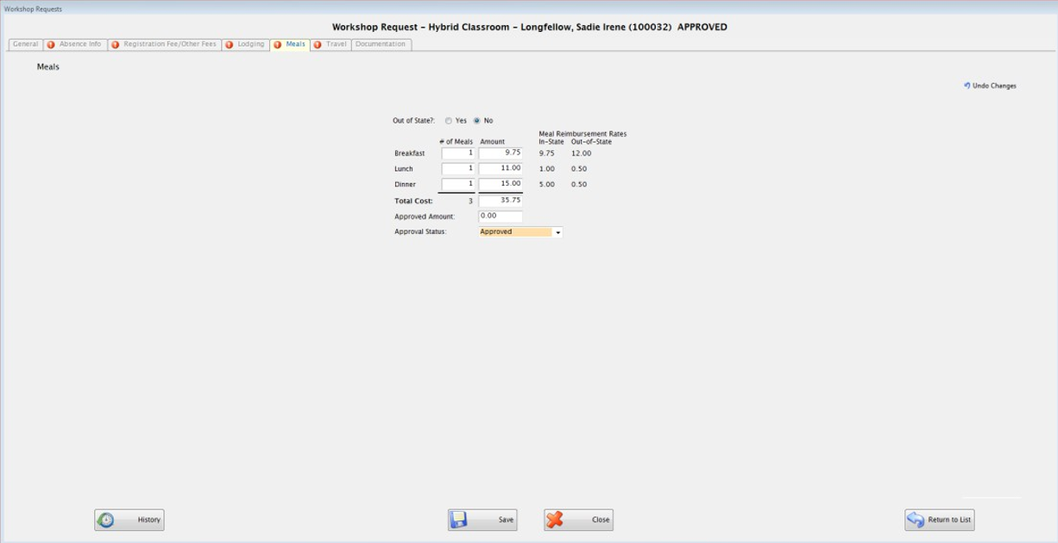

Travel Tab

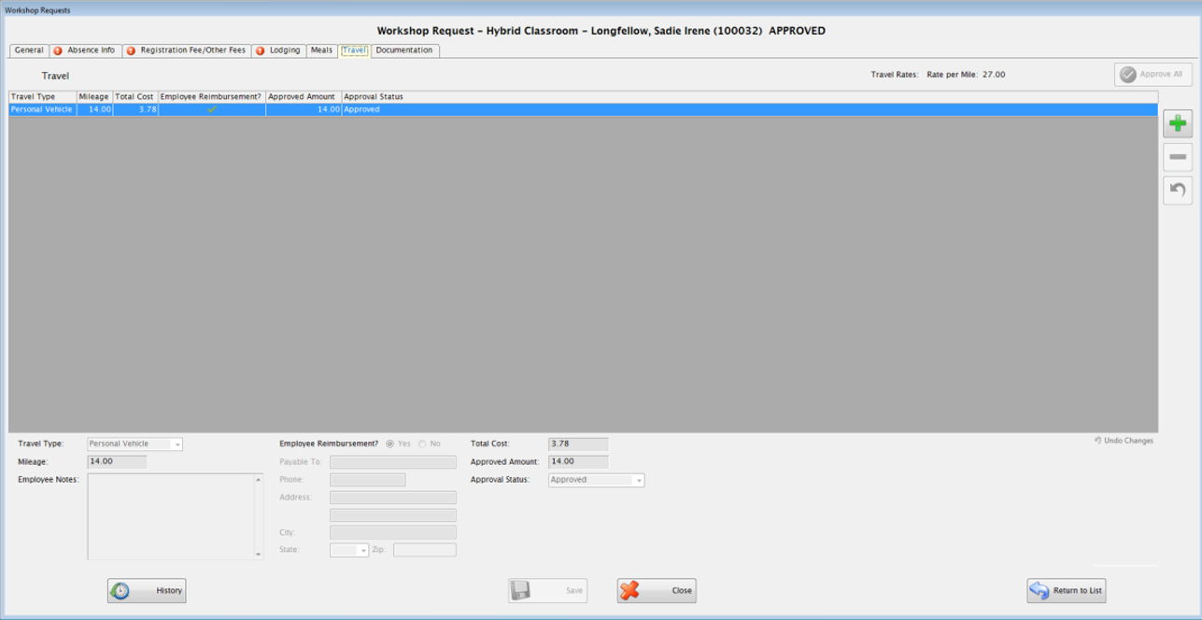

- Make any changes necessary to what was submitted.
- Enter the approved amount for each expense. Change the Approval Status to “Approved”. If the Approved Amounts are entered, the “Approve All” button can be used to approve all requests in this tab.
- Updating the status, will send the request to Fund Management to start the reimbursement process.
- Click Save.

Fund Management

Accounts Payable

Workshop Request Invoice
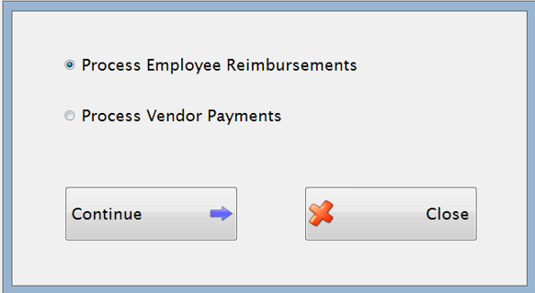
- Select the type of invoice and click ‘Continue’.

Employee Reimbursements
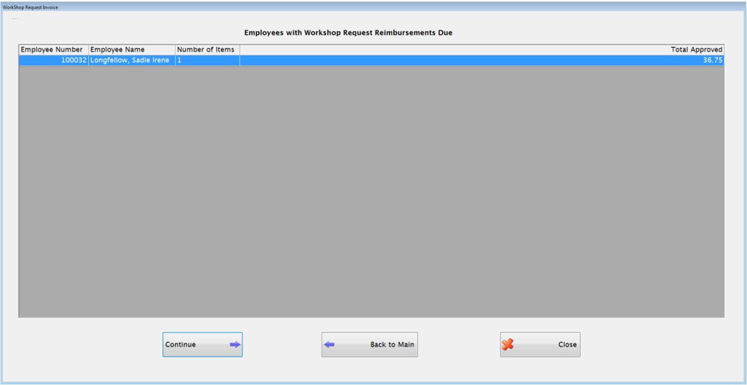
- A grid with workshop requested invoices that have been approved by the HR department will populate if there are any waiting to be paid.
- Select the invoice that you want Saved in Manage Invoices. Click the Continue button.
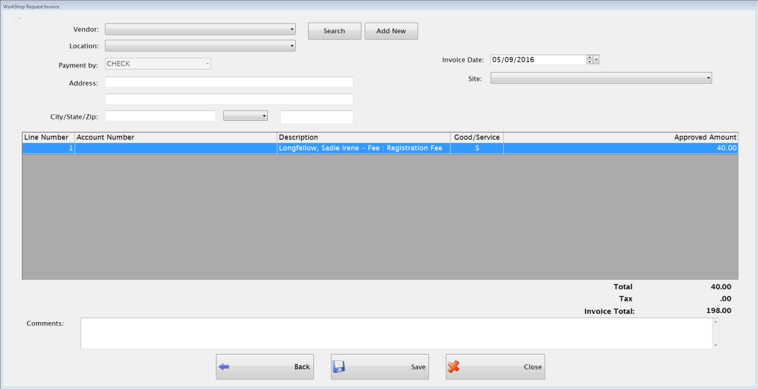

- Select an existing vendor or enter a new vendor.
- Select an Invoice Date and Site.
- Choose an Account Code for each line.
- Modify each line’s Amount if desired.
- Click Save when you are finished. Once the invoice is saved, it can be found in Manage Invoices wherethe invoice can be further modified and approved if needed.

NOTE: In Manage Invoices, the invoices are given an invoice number starting with WSRIE or WSRIV depending on whether or not it is for a vendor or an employee.

Payroll

Time Keeper
Manage Requests
- Requests for absences entered in Time Keeper Web through Out of District Workshop Requests will display here just like an Absence Request entered through the Request link in Time Keeper Web.

