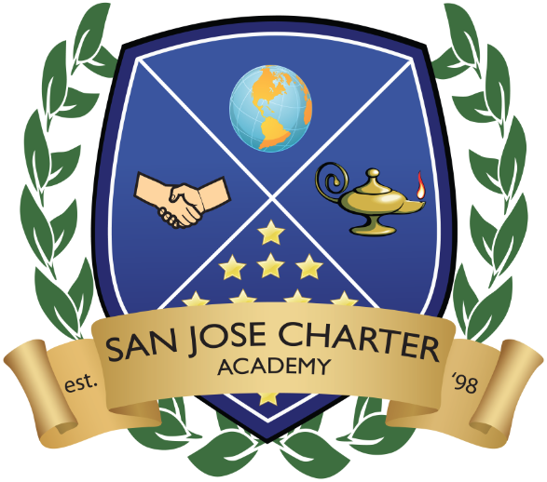San Jose Charter Academy

Notice of Public Hearing

The Education Protection Account (EPA) provides local educational agencies (LEA’s) with general purpose state aid funding pursuant to Proposition 30, the Schools and Local Public Safety Protection Act of 2012, approved by the voters on November 6, 2012. Proposition 30 requires that the use of Education Protection Account (EPA) funds be determined by the Governing Board at an open public meeting.

Funds received from the EPA account are not additional funds to the school. Similar to the local property taxes, charter school State Aid is reduced by one dollar for each dollar received from the EPA so that the total state-guaranteed funding amount to the school remains unchanged. The EPA account is simply providing a portion of the same state funding from the new Proposition 30 taxes.

For 2012-13 the California Department of Education (CDE) estimates the EPA proportionate share will be 20% of an LEA’s General Purposes Entitlement, which in SJCA’s case is $1,218.765. EPA revenues will be distributed at the end of June 2013. LEA’s are required to publish on its website an account of how much money was received from EPA and how much money was spent. In our case, these EPA funds will be spent solely on teacher salaries and corresponding benefit.

Any person wishing to give their input regarding the use of these funds is invited to speak during the Public Hearing session during the Board of Directors’ meeting. The meeting is taking place on Tuesday, May 7, 2013 at 6:00 p.m.

