LAGRANGE ELEMENTARY SCHOOL
SBDM Meeting
September 30, 2024| 2:30 p.m.| SBDM Council
______________________________________________________________________________

Council Members
Heather Thomas, Chair| Melinda Hadley, Teacher| Karla J-Stewart, Teacher| Jamie Parker, Teacher| Tovah Jeffries, Parent| Kylie Walker, Parent|
______________________________________________________________________________
Agenda Item Lead
______________________________________________________________________________

Welcome, Review Norms & Roll Call H. Thomas
- Council discussions stay within the group until the action item has been approved by the Council
- Start on time and end on time
- Maintain a focus on ensuring the learning of all students
- Be willing to share ideas and open to new learning
Approval of Agenda H. Thomas

Approval of Minutes from — Meeting H. Thomas

Council Action Items
- School Report Card E. Reed
- Policy Review H. Thomas
- Technology Fees M. Hadley

Committee Reports
- Intervention Committee J. Parker
- Tech Committee M. Hadley

Comprehensive School Improvement Plan (CSIP) Update

Public Comment

Principal’s Report
- SBDM Annual written and oral report

Adjournment H Thomas

La Grange Elementary
School-Based Decision-Making Council
August 26, 2024
The La Grange Elementary School Site Based Decision Making Council met in the library for the regularly scheduled monthly meeting with the following members in attendance: Jamie Parker - Teacher Rep, Kiley Walker – Parent Rep, Tovah Jeffries – Parent Rep, Melinda Hadley – Teacher Rep, Karla J-Stewart – Teacher Rep and Heather Thomas - Chair.
Mrs. Thomas called the meeting to order at 2:43 pm.
1) A motion was made by Tovah Jeffries to accept the agenda and minutes. The motion was seconded by Melinda Hadley and the motion carried with no opposition.
2) Mrs. Thomas reviewed the Statement of Ethics for LaGrange Elementary SBDM Council that is within the SBDM Council By-Laws. (Articles I & II) After reviewing, Mrs. Thomas asked that all Council members sign the Endorsement of the Statement of Ethics and it will be kept on file at LaGrange Elementary.
3) Mrs. Thomas then reviewed the By-Laws for the SBDM Council. Article I (Purpose), Article II (Mission) and Article III (Membership). No changes were made. A motion was made to accept these Articles as written by Jamie Parker. Karla J-Stewart seconded the motion and the motion carried with no opposition.
4) Mrs. Thomas then reviewed Article IV (Duties of Officers and Council Members). Mrs. Thomas noted that the Council needs to elect a Vice Chair to serve in the event that Mrs. Thomas is not able to attend a meeting. Melinda Hadley nominated Kiley Walker to serve as Vice Chairperson of the Council. Tovah Jeffries seconded the nomination and the nomination passed with no opposition.
5) Mrs. Thomas reviewed Article V (Committee System). She recommended one change in the working of the first section – Standing Committees. Within this section it stated “The standing committees are based on instructional practices, curriculum, assessment and student support.” Mrs. Thomas recommended that the wording be changed to “The standing committees are based on instructional practices, curriculum, assessment and student/staff support.” A motion was made by Tovah Jeffries to accept the Article with the change. Kiley Walker seconded the motion, and the motion carried with no opposition.
6) Mrs. Thomas reviewed Article VI (Schedule of Meetings). A change in wording was recommended in Section 2 – Schedule of Meetings. It currently states “The length of a meeting shall not exceed two hours unless Council agrees to extend the meeting to complete the agenda. If agenda items have not been addressed by the end of the meeting, a special meeting shall be called to complete the unfinished business.” The change is as follows: “The length of the meeting shall not exceed one and a half hours.” The recommendation was also suggested to take out the last sentence requiring a special meeting. “If agenda items have not been addressed by the end of the meeting, a special meeting shall be called to complete the unfinished business.” A motion was made by Jamie Parker to accept the changes made. The motion was seconded by Karla J-Stewart and the motion carried with no opposition.
7) Mrs. Thomas reviewed Articles VII (Conduct of Meeting), Article VIII (Minutes and Other Records), Article IX and Article X (Policy and Amendments). There were no changes to these Articles. A motion was made by Karla J-Stewart to accept them as written and seconded by Jamie Parker. The motion carried with no opposition.
8) Mrs. Thomas reviewed the Student Behavior Policy (9001) as well as Monitoring of Student Computer Network Access (4005). No changes were necessary at this time.
9) Liz Dant, OCBE Elementary Level Director, joined the meeting at 3:12 pm. Liz explained Title I and how those monies are determined as well as how they are distributed to qualifying schools and what that money can be used for. No action was necessary by the Council. Mrs. Dant exited the meeting at 3:34 pm.
10) With no additional business, a motion was made to adjourn by Melinda Hadley. The motion was seconded by Kiley Walker and the Council adjourned at 3:46 pm.

September 5, 2024
The La Grange Elementary School Council met in a special-called session with the following members in attendance: Kiley Walker (parent), Melinda Hadley (teacher), Karla J-Stewart (teacher) and Heather Thomas (chair), called the meeting to order.
1. The meeting was called to order at 7:11 AM
2. The Council reviewed and approved the agenda.
3. The Council entered a closed session to discuss certified personnel selection as
provided by KRS 61.810 (1)(f) at 7:20 AM.
4. The Council resumed open session at 7:20 AM.
5. With no further business, the Council adjourned.

September 30, 2024
Enclosure A

La Grange Elementary School Council
Oldham County Schools

CONCERN:

The School Report Card (SRC) is published annually and provides information about key topics and accountability at the school, district and state levels. ​​​​​​Kentucky School Report Card Dashboard (SRC) ​highlights key topic areas and performance indicators at the school, district, and state levels. The SRC Dashboard provides a collection of resources to help school districts collect, validate and submit required data.).

DISCUSSION:

The timeline for entering SRC started with the school profile tools opening on Sept. 18, 2024. Public release of new SRC Suite Dashboards will occur on November 20, 2024. The School Report Card populates information from the School Profile Report to create the Report Card. Mrs. Reed will be sharing our current School Profile Report for the 24-25 school year.
School Profile Report

RECOMMENDATION:

Approve the current School Report Card by signing

September 30, 2024
Enclosure B

La Grange Elementary School Council
Oldham County Schools

CONCERN:

The phrase council policies refer to what the school council develops and adopts concerning how the school operates. This includes such items as curriculum development, determining school schedules and technology use in schools. Policies are the rules, guidelines and procedures for school operations.

DISCUSSION:

School council policies need to contribute to raising student performance and keep a focus on achieving our mission and goals. As our goals and procedures evolve, the council needs to review our policies to determine if and how they need to be revised.
In regards to the selection and use of instructional resources, policy 2002, the passage of Senate Bill (SB) 1 (2022), the authority to determine instructional materials was transferred from the school-based decision making (SBDM) council to the local superintendent. Specifically, per KRS 160.345, Section 2(g), “the local superintendent shall determine which curriculum, textbooks, instructional materials, and student support services shall be provided in the school after consulting with the local board of education, the school principal, and the school council and after a reasonable review and response period for stakeholders in accordance with local board of education policy." Based on the law, policy 2002 needs to reflect that as a council, we are making a possible recommendation to the district curriculum team or delegated to a sub-committee formed to undertake this task.
In regards to our Extended School Service Policy, policy 4010, Mrs. Parker will share the 24-25 proposed in-school and after-school plan.

RECOMMENDATION:

Discuss council policy 2002 and 4010 make revisions, ask questions and seek additional information if needed. Pending no additional questions, approve policy revision as presented.

SELECTION OF TEXTBOOKS AND/OR INSTRUCTIONAL ALIGNMENT MATERIALS 2002
TOPICS STATEMENT

a. Instructional Instructional materials shall mean commercial materials, media, and
Materials software used by teachers to deliver instruction.

b. Committee A committee shall develop a plan for the acquisition of
instructional materials and/or technology.

The committee shall make recommendations and report to the Council. The school librarian/media specialist could assist in the development of
the recommendations. The recommendations shall be developed with a focus on the overall needs of the instructional program. Selection of materials shall be based on the alignment of the selected school curriculum and upon needs identified in the School Improvement Plan.

The committee shall be responsible for:
1. Surveying the teachers to determine their instructional material needs/technology and preferences.
2. Studying instructional material samples/technology and identifying instructional materials to be used in the instructional program.
3. Developing a written plan

From the point of a school recommendation shared with the Board of Education, superintendent shall determine which curriculum, textbooks, instructional materials, and student support services shall be provided in the school after consulting with the local board of education, the school principal, and the school council and after a reasonable review and response period for stakeholders in accordance with local board of education policy.

c. Budget The budget developed by the committee shall not exceed the available building funding. The Council shall approve the budget.

Extended School Services 4010

Topic | Statement
- Rationale Program Description | LaGrange Elementary is committed to assisting all students with  academic deficiencies consistent with students’ intervention or  individual learning plans.  The SBDM Council will be made aware of when and how  services will be provided based on the resources available from  district/state ESS funds.
- Eligibility | Per district policy, student eligibility will be based on the  following methods:  • Teacher recommendation  • Academic performance data, including diagnostic, formative and summative assessments  • Behavioral and developmental progress as documented on informal and formal assessments
- Student Selection | Students demonstrating the greatest need will be given priority. Students serviced through ESS will be monitored closely to  determine progress
- Parent Notification | Parents of eligible students will be notified through a  notification form. Parents will receive feedback outlining their  student’s progress towards their learning goals.
- Principal Approval | The building principal must approve any deviation to the above  guidelines.

September 30, 2024
Enclosure C
La Grange Elementary School Council
Oldham County Schools

CONCERN:

Students, not approved for fee reduction, are required to pay a yearly technology fee of $20. The Council, with input from our Technology Coordinator, needs to determine the technology needs of La Grange and how to best spend the funds.

DISCUSSION:

The Technology Committee is continuing to review software subscriptions and costs to best meet our school needs. There is no recommendation for purchase at this time.

RECOMMENDATION:

Review the recommendation to approve or make additional changes.

Intervention Committee
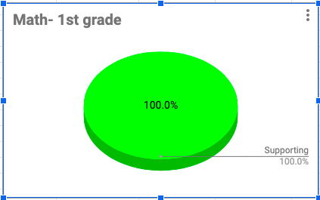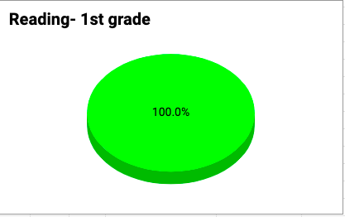

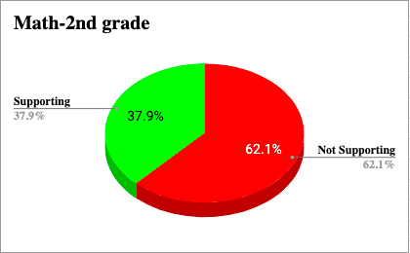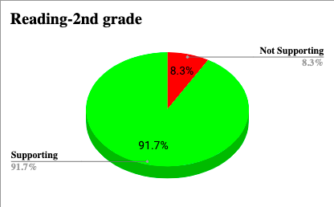

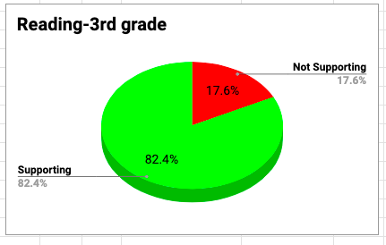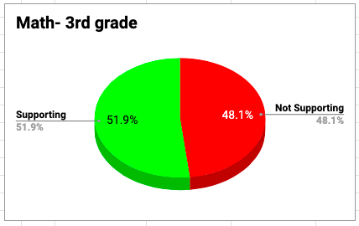

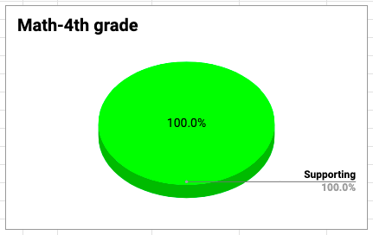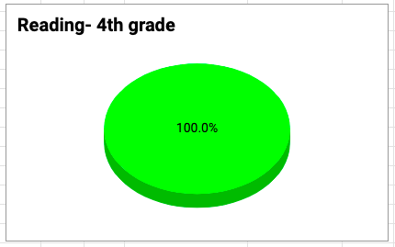

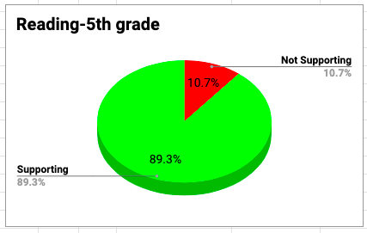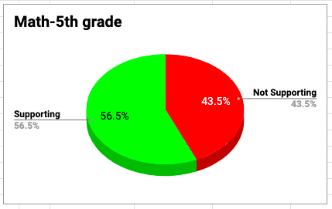

After analyzing the Fall iReady data there are 107 students that are considered “Two or more grade levels below” in reading and there are 107 students that are considered “Two or more grade levels below” in math. To meet the diverse needs of these students, our Special Education teachers, English Language Learning teachers, and our Intervention teachers instruct these students in a small group setting to accelerate their learning through targeted lessons matched to their needs.

Our Intervention Team is composed of three reading intervention specialists, one part time math intervention specialist, and one math coach. On average the reading intervention specialists are meeting with about 30- 40 students daily to meet the Tier 2 and Tier 3 needs of students in reading intervention. Our- part time math interventionist is meeting with 15 students daily to support the Tier 3 math needs of students, and that number will continue to grow as we add on kindergarten groups. Our math coach meets with 45 students daily to not only meet the Tier 2 and Tier 3 math needs, but also to reduce class sizes in second grade, and to enrich the learning of students in first grade.

The graphs above show how well we are able to support all of our lowest learners through this targeted instruction. In the grades where we are meeting with 100% of the students, we are then able to work with the next subset of students that are considered “One grade level below.” In certain grades, where the needs are very high, we are only able to reach students who are considered “Two or more grade levels below.” As you can see, the needs are very high at our school and our support staff is working with a high number of students daily to target specific needs and close gaps in student learning.

Technology Committee
At the June 14, 2024, La Grange SBDM meeting, our school technology committee reported on a new 2-year special funding. Due to the state waiving restrictions on capital dollars for the next 2 school years (2024-2025 & 2025-2026), the district has allotted $100 per student for the purchase of technology. Our projected enrollment for 2024-2025 was 446 students, so our allocated budget is $44,600.00 for technology from the district for 24-25.

Our original proposal which was approved was as follows:
Quantity | Item / Description | Cost Per Item | Total
11 | iPad Air for Apple TV pilot program | $566.50 | $6,231.50
11 | iPad Air cases | $30.00 | $330.00
4 | Apple TV for pilot program | $149.00 | $596.00
3 | 43” TV for pilot program | $238.00 | $714.00
11 | Apple Pencil Pro for pilot program | $119.00 | $1,309.00
15 | MacBook Air for staff | $1,545.50 | $23,182.50
1 | Dell laptop | $1508.00 | $1,508.00
10 | Chromebooks for students | $338.00 | $3,380.00
3 | iPad 10” for students | $346.50 | $1,039.50
3 | TV carts for pilot program | $49.99 | $149.97
 |  | TOTAL | $38,440.47

After sitting down with our district Director of Technology, Trey Greenwell, we developed a 5 year replacement plan for La Grange Technology. Below is the revised 24-25 adjusted Technology Purchase Plan.

Quantity | Item/Description | Cost per item | Total
55 | HP Chromebooks | $306.00 | $16,830.00
55 | Chromebook licenses | $32.00 | $1,760.00
36 | iPads | $329.00 | $11,844.00
36 | iPad licenses | $17.50 | $630.00
15 | Macbook Air | $919.00 | $13,785.00
15 | Macbook licenses | $17.50 | $229.00
1 | iPad Air (Sinkovic) | $649.00 | $649.00
1 | iPad license | $17.50 | $17.50
1 | Dell Latitude laptop | $1,481.60 | $1,481.60
 |  |  | $47,226.10
 | District covering licenses |  | -$2636.50
 |  |  | $44,589.60
 | Over/under |  | $10.40

2024-25 La Grange Elementary SBDM Presentation (written)
Data Snapshots:
KSA Snapshot:
- Will share during our SBDM meeting once everyone has signed a non-disclosure agreement
iReady:
- Reading: 68% proficient or above with high-frequency words. 71% ready for grade-level instruction according to IReady Reading (266 students).* at yellow or above. Projected proficiency if typical growth made: 36% overall in reading.
- Math: According to the Fall 2024 iReady diagnostic, 71% (265) of students ARE ready for grade-level content in math. However, 29% (109) of students are NOT ready for grade-level content and need some intervention. Measurement, Data, and Geometry have the most students unprepared for grade-level content.
Studer Survey:
- Student: A student strength, rated 4.58, is “my teachers challenge me to think.” Our area of growth is students showing respect for one another.
- Families: A family strength, rated 4.30, is that families believe their child’s learning is prioritized at La Grange. One of our lower-rated areas, at 3.97, is families not receiving regular feedback about how well their child is doing at school.
- Staff: Regarding our staff with the Studer survey, we showed growth, from 4.38 to 4.56, in “I believe that leaders in my immediate work environment are genuinely concerned for my welfare.” This was an intentional area of growth for our administrative team. Our area for growth this year is focused on staff having an opportunity to provide input on decisions that affect their job.
Attendance:
- LaGrange showed the second-highest attendance growth in the district last year. Our current attendance was 96.7% in August and currently 96% through September.
Behavior:
- Behavior events decreased from 221 events across 45 students in 22-23 to 131 events across 45 students in the 23-24 school year.
Addressing Data Finding:
Science is our most significant area of concern, with 24.6% proficiency. We’ve implemented strategies to address this, including providing high-quality, standards-aligned instructional materials and targeted teacher professional development focused on hands-on, inquiry-based learning. We also use data-driven instruction to identify student needs, offer after-school student clubs, and foster community engagement through STEM-related activities and family nights. These efforts aim to close achievement gaps and improve science proficiency for all students.
In math, we will be more intentional about using pre-requisite reports and the iReady ToolBox to fill math gaps for all students. After the Winter iReady, we can use the Standards Report to fill gaps and see which students we need to go back to and review specific standards with as we continue to partner with Lucy from iReady. A significant focus in reading is elevating our phonics programs through a continued partnership with OVEC and Lynn Schwallie. We are not close to meeting the 80% proficiency in Phonics according to iReady. The next step would be continuing UFLI but making time in the daily schedule to practice and integrate the skills taught through writing and more work with the connected text.
Strategic Plan:
Students and families: After analyzing Studer Survey results, we focused on growth around students owning their learning and increasing parent feedback. We are engaging students and families through student goal-setting practices and regular feedback to families on these goals. Each grade level must establish, track, and report to families on a goal from at least one content area and iReady throughout the school year. The school also focuses on improving communication and engagement with the monthly family newsletters, increasing positive phone calls, and mailing positive postcards directly related to the district strategic plan.
Staff: To empower our teachers and respond to Studer Employee Survey results indicating that employees would celebrate more input in decision making, each grade level team decides on their content area and method of parent feedback about student goals. To elevate our teachers and students in this process, teams were given a timeline to create their goal-tracking system. The administration will support their system with Goal Conversation walk-throughs before fall break with every student around their goals and a parent survey around academic feedback administered at conferences. In January, staff will analyze the parent survey results and reflect on their process for sharing feedback with parents. In addition, staff will be able to share and learn from each grade level in the school around goal setting and tracking processes via a virtual gallery walk and share-out.
Actions of Excellence:
We are focused on engaging students and families through clubs and family events throughout the school year.
- Clubs: LES offers 17 clubs throughout the school year, led by all Certified Staff members. Our club offerings are not just diverse but also exciting and engaging. They are based on current student passion trends, ensuring there's something for everyone, from Basketball to board games, Yoga, and Scrapbooking.
- Family Events: LES hosts several family events throughout the year. These events include our Open House, Family Math Night, Literacy Night, STEM Night, Paint Night, Art Glow Party, and Talent Show. This year, we will add our K-5 Musical! Many of these events are hosted in partnership with our Family Resource Center and PTA.
For staff, we are focused on empowering and elevating through extending opportunities to be teacher leaders, showcasing and teaching other teachers via learning walks, meeting with small groups to share skills and strategies, and presenting at faculty meetings. We are also intentional about the time and effort we pour into our teachers and keep track of these moments with our Check and Connect spreadsheet, which is a live document that we frequently update to ensure we have had touchpoints with all staff, whether it be a walkthrough, positive interaction, support, etc. This document ensures that we are intentional with our interactions with staff and encourages equity among interactions and opportunities for support and growth.

Possible Questions and Answers the Board may ask:
This will be added Monday once we have all signed out non-disclosure agreements

