

NYSITELL FAQ’s

- When will the scantrons be available to download and print
They are on the FTP site now in a sub folder named Blanks in the NYSITELL folder.

- What would the turn-around time be for getting pre-printed answer sheets via a .csv request?
Same day or next day depending on what time the file is received by the Nassau BOCES Regional Information Center (RIC).

- Can we pre-print labels from our student management system and add them to the answer sheets?
No, the information would not appear in the designated fields on the answer sheet.

- How are the scores being sent back to us?
You will be able to access your scores in ASAP.

- If our BOCES Coordinator is not in (or if we don't know if they are in), who should we contact?
You can contact Fran Werner at (516) 608-6688. If Fran is not available, contact
Meador Pratt at (516) 608-6612

- Will we be able to access NYSITELL scores for an ELL coming from another district?
Previous NYSTELL scores should be obtained from the records request from the previous school.

- ASAP generally requires that students are loaded thru level 0. With many new NYSITELLs being administered in very early September. Generally, Level 0 for the new year is not opened until late September. This might be a problem with new year opening. Assuming district is pushing data very often.
As long as the student name and ID are provided, you will be able access the students in ASAP so you can see the scores. There will be a lag time before the data is loaded to level 1. This will not impact students in September.

- Would you please describe the "multipage tiff" thing again?
If you have more than one sheet for a Level, you would choose the “Multi Tiff” option on your scanner. This will put all of the sheets for that level in 1 file rather than creating a separate file for each sheet.

- Is the NYSETILL option already available on ASAP
Yes, your district data coordinator has to give your log in access to it.

- Can’t I just bring the answer sheets to BOCES?
Yes, you can bring the sheets to Nassau BOCES RIC and we will scan and process them.

- Is kindergarten "00" for the “GradeLevel” field if a file is being sent for pre-printed answer sheets?
No, it would be a “KF”.

- How many scantrons are there for the levels?
There are 8 levels, Level 1 is not yet available. Each level has it’s own district specific reproducible answer sheet.

- What is the process for K-6 Districts to get access to ASAP?
ASAP is web based (http://asap.nasboces.org). your district data coordinator can give you a user ID and Password.

- What if the student grade is not determined at the time of the test or we don’t know that info yet?
Each level encompasses more than 1 grade and the grade levels overlap. If the wrong level is given and this is realized before the data is sent to the state at level 2, the correct level can be administered and the original level can be deleted. After data is loaded to level 2, this will have to be corrected at the state level. Nassau RIC will not be reporting to Level 2 immediately after processing so that such issues can be avoided.

- How do we post the answer sheet to the FTP site?
You have to download the CoreFTP client to your desktop and set up the site manager. Once this is done it is just a matter of selecting the scanned image (tiff) file and clicking on the arrow to move it over. The testing coordinator in your district will be familiar with this and can assist you. If not, contact your BOCES coordinator and they will help you set it up. It looks like this:

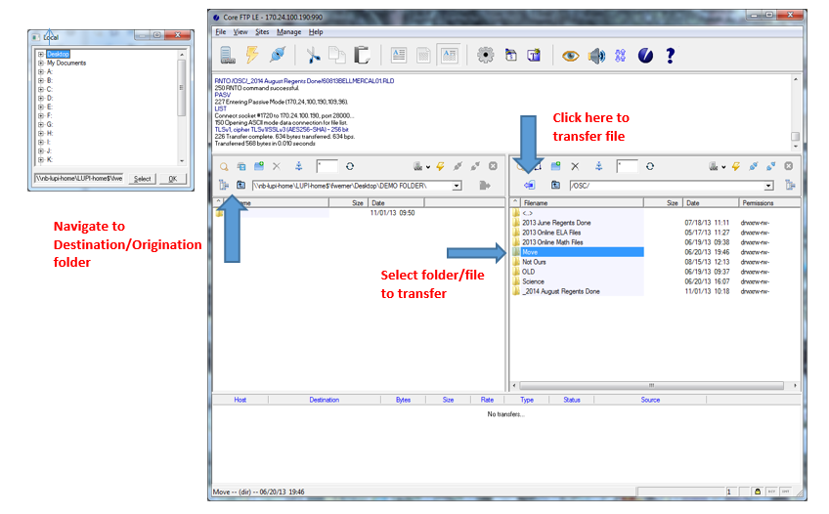

- Pre-K students are screened in June for Kindergarten entry in September. Want to confirm that the scans can still be graded in June (for class placement) and not uploaded to NYS until they have a September date of enrollment.
Yes, these scores cannot be reported until Level 0 opens and the students are entered and pushed to level 1. As long as we have a name an ID we can manually process and post to ASAP so districts can view the scores.

- Where is the student writing the constructed response to the writing prompts? Are districts still scoring the constructed responses then adding it to the answer sheets?
The test booklets follow the same format as the NYSESLAT exam. Yes, district personnel are responsible for scoring the students constructed responses and bubbling in the scores for each item on the answer sheet.

- Do you know when level 1 scan sheets will be available?
We have been told they will be available by June.

- Can the information in the FTP site be uploaded to eschool or other student management system? Or do we have to enter the scores ourselves?
The information can be uploaded into the SIS from ASAP. Nassau BOCES RIC will load the data into Level 1 & 2.

- How long after administering the NYSITELL do answer sheets need to be submitted?
Nassau BOCES RIC does not have any time requirements beyond what is outlined by NYSED. However, scores are not available in ASAP until the sheets are scanned and sent to Nassau RIC from the district.

- What scanner can I use?
Any scanner can be used. The answer sheets have to be scanned by level as multi-page
tif images at 300 dpi. If the Regent’s scanner is used Do Not use the EASE icon to scan.
Use the Epson Scanner icon.

- What is the file format used to order pre-printed answer sheets?
The file should be created in Excel and saved as a .csv. The file format can be found here: https://www.nassauboces.org/Page/384

23 What if I don’t have an ID for a student?
Provide as much information as you have. If you don’t have an ID leave it blank. Once an ID is established for the student, contact your Nassau BOCES RIC testing coordinator and they will correct the record in ASAP.

