
GISD Mission Statement:
The Garland Independent School District exists as a diverse community with a shared vision that serves to provide an exceptional education to all its students.
Vision: We envision a middle school where intentionality, vibrant culture, and unwavering support converge to create an inclusive and empowering environment for all students.
Mission: To cultivate an inclusive and empowering middle school environment where intentionality guides our actions, vibrant culture enriches our community, and unwavering support ensures every student thrives academically, socially, and personally.

What is a School-Parent Compact?
School-Parent Compact
2024-2025
Sam Houston Middle School
“a school-parent compact outlines how parents, the entire school staff, and students will share responsibility for improved student academic achievement and the means by which the school and parents will build and develop a partnership to help children achieve the State’s high standards.”
Every Student Succeeds Act: Section 1116
Here at Sam Houston Middle School, our compact will ensure that parent feedback is appreciated, valued, and welcomed. Parent contributions are vital to the success of all students on campus.
How Sam Houston Middle School will build partnerships between school and home…

Colt Camp
Back to School Night
Meet the Teacher
Annual Title I Meeting
Science/Literacy/AVID Nights
Harvesting High School
Game Nights
TELPAS Parent Meetings
PTA Meetings

A Family-School Compact is an action plan to enhance schools and promote student success!

-Jointly Developed-
This compact was developed jointly with the input of parents, teachers, staff, and students. It is introduced and discussed at the Annual Title I Meeting and reviewed frequently throughout the year.
This compact is a living document meant to reflect the current needs of parents and students at Sam Houston. For any questions or contributions, please reach out to Hanna Taylor at (972) 926-2640.

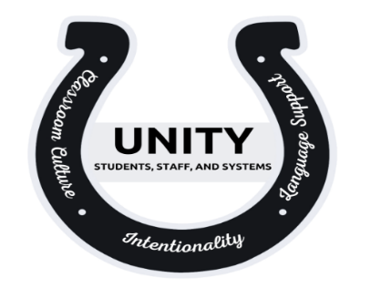

This compact aims to create a partnership between school and home and is also your parental right. under ESSA.

2232 Sussex Drive
Garland, TX 75041

Our Goals for Student Achievement
District Goal:
Parents As Partners
We desire that parents commit to supporting Sam Houston in the following ways:
- I will communicate regularly with my child’s teacher in order to understand my student’s progress including checking Skyward (online gradebook).
- I will make sure my child is at school on time and ready to learn.
- I will create a home environment that Is safe for my child.
- I will reach out to the school directly with any concerns or questions.
Student Responsibilities
We desire that students commit to supporting Sam Houston in the following ways:
- I will reach out to my teachers, principal, or counselor when I need support.
- I will follow the dress code policy.
- I will come to school prepared with my supplies and materials.
- I will come to school on time and with a positive attitude.
Garland ISD will ensure that all students graduate prepared, for college, careers, and life by increasing student performance, measures, postsecondary readiness, and graduation rates and decreasing student management instances.
2024-2025
Sam Houston Middle School Goals

Our campus goal is for all student groups to achieve 70% Approaches, 40% Meets, and 15% Masters on all STAAR assessments.
Teacher/Staff Responsibilities
We desire that teachers and staff commit to supporting Sam Houston in the following ways:

- We will create and challenge all students to learn at rigorous, high levels of thinking and make connections with learning to real world applications.
- We will create a learning environment where students feel safe, respected, and nurtured in order for healthy student-to-student relationships and healthy teacher-to-student relationships exist.
How We Will Communicate…
We intend to communicate with parents in the following ways:
Sam Houston Middle School recognizes the importance of frequent, consistent and specific communication with parents.
Parent-Teacher Conferences will take place the weeks of 11/6/24 and 2/26/25.
Access to Staff - Email addresses of ALL staff are available on our school website.
We also communicate weekly through the parent S’MORE and both individually and as a campus through Talking Points.

