
Diversus Health Parkside Child & Family Services
115 S. Parkside Dr.
Colorado Springs, CO 80910
Phone: (719) 572-6100
Crisis Line: 844-493-TALK (8255)
Crisis Text: TALK to 38255
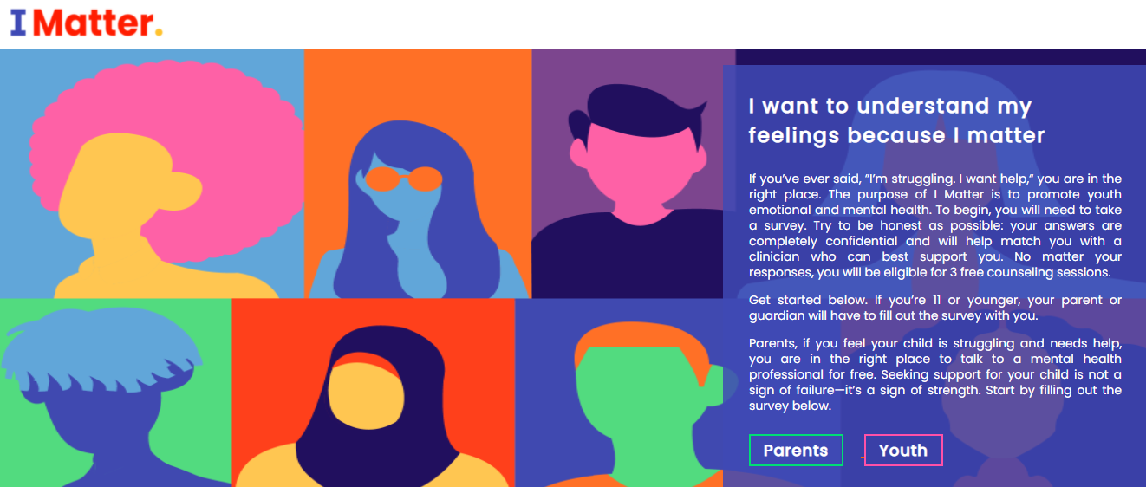
FREE COUNSELING SERVICES: 6 free Telehealth counseling sessions (some in-person as well).
Imattercolorado.org


Peak View Behavioral Health
7353 Sisters Grove
Colorado Springs, CO 80923
888-235-9475

Children’s Hospital
4090 Briargate Pkwy.
Colorado Springs, CO 80920
719-305-1234


Cedar Springs Hospital
2135 Southgate Road
Colorado Springs, CO 80906
719-633-4114

