CAN – Central Registry Check

Use the KOG onboarding instructions to set up an account.
When you receive the confirmation email, click the link.
Then you can sign in
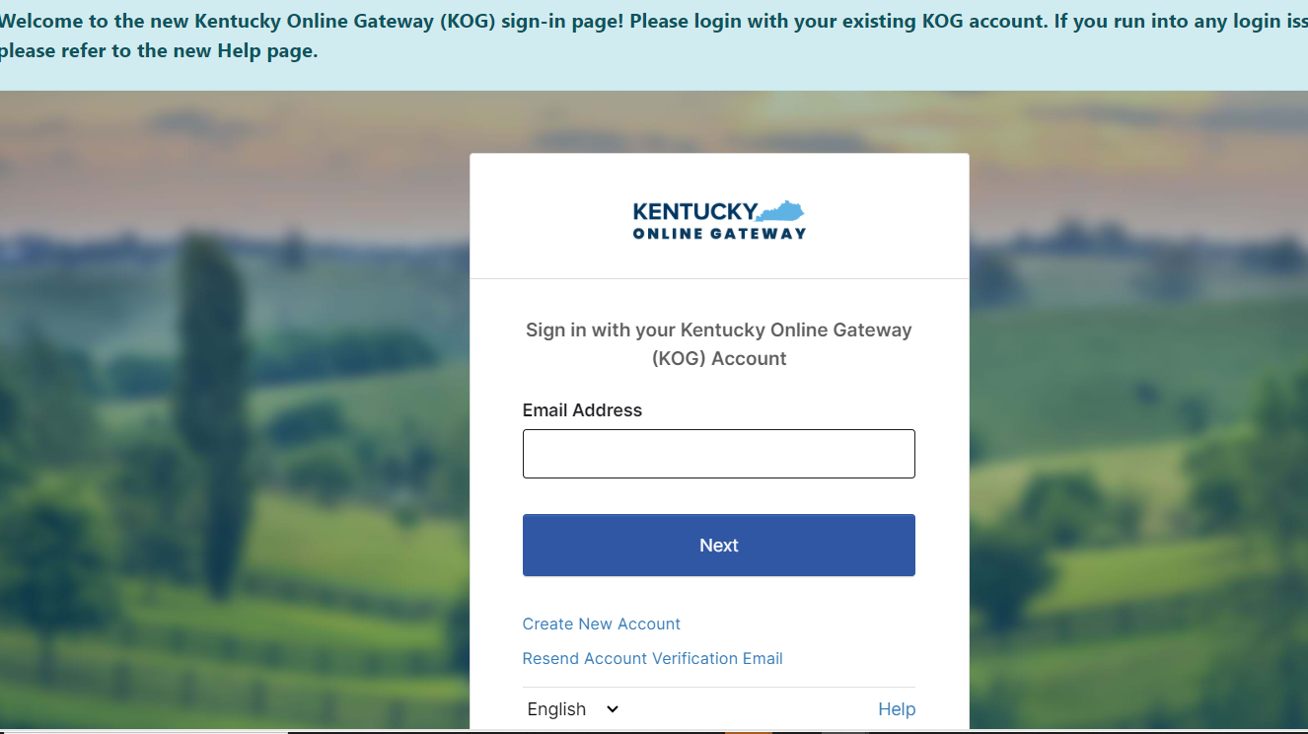
Log in = Click Launch on the CAN and Adam Walsh Verification
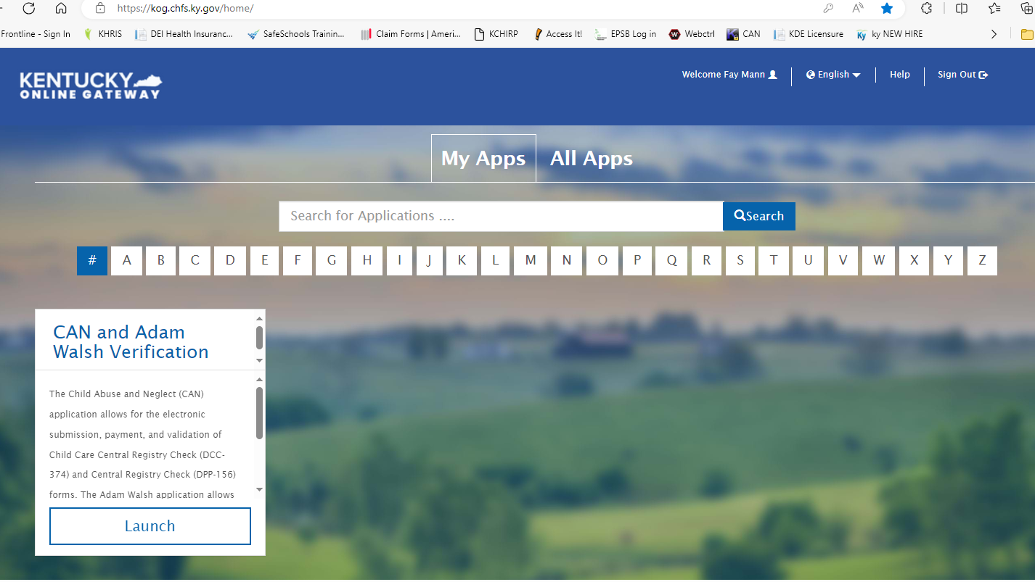
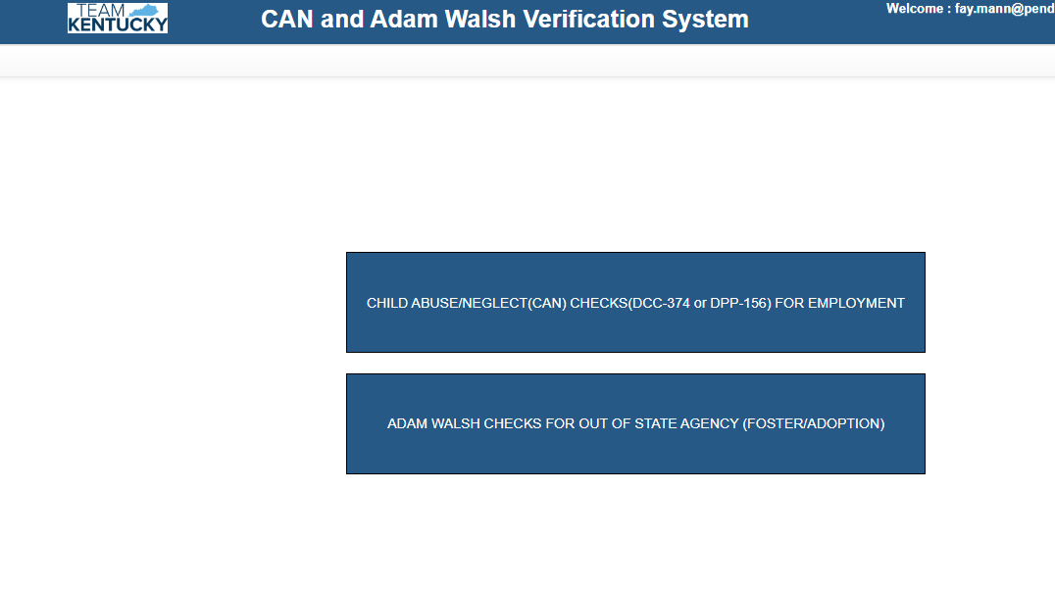

Choose the Child Abuse Neglect CAN

Then choose “Central Registry check (DPP-156) from the drop down menu on FORM
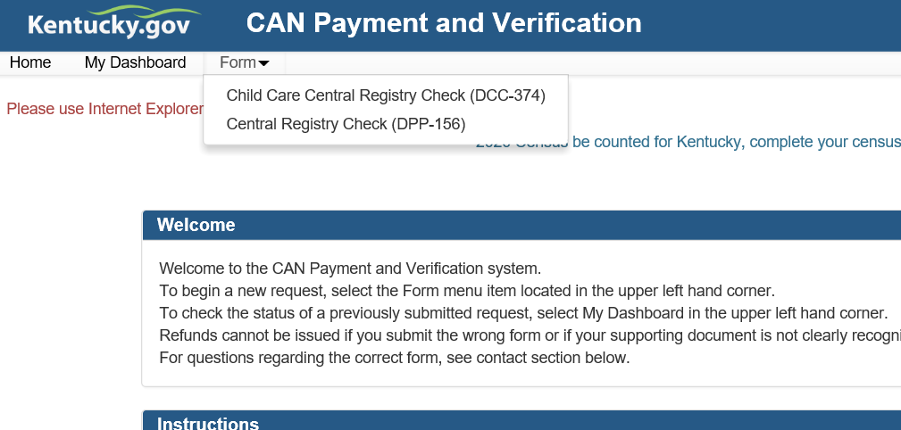

Check mark the option of “Public School employee”

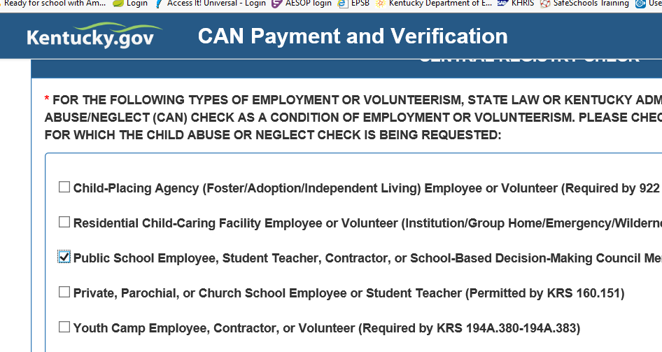

You are asked to provide the last 5 years of home addresses.
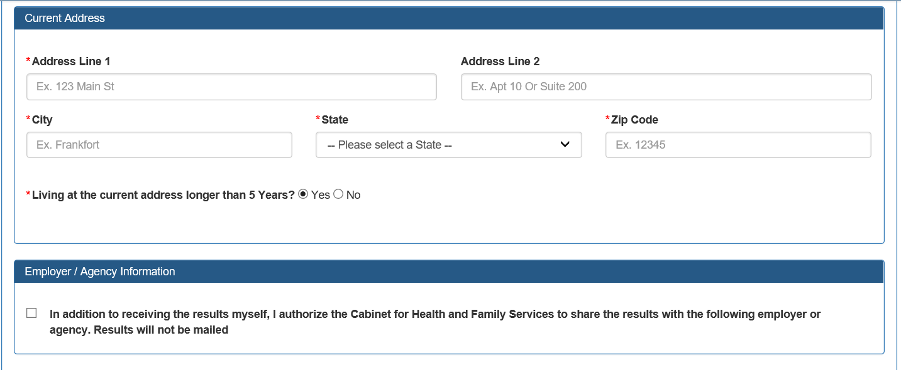

Then Check the option to send results to your employer and fill in the information in the screen shot below
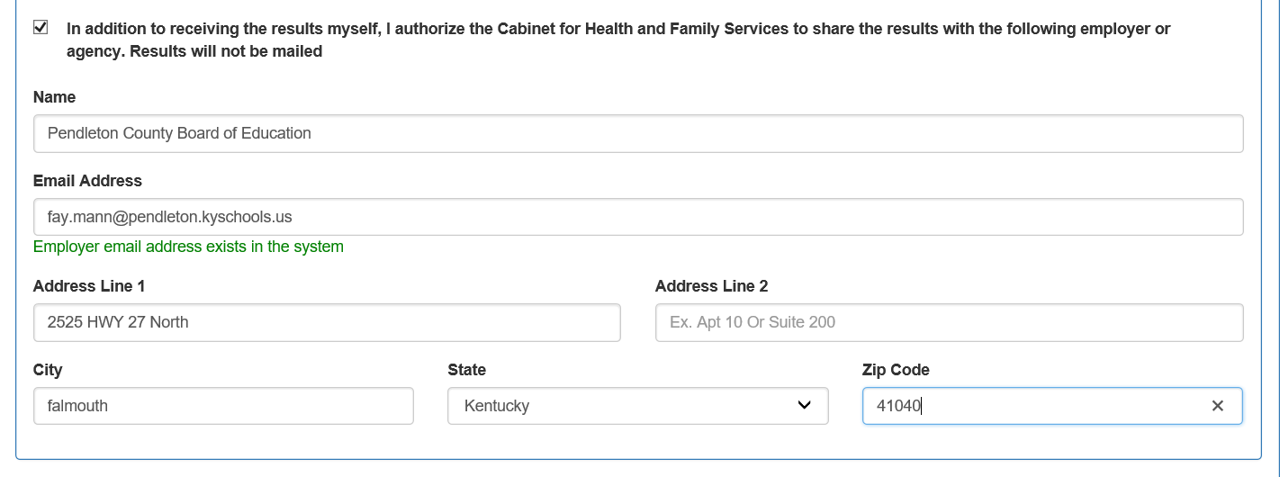

In the screen shown below, You will need to upload:
A proof of ID (driver’s license, birth certificate, or Social Security card) photograph must be attached to each request.
Approved file types are as follows:
- .JPEG
- .PNG
- .BMP
- .PDF
If you are unable to scan your driver’s license, you can take a clear picture with your phone, send to your email, save to your computer and then upload it.
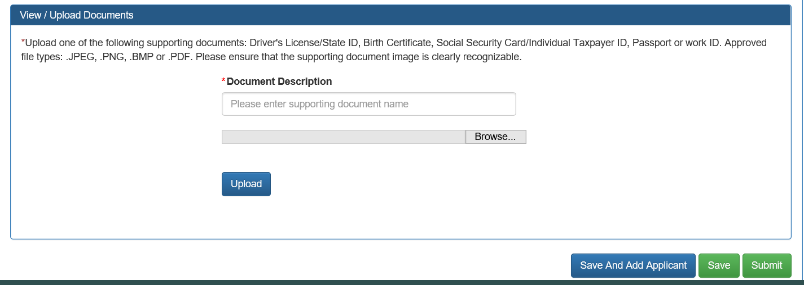

Click Submit:
From there you will enter your payment information.
You will receive an email confirmation from CAN no reply

