Stockbridge High School
‘Rigorous Recycling Research’
A STEAM Project
(Funded by Snapping Shoals EMC Bright Ideas Mini Grant)




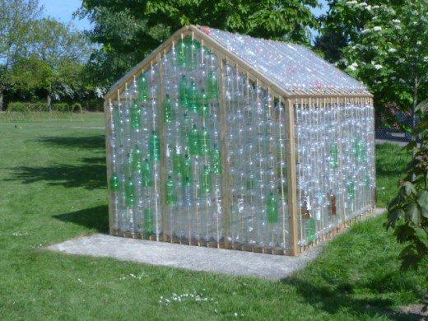
Scientific Research classes (Biology & Chemistry) and National Honor Society members in collaboration with Technology and Art departments are engaged in a rigorous, recycling research project consisting of the following 3 parts:
- School wide collecting & using plastic bottles to build a greenhouse.
- Composting and repurposing solid waste.
- Construction and usage of three Open Ag MVP Food computers to sustainably grow and monitor consumable plants year round.

Please Note: We invite Parents also to participate by sending empty plastic bottles with students or drop them in the bin
at the main entrance. Thank you.

