
Close Up Washington DC
Teacher Recommendation

Students interested in Close Up this year must have three (3) teacher recommendation forms filled out and submitted. Teachers can access this form with the QR code below. Each student is responsible for getting one of these to each of their three teachers. Thank you for taking the time to do this.
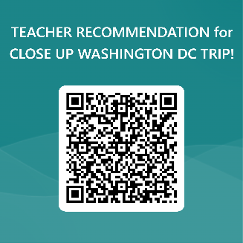

TEACHER NAME: _______________________________________

STUDENT NAME: ______________________________________

***PLEASE COMPLETE NO LATER THAN WEDNESDAY OCTOBER 30TH!
THANK YOU!

--------------------------------------------------------------------------------------------------------------------------------------

Close Up Washington DC
Teacher Recommendation

Students interested in Close Up this year must have three (3) teacher recommendation forms filled out and submitted. Teachers can access this form with the QR code below. Each student is responsible for getting one of these to each of their three teachers. Thank you for taking the time to do this.
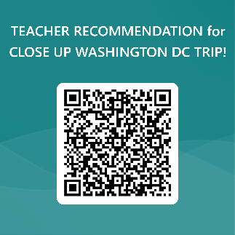

TEACHER NAME: _______________________________________

STUDENT NAME: ______________________________________

***PLEASE COMPLETE NO LATER THAN WEDNESDAY OCTOBER 30TH!
THANK YOU!

--------------------------------------------------------------------------------------------------------------------------------------

Close Up Washington DC
Teacher Recommendation
Students interested in Close Up this year must have three (3) teacher recommendation forms filled out and submitted. Teachers can access this form with the QR code below. Each student is responsible for getting one of these to each of their three teachers. Thank you for taking the time to do this.
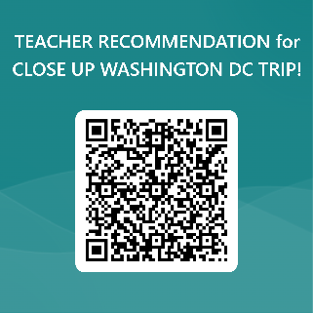

TEACHER NAME: _______________________________________

STUDENT NAME: _____________________________________

***PLEASE COMPLETE NO LATER THAN WEDNESDAY OCTOBER 30TH!
THANK YOU!

