2024 - 2025 William Allen White
Master List
Grades 6 – 8

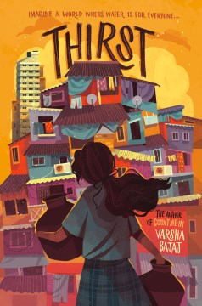 | Thirst by Varsha Bajaj  Minni lives in the poorest part of Mumbai, where access to water is limited to a few hours a day and the communal taps have long lines. Lately, though, even that access is threatened by severe water shortages and thieves who are stealing this precious commodity—an act that Minni accidentally witnesses one night.  Meanwhile, in the high-rise building where she just started to work, she discovers that water streams out of every faucet and there’s even a rooftop swimming pool.  Then one day, Minni encounters the water mafia boss and faces her biggest dilemma yet—should she expose him even if it means risking her job . . . and maybe her life? How did her future get so complicated?  Nancy Paulsen Books/Penguin Young Readers  Thirst Book Trailer (1:17)
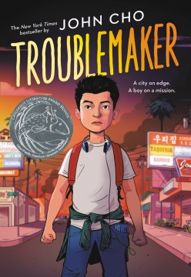 | Troublemaker by John Cho  12-year-old Jordan feels like he can't live up to the example his older sister set, or his parent's expectations.  When he returns home from school one day hoping to hide his suspension, Los Angeles has reached a turning point. In the wake of the acquittal of the police officers filmed beating Rodney King, as well as the shooting of a young black teen, Latasha Harlins by a Korean store owner, the country is at the precipice of confronting its racist past and present.  As tensions escalate, Jordan's father leaves to check on the family store, spurring Jordan and his friends to embark on a dangerous journey to come to his aide, and come to terms with the racism within and affecting their community.  Hachette Book Company  Troublemaker – Book Trailer (1:34)
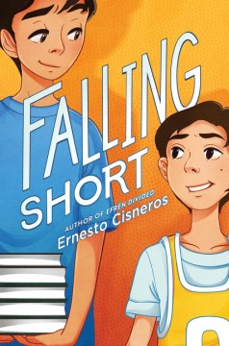 | Falling Short by Ernesto Cisneros  Isaac and Marco already know sixth grade is going to change their lives. But it won’t change things at home—not without each other’s help.  This year, star basketball player Isaac plans on finally keeping up with his schoolwork. Better grades will surely stop Isaac’s parents from arguing all the time. Meanwhile, straight-A Marco vows on finally winning his father’s approval by earning a spot on the school’s basketball team.  But will their friendship and support for each other be enough to keep the two boys from falling short?  Quill Tree/Harper Collins Publishers  F.S. - Book Trailer (3:04)
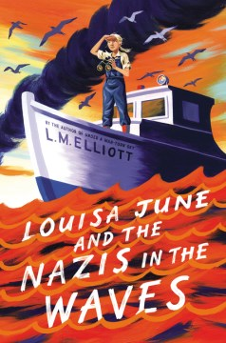 | Louisa June and the Nazis in the Waves by L.M. Elliott  Days after Japan’s attack on Pearl Harbor in 1941, Hitler declared war on the U.S., unleashing U-boat submarines to attack American ships. Suddenly the waves outside Louisa June’s farm aren’t for eel fishing or marveling at wild swans or learning to skull her family’s boat—they’re dangerous, swarming with hidden enemies.  Her oldest brothers’ ships risk coming face-to-face with U-boats. Her sister leaves home to weld Liberty Boat hulls. And then her daddy, a tugboat captain, and her dearest brother, Butler, are caught in the crossfire.  Her mama has always swum in a sea of melancholy, but now she really needs Louisa June to find moments of beauty or inspiration to buoy her. Like sunshine-yellow daffodils, good books, or news accounts of daring rescues of torpedoed passengers.  Determined to help her mama and aching to combat Nazis herself, Louisa June turns to her quirky friend Emmett and the indomitable Cousin Belle, who has her own war stories—and a herd of cats—to share. In the end, after a perilous sail, Louisa June learns the greatest lifeline is love.  Harper Collins Publishers  L.J.A.T.N.I.T.W.- Book Trailer (0:58)
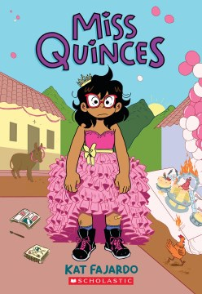 | Miss Quinces by Kat Fajardo  Sue just wants to spend the summer reading and making comics at sleepaway camp with her friends, but instead she gets stuck going to Honduras to visit relatives with her parents and two sisters.  They live way out in the country, which means no texting, no cable, and no Internet! The trip takes a turn for the worse when Sue's mother announces that they'll be having a surprise quinceañera for Sue, which is the last thing she wants.  She can't imagine wearing a big, floofy, colorful dress! What is Sue going to do? And how will she survive all this "quality" time with her rambunctious family?  Scholastic Press  M.Q.– Book Trailer (0:40)
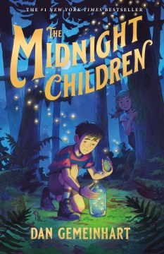 | The Midnight Children by Dan Gemeinhart  In the dead of night, a truck arrives in Slaughterville, a town named after its windowless slaughterhouse.  Seven mysterious kids with suitcases stealthily step out of the vehicle and into an abandoned home on a dead-end street. But lonely Ravani Foster witnesses their arrival and is eager to learn everything he can about his new neighbors: What are they hiding? And where are the adults?  Yet amid this group of children, Ravani finds an unexpected friend in gutsy Virginia. But with friendship comes secrets revealed--and danger.  When Ravani learns of a threat to his new friends, he must fight to keep them safe, or lose the only person who has ever understood him.  Macmillan Publishing  T.M.C. - Book Trailer (2:18)
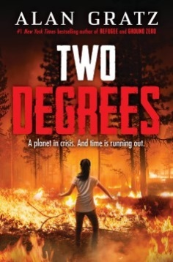 | Two Degrees by Alan Gratz  Fire. Ice. Flood. Three climate disasters. Four kids fighting for their lives.  Akira is riding her horse in the California woods when a wildfire sparks--and grows scarily fast. How can she make it to safety when there are flames everywhere?  Owen and his best friend, George, are used to seeing polar bears on the snowy Canadian tundra. But when one bear gets way too close for comfort, do the boys have any chance of surviving?  Natalie hunkers down at home as a massive hurricane barrels toward Miami. When the floodwaters crash into her house, Natalie is dragged out into the storm--with nowhere to hide.  Akira, Owen, George, and Natalie are all swept up in the devastating effects of climate change. They are also connected in ways that will shock them--and could alter their destinies forever.  Scholastic Press  T.D. - Book Trailer (0:30)
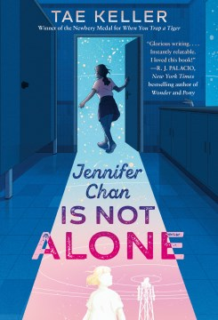 | Jennifer Chan is Not Alone by Tae Keller  Sometimes middle school can make you feel like you're totally alone in the universe . . . but what if we aren't alone at all?  Thanks to her best friend, Reagan, Mallory Moss knows the rules of middle school. The most important one? You have to fit in to survive. But then Jennifer Chan moves in across the street, and that rule doesn’t seem to apply. Jennifer doesn’t care about the laws of middle school, or the laws of the universe. She believes in aliens—and she thinks she can find them.  Then Jennifer goes missing. Using clues from Jennifer’s journals, Mallory goes searching. But the closer she gets to answers, the more Mallory has to confront why Jennifer might have run . . . and face the truth within herself.  Random House Children's Books  J.C.I.N.A.- Book Trailer (Stop at 1:44)
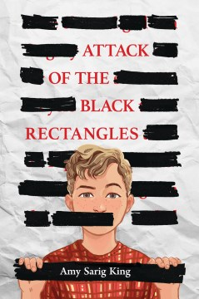 | Attack of the Black Rectangles by A.S. King  When Mac first opens his classroom copy of Jane Yolen's The Devil's Arithmetic and finds some words blacked out, he thinks it must be a mistake. But then when he and his friends discover what the missing words are, he's outraged.  Someone in his school is trying to prevent kids from reading the full story.  But who?  Even though his unreliable dad tells him to not get so emotional about a book (or anything else), Mac has been raised by his mom and grandad to call out things that are wrong. He and his friends head to the principal's office to protest the censorship... but her response doesn't take them seriously.  So many adults want Mac to keep his words to himself.  Mac's about to see the power of letting them out.  Scholastic Press  A.O.T.B.R. – Book Trailer (1:01)
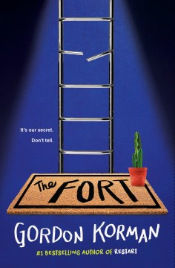 | The Fort by Gordon Korman  The morning after Hurricane Leo rips through their town, four friends find a total mess outside, with downed branches and uprooted trees everywhere. They know they should stay indoors, but they want to go exploring, even if it means having a new kid, Ricky, tagging along.  Ricky’s the first to discover a strange trapdoor in the middle of the woods – the door to an old bomb shelter, unearthed by the hurricane. Inside, the boys find a completely intact underground lair, with electricity, food, and even a TV. The boys vow to keep the place a secret. It’s theirs now.  But some secrets are hard to keep … especially when adults and older kids are closing in. And what started as a fun hangout spot soon becomes a serious refuge for one of the boys. The Fort has become the safest place they have. But will they be able to protect it?  Scholastic Press  The Fort Book Trailer (1:03)
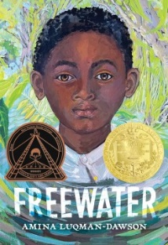 | Freewater by Amina Luqman-Dawson  Under the cover of night, twelve-year-old Homer flees Southerland Plantation with his little sister Ada, unwillingly leaving their beloved mother behind. Much as he adores her and fears for her life, Homer knows there’s no turning back, not with the overseer on their trail. Through tangled vines, secret doorways, and over a sky bridge, the two find a secret community called Freewater, deep in the swamp.  In this society created by formerly enslaved people and some freeborn children, Homer finds new friends, almost forgetting where he came from. But when he learns of a threat that could destroy Freewater, he crafts a plan to find his mother and help his new home.  Deeply inspiring and loosely based on the history of maroon communities in the South, this is a striking tale of survival, adventure, friendship, and courage.  Hachette Book Company  Freewater Book Trailer (1:16)
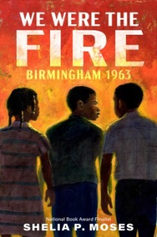 | We Were the Fire: Birmingham 1963 by Sheila P. Moses  The powerful story of an eleven-year-old Black boy determined to stand up for his rights, who’s pulled into the action of the 1963 civil rights demonstrations in Birmingham, Alabama.  Rufus Jackson Jones is from Birmingham, the place Dr. Martin Luther King Jr. called the most segregated place in the country. A place that in 1963 is full of civil rights activists including Dr. King.  The adults are trying to get more attention to their cause—to show that separate is not equal. Rufus’s dad works at the steel factory, and his mom is a cook at the mill, and if they participate in marches, their bosses will fire them. So that’s where the kids decide they will come in: Nobody can fire them!  So on a bright May morning in 1963, Rufus and his buddies join thousands of other students to peacefully protest in a local park. There they are met with policemen and firemen, who turn their powerful hoses on them, and that’s where Rufus realizes that they are the fire.  Nancy Paulsen Books  W.W.T.F.B.1963. Book Trailer (0:56)
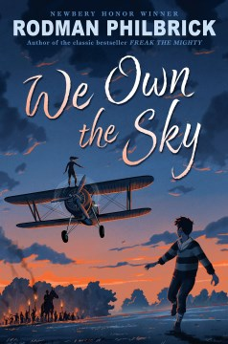 | We Own the Sky by Rodman Philbrick  Davy and Jo Michaud have been recently orphaned. Taken in by a distant relative, a famous aviator they are now working with a group of stunt pilots who spend their time wing walking, leaping from plane to plane, and flying through fireworks! But though the stunts are dangerous, the real threat is building behind the scenes.  The KKK is on the rise in Maine that summer, inspired by the racial fears promoted in Birth of a Nation. They spew hatred of immigrants, Blacks, Jews, and French Catholics that last, a rage that will be directed at Davy and Jo.  When Davy and Jo cross paths with the Klan, they get tangled up in a terrible revenge plan, and held as hostages. Can they escape with their lives?  Scholastic Press  W.O.T.S.Book Trailer (1:00)
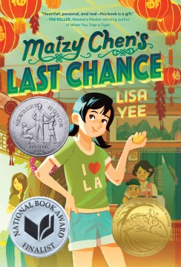 | Maizy Chen’s Last Chance by Lisa Yee  Maizy has never been to Last Chance, Minnesota . . . until now. Her mom’s plan is just to stay for a couple weeks, until her grandfather gets better. But plans change, and as Maizy spends more time in Last Chance (where she and her family are the only Asian Americans) and at the Golden Palace—the restaurant that’s been in her family for generations—she makes some discoveries.  For instance:  You can tell a LOT about someone by the way they order food.  And people can surprise you.  Sometimes in good ways, sometimes in disappointing ways.  And the Golden Palace has secrets.  But the more Maizy discovers, the more questions she has. Like, why are her mom and her grandmother always fighting? Who are the people in the photographs on the office wall? And when she discovers that a beloved family treasure has gone missing—and someone has left a racist note—Maizy decides it’s time to find the answers.  Random House Children's Books  M.C.L.C. Book Trailer (1:13)

