2024 - 2025 William Allen White Master List
Grades 3 – 5

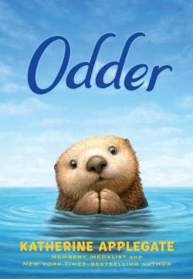 | Odder by Katherine Applegate  Meet Odder, the Queen of Play:  Nobody has her moves.  She doesn’t just swim to the bottom, she dive-bombs.  She doesn’t just somersault, she triple-doughnuts.  She doesn’t just ride the waves, she makes them.  Odder spends her days off the coast of central California, practicing her underwater acrobatics and spinning the quirky stories for which she’s known. She’s a fearless daredevil, curious to a fault. But when Odder comes face-to-face with a hungry great white shark, her life takes a dramatic turn, one that will challenge everything she believes about herself—and about the humans who hope to save her.  Inspired by the true story of a Monterey Bay Aquarium program that pairs orphaned otter pups with surrogate mothers, this poignant and humorous tale told in free verse examines bravery and healing through the eyes of one of nature’s most beloved and charming animals.  Macmillan Publishing  Odder Book Trailer (1:40)
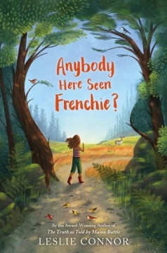 | Anybody Here Seen Frenchie? by Leslie Connor  Eleven-year-old Aurora Petrequin’s best friend has never spoken a word to her. In fact, Frenchie Livernois doesn’t talk.  Aurora is bouncy, loud, and impulsive— “a big old blurter.” Making friends has never come easily. When Frenchie, who is autistic, silently chose Aurora as his person back in third grade, she chose him back. They make a good team, sharing their love of the natural world in coastal Maine.  In the woods, Aurora and Frenchie encounter a piebald deer, a rare creature with a coat like a patchwork quilt. Whenever it appears, Aurora feels compelled to follow.  At school, Aurora looks out for Frenchie, who has been her classmate until this year. One morning, Frenchie doesn’t make it to his classroom. Aurora feels she’s to blame. The entire town begins to search, and everyone wonders: how is it possible that nobody has seen Frenchie?  Harper Collins Publishers  A.H.S.F? – Book Trailer (1:21)
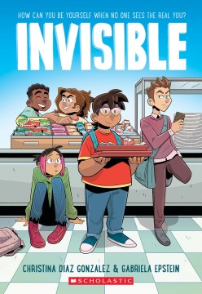 | Invisible by Christina Diaz Gonzalez  Five students meet in the school cafeteria when they’re forced to complete their school community service hours.  There’s George: the brain  Sara: the loner  Dayara: the tough kid  Nico: the rich kid  Miguel: the athlete  Although they’re sure they have nothing in common with each other, some people see them as all the same… just five Spanish-speaking kids. Then they meet someone who truly needs their help, and they must decide whether they are each willing to expose their own secrets to help… or if remaining invisible is the only way to survive middle school.  Scholastic Press  Invisible - Book Trailer (0:30)
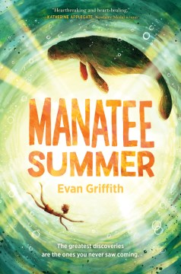 | Manatee Summer by Evan Griffith  Peter and his best friend, Tommy, have a goal for their last summer before middle school: finish their Discovery Journal, a catalog of the wildlife around their Florida town. When they spot a manatee in a canal, Peter knows they’ve found something special—and when the manatee is injured by a boat, something to protect!  As Peter joins the fight to save Florida manatees, he also finds himself taking care of his ailing grandfather and facing an unwelcome surprise that jeopardizes his friendship with Tommy. Soon Peter is adrift, navigating shifting tides and realizing that he has as much to discover about himself as he does about the world around him.  Harper Collins Publishers  M. S. - Book Trailer (2:34)
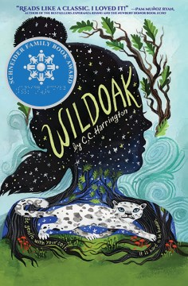 | Wildoak by C.C. Harrington  Maggie Stephens's stutter makes school especially hard. She will do almost anything to avoid speaking in class or calling attention to herself.  So, when her unsympathetic father threatens to send her away for so-called "treatment," she reluctantly agrees to her mother's intervention plan: a few weeks in the fresh air of Wildoak Forest, visiting a grandfather she hardly knows.  It is there, in an extraordinary twist of fate, that she encounters an abandoned snow leopard cub, an exotic gift to a wealthy Londoner that proved too wild to domesticate. But once the cub's presence is discovered by others, danger follows, and Maggie soon realizes that time is running out, not only for the leopard, but for herself and the forest as well.  Scholastic Press  Wildoak – Book Trailer (1:11)
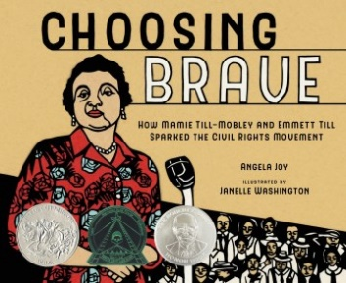 | Choosing Brave: How Mamie Till Mobley and Emmett Till Sparked the Civil Rights Movement by Angela Joy  Mamie Till-Mobley is the mother of Emmett Till, the 14-year-old boy who was brutally murdered while visiting the South in 1955. His death became a rallying point for the civil rights movement, but few know that it was his mother who was the catalyst for bringing his name to the forefront of history.  In Choosing Brave, Angela Joy and Janelle Washington offer a testament to the power of love, the bond of motherhood, and one woman's unwavering advocacy for justice. It is a poised, moving work about a woman who refocused her unimaginable grief into action for the greater good. Mamie fearlessly refused to allow America to turn away from what happened to her only child. She turned pain into change that ensured her son's life mattered.  Roaring Brook Press  Mamie Till-Mobley Honor Video (1:45) (Not a book tailer)
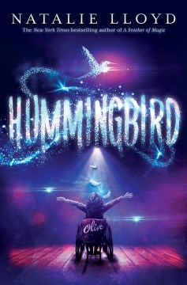 | Hummingbird by Natalie Lloyd  Twelve-year-old homeschooled Olive is tired of being seen as “fragile” just because she has osteogenesis imperfecta (otherwise known as brittle bone disease) so she’s thrilled when she finally convinces her overprotective parents to let her attend Macklemore Elementary. Olive can’t wait to go to a traditional school and make the friends she’s always longed for, until a disastrous first day dashes her hopes of ever fitting in.  Then Olive hears whispers about a magical, wish-granting hummingbird that supposedly lives near Macklemore. It’ll be the solution to all her problems! If she can find the bird and prove herself worthy, the creature will make her most desperate, secret wish come true.  When it becomes clear that she can’t solve the mystery on her own, Olive teams up with some unlikely allies who help her learn the truth about the bird. And on the way, she just might learn that our fragile places lead us to the most wonderful magic of all . . .  Scholastic Press  Hummingbird- Book Trailer (0:39)
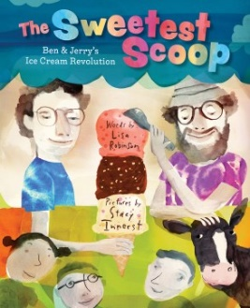 | The Sweetest Scoop: Ben & Jerry’s Ice Cream Revolution by Lisa Robinson  Chunky Monkey. Cherry Garcia. Truffle Kerfuffle.  Legendary ice cream makers Ben & Jerry are behind some of the wackiest, tastiest flavors we know and love. It all began when two groovy guys, Ben Cohen and Jerry Greenfield, met when they were 12 years old. Ben liked art, Jerry liked science, and they both loved food . . . especially ice cream!  They started a business together, and with no idea how to actually make ice cream, they made it happen with teamwork, determination, and an appetite for fun and experimentation. When the doors of Ben & Jerry’s Homemade ice cream shop finally opened, crowds flocked. But the pair would still have a rocky road ahead—and ambitious activist goals to fulfill.  Chock-full of facts and humor, this entertaining biography about two hardworking partners living their Americone Dream gives readers plenty to chew on. Through their inventiveness, passion, and activism, Ben & Jerry dreamed of making the world a better, more delicious place—one scoop at a time.  Abrams Books Publishing  How Ben and Jerry’s Ice Cream is Made Video (1:51) (Not a Book Trailer)

