Menlo Park City School District Council
Meeting Agenda
May 31, 2024
Location: MPCSD TERC, 181 Encinal Ave., Atherton, CA
(In Person only; no Zoom option)
In attendance: Jill Vizas, May Matsui, Teresa Kwon, Allison Jagtiani, Julie Hartstein, Kristen Gracia, Parke Treadway, Sharon Burns, Danielle O’Brien, Linda Creighton, Alicia Heneghan, Alicia Payton-Miyazaki, Carrie Chen, Suzanne Yonkers, Eleanor DeJong, Sarah Sobel, Katherine Bicer, Meredith Nonnenberg, Laura Low Ah Kee, Sherwin Chen
8:45 to 9:00 — District Council Business
8:40 AM
Call to Order –Kirsten Gracia, MPCSD Superintendent
Welcome - Jill Vizas, DC President
Approval of March Meeting Minutes— May Matsui, Secretary/Parliamentarian
• Danielle O’Brien motioned to approve; Allison Jagtiani seconded. The Minutes are approved by vote. Motion passed.

Approval for 2024-25 District Council Secretary/Parliamentarian Slate - May Matsui, Secretary/Parliamentarian
• May presented Laura Wiggs, as the nominated slate for District Council Secretary/Parliamentarian role for 2024-2025. All voted for this District Council Secretary/Parliamentarian role to be filled by Laura Wiggs, with Sharon Burns motioned to approve, and Jill Vizas seconded. The District Council Secretary/Parliamentarian candidate is approved.
. 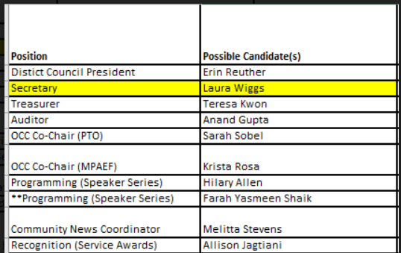
Treasurer’s Report and Proposed 2024-25 Budget — Teresa Kwon, DC Treasurer
- Insurance is the only expense for next year. The only outstanding budget is for the service award. We should have $1000 overflow to carry-over. 2024-2025 income went down but there’s a $1000 surplus.
- The proposed 2024-2025 District Council Budget was presented, with the dues from each school at $1350/year. This is decreased from last year’s budget of $1500/yr per school. All other line items on the proposed budget remained the same as the prior year. See proposed budget below:
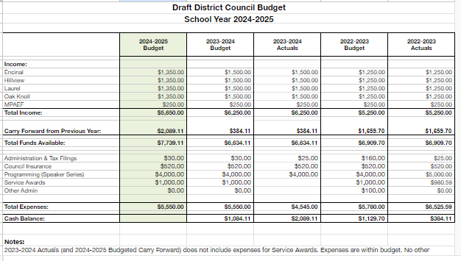

- Sarah Sobel motioned to approve the proposed budget, and Danielle O’ Brien seconded. The proposed 2024-2025 District Council Budget was approved.
8:59 am to 10:10am — Updates
8:59 am
One Community Campaign Update — Sarah Sobel, OCC Co-Chair
- Demystifying OCC with Q & A sessions are starting. This event will give the parents the opportunity to learn more about the OCC and ask questions.
MPAEF Update —Suzanne Yonkers, MPAEF Co-President
- 98% portion of OCC donation, $27K raised endowment for excellence in teaching, doing spring outreach with graduating families. Final numbers 325 guests, $575K raised from Laurel from Auction. The 5K race event had over 1400 runners, all schools participated, it was a great community building day for the district.

9:03 am
Superintendent Update and Q&A – Kristen Gracia, MPCSD Superintendent
- Thanked DC President, Jill for planning out the meetings for the whole year. Reflected on all the areas that were covered during the school year. Important topics were discussed, and the District Council is a meaningful place to get input. This is the purpose of the District Council, thus the sharing space amongst PTOs and school leaders to see what is working and what’s not working.
- Thanked the PTOs/Volunteers this past year. All the events the PTOs put together at schools had been very meaningful. PTO volunteers are part of helping the kids make core memories in the district.
- Speaker series update --1st initial meeting was 5/30/24 to discuss the next event, “The Anxious Generation “is coming up. Read the book. Vision is embracing childhood through education. We will continue to focus on strengthening belonging with the students. Planning the topics to focus on for next year’s speaker series events. Lots of researching right now for the vision for next year.
- Facility planning—still in the works. June 6th agenda for board meeting—she will bring up the bond.
- Question for Kirsten: Are we looking at a new vendor for hotlunch? Per Kirsten, we are still in contract with the current vendor. We are limited to our Hotlunch vendor since there’s not much out there. We can continue to research more on this.
- Hotlunch Bulk ordering pilot update: This new hot lunch process is going great. The students get their lunches in less than 10 minutes; thus 250 kids get lunch right away.
9:30 am
School Board Update — Sherwin Chen, School Board Vice President
- Facility Planning—Board is voting on putting the bond on the ballot –identify needs, putting budget, tons of work in researching this bond. Community campaigns will be led by Katherine Bicer. All these investments go to the safety and security of our campuses, safety/sound for kids, fundamentally important things, and heart of our charter.
- The Board has learned by researching this bond, this time around will be more challenging. Things are going to be fundamentally harder due to the November presidential election and getting our attention from voters on the ballot. Many of the funds are for infrastructures improvement in schools that are invisible to the parents. We identified third party fundings, state matching grants, money is limited, distributed on a first come first served basis. Continue to stay informed and be advocates for this bond.

9:48 am
Principals & PTO President Discussion Topic: One thing you are proud of and one thing you look forward to in 2024-25
Encinal PTO—Eleanor DeJong, PTO President
- The Science Fair event was a huge success with lots of parents and outside vendors (Mad Science), Robotics team was inspiring and fun. Looking forward to next year is revamping our Enspired lab, upgrading our storage lab. Revamping that space.
Encinal School---Sharon Burns, Principal
- TK was in its 1st year and was a hug success and we had great teachers who launched it.
Oak Knoll School—Alicia Payton-Miyazaki, Principal
- Community circles in every classroom including non-teachers was the highlight for her since every adult on campus heard at least 1 child each day each year. Looking forward to next year, staffing changes always bring new team and energy.
Oak Knoll PTO--Meredith Nonnenberg, PTO President
- After school athletic programs were a huge success! Getting everyone synced up at the beginning of the year and adopting “Oak Knoll way philosophy”. Also, the Science Fair and School Picnic were successes too!
Laurel Lower School— Linda Creighton, Laurel Lower Campus Principal
- Open House event was huge event. The sense of belonging feeling was felt by all.
- Looking forward to next year and with continuing to promote and build classified staff to professionally develop them.
Laurel Upper School--Alicia Henneghan, Laurel Upper Campus Principal
- Re-imaging our library by re-organizing and re-generalizing books for kids. The student podcast that was launched by 5th grade students was a success too.
- Looking forward to the new year with new staffing and new teams.
Laurel PTO -Erin Reuther, PTO President
- The PTO’s focus on bringing back community and bringing together upper and lower campus to same family gatherings was a hit. This helped instill community and volunteering with the families and hope they will continue to volunteer next year and possibly on the PTO Board.
- Next year—looking forward to having new faces and families to be part of the community.

Hillview School--Danielle O’ Brien, HV Principal
- ASB programs were great this year, especially the rallies at end of the day. Almost entirely student lead and it was fun for all.
- Looking forward to the first football games at M-A event next year where the middle schools get together with other middles schools within the same area/zip code before they meet at high school.
Hillview PTO--Katherine Bicer, HV PTO Vice President
- Volunteer/parent recognitions at Open House this year were wonderful. The recognition being published in the school newsletters was great. These recognitions made the volunteers feel very special.
- The Parent Engagement PTO Role that was created by Amy Heinz this year was a success and she is excited to continue this role for next year.
Closing Remarks—Jill Vizas, DC President
- Next year’s DC meeting dates posted but some dates are tentative.
10:11 AM
Meeting Adjourned-Jill Vizas, DC President

