We are committed to partner with parents through open communication focused on the needs of your child. Mutual trust and respect between parents and teachers is critical to maintain a positive learning experience at any school. We believe that your trust in New River is essential to ensure your child’s success.
All About Mrs. Haggard:
Guten Tag (Hello),
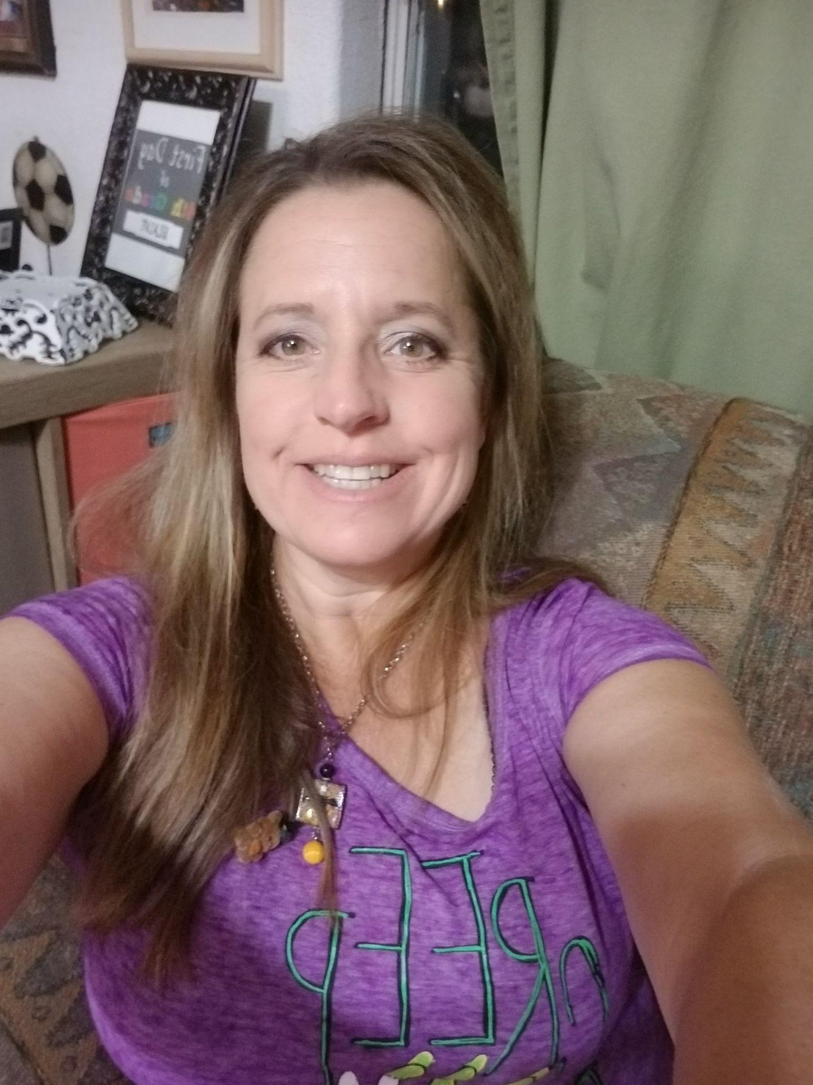
I graduated from Northern Arizona University (NAU) with a Bachelor’s in Art Education. I have been teaching art for 14 years in three different school districts with many different styles/techniques. I was a Stay-at-home-MOM for the last 8 years and I am back to teaching art. My grandpa (Opa)inspired me to draw. Someday I will learn the German Language and visit my family in Germany from both sides of the family. I am married to a Demolition man and have a son/daughter- teenagers, whom I love so much:)
I am looking forward to a“Creative” year at New River Elementary School! We will be exploring various kinds of art such as watercolor, painting,oil pastel, ceramics and much more! I use Monart techniques and positive art methods to help explore their growth in art. It is important that we work together to help your child have a successful year!

I want to work in a positive environment, with the students,staff, and parents. Teamwork is the key to success and I am willing to put forth the energy for the students. So don't be shy and stop by my room and tell me about your “Colors !”

“ Whether the creative artist uses figurative or abstract design depends on the nature of
the job and his own inclination” Hans Erni
Mrs. Lisa Haggard
Die kunst (Art)
Der Schreibtische (Teacher)

Communication
You may reach me
● School-wide New River Elementary School Website
● Email: Lisa.Haggard@dvusd.org
・ The best times to reach me by email are 8am-3:30pm on Wednesday-Friday
- Phone: (623) 376-3500 extension 63542
・ Email is the fastest way to contact me because I am only on campus
Wednesday-Friday

Academics
● DVUSD uses Visual art standards for each grade level
Some of the things students will learn in art are:
• Design elements and principles
• Best practices for using art tools and supplies
• Fine motor skills such as cutting, tracing, and gluing
• Eye hand coordination
• How artists plan and design their artwork
• Discussing art and art criticism
• Color theory, composition, and creating a visually appealing artwork.
• Creating an art portfolio which reflects the artistic growth of the student.
• How to create a sketchbook to organize thoughts and ideas
• How to create artwork for an art show
• Art jobs and how to become a professional artist
• Creating art for fun or art as a way to improve emotional health (Social Emotional Learning)
• Discussion of famous artists and artworks from multicultural and diverse standpoints

▪ DVUSD Fine Arts Resources

Growth Mindset
The backbone of my class is teaching children about a growth mindset. A growth mindset is a way of thinking which stresses the importance of thinking positively about learning new material instead of fearing a new learning experience. This is a great lesson to learn because once a child begins to think of learning in a positive way then many ways of thinking open up to them and they are encouraged to challenge themselves.

Class guidelines and procedures:
Students are expected to follow all art class guidelines and procedures.
My main class guideline is:
- All students and teachers deserve to work in a safe, positive, and supportive learning environment.

Rewards
I reward positive behavior by giving verbal or written praise, wildcat bucks, art class parties, art trophy, stickers, and small prizes. I also have a student of the month to award individual students who have shown great leadership skills.

Art rules and procedures regroup
If a student has a difficult time following class rules and procedures I will often give them a warning and then ask them to rethink their behavior. I model the proper behavior to them and then ask that they exhibit the desired behavior in class. If the misbehavior continues then a reflection sheet is given so that the student may process their behavior on paper. Once the child has completed the reflection sheet we regroup and I ask the student to help me brainstorm ways for them to create a successful day in art. We then implement the plan together as a team.

PBIS
All students are taught to follow the CATS expectations: Constantly Caring, Always Respectful, Take Responsibility, Self-Control. These expectations are outlined in this CATS Matrix. Students earn Wildcats Bucks for demonstrating these expectations that they can use to purchase items or experience coupons in the Wildcat Den.

All Things EQ
We have implemented a philosophy called “All Things EQ.” IQ is your book smarts or school smarts. EQ is your emotional quotient or self-smarts. The EQ philosophy focuses on the following key questions: How can I be kind and helpful in this moment?
How are you showing up at school today?
Am I making an honest effort?
Am I focusing on solutions instead of problems?

To reinforce the EQ philosophy our 5th and 6th graders are trained to be our EQ Ambassadors so they can be role models for the rest of the students. In addition, each teacher is holding class meetings every Friday, showing videos that focus on the four key questions and we have daily announcements focused on the core questions and weekly motto.

PROFESSIONAL LEARNING COMMUNITIES (PLC’s)
Most Fridays, students will be released early so that we are able to participate in PLC work. This work is directly related to the planning, instruction and interventions we implement in our classrooms to ensure that students master the standards.

A professional learning community is a group of educators that meet regularly and work Collaboratively to improve teaching practices and the achievement of students. The questions that drive the work of PLC’s are:
● What do we want all students to know and be able to do?
● How will we know if they learn it?
● How will we respond if some students do not learn?
● How will we extend the learning for students who are already proficient?

Please be sure to read the weekly newsletter for ongoing information regarding the content of each early release day.

GRADING PRACTICES

Learning is a process that takes place over time and at different speeds for different students. Grades are a reporting tool utilized to reflect what a student knows and is able to do in a content area. We measure achievement, not effort or behavior, in our grading system. There is no course grade in kindergarten.

Kindergarten

You will see student proficiency levels marked for each standard according to the following scale:
4 = Applies grade level skills with greater depth or complexity
3 = Demonstrates grade level proficiency
2 = Approaches grade level proficiency
1 = Displays a significant lack of grade level proficiency
First-Second Grade
You will see student proficiency levels marked for each standard according to the following scale:
4 = Applies grade level skills with greater depth or complexity
3 = Demonstrates grade level proficiency
2 = Approaches grade level proficiency
1 = Displays a significant lack of grade level proficiency

A proficiency standard will be marked at least once a week for each content area. Overall standard grades are determined by the average of the most recent three proficiency levels to determine the overall course grade according to the following scale:
E = Excellent (100-80%)
S = Satisfactory (60-79%)
N = Needs Improvement (42-59%)
U = Under Performing (0-41%)

Grades
You will see student proficiency levels marked for each standard according to the following scale:
4 = Highly Proficient
3 = Proficient
2 = Partially Proficient
1 = Minimally Proficient
A proficiency standard will be marked at least once a week for each content area. Overall standard grades are determined by the average of the most recent three proficiency levels to determine the overall course grade according to the following scale:
A = 90-100%
B = 80-89%
C = 70-79%
D = 60-69%
F = 0-59%

Re-assessments
We want students to do their best all the time. However, we acknowledge that sometimes the process of learning takes longer than teachers anticipate; therefore, students are allowed to reattempt their assessments after receiving feedback and guidance, following the guidelines outlined below.
- Students will be retaught using a different strategy or more time and practice.
- The reteaching may be from the teacher or by another teacher/ specialist within the school day.
- Once students have demonstrated mastery of the content their grade will be replaced.

Late Work
In order to accurately reflect a student’s academic performance level, teachers will accept late work and missing work for full credit if the work is submitted within the timeframe and before the end of the grading period. A “1” will be entered in the gradebook until the work is submitted. A notation of “M” for missing or “L” for late work will also be denoted in the gradebook. Students will still be responsible for turning in late work in addition to their current coursework, which results in the natural consequence of a heavier workload. The primary consequence for students not completing the work is to complete the work.

Powerschools
PowerSchool is an essential resource for parents and students. It is not only a tool for communication regarding grades, it is a resource for our students and parents to check progress, missing work, and what is being taught/learned regularly. Please ensure that you and your child have access (separate accounts) and even sign up for the app and push notifications or weekly email updates as an option in PowerSchool.
Principal’s List
All A’s (including special area and other elective courses)
No Incompletes
Honor Roll
All A’s and B’s (including special area and other elective courses)
No Incompletes

Birthday Celebrations and Treats
Birthday celebrations will be done during lunch or recess. Parents are encouraged to use the district sponsored birthday buckets order form at this link: https://www.dvusd.org/Page/65635.

AI Guidance
To be college-, career-, and community-ready, students in the Deer Valley Unified School District are expected to demonstrate academic integrity. Academic integrity is all about being honest and fair in your schoolwork. It means doing work that is entirely your own and giving credit to others (including generative Artificial Intelligence tools) through proper citation when you use their ideas or words.

