
Canvas: A Parent’s Guide
Canvas is the district’s online classroom management system. Teachers are using the system to post course lessons, assignments, quizzes, discussions, and much more. As a parent of a Canvas user, you have the unique opportunity to create your own log in account so you can observe your child’s progress. Once an account is created, you will have access to all of your child’s classes where a Canvas course is being used. Please be aware that not all teachers are using Canvas so you may not see all of your child’s subjects listed. Many teachers use other sources, like Google Classroom, to list content.
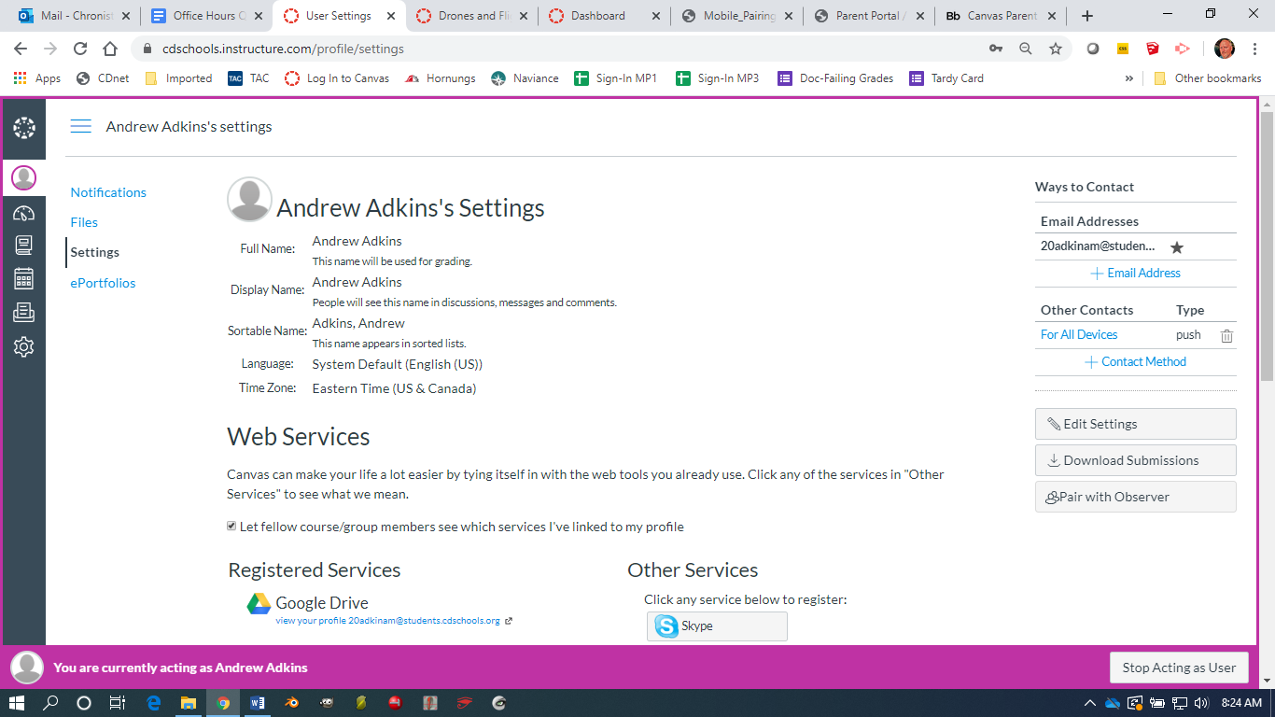
Canvas can be accessed from the cdschools.org main page under “PARENTS” or by entering this URL directly: https://cdschools.instructure.com/login/canvas
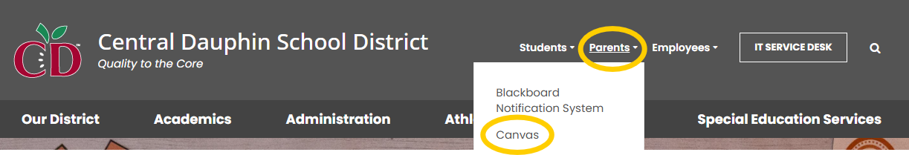
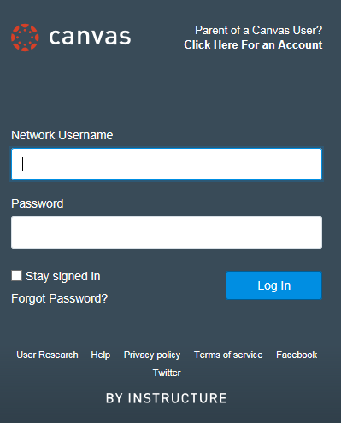
Student Pairing Codes- Your child will first need to log into Canvas and go to their Account Settings in the left-hand gray navigation bar to generate a code for you to use. On the right-hand side of the screen, there will be a button called “Pair with Observer”. When you check this box, you will be provided with a code that can be used to generate the parent observer account as described above.

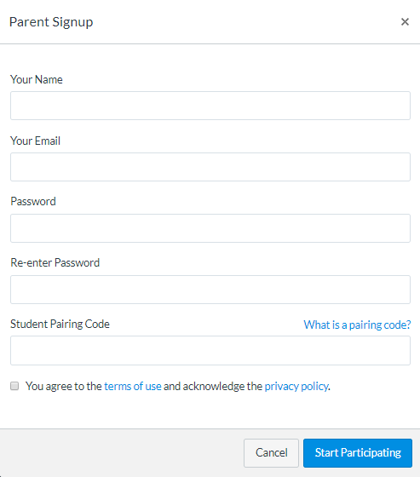
At the log in screen, you can either type your child’s log in credentials or click the option in the upper right corner “Parent of a Canvas User? Click Here For an Account”.

When you select the option to create your own account, you will be presented with a parent signup screen where you enter your information. Your child needs to generate a “Student Pairing Code” from their account to provide to you (see instructions above). Check the box to agree to the terms.
The Canvas Interface
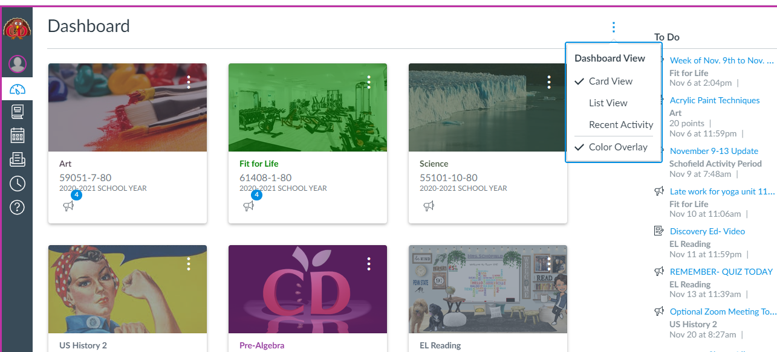
If you do not see class tiles, click the 3 dots and select Card View.
When you first enter Canvas, you will see the user dashboard. The dashboard will display your entire current courses. You will also see a bar on the left with some account and other options to explore. Current assignments and other information entered by the teachers will be displayed on the right.
By clicking on a class, you will be taken into the main stream of that course. Since Canvas can be set up to display the course in a variety of ways, you may see a web page structure, a course stream, or even a module list. Explore the site and if you have any specific questions about the structure, you should email the teacher for assistance. The left sidebar displays many important features such as assignments, quizzes, grades, etc. Your child will be able to help you navigate the site. For additional assistance, explore the Help button found at the bottom of the far left menu.
Account-
Personal Account setting and notifications
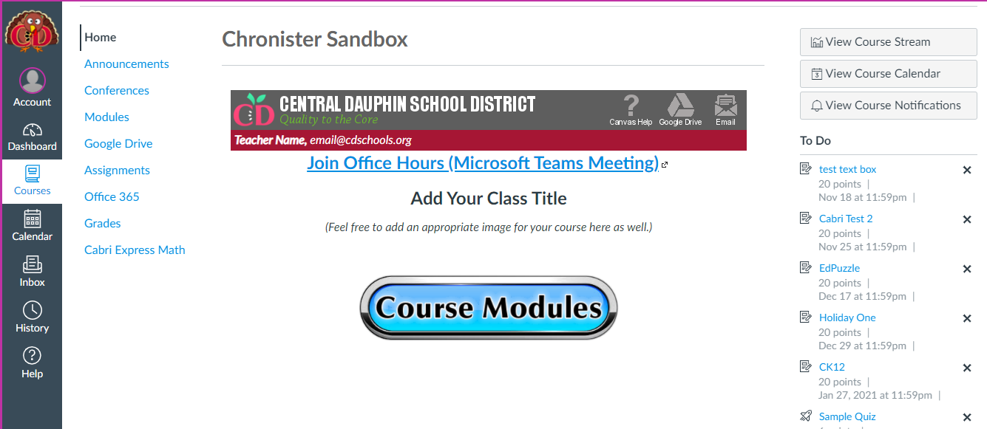

Dashboard-
Navigate back to all classes.

Course Navigation-
Various features of the course.

For additional information on navigating and using Canvas, click the “Canvas Help” button found in the home page bar on any class. This link will take you to a page of useful links, documents, and videos on Canvas basics.
Help-
Program help and user support forums.


