Addressing the Dignity Act through
Challenge Course Programs

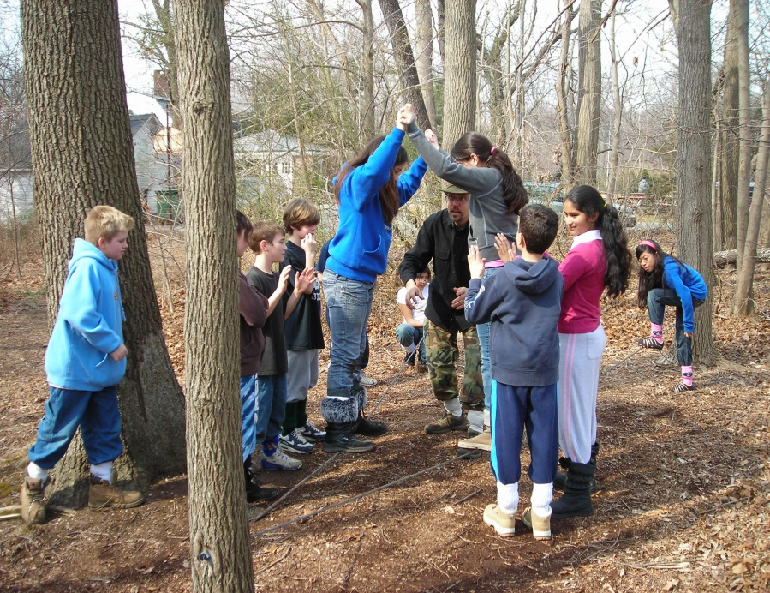
The Nassau BOCES Challenge Course Program provides experiences to address the Dignity Act, Social Emotional Learning (SEL) and 21st Century Skills while also providing real world applications for NYS ELA Common Core Standards.

Skills and Concepts

- Using communication skills
- Being collaborative
- Taking responsibility
- Taking a risk
- Critical thinking

- Problem solving
- Cultural awareness
- Showing respect for others
- Being a leader

Program Logistics:
- Group Size: 15 students/naturalist; capacity up to 250 students per day
- 1 adult chaperone/student group
- 4 hour day with additional hourly rates possible.
- This Low Ropes Challenge Day can occur at both Environmental Education Centers locations in Brookville and at Caumsett State Historic Park Preserve

Contact: Carolann James: cjames@nasboces.org or William Monahan: wmonahan@nasboces.org

“Study nature, love nature, stay close to nature. It will never fail you.” —Frank Lloyd Wright

