Partnership With Applied Therapies and Wellness
We are pleased to announce that Applied Therapies and Wellness will have a branch office located right at Glen Hills Middle School, staffed with a clinical professional. Your child can be seen during the school day at a convenient time in their schedule. This partnership allows for greater accessibility to mental health treatment for kids and families. If you are interested in utilizing this resource for your child, contact Applied Therapies and Wellness in the following ways:
- Email: appointment@appliedtherapiesandwellness.com please include your phone number in the email.
- If it’s easier to call than email, you can connect at the following number: (262) 825-5820 (referral line), or 414-302-1233 (clinic).

Ashley Koehler, Psychotherapist MSW, APSW

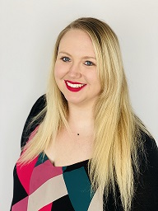
Ashley is a Certified Advanced Practice Social Worker who completed her graduate level internship at Applied Therapies and Wellness Center, S.C., in 2021. She graduated with her bachelor's degree in social work from the University of Wisconsin-Green Bay and with her master's degree in social work from the University of Wisconsin-Milwaukee. Ashley also obtained her certification in providing Trauma-Informed Care.
Ashley has over 9 years of experience working with children and families in a professional setting. She has a great interest and passion for working with children, adults, and families who had had the unfortunate experience of trauma in their lives as well as with the LGBTQ community.

Ashley's therapeutic approaches are Cognitive Behavioral Therapy (CBT), Strengths Based Therapy, Play Therapy techniques, Mindfulness, and Client Centered Therapy. Each treatment plan is carefully created to meet each client's needs with attainable goals.
akoehleratwc@gmail.com
akoehler@appliedtherapiesandwellness.com

