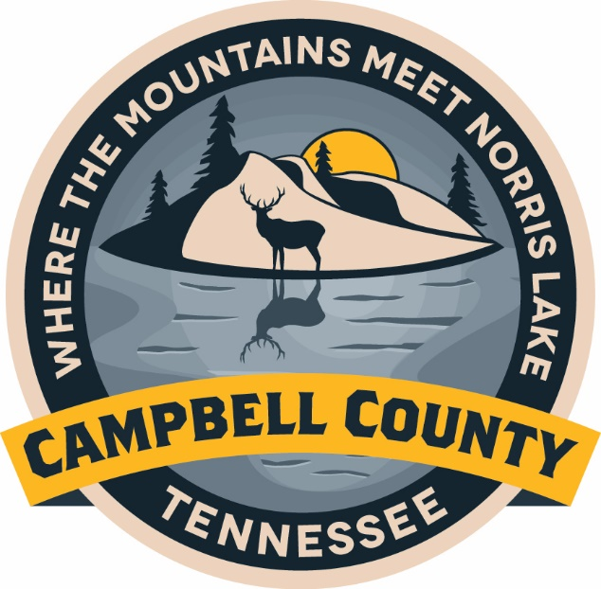

Campbell County Schools
STRATEGIC PLAN

Approved: May 2022
Strategic Planning Team Members

Campbell County Board of Education
Johnny Byrge
Crystal Creekmore
Lisa Fields
Faye Heatherly
Josh James
Ronnie Lasley
Brent Lester
Jeffrey Miller
Steve Morgan
Sharon Ridenour

Director of Schools
Jennifer Fields

Board of Education Supervisors
Lori Adkins
Robbie Heatherly
Jason Horne
Donna Singley
Pam Walden
Vision Statement

Excellence for Every Student, Every Day!

Mission Statement

The mission of the Campbell County School System is to provide all students with the skills they need to be academically, socially, and emotionally successful.
Objective: By July 1, 2026, 100% of students will graduate with some post-secondary credit or industry certification.
Goal 1: Focus On Every Student

Strategy: Provide all students with Advanced placement, Dual Enrollment, Local Dual Credit, Work-Based Learning, and Industry Certification Programs.

Strategy: Administer a “Career Exploration” interest inventory to all students to determine their interests, strengths, and learning styles.

Strategy: Conduct site visits to allow all high school students an opportunity to visit 4-year colleges and universities, 2-year community colleges, local Tennessee College of Applied Technology, and job shadow opportunities with local businesses.

Objective: By July 1, 2026, we will meet the state average ACT score.

Strategy: Provide all high school students with a 45-minute ACT prep class every day.

Strategy: Provide teachers with an opportunity to become an ACT Certified Educator.

Strategy: Provide students with high quality instruction, high quality materials, differentiated instruction, before school and after school tutoring opportunities at no cost.

Objective: By July 1, 2026, at least 50% of all 3rd grade students will be on grade level and ready for the next grade based on summative assessments.

Strategy: Ensure that each teacher provides differentiated instruction in the classroom.

Strategy: Evaluate student performance and growth by administering Benchmark testing periodically throughout the school year.

Strategy: Teachers will participate in the Early Literacy Network Training that provides
in-depth training on research based methods of instruction and best practices to develop skilled readers.

Objective: By July 1, 2026, 100% of students will be supported through social, emotional, and physical learning.

Strategy: Create an inclusive environment that supports all students and staff.

Strategy: Expand the availability of health related resources and services for all
students.

Strategy: Increase extracurricular opportunities to meet the interest of all students and to foster well-rounded student experiences.

Strategy: Provide all students access to software programs that teach lessons on social and emotional awareness.

Goal 2: Invest in Our People
Objective: By July 1, 2026, implement a professional growth and development plan for all employees.

Strategy: Provide high quality, on-site, professional development for all staff members and school leaders.

Strategy: Offer teachers and staff online trainings and professional development to complete at their convenience and interest level.

Objective: By July 1, 2024, the district’s technology infrastructure will be improved in every school to provide staff with a high quality work environment.

Strategy: Increase broadband access, upgrade bandwidth, purchase additional technology devices, and upgrade and expand existing technology.

Strategy: Provide on-going training in the use of technology for all ability levels.

Objective: By July 1, 2026, the district’s infrastructure will be improved at every school to provide students, staff, and community with a safe facility.

Strategy: A needs assessment will be conducted at every school to repair or replace roofs, HVAC, and parking lots.

Strategy: Develop a multi-year maintenance plan to manage and plan for the up-keep of all buildings in the district.

Objective: By July 1, 2026, the district will have a strong Human Resource department to recruit and hire high-quality employees.

Strategy: Secure a competitive retirement incentive.

Strategy: Advertise employment opportunities on an updated website with a
broad outreach.

Strategy: Implement software strategically designed for hiring and streamlining the on-boarding process.

Goal 3: Partner with Our Stakeholders
Objective: By July 1, 2026, programs and coursework will be aligned to local need and in-demand career opportunities.

Strategy: Develop partnerships with local businesses to allow job shadowing opportunities for students throughout the school year, work based learning opportunities, and summer or seasonal employment.

Strategy: Host annual career and job fairs to provide opportunities for businesses to advertise and recruit student for employment, military, mentoring, or job shadowing opportunities.

Strategy: Implement an online portal that utilizes market data to support and align coursework and programs.

Objective: By July 1, 2026, engage families and communities to create meaningful learning environments for all students.

Strategy: Host annual community meetings at each school or community center to provide meaningful engagement with all families to support student success.

Strategy: Create parent resource centers in all schools.

Strategy: Develop and publish an annual report to inform the community of the improvements and accomplishments in the school system.

