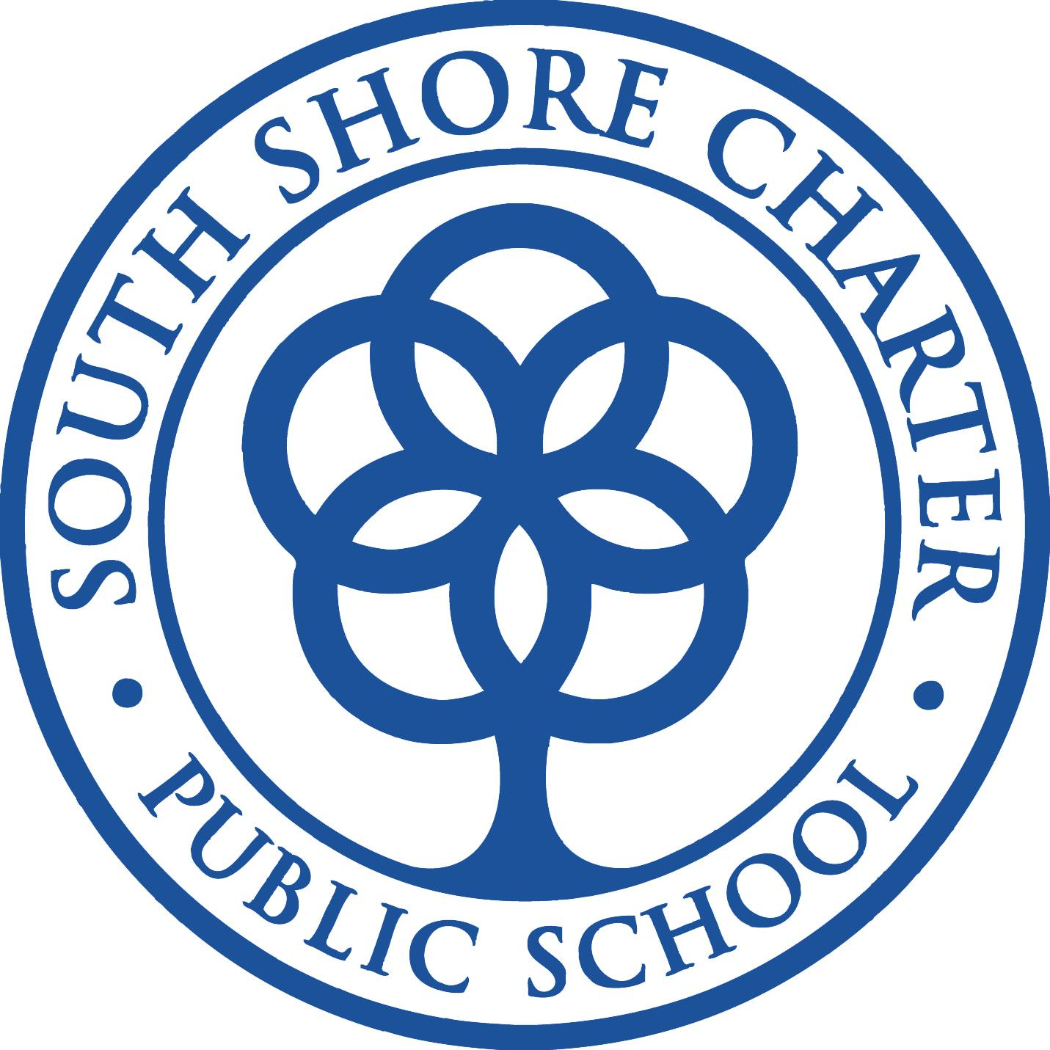
SOUTH SHORE CHARTER PUBLIC SCHOOL
Application for Renewal of a Public School Charter

SOUTH SHORE CHARTER PUBLIC SCHOOL
100 Longwater Circle
Norwell, Massachusetts 02061
www.sscps.org

Contact Information
Alicia Savage
Executive Director
781-982-4202
asavage@sscps.org

Approved by the SSCPS Board of Trustees on July 29, 2024
Submitted on July 30, 2024

Table of Contents

Introduction to the School 3

Faithfulness to Charter 3
Criterion 1: Mission and Key Design Elements 3
Criterion 2: Access and Equity 8
Criterion 3: Compliance 13
Criterion 4: Dissemination 14

Academic Program Success 17
Criterion 5: Student Performance 17
Criterion 6: Program Delivery 22
Criterion 7: School Climate and Family Engagement 29

Organizational Viability 31
Criterion 8: Capacity 31
Criterion 9: Governance 32
Criterion 10: Finance 33

Plans for the Next Five Years 34

Appendix A: Accountability Plan Performance 35

Introduction to the School

South Shore Charter Public School
Type of Charter | Commonwealth | Location (Municipality) | Norwell, MA
Regional or  Non-Regional | Regional | Districts in Region | Abington, Braintree, Brockton, Cohasset, Duxbury, East Bridgewater, Halifax, Hanover, Hanson, Hingham, Holbrook, Hull, Kingston, Marshfield, Norwell, Pembroke, Plymouth, Plympton, Quincy, Randolph, Rockland, Scituate, Weymouth, Whitman
Year Opened | 1995 | Years Renewed | 2000, 2005, 2010, 2015, 2020
Maximum Enrollment | 1075 | Projected Enrollment for 2024-25 | 1,075
Chartered Grade Span | K-12 | Grade Span for 2024-25 | K-12
Number of Instructional Days for the 2024-25 School Year | 180 | Students on Initial Waitlist for 2024-25 | 658
School Hours for the 2024-25 School Year | 8:15-3:00 | Age of School in 2024-25 | 30
Mission Statement: Inspiring every student to excel in academics, service, and life

Faithfulness to Charter
Criterion 1: Mission and Key Design Elements
Mission
Inspiring every student to excel in academics, service, and life

The South Shore Charter Public School (SSCPS/the School) has held fast to the institutional mission of inspiring every student to excel in academics, service, and life. Founded in 1995, the School remains dedicated to an educational model that combines project-based learning and community service with a standards-based college preparatory curriculum. Whether it is a high school student mentoring a third grader in the afterschool enrichment program, a middle school student collecting coats for a homeless shelter, or a first-grade student growing vegetables from an organic garden in the outdoor classroom, student life at South Shore Charter empowers students to make an impact on the world around them. encompasses these core principles lifting us to where we are today.

We have come a long way in thirty years. Teachers at South Shore Charter are dedicated to teaching every child in tandem with nurturing social and emotional health. Service learning is an essential principle of the School’s mission as all K-12 students complete community service requirements. Students become involved in the community beyond the school walls to learn about the importance of teamwork and service to others. This innovative approach is embodied in the School’s Projects (K-8) and Workshops (9-12). South Shore Charter continues to build a comprehensive curriculum and instructional framework that upholds rigorous standards, ensures alignment across all levels, and embraces differentiated instruction to accommodate all learners. We are committed to empowering every student to excel academically and flourish in today’s world. We recognize that language and mathematics literacy are the foundation of academic achievement, and we work to ensure that every student is provided an education embedded with academic rigor and high expectations.

Diversity is our strength. Students come to South Shore Charter bringing a rich mosaic of languages and cultures from the South Shore and around the world. Over forty languages are spoken by families in our school community. South Shore Charter remains dedicated to embracing the diversity of our student population, and to providing a college preparatory education for all students. As a full inclusion school, we remain steadfast in the pursuit of academic achievement for all, and we foster equity for every student.

Key Design Elements
The founders of the School established an instructional model based upon the premise that experiential and inquiry-based learning is an essential component of a meaningful education. Over the course of the past 29 years there have been modifications and institutional evolution to serve a larger and more diverse student population. Now more so than ever before, the South Shore Charter Public School maintains a school culture committed to student achievement, academic rigor, and project-based learning. As we look to the School’s 30th anniversary we identify the following key design elements.

Rigorous academics in major subject areas including the arts, sciences, foreign language, and social sciences; combined with project-based learning
The School's commitment to rigorous academics in major subject areas, including the arts, sciences, foreign language, and social sciences, is evident through a blend of traditional instruction and project-based learning. Literacy efforts saw a significant increase in support with the addition of two full-time reading intervention teachers and three part-time administrators. This allowed K-4 students to receive instruction in 25 small, dynamic reading groups tailored to their data-driven needs. Additionally, after-school reading support groups were available for students in grades 2-8 from November through April. K-4 teachers also participated in a year-long, 36-hour Keys to Beginning Reading course to enhance their instructional skills.
Writing instruction was strengthened by reintroducing the Collins Writing Program for grades 5-12 in ELA, social studies, and history, fostering a common language of instruction and shared strategies, many of which are project-based. Mathematics instruction focused on equitable practices, peer collaboration, hands-on activities, inquiry-based learning, and math games, with an emphasis on enhancing math language understanding and implementation strategies across grades 5-12.
In the fields of science, technology, and engineering, there was a strong emphasis on higher-order thinking, questioning, and phenomena-based problem solving. Teachers concentrated on refining instructional practices, including inquiry-based and project-based learning, and providing scaffolded support to students. World Languages adopted a proficiency-based curriculum that prioritized communicative activities and the use of authentic cultural resources, alongside the implementation of a standards-based grading system in 2023-2024, with common rubrics for grades 5-12.
The integrated K-2 science program continued its partnership with Holly Hill Farm, offering hands-on, outdoor classroom learning aligned with Massachusetts Frameworks and K-2 science standards. Project-based learning was prominently featured, with grade 6 and 7 students engaging in design and engineering projects and researching ecosystem impacts. The return of science fair-style Exhibition of Mastery presentations for grades 6 and 7 marked a significant achievement in bringing back project-based learning suspended in 2020.
Projects (K-8) and Workshops (9-12)  Classes that implement a project-based methodology whereby students take on a leadership role and are responsible for their own learning.  Provide exemplary opportunities for students that change lives and give meaning to the school day. | Pandemic health and safety protocols limited Projects and Workshops from 2020-2021, but soon returned to full course offerings. By 2024 all SSCPS students had participated in Projects and Workshops. 610 out of 645 or 95% of students in grades 5-12 earned a grade of 80% or higher in Project/Workshop courses, and over 90% of students met the academic standards set for each grade and level.
Exhibition of Mastery (EoM)  A summative assessment allowing students to present to their peers on a topic of their choice after fully exploring the topic in detail. | Have successfully evolved with the school allowing for cross-grade collaboration and have taken on such forms as the science fair, the history wax museum, the fashion show, and the civics project showcase.

Support of both the academic and social emotional needs of all students in an inclusion model within a nurturing K-12 school culture
South Shore Charter Public School (SSCPS) supports both the academic and social-emotional needs of all students within an inclusion model and a nurturing K-12 school culture. The school conducts Kindergarten screenings to assess development and identify special education needs. At enrollment, families complete the Home Language Survey to determine the need for ESL services, with timely testing and communication regarding eligibility and options.
SSCPS has Student Support Teams for K-4, 5-8, and a data review team for grades 9-12. These teams use a Response to Intervention model to address academic, social, or emotional difficulties before referring students to special education. They focus on evidence-based interventions and data-driven decision-making.
The School provides comprehensive services through its Learning Services Department, offering inclusion and pull-out services to meet diverse student needs. Specialized equipment and assistive technology are provided as specified in IEPs or 504 plans. SSCPS employs school psychologists and pupil adjustment counselors to evaluate and support students with various needs, including academic, emotional, and behavioral issues. These counselors also support the Therapeutic Academic Support Program (TASC) for high school students facing significant social/emotional challenges.
Speech and Language Pathologists, Occupational Therapists, a Physical Therapist, and a BCBA, along with Behavior Support Assistants, provide targeted services to address communication, sensory integration, fine motor skills, and behavioral challenges. Individual and small group academic support is aligned with the State Curriculum Frameworks, ensuring students can access the general education curriculum while receiving the necessary support.
Inclusion  The pedagogical practice of keeping all students together in the same learning environment to provide support in the general education classroom instead of pulling students out into substantially separate classes. | All SSCPS students participated in inclusion classes with tremendous benefits to all learners. By 2023-2024, 82 out of 161, or 51%, of high needs high school students successfully completed Honors and/or Advanced Placement coursework.

K-12 community service both through a project-based learning model and within student home communities

Community service experienced a revival in 2023-2024. The school community has been fortunate to bring new focus on community service and the importance of service to others. Over the past year, students and families worked hard throughout their communities and reflected on their experiences. In September, the School created a new platform for students to use to record their community service hours and meet their grade level expectations.

Community service has been improving. The new platform has allowed students to reflect as they work within their communities to make a difference. Examples include running in or volunteering for the School’s annual road race or school event, working in a food bank, or helping a neighbor or at a church. Community service aligns with the School’s mission statement, but more importantly, it aligns with who students are as individuals. By actively participating in community service, students go beyond the realm of academics and the school campus to show what they know in practical and meaningful ways. Through service, SSCPS students learn the immeasurable value of contributing to the well-being of others and develop a sense of responsibility for something collectively great. We see much in our students through community service, empathy, leadership, and a commitment to making a positive impact on the world.

Community Service/Service Learning  Inherent in most Projects and Workshops, opportunities for students to serve others in the school and local communities. Community service is also an Exit Standard at each grade.  This central component of our mission allows for students to make meaningful contributions to the world around them. Service learning has often been the driving force behind student achievement. | Service learning proved a challenge during the COVID-19 pandemic. The School was able to gradually reintroduce service learning as pandemic protocols were lifted. By 2023-2024, 43 out of 56 or 78% of Projects and Workshops participated in community service over the course of the year.  The School will continue to support community service initiatives for families and increase communication of opportunities and the online record keeping system introduced in the fall of 2023.

Support of college and career readiness through a strong academic program that includes internship opportunities and college-level coursework
The School's support of college and career readiness is evident through a strong academic program that includes internship opportunities and college-level coursework. Standardized test preparation is a priority, with the PSAT administered to juniors, grade 10 students, and grades 8/9 to gather data for curricular changes and interventions. SAT preparation is offered to all students, with participation rates exceeding those of the top three sending districts. Math acceleration and support are also emphasized. The use of iXL Math for grades 9-12 helps with assessment and growth tracking, supported by professional development sessions for teachers.
College-level coursework is a significant component of the academic program, with students placed in AP Calculus AB, AP Calculus BC, AP Statistics, and AP Precalculus. Additionally, students have the opportunity to enroll in the John Hopkins University online Multivariable Calculus course. The Seal of Biliteracy program, established in 2019-2020, has seen growing student participation and achievements. In the 2023-2024 school year, 18 students took part in language proficiency testing, earning awards for the Massachusetts Seal of Biliteracy and the Global Seal of Biliteracy.

College Preparatory Curriculum and Programming  The School continues to attract students from twenty-six diverse sending districts who seek an academic setting with college and career readiness as a focus for all.  Implementation based on the core belief of the School that all students deserve equal educational opportunity for successful life outcomes. | By 2024 29 out of 69 or 42% of graduating Seniors earned a score of 3 or higher on at least one Advanced Placement exam prior to graduation and 79 out of 87 or 91% of eleventh grade students participated in the SAT thus far. The mean total score for SSCPS students was 972, above the state average of 971 and the national average of 952.  Although health and safety protocols made Senior Internships unattainable during the COVID-19 pandemic, students were able to regain traction in this program and by 2024 all graduating students either participated in an internship or completed an Independent Study project.

Integrated K-12 academic program within a culture of continuous improvement
The integrated K-12 academic program is fostered within a culture of continuous improvement. Literacy and reading support were strengthened through reading summer programs in 2021 and 2022 for rising first through fifth graders. The DIBELS assessment was administered in grades K-5 three times a year, with additional progress monitoring to ensure ongoing progress.
Assessment and program evaluation utilize MCAS and PSAT data for informed instructional decision-making in Math, Science, and Technology/Engineering, alongside formative and summative assessments in history and social studies to identify gaps and opportunities for acceleration and remediation. Professional development included a year-long Keys to Beginning Reading course for K-4 teachers and focused sessions for grades 3-8 teachers to support changes in the STE MCAS. Teachers participated in the Lead for Literacy Institute, funded by the Lead for Literacy grant, focusing on evidence-based literacy practices.
Continuous improvement in math instruction was achieved through the use of iReady data to identify students for math acceleration and create targeted intervention groups. Diagnostic data supported student learning and practice throughout the school year. Additionally, an after-school tutoring program focused on mathematics for students in grades 2-8 from November through May, complemented by expanded summer programming for 2023 and 2024 targeting math acceleration and remediation in grades 3-10.
Science instructional practices saw teachers embedding hands-on classroom tasks and digital performance tasks to support deeper learning goals and align with MCAS changes. Common and formative assessments were developed collaboratively by teachers to inform instruction and improve student achievement.
Integrated K-12 Academic Program within a Culture of Continuous Instructional Improvement  As a K-12 institution, the School provides opportunities for students and teachers alike to learn from one another across campus. At the student level this includes mentoring partnerships, cross-level collaboration, and multi-grade learning opportunities. At the faculty level this work focuses on vertical curriculum alignment and the development of common learning practices. | By 2023-2024 44 out of 56 or 79% of Projects and Workshops participated in multi-grade level activities. These activities included performances, presentations, and mentoring relationships that spanned grades K-12.  Teachers continue to meet weekly both by department and bimonthly by Level to assess student learning and identify learning gaps in need of remediation. A significant portion of the professional development time embedded in the school year in monthly half days remains dedicated to analyzing assessment data, prioritizing standards, and planning for student interventions.

Amendments

Amendment Requests | Approval Date
School Accountability Plan Approval | 30 November 2020
Enrollment Policy | Section I. j.  The South Shore Charter Public School will provide regional transportation services to residents of the School’s sending districts identified in the School’s charter. Transportation routes for all students who reside more than two miles from school, will be provided with transportation to school by SSCPS, with a bus stop one mile or less from the student’s residence. Transportation routes may be established in the following cities and towns: Abington, Braintree, Brockton, Cohasset, Duxbury, East Bridgewater, Halifax, Hanover, Hanson, Hingham, Holbrook, Hull, Kingston, Marshfield, Norwell, Pembroke, Plymouth, Plympton, Quincy, Randolph, Rockland, Scituate, Weymouth, and Whitman. Students residing in the Town of Norwell are eligible for transportation through Norwell Public Schools. Transportation will be provided in accordance with the Charter School Technical Advisory 16-1: Transportation. | 28 June 2022

Criterion 2: Access and Equity
Equal Access: Recruitment, Enrollment, and Retention
The South Shore Charter Public School has demonstrated significant successes in implementing its Recruitment and Retention Plan. Despite a statewide decline in enrollment, the school received an impressive 756 applications for 97 openings for the March 2024 enrollment lottery, indicating strong community interest and trust in the school’s mission and vision. The School has targeted social media efforts and online strategies to reach all sending districts and learners. The effective organization of recruitment events, such as the November Open House and Talk to us Tuesday sessions, which included assisting families to apply on the spot with full translation capacity. Open house and enrollment events played a key role in attracting a total of 368 visitors, allowing prospective students and their families to experience the school environment firsthand. All learning services, including services for students with IEPs and 504s as well as English Language programming, are presented at enrollment events and in admissions materials. Links to those materials may be found on the South Shore Charter website:
https://www.sscps.org/academics/learning-services
https://www.sscps.org/academics/learning-services/english-language-learner-program
The School's commitment to diversity is evident in its recruitment from twenty-six sending districts, with the highest number of applications coming from Brockton (165), followed by Weymouth (155), and Randolph (100). South Shore Charter has faced challenges, such as adjusting to the DESE directive to exclude Randolph from targeted recruitment and enrollment beginning in the 2021-2022 school year. The Randolph shift, following the DESE Regulatory Notification, highlights the school’s ability to adapt its recruitment and retention strategies while maintaining a diverse student population when faced with challenges to its institutional commitment.
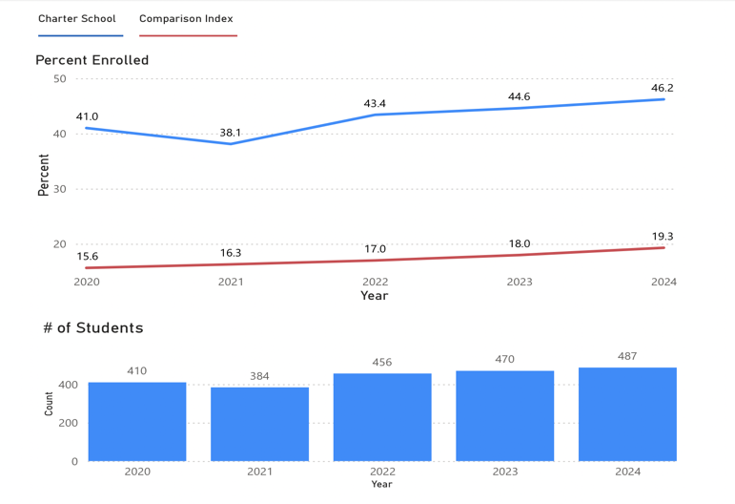
Of primary importance to recruitment and retention has been the successful implementation of the regional transportation initiative which has completed its second year of operation. The School identified transportation as the number one reason students leave or decline admission offers. In the FY22 data provided by the SSCPS Admissions Office, out of the 142 students confirmed to not be returning or those that withdrew, 21 percent indicated lack of transportation. Furthermore, of those prospective students who declined an accepted enrollment offer, 213 declined and at least 15 percent indicated the reason was due to the lack of sufficient transportation. As outlined in the June 2022 Amendment Request, South Shore Charter now provides regional transportation at no cost to families. Regional transportation has had a twofold ramification; increased student recruitment from sending districts and decreased attrition.
Chart I: South Shore Charter Student Enrollment 2020-2024
First Language Not English

DESE CHART data demonstrates an increase of the First Language Not English student population subgroup at South Shore Charter. Over a five-year trajectory, CHART data indicates a 5.2 percent increase in the FLNE subgroup for SSCPS, 41.0 to 46.2 by 2024. Comparison Index CHART data indicates a lesser 3.7 percent increase of the FLNE subgroup over a five-year trajectory; 15.6 in 2020 to 19.3 in 2024.

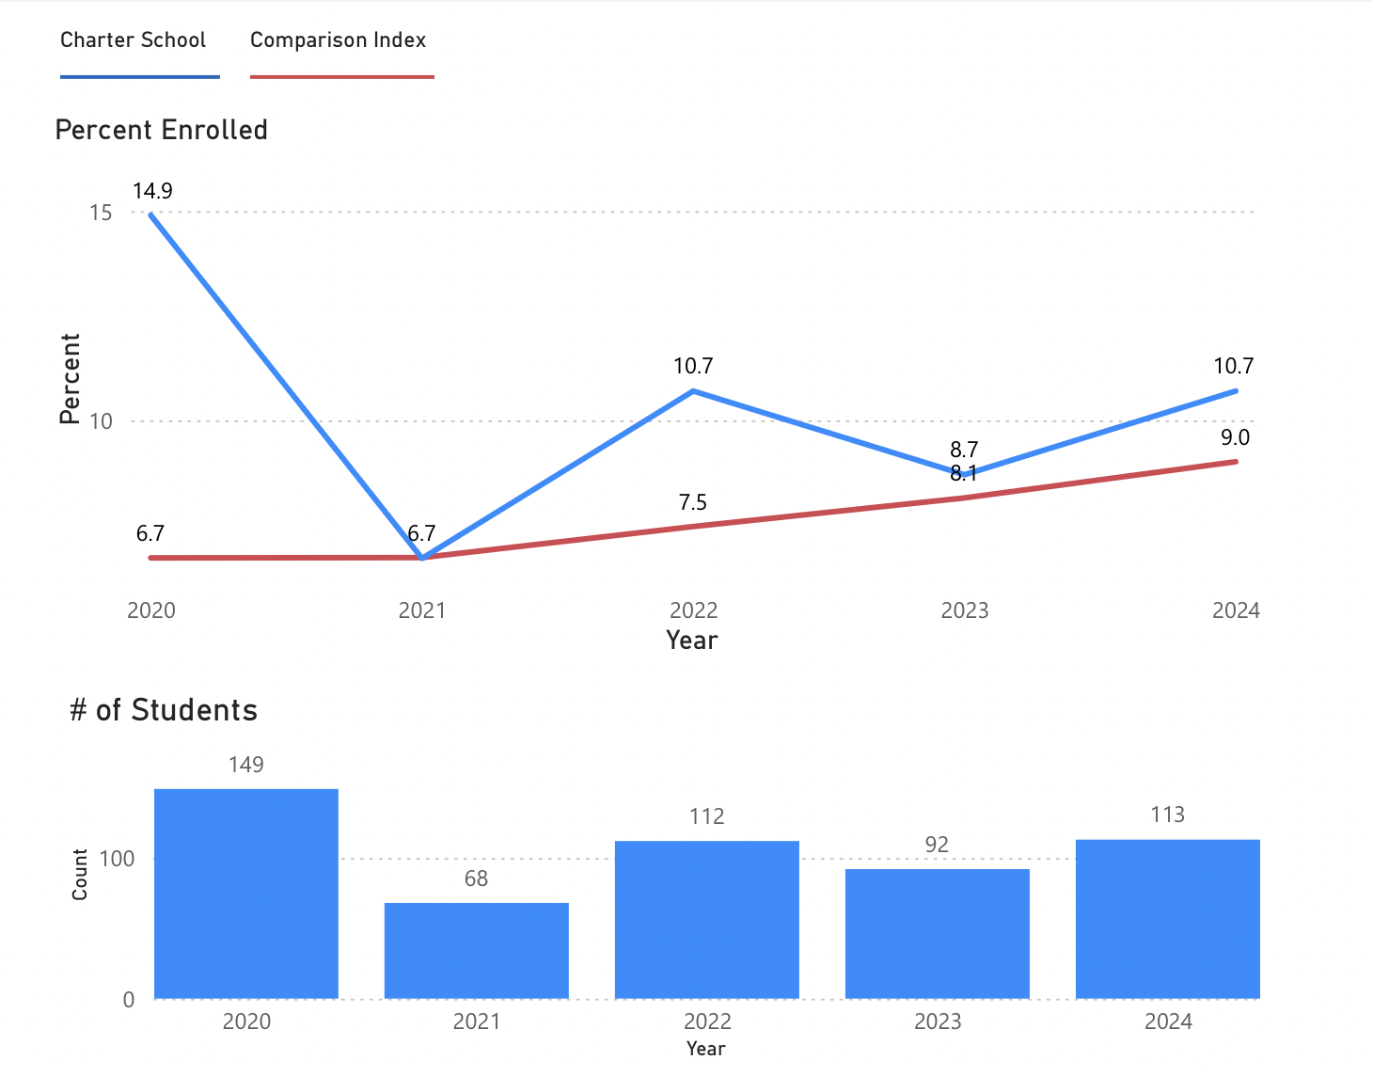
Chart II: South Shore Charter Student Enrollment 2020-2024
English Learners

Over a five-year trajectory, CHART data indicates a 4.2 percent decrease in the EL subgroup for SSCPS; from 14.9 in 2020 to 10.7 by 2024. CHART data for the Comparison Index indicates an increase of 2.3 for this subgroup, from 6.7 in 2020 to 9.0 by 2024.

Variations of the English Learners/First Language Not English student subgroup growth may be attributed to the School’s inability to actively recruit and enroll students from Randolph due to the DESE “At-Cap” mandate. Although the Comparison Index remains lower than SSCPS, the School predicted and noted concerning enrollment data and designed remediation factoring in this information, including implementation of the 1.4-million-dollar transportation program in FY23. Consequently, the school experienced an increase in this student population from 8.1 in 2023 to 10.7 in 2024.

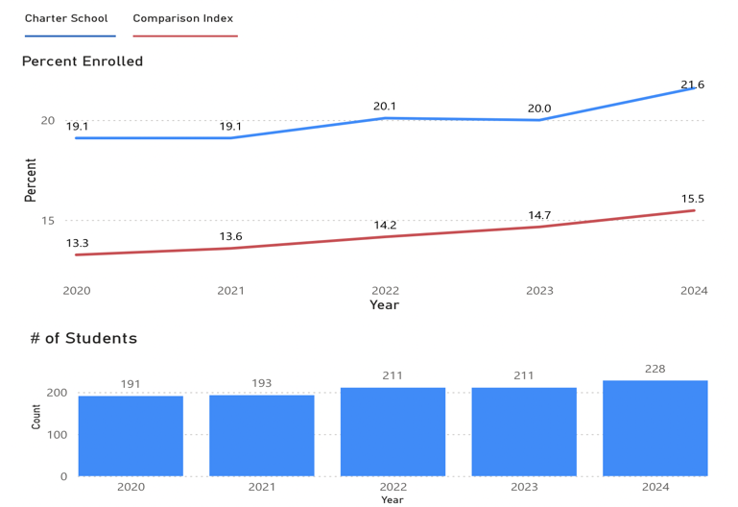

Chart III: South Shore Charter Student Enrollment 2020-2024
Students with Disabilities

The Students with Disabilities subgroup has increased over the five-year trajectory at South Shore Charter. CHART data indicates a 2.5 percent increase in this subgroup for SSCPS, from 19.1 in 2020 to 21.6 by 2024. CHART data for the Comparison Index indicates a lesser 2.2 percent increase of the Students with Disabilities subgroup, from 13.3 in 2020 to 15.5 in 2024.

Chart IV: South Shore Charter Student Enrollment 2020-2024
Low Income/Economically Disadvantaged

Over a five-year trajectory, CHART data demonstrates a 11.6 percent increase in the Low Income student subgroup at SSCPS, from 21.1 in 2020 to 32.7 by 2024. CHART data for the Comparison Index indicates a 9.4 percent increase of the Low Income subgroup, 24.7 in 2020 to 34.1 by 2024.

The School has addressed the Comparison Index gap through the implementation of the 1.4-million-dollar transportation program in FY23, thereby increasing this subgroup from FY23 to FY24.

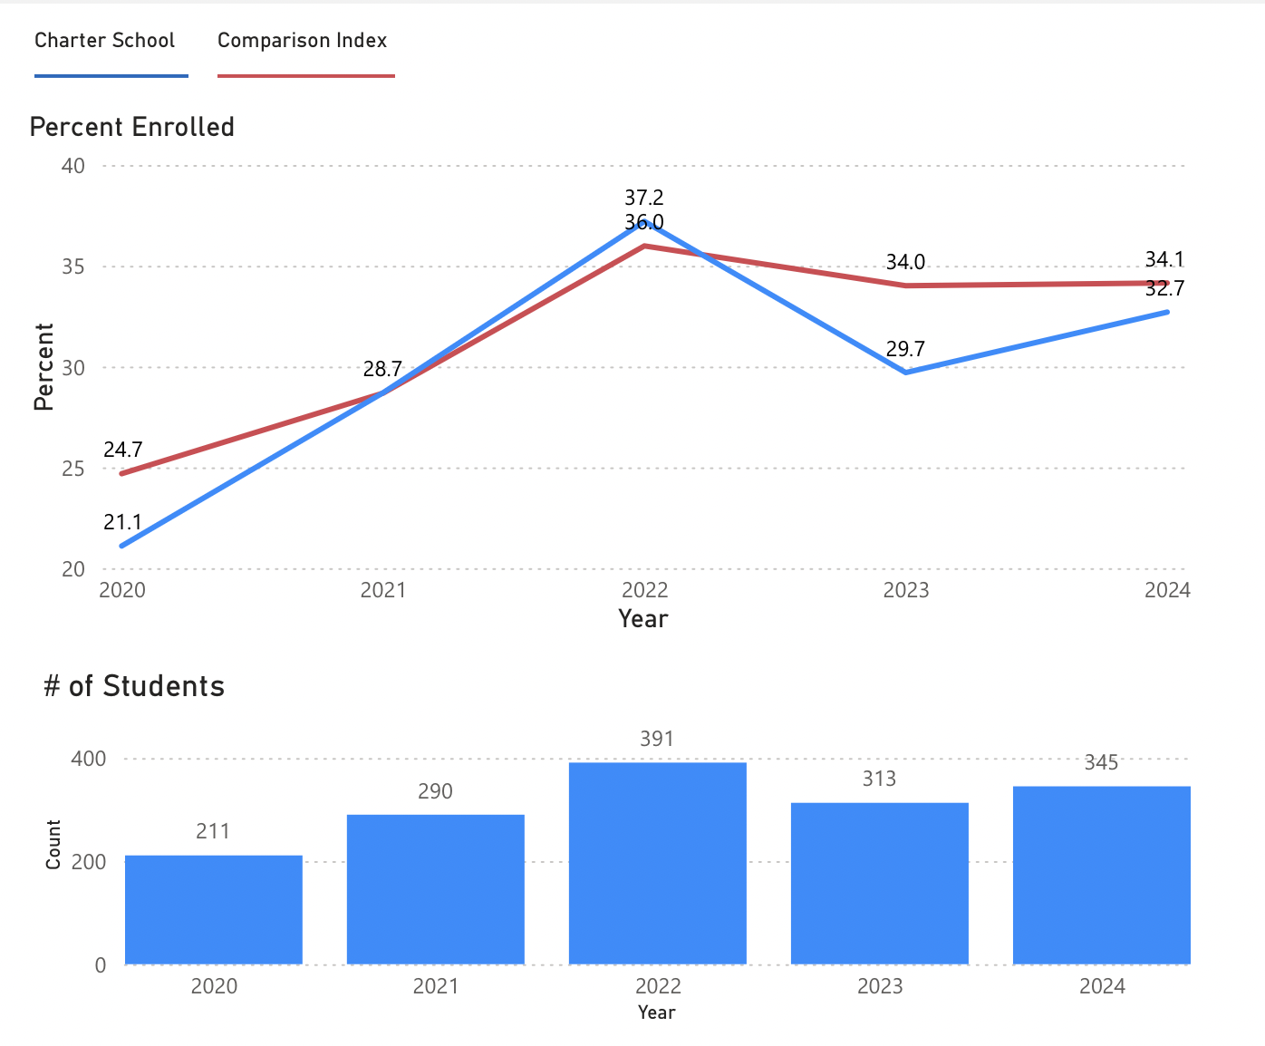

Attrition
The School identified transportation as the most given reason for student withdrawal. In the FY22 data provided by the SSCPS Admissions Office, out of the 142 students confirmed to not be returning or those that withdrew, 21 percent indicated lack of transportation. Following the institution of regional transportation the School experienced a decreased rate of attrition and has received positive feedback from families when surveyed in March 2023 and March 2024. Data collected during the first two years of implementation revealed high satisfaction among responding families; 30.88 percent of responding families gave the program the highest rating of 10 in 2023 and 21.98 in 2024, indicating outstanding performance. This rating was the most popular choice among respondents. The weighted average rating for the program was 9.3 in 2023 and 9.16 in 2024 based on all ratings received. All comments and suggestions provided by respondents have been thoroughly reviewed and shared with the school community.

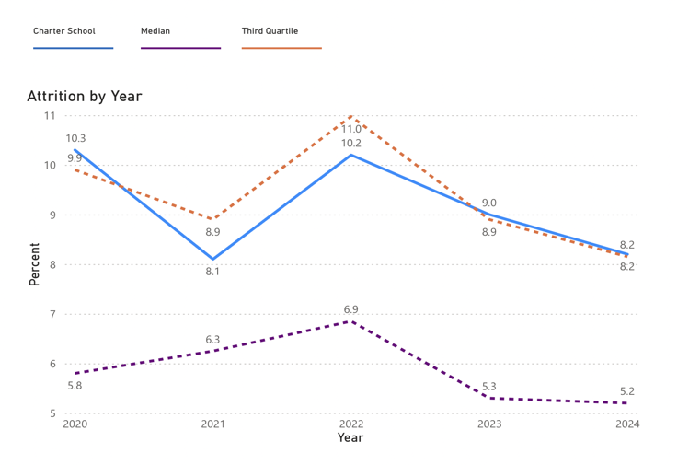
Chart V: South Shore Charter Student Attrition 2020-2024
All Students

CHART data indicates a stabilized rate of attrition at South Shore Charter by 2024; from 10.2 in 2020, to 8.1 in 2021, to 10.2 in 2022, to 9.0 in 2023, to 8.2 in 2024. The retention rate of the South Shore Charter Public School is 91.8. The School has met its annual goal of 90 percent for student retention over the past two years.

The School’s attrition rate for the student subgroups, English Learners, Students with Disabilities, and Low Income, have remained below Third Quartile percentages during the five-year period from 2020 - 2024.

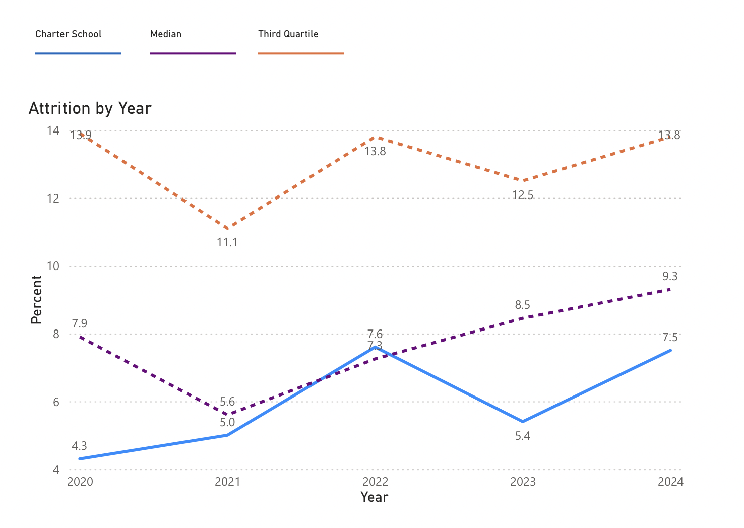

Chart VI: South Shore Charter Student Attrition 2020-2024 | English Learners

CHART Data indicates that the English Learner student population has remained well below the Third Quartile reaching 6.3 percent by 2024.

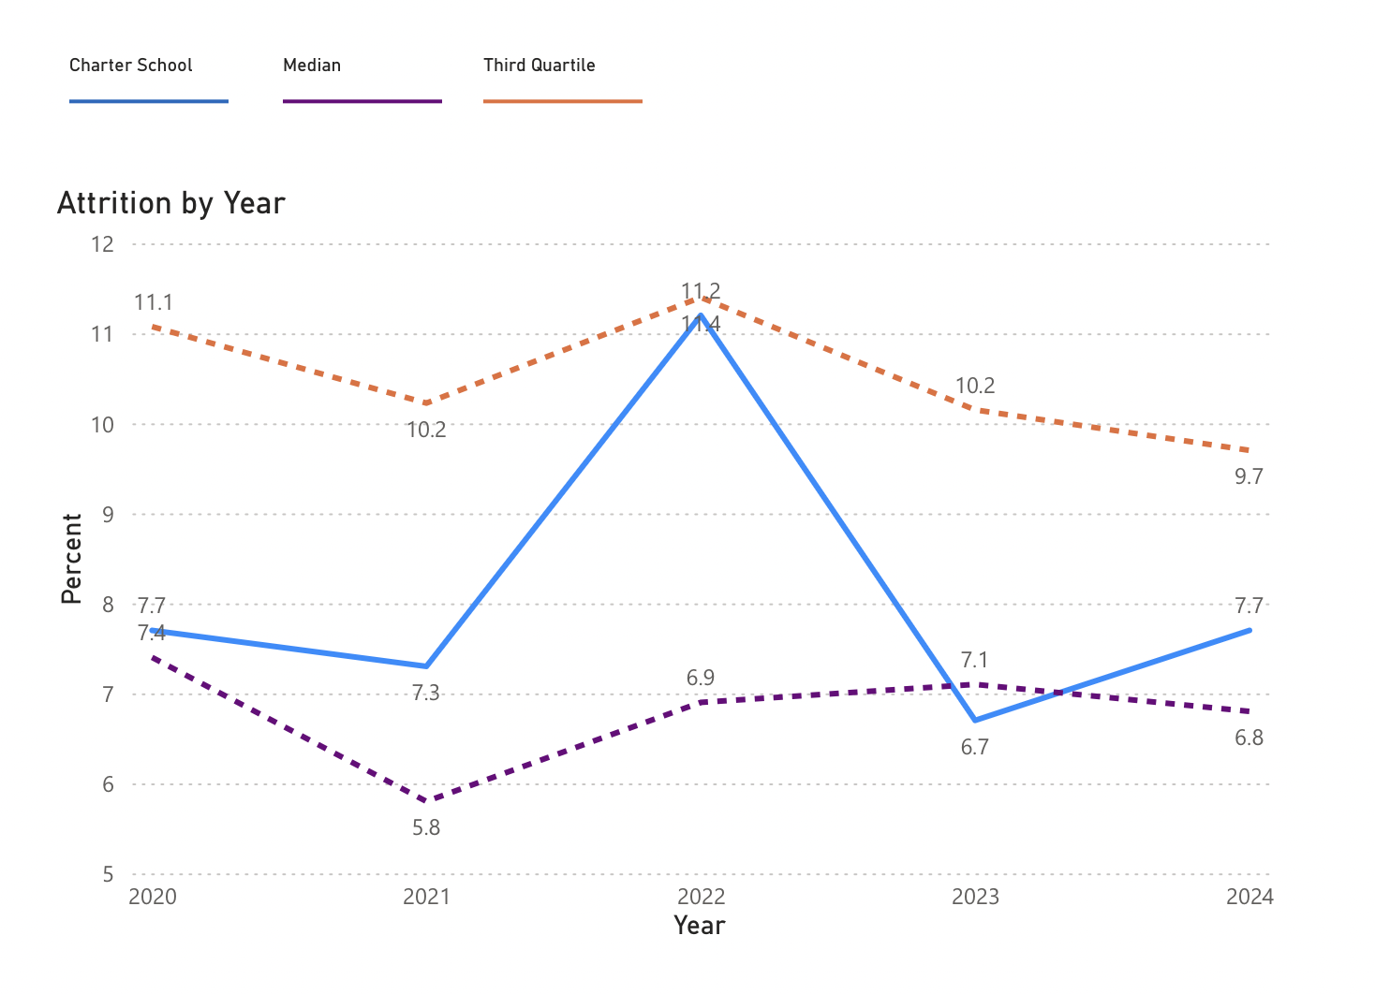

Chart VII: South Shore Charter Student Attrition 2020-2024 | Students with Disabilities

CHART Data indicates that the Students with Disabilities student population has remained below the Third Quartile reaching 2 percent by 2024.

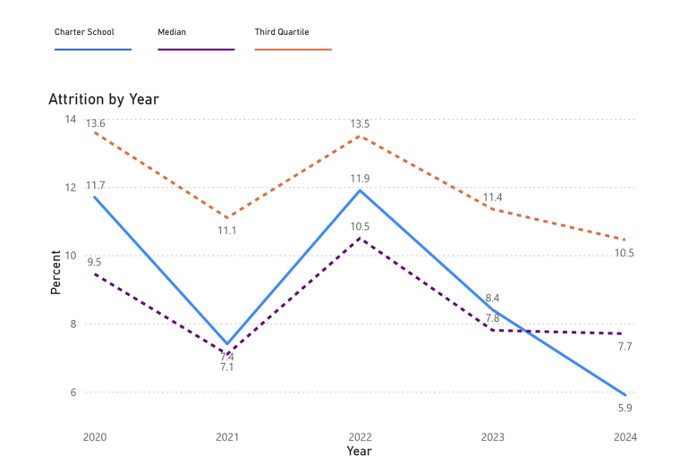

Chart VIII: South Shore Charter Student Attrition 2020-2024 | Low Income/Economically Disadvantaged

CHART Data indicates that the Low Income/Economically Disadvantaged student population has remained consistently below the Third Quartile reaching 4.6 percent by 2024.

Social Emotional Learning and Discipline
At South Shore Charter Public School building strong relationships is central to maintaining a strong school community and positive school culture. The challenges presented by the pandemic during this charter term only strengthened that belief. SSCPS strives to establish policies and procedures that handle harm and misbehavior in a way that strengthens relationships rather than weakening them. The faculty and staff at SSCPS have done significant work to find effective ways to address disciplinary infractions without excluding students from school.

The social emotional impact of the pandemic on the social interactions of children is a significant one. Closer analysis of the disciplinary data shows that most disciplinary infractions recorded in the 2021-2022 school year took place in April, May, and June when students were back in person full time and were the result of challenges navigating the social scene after months of separation and isolation. This number remained low with 12 students or 1% suspended. This is the only year of the charter term that South Shore Charter Public School’s suspension rate exceeded the state average, most likely due to the School maintaining in person learning for the majority of the school year.

Student discipline was a considerable challenge during the 2021-2022 school year as is reflected in the data. With the return of full in person schooling, many students faced difficulties navigating social interactions after months of separation and isolation. Students had fallen out of their learning routine and conflict frequently resulted from these challenges. This was especially true for students with disabilities as this school year saw a higher rate of suspension for students with disabilities compared to the student body as a whole. This challenge was not unique to SSCPS. While the suspension rate at SSCPS during the 2021-2022 school year remained well below the state average, more students served suspensions both internally and externally than had in the pre pandemic years. The school year saw the highest rate of suspension of the charter term with 23 students or 1.8% suspended over the course of the year. Despite this higher rate, the number was well below the state average of 3.1%.

In response to these challenges, teachers in grades K-8 implemented a new social-emotional learning curriculum, PATHS in grades K-5 and Emozi in grades 6-8 during the 2022-2023 school year. At the high school level, the faculty led a dynamic faculty-created Advisory curriculum that focused on social-emotional learning, relationship building, and conflict resolution. That curriculum is currently in the revision process and a new version will be implemented during the 2024-2025 school year. School events and traditions that were difficult to execute during the pandemic returned, contributing positively to school culture. The high school increased supervision during unstructured times, began using a new hall pass system, and worked to develop common practices across classrooms. Ultimately, these efforts resulted in significantly fewer suspensions during the 2022-2023 school year than during the 2021-2022 school year. The number of students disciplined dropped to six in 2022-2023 from twenty-three in 2021-2022, a reduction by 70% in the total number despite higher enrollment.

Equal Rights of Access
South Shore Charter will persist in providing an extensive range of academic programs and extracurricular activities to involve and motivate all students, aiming to ensure their continued enrollment. These additional educational services comprise tutoring sessions before and after school, enhanced support services during the summer, free tutoring for students facing academic challenges, accelerated programs for students performing at or above grade level, and extended day opportunities. Furthermore, students will continue to have the opportunity to engage in after-school sports and participate in music programs before school.

The faculty is continually engaged in selecting and developing curricula that align with the Massachusetts Curriculum Frameworks; ensuring all students are given the support and opportunities necessary to succeed. The curriculum reflects an unwavering commitment to serve the full array of students currently enrolled at the School, including students eligible for learning services and the growing population of English Language Learners. South Shore Charter remains a full inclusion school, and modifications reflect the belief that every child can learn if provided the appropriate scaffolds. In this process of curriculum alignment, careful consideration is made to identify dated curriculum that holds simplistic and demeaning generalizations on the basis of race, limited English proficiency, disability, color, religion, sex, gender identity, national origin, housing status, and sexual orientation.

What is unique to South Shore Charter continues to retain students and their families. The student to teacher ratio and class size remains low; and class sizes of six to ten students for at-risk populations. During the 2023-2024 school year there were four kindergarten and eight grade one classrooms with a student teacher ratio of 12 to 1. The student teacher ratio at all other grades will remain low averaging 10.6 to 1. Parents continue to be recognized as partners in their child’s education. In addition to the Weekly Update, the school community continues to be engaged through the School’s website and school community events including literacy events, diaspora events, and a multicultural food night.

Criterion 3: Compliance
The South Shore Charter Public School remains in compliance with the terms of its charter and all applicable state laws and regulations, including the Statement of Assurances. There have been two compliance findings from previous accountability visits that have been addressed.

SOR 2020 Finding: SSCPS is out of compliance with state regulations and statutes regarding teacher qualifications. Per state regulations (603 CMR 1.06 (4)), all teachers beyond their first year of employment must have taken and passed the Massachusetts Test for Educator Licensure (MTEL). As of the date of the renewal inspection, two teachers (out of a total 55) beyond the first year of employment had not passed the required MTELs.• As of the date of the renewal inspection, six teachers were not qualified to independently deliver special education services. These teachers are not directly supervised by an individual who is qualified to administer special education services and/or this supervision is not documented in the IEPs these teachers implement. • Per state statute (Acts of 2002, c. 218, § 24), English as a second language (ESL) instruction must be delivered by a licensed ESL teacher. As of the date of the renewal inspection, one teacher providing ESL instruction to English learners did not have an ESL license.
The South Shore Charter Public School has ameliorated the SOR 2020 finding with extensive action. Through the Teacher Diversification Grant, the School has been able to provide fee reimbursement for teachers taking the MTEL as well as MTEL preparation courses. Since 2020, teachers who have not taken and passed the Massachusetts Test for Educator Licensure (MTEL) are no longer employed at South Shore Charter Public School. All SSCPS teachers who administer special education services are either highly qualified or have been directly supervised by an individual who is qualified to administer special education services. Cases requiring direct supervision will be documented in the student’s IEP on a more consistent basis. Per state statute, all ESL teachers have an ESL license.
2022-23 Site Visit Report Finding: The board of trustees operates in a manner that is not fully in compliance with the Open Meeting Law (OML). As required by the OML, board meeting minutes do not consistently include the time of the meeting and a list of documents and other exhibits used at the meeting. The governance, personnel, and finance committees’ meeting minutes do not consistently include a summary of the discussion of each topic, as required by the OML, and all committees of the school’s board do not consistently record meeting minutes, a requirement of the OML.
The South Shore Charter Public School Board of Trustees has made significant changes to improve the consistency of the recording of meeting minutes and summaries. To address this 2022-2023 finding, meeting minutes from all committees have since been taken by school personnel to ensure consistency and that all OML requirements are being met.

Criterion 4: Dissemination
Year | Best Practice Shared | Vehicle for Dissemination | Who at the school was involved with the dissemination efforts? | With whom did the school disseminate its best practices? | Result of Dissemination
2020  2021  2022  2023 | Building necessary supports for students with low incidence disabilities and ELL needs | Bi-monthly | Matthew Tondorf, Director of Learning Services | Southeastern MA Cluster Partnership Group | Building and development of necessary staffing, fund allotment, and programming for students with low incidence disabilities and ELL needs
2020 | Best Practices | Southeast Regional Charter Partnership Group | Alicia Savage, Executive Director  Kristine Bingham, Director of Finance/HR | Massachusetts Charter Public School Association | Networking and shared best practices with other charter school peers
2020 | Best Practices | Delegate assembly from Massachusetts Charter School Association | Kristine Bingham, Director of Finance/HR | Massachusetts Charter Public School Association | Networking and shared best practices with other charter school peers
2020 | Best Practices | Business Manager/CFO/COO & Business Manager COP meetings | Kristine Bingham,  Director of Finance/HR | Massachusetts Charter Public School Association | Networking and shared best practices with other charter school peers
2020 | Building effective guidance programming | Met monthly and attended by the SSCPS Director of Guidance | Mary Carter, Director of Guidance | Southeastern MA Charter School Guidance cluster | Development of programming across guidance departments to support effective practices
2020 | Play in Healthcare Environments and Issues for Classroom Teachers | Taught three classes about helping children make meaning through play | Beverly Bruce,  Title I Reading Specialist | Wheelock College/BU | Facilitated undergraduate learning of essential issues for children in healthcare environments
2020 | K-2 Early Literacy Initiative | The Hill for Literacy | Beverly Bruce,  Title I Reading Specialist  Hanora Broderick | Partnership with DESE, 3 sessions held in Southeastern Massachusetts. | Advise the DESE on a new K-2 Early Literacy initiative which will provide "guidance" to teachers and administrators to promote early literacy.
2020  2021 | Designing inclusive practices and supporting sending districts in developing professional development opportunities. | Meet monthly with 15-35 special education directors in South Shore Special Education Directors Network | Matthew Tondorf, Director of Learning Services | North River Collaborative | Designing inclusive programming & designing professional development for special education staff. Sharing of best practices, development of documentation tools for parents.
2020  2021  2022  2023 | Supporting students with High Needs transition from High School | All LS staff at SSCPS working with students aged 14 and up are using the new Transition Inventory (TPI 3) to develop best practices for IEP students, with additional PD from DESE on Transition and interagency team development. | Michelle Gallagher, Learning Service Teacher and HS SPED Coordinator,  Matthew Tondorf, Director of Learning Services | Regular conversations with DDS to help gain the most information possible to help guide parents through the transition process.  Best Buddies Pre-Employment division | Developed a plan for transitional planning and increased the programming for aging out students at SSCPS.  Worked directly with Best Buddies Pre-Employment program to provide a class option for students outside of the school day to access pre-employment training and practice.
2021 | Best Practices in Sustaining Learning and Transitioning between Learning Models during COVID-19 | Brockton Schools Roundtable Discussions with Mayor Robert F. Sullivan via Zoom | Alicia Savage, Executive Director | Working group of leadership from charter and Catholic schools serving students who reside in Brockton | Provided information to Mayor Sullivan regarding best practices for increased in-person learning, health and safety protocols, air quality, staffing, and testing during the COVID-19 pandemic.
2022  2023 | Social-Emotional Learning Resources | Early Childhood  Education Program  Quality Workgroup  (PQW) SEL  Subcommittee | June Fontaine, Level I Teacher | Served on the Early Childhood Education Program Quality Workgroup SEL Subcommittee | Social Emotional Learning  Resources are posted on the DESE Early Learning Resources webpage and are used by educators across the Commonwealth
2022 | The importance of  teaching about  UNESCO World  Heritage Sites/  implementation of related intercultural  novice and intermediate level activities | Presentation at the  Massachusetts Foreign Language Association  Conference in October | Maria Lappas, 5-8 World Languages  Teacher | Attendees at the  Massachusetts Foreign Language Association  Conference in October | Curricular materials, resources, videos, supporting instruction about UNESCO World Heritage Sites
2023 | High School Advisory, Focused Instructional Time, and Workshop model | Correspondence and visit by a team from St. George Monoux College (High School) London | Christophe Teulet-Cote, High School Assistant Principal  Angie Pepin, K-12 Principal | Administrative team from St. George Monoux College in London | Visit agenda, documents outlining best practices from both schools  focused on preparing students aged 16-18 for higher education
2023 | Designing and implementing inclusive practices | Correspondence and visit by faculty from local Charter Schools | Matthew Tondorf, Director of Learning Services | Abby Kelley Foster School | Shared best practices for inclusive programming and program design.
2024 | 1. Interagency Transition Group  2. Pre-Vocational and Transition Programming | Zoom three times a year  Quarterly Zoom meetings | Michelle Gallagher, High School Learning Services Coordinator/Transition Specialist | Stakeholders and Leaders from the following districts and agencies:  Carver Public Schools,  Mass Hire, DDS Massachusetts, Plymouth Public Schools, Plymouth County Family Support, Pilgrim Area Collaborative, Justice Resource Institute Schools, Mass Rehab Commission, Easter Seals | Networking  Problem-solving  Plymouth County Family  Support visited SSCPS to present to SEPAC  SSCPS shared their relationship with Easter Seals and Mass Hire to help other area schools tap into grant monies and help develop similar partnerships  Through these quarterly meetings and the networking and dissemination that occurs SSCPS was able to support some students in entering the workforce after high school by connecting with South Shore Vocational Technical Career Technical Initiative Training Program.
2024 | Standards for Teaching Heritage Speakers in the Language Classroom | Heritage Language Advisory Framework Group Meetings | Maria Lappas, World Language Teacher | Other districts participating in the meetings, eventually a wider audience state-wide | Shared best practices for heritage speakers in the World Language classroom
2023  2024 | Dealing with trauma in schools, best practices for Pupil Adjustment Counselors | Monthly Job-alike meetings for Pupil Adjustment Counselors | Tanya Ames, Pupil Adjustment Counselor  Karen Foy, Pupil Adjustment Counselor | Local school districts | Sharing best practices and resources to help in dealing with trauma and SEL in schools.
2024 | Differentiated Instruction and Alternate Assessment for Heritage Learners | American Council on the Teaching of Foreign Languages 2023 Conference | Maria Lappas, World Language Teacher | ACTOFL Attendees | Shared best practices for heritage speakers in the World Language classroom
2022  2023  2024 | Teacher Diversification PLC | DESE/Williams College Professional Learning Community | Nadeen Sullivan, Alicia Dupuis, AuJané Stewart, Teachers,  Sheina Prince, Teacher and Civil Rights Coordinator,  Kristine Bingham, Director of Finance and Human Resources,  Alicia Savage, Executive Director | Teachers and administrators from participating charter schools and public school districts statewide. | Shared best practices and lessons learned from yearlong institutional strategic planning and the impact on diversity in teacher recruitment and retention. Best practices include how members of the SSCPS Teacher Diversification PLC participated on the Strategic Planning Committee.  Shared techniques on how this comprehensive approach helped create a better understanding of the school’s faculty and staff recruitment to determine an institutional vision for the future.
2024 | Building equitable, accessible, and sustainable digital literacy and computer science programming | DESE DLCS Summit 2024 | Jamie Allen, Science Curriculum Coordinator  John Oliva, High School Science Teacher | Summit Attendees: Elementary Teachers, Middle School Teachers, High School Teachers, Administrators, DLCS Leaders | CS Engage is a state competitive grant to support public school districts in establishing and promoting rigorous, engaging, and standards-aligned digital literacy and computer science (DLCS) education. SSCPS disseminated visioning for building and implementing inclusive and sustainable K-12 DLCS education, starting in the 5-8 grade span and then targeting the high school and K-4.
2024 | SPA STE MCAS Performance Ambassador and District Trainer | Zoom-2 full days and 4 additional quarterly meetings yearly | Jamie Allen, Science Curriculum Coordinator | WPI Stem Education Center, DESE, MA District Administrators, and STE Educators | Develop an understanding of the new 5th and 8th grade STE MCAS and classroom performance tasks by collaborating with WPI, DESE and MA Districts to become highly qualified trainers (and reviewers) for using STE assessments to create equitable learning experiences.
2024 | Building regional capacity and community partnerships through shared vision through project-based learning and | Workshops, zooms, and seminars | Jamie Allen, Science Curriculum Coordinator  Alicia Savage, Executive Director | Spearheaded by Cohasset Center for Student Coastal Research, the National Oceanic and Atmospheric Administration, North-South River Watershed Association, Neponset River Watershed Association, in collaboration with charter schools and districts. | Share SSCPS practices, included project-based learning, with districts and organizations to make improvements to ongoing programming by increasing community partnerships and building regional capacity. SSCPS serves to be an active and committed partner to CSCR’s BWET grant to “Move the MWEE to the summer months,” credential student learning, and work collaboratively with CSCR, its partners, and Stellwagen Bank National Marine Sanctuary to ensure that students from our school earn recognition as STREAM to Sanctuary watershed stewards.

Academic Program Success
Criterion 5: Student Performance

The South Shore Charter Public School is a data-driven institution focused on the needs of all students and educators. Teachers and school administrators look to multiple measures to determine strengths and areas for improvement. Although there is a panoply of assessments used to determine student learning, the MCAS provides a specific window to help determine if our curriculum aligns with state standards. Teachers and administrators review MCAS data schoolwide in multiple ways: individually, in subgroups, by grade, and schoolwide. The School reviews statewide trends to see where students at South Shore Charter fall within those trends and make decisions accordingly.

Reviewing annual comparison data allows teachers and school administration to determine where the weakest links are and how best to design a remediation plan in those areas. Using 2023 DESE data as an example, South Shore Charter has an Average Scaled Score of 495 in 2023, one point higher than the Massachusetts average in ELA for Grades 3-8. As seen in DESE accountability and assessment data, South Shore Charter has an Average Scaled Score of 504 in 2023, which is the same score as the Massachusetts average for Grade 10 ELA. Regarding Mathematics Grades 3-8 South Shore Charter has an Average Scaled Score of 492 in 2023, two points lower than the Massachusetts average of 494. For Grade 10 Mathematics South Shore Charter has an Average Scaled Score of 495 in 2023, five points lower than the Massachusetts average of 500. In Science, Technology/Engineering South Shore Charter has an Average Scaled Score of 496, two points higher than the state average for grades 5 and 8, and an Average Scaled Score of 493, six points lower, for Grades 9 and 10.

DESE Next Generation Annual Comparisons and DART for grades 10, 8, 7, 6, 5, 4, and 3 provide data for comprehensive analysis. Grade 10, the grade for which the MCAS is considered a high stakes test for graduation, has been closely reviewed over a three-year period. Data indicates that the number of students scoring Not Meeting Expectations (NM) has decreased since 2021, the year the MCAS was reintroduced after the 2020 break from MCAS due to the COVID-19 pandemic in English Language Arts, Mathematics, and since last year’s administration of the Science and Tech/Engineering MCAS. The first year of the new Physics sequencing implementation was 2022-2023. For the 2022-2023 academic year, South Shore Charter transitioned from administering the Biology MCAS to tenth graders in 2022 to administering the Physics MCAS to students in grade 9 in 2023. This change resulted in two positive outcomes for the student population; students were able to enter tenth grade with one MCAS assessment completed and there were fewer students scoring Not Meeting Expectations.

Although the School is heartened by the decrease in students scoring Not Meeting Expectations, there is room for improvement. As seen in Charts I and II, Appendix D, data from 2021-2023, and the impact of pandemic learning and assessment, has created areas of growth. The next progression for the School will be to have an increase in students scoring Exceeds or Meets Expectations.

Student Growth Percentile (SGP) is what teachers and administrators use to illuminate the academic progress of a student, class, or grade in one or more years at South Shore Charter. Reviewing this data allows for a comparison of an individual student's growth to a similar scoring group. The School has used SGP to determine if a student is higher or lower based upon a typical growth. Table I, Appendix D, provides SSCPS Growth Data from the Spring of 2023 at each grade level.

Data taken from the Spring 2023 MCAS indicates SSCPS demonstrates Typical growth in English Language Arts (ELA) for six out of seven grade levels. In Math, growth data demonstrates Typical growth in three out of seven grade levels and High growth in two out of seven grade levels. Growth data from Grade 8 indicates Low growth for ELA and Math. The grade and subject area showing the greatest change over a one-year period is Grade 6 Math with a 32-point increase in student growth scores. Charts III and IV, Appendix D, identify SGP over a three-year trajectory.

Subgroup data from 2021 to 2023 may be found in Charts V-XVI, Appendix D. Charts V, VI, and VII illustrate the percentage of students in grades three through eight scoring at Meeting/Exceeding, Partially Meeting, and Not Meeting Expectations on the Mathematics MCAS. All subgroups show an increase in the number of students scoring Meeting or Exceeding over the three-year period. However, only the Low Income subgroup shows a decline in the Not Meeting Expectations category by 2023. The Students w/Disabilities subgroup has shown the greatest struggle in reaching the Meeting or Exceeding Expectations percentage. The Partially Meeting Expectations category holds the highest percentage of all student subgroups consistently over a three-year period. Data from the 2024 school year remains embargoed, thus preventing an analysis of the first year of iReady implementation in this data set.

Charts VIII, IX, and X, Appendix D, compare the percentages of tenth grade students scoring at Meeting/Exceeding, Partially Meeting, and Not Meeting Expectations on the Mathematics MCAS. The lowest percentage of students Meeting or Exceeding Expectations was during the 2021 school year. There was a significant improvement in 2022, and then a decline in 2023 bringing the percentage scores to hover just above scores from 2021. Data from 2023 shows a high percentage, 87 percent, of Students with Disabilities scoring at Partially Meeting Expectations. Students in the Low Income and High Needs subgroups have a percentage score of 62 and 66 respectively in the Partially Meeting Expectations category. By 2023 all students in the Students w/Disabilities subgroup passed the MCAS. Students in the Low Income and High Needs subgroups have a percentage score of 6 and 4 respectively in the Not Meeting Expectations category in 2023, showing a decline in the number of students unable to meet the academic requirement when taking the assessment initially. Students unable to meet the academic requirements are provided additional support during Focused Instructional Time until the next testing period.

Charts XI, XII, and XIII illustrate the percentage of students in grades three through eight scoring at Meeting/Exceeding, Partially Meeting, and Not Meeting Expectations on the English Language Arts MCAS. Data from Chart XI shows an equal or decline in the percentage of students scoring Meeting or Exceeding Expectations in 2023 when compared to 2022. Students in the Students with Disabilities subgroup have the lowest percentage of students scoring in this category, from 20 percent in 2021 to 13 percent in 2022 and 2023. All other subgroups hold percentiles of 31 to 39 percent over the three-year period. The highest percentage of students in the four subgroups scored in the Partially Meeting Expectations category. Score percentages range from 42 to 56 percent of students in each subgroup over the three-year period. Students with Disabilities had the highest percentage of students Not Meeting Expectations for all three years, with increases in this category from 29 percent in 2021, to 36 percent in 2022, to 45 percent in 2023. Students in the other three subgroups had a lower percentage of students in the Not Meeting Expectations category, the lowest being English Learners/Former English Learners. However, all subgroups demonstrated percentage increases in the Not Meeting Expectations category over the three-year period. Review of this data, and DIBELS data, led teachers and administrators to vertically reevaluate the ELA curriculum and move forward with the full implementation of the new Wonders curriculum in the fall of 2023.

Charts XIV, XV, and XVI compare the percentages of tenth grade students scoring at Meeting/Exceeding, Partially Meeting, and Not Meeting Expectations on the English Language Arts MCAS. It is on this assessment the School demonstrates the highest percentage of students in all subgroups scoring Meeting or Exceeding Expectations. The percentage of students in the Students with Disabilities subgroup scoring at this level was 41 percent in 2021, 23 percent in 2022, and then rising to 47 percent in 2023. The percentage of students in the Low Income subgroup scoring at this level was 54 percent in 2021, 59 percent in 2022, and then down to 38 percent in 2023. Most English Learners/Former English Learners scored Partially Meeting Expectations, however, because the number of students is low in 2021 and 2022, and less than 10 in 2023, it is difficult to recognize data patterns. The percentage of students Not Meeting Expectations was lower in all subgroups. Students with Disabilities ranged from 12 percent in 2021, to 31 percent in 2022, and down to 13 percent in 2023. The percentage of English Learners and Former English Learners scoring Not Meeting Expectations was 17 percent in 2021 and down to 9 percent in 2022, with no comparative data available for 2023. The percentage of students in the Low Income subgroup scoring Not Meeting Expectations was 0 in 2021, 7 percent in 2022, and 9 percent in 2023. Students in the High Needs subgroup scored at 9 percent in 2021, 12 percent in 2022, down to 7 percent in 2023. Students unable to meet the academic requirements are provided additional support during Focused Instructional Time until the next testing period.

Over the course of the last three years, the School has reviewed data to draw comparisons to statewide data. Charts XVII, XVIII, and XIX, Appendix D, provide the percentage of students in the Students with Disabilities subgroup performing at Meeting or Exceeding Expectations on the Math, ELA, and Science and Tech/Eng MCAS over a three-year period. This data compares students at the South Shore Charter School with students statewide. While the state shows equal or higher percentages in Math, South Shore Charter students achieved higher percentages in ELA and Science and Tech/Eng. In response to this and similar data from other subgroups, the School purchased a new math curriculum in 2023 for grades K-8. Over this three-year trajectory, MCAS participation rates for the Students with Disabilities subgroup averaged 97% at South Shore Charter compared to 94% statewide. The high participation rate at South Shore Charter may be attributed to the schoolwide inclusion model.

Charts XX, XXI and XXII, Appendix D, provide the percentage of students in the English Learners and Former English Learners subgroup performing at Meeting or Exceeding Expectations on the Math, ELA, and Science and Tech/Eng MCAS over a three-year period. The School demonstrates a higher percentage of students performing at the Meeting or Exceeding Expectations level in all subjects and grade levels except for Grade 10 Math in 2021, Grade 10 ELA in 2022, and Grade 9/10 Science and Tech/Eng in 2022. This data elucidates the impact of the DESE enrollment mandate preventing the School from accepting students from Randolph. Grade nine is the second largest enrollment grade for South Shore Charter; second only to kindergarten. Over a three-year trajectory the number of EL students decreases significantly at the high school to the point where there are too few students taking the MCAS to provide percentage data by 2023. Consequently, the value of this data is limited.

In response to concerns identified with this subgroup and schoolwide in 2022, the Science department embarked upon a new Physics curriculum the following year. The Introductory Physics (Physics First) curriculum is now in its second year, with adjustments informed by FY23 MCAS data and teacher feedback to enhance student learning, engagement, and MCAS performance. The physics team developed common and formative assessments to ensure universal and informative instructional practices that address the learning strengths of EL students. These assessments help keep students on track and enable teachers to adjust and identify students for MCAS preparation and additional support during FIT blocks.

Charts XXIII, XXIV and XXV, Appendix D, provide the percentage of students in the Low Income/Economically Disadvantaged subgroup performing at Meeting or Exceeding Expectations on the Math, ELA, and Science and Tech/Eng MCAS over a three-year period. The School demonstrates a higher percentage of students performing at the Meeting or Exceeding Expectations level in all subjects and grade levels except for Grade 10 Math in 2021, and Grade 9/10 Science and Tech/Eng in 2023. The School was equal to the State with 38 percent of students reaching these percentages in Grade 10 ELA in 2023. In response to the Grade 10 decline for this subgroup in 2023, the School reintroduced the Collins Writing Program in ELA and History classes.

Charts XXVI, XXVII, and XXVIII, Appendix D, provide the percentage of students in the High Needs subgroup performing at Meeting or Exceeding Expectations on the Math, ELA, and Science and Tech/Eng MCAS over a three-year period. In Math, the School performed below the State in 2021, with performance improvement in 2022, and by 2023 the School outperformed the State. The School outperformed the State for all three consecutive years in ELA. In Science and Tech/Eng the School outperformed the State, except for Grade 10 students in 2022, the year prior to making the change from MCAS Biology to MCAS Physics.

Charts XXIX - XXXII, Appendix D, provide comparisons among four school districts: Brockton, Randolph, Weymouth, and South Shore Charter over a five-year period with four years of MCAS administration. Although the MCAS was not administered in 2020 and the test was significantly shortened in 2021, the School analyzes this data and pre-pandemic data from 2019 to determine the impact of pandemic learning loss for the School and its top three sending districts.

Chart XXIX, Appendix D, demonstrates trends among South Shore Charter and its three top sending districts for MCAS ELA Grades 3-8. In 2019, Brockton had 27% of its students scoring at the Meeting or Exceeding Expectations level, which decreased to 21% in 2021 and 2022 before rising one percentage point to 22% in 2023. Similarly, Randolph had 38% of its students scoring at the Meeting or Exceeding Expectations level in 2019 but experienced an ongoing decline, reaching 29% in 2023. Weymouth reported 48% of students scoring Meeting or Exceeding Expectations in 2019, which declined to 42% in 2021, then 36% in 2022, but then improved to 40% in 2023. South Shore Charter maintained a higher performance with 50% of students scoring Meeting or Exceeding Expectations in 2019, and the percentage decreasing by one percentage point on the shortened assessment in 2021, declining to 44% in 2022 and 2023, and raising to 49% by 2023 with a higher percentage of students meeting or exceeding expectations than the three top sending districts.

Chart XXX, Appendix D, demonstrates trends among South Shore Charter and its top three sending districts for MCAS ELA in Grade 10. In 2019, Brockton reported 34% of its students scoring at the Meeting or Exceeding Expectations level, which saw a one percent increase to 35% in 2021 and another one percent increase to 36% in 2022, but then dipped three percentage points to 32% in 2023. Randolph exhibited higher fluctuation; 40% of students scored Meeting or Exceeding Expectations in 2019, decreasing to 33% in 2021, surging to 44% in 2022, and maintaining 44% in 2023. Weymouth reported 63% of students Meeting or Exceeding Expectations in 2019, which declined to 59% in 2021 and to 54% in 2022, and then saw a recovery to 57% in 2023. South Shore Charter also had 63% of students scoring Meeting or Exceeding Expectations in 2019, then experienced a decrease to 57% in 2021, an increase to 58% in 2022, and then a decrease to 52% in 2023.

Chart XXXI, Appendix D, demonstrates trends among South Shore Charter and its top three sending districts for MCAS Math Grades 3-8. In 2019, Brockton reported 22% of its students scoring Meeting or Exceeding Expectations which dropped by half to 11% in 2021. Brockton experienced an increase in 2022 to 16% and another increase to 19% in 2023. Randolph’s scores followed a similar trajectory, with 34% of students scoring Meeting or Exceeding Expectations in 2019, which declined to 24% in 2021, but gradually increased to 26% in 2022 and 30% in 2023. Weymouth started with 43% in 2019, which decreased to 30% in 2021, but improved to 35% in 2022 and further to 38% in 2023. South Shore Charter began at 36% in 2019, experienced a drop to 21%in 2021, followed by an increase to 31% in 2022, and back to 36% in 2023.

Chart XXXII, Appendix D, demonstrates declines as well as fluctuating trends among South Shore Charter and its top three sending districts for MCAS Math Grade 10. In 2019, Brockton reported 26% of students scoring Meeting or Exceeding Expectations, a figure that gradually declined to 22% in 2021, 20% in 2022, and further to 16% in 2023. Randolph exhibited a varying trend, starting at 45% in 2019, but then experiencing a significant drop to 24% in 2021, before recovering to 37% in 2022 and settling at 30% in 2023. Similarly, Weymouth began with 50% in 2019, declining to 42% in 2021, maintaining the same percentage in 2022, and slightly decreasing to 41% in 2023. South Shore Charter reported math proficiency at 51% in 2019, which saw fluctuations to 36% in 2021, an increase to 50% in 2022, and then back to 36% in 2023.

At the statewide MCAS and Accountability meeting in September 2023, DESE reported to districts and charter schools that MCAS scores were recovering from pandemic learning. Evident statewide, the recovery is not happening rapidly enough. At South Shore Charter there are areas needed improvement as well as areas of strength. Over the course of the 2022-2023 school year the Instructional Leadership Team recognized the need for curriculum changes for English Language Arts and Mathematics. Using DESE grant funds, the School purchased new curricula for implementation in the 2023-2024 school year. MCAS data from 2022-2023 will be used as the baseline to determine the academic impact of the changes implemented this year.

The South Shore Charter Public School offers all students in grades 8-10 to take the PSAT in class during regular school hours. Teachers and administrators use data gleaned from this College Board assessment as another focus point to evaluate teaching and learning. For students there are multiple reasons why practice with this test may be beneficial including: practice for the SAT assessment, practice for the grade 11 PSAT which provides scholarship opportunities for students and provides indicators of college readiness and Advanced Placement coursework.

Using 2023 as an example, Grade 8 PSAT scores were reviewed comprehensively considering the MCAS Growth Data for the Spring MCAS administration. Chart XXXIII provides a comparison of the Grade 8 PSAT scores taken in April 2023. Total scores indicate that South Shore Charter Public School students surpassed the State Total Mean Score and were two points fewer than the All Testers category. South Shore Charter Students scored above the State in Reading and Writing and scored the same as the All Testers category. In Math South Shore Charter Students scored higher than the State and one point fewer than the All Testers category. School administrators have reviewed this data and have determined that the Grade 8 Mathematics curriculum needs to be realigned and paced to more closely parallel the standards measured on the MCAS. However, the alignment must also retain what students are performing well on as measured by the PSAT.

Chart XXXIV, Appendix D, provides data for the Grade 11 PSAT/NMSQT from October 2022. This data indicates that the School, with 67 test takers has a mean total score of 1000, 9 points higher than the State and 14 points higher than the All Testers group. The School shows a higher mean for Reading and Writing at 516, which is above both groups, versus Math at 464, which is below.

Chart XXXV, Appendix D, indicates that the same group of students, now in the eleventh grade, scored higher on the SAT given on a school day in Spring of 2023. This data indicates that the School, with 63 test takers has a mean total score of 1001, 37 points higher than the State and 41 points higher than the All Testers group. There were fewer test takers for the in-school SAT Day due to some students opting to take the exam on a Saturday administration prior to Spring of 2023. The School shows a higher mean for Reading and Writing at 514, which is above both State and All Testers groups, and Math at 487, also above both groups. South Shore Charter continues to offer the SAT exam to all students during a regular school day. These snapshots are for analysis curriculum analysis purposes only. State and All Testers scores change throughout the year as additional College Board testing dates are added.

School administration and teachers will continue to make data-informed decisions using DIBELS 8 scores, PSAT scores, iXL diagnostics, iReady diagnostics, formative assessments, and qualitative data gleaned from classroom observations. Data information will continue to be used to guide instructional supports and interventions: summer programming, Title I and Title III instruction, special education services and instruction, the Summer Acceleration Academy, iXL supports, Focused Instructional Time (FIT), tiered supports, and after school tutoring.

Several changes have been put in place for the 2023-2024 academic year. To enhance the English Language Arts (ELA) curriculum, a new program Wonders has been introduced for all students in grades K-4, with the plan to include Grade 5 in 2024-2025. To support these changes and ensure their effective implementation, the Keys to Beginning Literacy professional development was provided to all teachers in grades K-4, building upon the program that ran throughout the 2022-2023 school year. The Collins Writing Program has been reintroduced for Social Students, History, and English Language Arts in grades 5-12. In addition, the literacy block for students in grades K-4 will be extended, and professional learning communities have been established for teachers working with these grade levels. The DIBELS testing and Title I services will be extended to Grade 5 to further monitor student progress.

A new Mathematics Curriculum, iReady from Curriculum Associates, has been implemented for all students in grades K-8. The educational team has been strengthened by the addition of a Math Specialist who will serve Grades K-12. To address specific needs, the Level II Learning Model will shift from switch teaching to self-contained. This change has been based on DIBELS data analysis. These changes reflect a commitment to improving educational outcomes and fostering student success.

Criterion 6: Program Delivery
South Shore Charter Public School has worked to recover and accelerate student learning in the wake of the COVID-19 pandemic. The past four years have presented significant challenges to academic achievement statewide. At South Shore Charter, the ELA and mathematics curricula underwent a significant evolution to address learning gaps experienced by our student population; particularly those students who remained fully remote from the spring of 2020 to 2021. The School assessed students, developed systems of support, and revised the curricula where necessary. The ongoing effort to meet student needs with curriculum and instructional practices that are aligned to state frameworks and expectations, ensuring both vertical and horizontal coherence across grades and classrooms in English Language Arts, Mathematics, Science, Social Studies/History, and World Languages resulted in curriculum adaptations and, in the case of ELA and Mathematics, curriculum replacement at certain grade levels.
Key Indicator 6.1: Curriculum
The end of the 2023 school year launched a significant curriculum change in English Language Arts in grades K-5. Following a year of ongoing learning assessment, South Shore Charter Public school extended the literacy block, increased grade-level teacher collaboration focused on reading, increased the number of assessments administered, and chose a new tier 1 reading curriculum, Wonders 2023 for students K-4. To move from the Wit & Wisdom curriculum, the Lead for Literacy team underwent a rigorous curriculum selection process, looking for programs that address all areas of literacy comprehensively, use evidence-based practices, and offer diverse cultural perspectives. The School applied for and was granted a High Quality Instructional Materials Grant through the DESE to help fund this purchase.
During the past school year, the School implemented the Wonders reading curriculum in grades K-4, supported by extensive professional development, biweekly curriculum meetings, and ongoing feedback. While implementing the program, the K-2 teaching team determined that students required additional support in phonics instruction. The School applied for the Appleseeds Materials and Professional Development grant and began the process to support full implementation of the evidence-based phonics curriculum in all grade K-2 classrooms during the 2024-2025 school year.
In grades 5-8 teachers completed full implementation of the Wit & Wisdom curriculum during the 2020-2021 school year. Cross-curricular connections have been an important focus in these grade levels and teachers have done work to create units that cover the standards in both the English Language Arts and the History/Social Studies Framework.
At the high school level, teachers of students in grades nine and ten implemented the Pre-AP English curriculum for all students to more effectively align with the AP English Language and Composition and AP English Literature learning standards. The 5-12 English Language Arts (ELA) curriculum was enhanced by comprehensive, year-long professional development focused exclusively on writing. Teachers received a unified, research-based program through Collins Writing. Social Studies and ELA teachers work and learn together to implement best practices targeted to improve writing proficiency for both subjects; specifically utilizing Type 2 writing assignments to measure progress and inform both remediation and acceleration strategies.
The past four years have demonstrated transitions in social studies and history classrooms to reflect statewide and College Board initiatives. This year Several History and Social Studies teachers (grades 8-12) incorporated genocide education lessons following a professional development workshop facilitated by the Genocide Education Project. Funding from genocide education grants facilitated curriculum enhancements, including materials, field trips, and stipends. Regular reflections on best practices for genocide education were conducted and supplemented by virtual workshops designed for middle and high school teachers. SSCPS piloted the AP African American Studies course for juniors and seniors. The instructor provided regular updates to the curriculum coordinator and history teachers and made significant adjustments, such as replacing the original research paper requirement with a presentation and oral defense to mitigate overreliance on artificial intelligence. The history department will run AP Government and Politics and AP World History: Modern alongside AP African American Studies in 2024-2025. Advanced Placement United States History will be offered again in 2025-2026. Teachers of grades 5-7 explored DESE’s Investigating History modules with the intention of integrating at least a partial unit in the upcoming school year.
The Mathematics department similarly experienced a significant K-8 curriculum change for the 2023-2024 school year. The primary focus of the 2022-2023 math curriculum work for the math department was on finding a high-quality curriculum for all K-8 students. The Mathematics Curriculum Search Committee made up of math teachers, school administrators, and the Mathematics Curriculum Coordinator met once a month throughout the school year. The team identified the need for a new curriculum following an extensive analysis of student data over the past three years. The team researched extensively to ensure that the curriculum scope and sequence addressed all of the standards in the grade level appropriate Massachusetts Curriculum Frameworks for mathematics over the course of a school year. The team sought a curriculum that embedded high quality assessment and provided diagnostic data to assess student growth using appropriate benchmarks. Additional care was taken to ensure that the curriculum was engaging, interactive, student-driven, and visually appealing. To support social and emotional skills, the team searched for a program that provided numerous opportunities embedded in the methodology for students to collaborate and problem solve cooperatively.
Using a rubric that assessed instructional focus, student texts and workbooks, teacher materials, assessment, and integrated technology, the team narrowed the search down to three curriculum programs used by surrounding school districts. The three programs were trial piloted in the spring of 2023 by teachers who were on the search committee. Following this extensive search process, the South Shore Charter Public School selected the iReady curriculum from Curriculum Associates. The transition from Eureka Math to iReady Math began for all K-8 students during the 2023-2024 school year. In August 2023, faculty across grades K-8 engaged in comprehensive iReady professional development sessions to facilitate the successful implementation of the new program and digital platform. Led by an iReady specialist, teachers received initial training, followed by follow-up PD sessions in November and February. Biweekly grade level meetings were established to support curriculum pacing, planning, and data analysis. Utilizing the My Path feature within the iReady digital platform, teachers were equipped to address student learning gaps and provide acceleration opportunities tailored to individual student needs throughout the school year.
The Introductory Physics (Physics First) curriculum marked its second year, with adjustments informed by FY23 MCAS data and teacher feedback to enhance student learning, engagement, and MCAS performance. The CS Engage grant and additional partnership opportunities have opened doors to new curriculum. A team of teachers and administrators is working on increasing computer science offerings and ensuring digital literacy standards are addressed at each grade level. With the Citadel grant, we will offer AP Computer Science Principles in person at the high school for FY25. Planning has also concluded for embedding a computer science instructional unit and developing digital literacy units and lessons into the core academic science instruction for grades 5-8, ensuring comprehensive exposure to computer science. Programming will expand each year with vertical integration by grade level until implementation is K-12. The physics team developed common and formative assessments to ensure universal and informative instructional practices. These assessments help keep students on track and enable teachers to make practice adjustments and group students for MCAS preparation and additional support during FIT blocks.

The School’s continued participation in the STEM AP Access Expansion Opportunity (SAPAO) grant program, in partnership with the MA Department of Elementary and Secondary Education (DESE) and VHS Learning, allowed for four additional AP offerings, benefitting eight students. Through this partnership, the School will send a teacher to a summer professional development course in Computational Thinking and Problem Solving, which will be offered as a workshop during the FY25 school year to support the expansion of our DLCS opportunities. 2023-2024 was the first year in which advanced 10th grade students could enroll in AP Biology, as well as 11th grade students without prior Chemistry could enroll in AP Chemistry. This change is reflective of allowing academically focused and advanced students the opportunity to have as many AP level experiences as possible without having to sacrifice rigor and heterogeneousness of course schedules.

The World Languages Department has transformed the curriculum to be proficiency based. Curriculum mapping for grades K-12 has been a crucial aspect of professional development over the past three years. Teachers continue to work collaboratively to discuss and incorporate key components of the 2021 World Language Curriculum Framework into school wide curriculum maps. Teachers developed a map template and revised to ensure a stronger emphasis on proficiency-based approaches.
Key Indicator 6.2: Instruction
Literacy efforts during the 2020-2021 school year were largely focused on providing in-person learning for as many students as possible safely and on delivering instruction in a new online format. The focus then shifted to recovery in 2021-2022. The School increased reading intervention support by more than doubling the number of groups available to students. Two full time reading intervention teachers as well as three administrators teaching on a part time basis provided K-4 students with 25 small, reading groups that provided focused instruction based on needs determined using data. The groups were dynamic and shifted over the course of the school year.
Outside of the school day, the School ran two reading summer programs, one in the summer of 2021 and one in the summer of 2022, for rising first through fifth graders needing reading support. The School ran after school reading support groups from November through April for students in grades 2-8. These efforts have continued for the 2022-2023 and 2023-2024 school years.
During the 2022-2023 school year K-4 teachers participated in a year-long thirty-six-hour Keys to Beginning Reading course. Teachers used this structured language approach into their classrooms, planning for implementation during regular grade level meetings focused on individual instructional practices from the course. The modules covered included reading basics, oral language, vocabulary, phonological and phonemic awareness, phonics and advanced word study, fluency, sentence and text structure, comprehension, students with reading disabilities, and reading assessment.
The School applied for and was awarded the Lead for Literacy grant which allowed a team that included teachers, the Literacy Coach/Reading Specialist, and the Principal to take part in the Lead for Literacy Institute. The team participated in seven professional development sessions guided by the Lead for Literacy Framework. Outside of the professional development the PLC met biweekly. Together they worked to recognize and support teacher implementation of evidence-based literacy practices in the School’s work to improve student reading outcomes.
Classrooms in grades 5-12 in ELA, social studies, and history reintroduced the Collins Writing Program to develop a common language of instruction and shared strategies for writing instruction. The chosen model that teachers employed this year and will implement every year going forward consists of the Five Types of Writing. The focus on Types 1-3 is to capture ideas quickly, respond correctly, demonstrate understanding, address focus correction areas for organization, style, and mechanics. The final two types of writing allow students to collaborate for peer editing and publishing. Teachers simultaneously introduced each writing type in their classrooms enabling students to learn skills and develop daily writing habits that may function as short assessments corrected in the classroom.
Teacher work in the Mathematics, Science and Technology/Engineering classes has been centered on implementing equitable math instruction to ensure that all students, especially students in targeted subgroups, have access and develop the confidence necessary to become successful math practitioners. Classroom methodology is strongly focused on peer collaboration, hands-on activities, inquiry-based learning, as well as math games. Faculty focus on enhancing math language understanding and implementation strategies across grades 5-12, compiling a reference list of key terms and phrases from standardized tests. Discussions center on better incorporating language into instruction to foster student comfort and success in assessments.

Workshops at the High School level continued to expand mathematics options. The Personal Finance workshop curriculum was fine tuned to incorporate semester-long curriculum that culminated in simulated budget challenges that were participated in on a national level. The Matheletes workshop prepared and sent students to compete in Northeastern University's Calculus Field Day Competition where calculus students placed in the top standings of the teams competing.

Science, technology, and engineering teachers foster a student-centered instructional model emphasizing higher order thinking, questioning, and phenomena-based problem solving. The primary focus remains on refining instructional practices and providing scaffolded support for students. Instruction not only revolves around anchoring phenomena, but also through strong emphasis on the science and engineering practices in conjunction with developing 21st century science-based skills that are crucial for post-secondary success in STEM fields. By using phenomena that are relevant and engaging, students can see the practical applications of their learning and apply this to college and career pathways.
For students in grades K-2, the partnership with Holly Hill Farm in Cohasset continues to thrive. This hands-on, outdoor classroom approach is integral to SSCPS and our mission. The School increased student learning time at Holly Hill Farm during the 2020-2021 school year to address COVID-19 protocols and has continued with the expanded model since that time. As the farm program matures, the School continues the work of aligning it with the Massachusetts Frameworks and the K-2 science standards to ensure coherence and relevance.

In response to the evolving STE MCAS for grades 5 and 8, which now includes digital simulation-based performance tasks, teachers in grades 3-8 received resources to better prepare students for the pilot and forthcoming changes. This preparation will involve two years of focused professional development by the SPA Performance Ambassador and focus on supporting teachers and students in grades 3-8. Grades 6 and 7 focused on refining their Exhibitions of Mastery and adjusting rubrics to reflect updated standards and expectations. Grade 6 students engaged in the design and engineering process by creating prototypes and showcasing their mock-ups. Concurrently, Grade 7 students researched ecosystems and human impacts, creating visuals and 3D models to illustrate these impacts and propose protective measures for natural environments. This marked the return of the science fair style Exhibition of Mastery presentations since COVID.

Instruction in the World Languages classrooms reflect a proficiency-based curriculum. The proficiency-based world language program students learn to use the target language instead of learning about the language. Communicative activities are the priority; grammar is taught embedded within engaging activities. Students examine authentic cultural resources, literature, and language. Instruction is planned using backward design honed to proficiency-based teaching and learning.

Key Indicator 6.3: Assessment and Program Evaluation
The South Shore Charter Public School continues an increased level of student support for early literacy and literacy intervention that began post-pandemic. These practices are evident in all ELA, History, and Social Studies classes. Teachers continue school-wide efforts to close learning gaps and accelerate student achievement. The School continues to administer the DIBELS assessment in grades K-4 and added grade 5 in 2023. The school assesses all students in grades K-5 three times, beginning, middle, and end of the school year, with additional progress monitoring between assessment periods for those students who fell below benchmark. After school intervention done through Title I tutoring groups continue to run each year from November through April which dovetail targeted intervention with reading teachers during the school day. This year DIBELS 8 data indicates a significant increase in the number of K-3 students performing at or above benchmark at the close of the school year.

The School continues to provide students with extensive preparation for the SAT and uses data gleaned from the PSAT to inform instruction. As done each year, the School administered the PSAT to Juniors in October 2023 with a participation rate of 76 out of 79, or 97% of students testing. The school tested students in grade 10 with the PSAT 10 in the spring with 78 out of 81, or 96% of students testing. Eighth graders and ninth graders participated in the PSAT 8/9. Seventy-seven out of 87, or 88% of ninth graders tested. Seventy-seven out of 84, or 92% of eighth graders participated. These exams provided teachers with excellent data to use as they planned for curricular changes and interventions to close the learning gaps and to accelerate student learning. The South Shore Charter Public School continues to have the highest percentage of student SAT participation when compared to its top three sending districts, Weymouth, Brockton, and Randolph.
To guide a learning trajectory over the past four years, history and social studies teachers continue to deploy formative and summative assessments to inform instruction and identify gaps, primarily in reading and writing skills as well as stamina. Departmental discussions focused on the progression of foundational knowledge across grades and opportunities for acceleration and remediation. This year eighth grade students participated in a civics field test, with forthcoming data analysis intended to enhance instruction.
Analysis of MCAS and PSAT data from grades 3-12 serve as a foundation for informed instructional decision-making in Math, Science and Technology/Engineering. Teachers collaboratively identify strengths and weaknesses through item and strand analysis, subsequently devising curriculum and fluency strategies for implementation. Teachers use the inventory of test items to analyze and integrate MCAS practice into classroom instruction, supplemented by support blocks.
In grades 4-8, teachers identify students eligible for math acceleration using iReady data, with some students enrolled in supplemental Khan Academy courses. Utilizing the My Path feature within the iReady digital platform, teachers were equipped to address student learning gaps and provide acceleration opportunities tailored to individual student needs. Growth data analysis culminated in the dissemination of iReady reports to families, while the Math Interventionist utilized this data to create targeted intervention groups and monitor student progress.
Using this data for student identification, the School continues to offer the after school tutoring program focused on mathematics, offering in person tutoring to students in grades 2-8 from November through May. The School continues to run expanded summer programming for 2023 and 2024 to provide identified students with opportunities for both acceleration and remediation in math in grades 3-10.
Teachers in grades 9-12 continue to have access to iXL to better assess student grade level performance and growth. In grades 9-12, teachers underwent iXL Math PD sessions to familiarize themselves with the software's diagnostic tools and implementation strategies. Common planning sessions facilitated collaborative learning and implementation efforts among educators. Meanwhile, across grades 5-12, faculty convened to set department goals centered around utilizing diagnostic data to support student learning and practice throughout the school year. Through comprehensive discussions and data analysis, grade 8-12 teachers strategically place students in appropriate math courses, including AP Calculus AB, AP Calculus BC, AP Statistics, and AP Precalculus. Students were also enrolled in the John Hopkins University online Multivariable Calculus course based on acceleration strategies implemented in the prior year. This placement process ensures that students are challenged at an appropriate level while also providing necessary support and resources to foster their academic growth and success.
Upon review of MCAS data over the past four years, areas of strengths and needed growth were identified at key grade levels in science. Last year was the first year of the new Physics sequencing implementation. For the 2022-2023 academic year, South Shore Charter transitioned from administering the Biology MCAS to tenth graders in 2022 to administering the Physics MCAS to students in grade 9 in 2023. This change resulted in two positive outcomes for the student population; students were able to enter tenth grade with one MCAS assessment completed and there were fewer students scoring Not Meeting Expectations.
In response to the developing grade 5 and 8 STE MCAS, teachers embedded instructional practices and assessments to support DESE’s deeper learning goals. Teachers in grades 3-8 were challenged with providing instructional practices to students that supported changes centralizing around incorporation of hands-on classroom tasks and digital performance tasks. These instructional practices align with anticipated changes to the MCAS STE assessment and encompass students demonstrating their learning through being able to think like a scientist and carry out the science and engineering processes. The classroom tasks and the digital performance will take the place of traditional Edulastic based formative assessments and will serve not just as MCAS practice, but a way to also assess instructional practices and student comprehension. The assessments embedded within OpenSciEd units, are in alignment with MCAS changes and offer an assessment system that promotes teacher autonomy and multiple ways for students to demonstrate their ability to reason with the three dimensions.
In addition to statewide assessments, teachers develop common and formative assessments working collaboratively. Data gleaned from these formative assessments is analyzed collaboratively during common curriculum planning sessions. Teachers deploy these findings to inform instruction and hone strategies for improved student achievement through common instructional approaches. For example, the physics team developed common and formative assessments to ensure universal and informative instructional practices. These assessments help keep students on track and enable teachers to make practice adjustments and group students for MCAS preparation and additional support during FIT blocks.
World Languages teachers have been working on the adoption of a standards-based grading system over the past three years. The new grading system, honed to align with proficiency-based teaching and learning, was fully implemented during the 2023-2024 school year. The department collaboratively redefined gradebook categories to interpreting, interpersonal, presentational, and formative assessments, developing specific tasks and assessments for each category. Additional work was done to establish common rubrics for grades 5-12 to vertically calibrate proficiency levels. The creation of a standardized presentational rubric tailored for each proficiency level was the result of this multi-year teacher-led initiative.

The South Shore Charter Public School established the Seal of Biliteracy program for students who demonstrate proficiency in their heritage or studied language in 2019-2020. Over the course of five years the program has grown as more students attain proficiency in two or more languages. During the 2023-2024 school year, 18 students in grades 9-12 took part in language proficiency testing, achieving 8 intermediate-high proficiency scores and 3 intermediate-mid proficiency scores. At graduation, 4 seniors were awarded the Massachusetts Seal of Biliteracy, while one senior received the Global Seal of Biliteracy. For the first time, one student earned the Massachusetts Seal of Biliteracy with Distinction, done impressively in both Spanish and Portuguese.

Key Indicator 6.4: Supports for All Learners
South Shore Charter Public School conducts Kindergarten screenings designed to assess and review a student’s development and assist in the identification of students’ evaluation for special education for all students who are entering Kindergarten. Participation in screening is optional and parents are notified of the results.

At the time of enrollment, the School asks families to complete the Home Language Survey (HLS), available in the parent(s)/guardian(s) native language if needed. If the HLS indicates a language other than English in the home, a copy of the HLS will be forwarded to the ESL provider and the student will be tested within 30 days. The testing results will determine if services are necessary based on English proficiency criteria set by the district and the student should be classified as LEP. Parents will be notified in writing if their child is eligible for ELL services in the form of SEI program and ELD instruction. This letter will also provide information about requesting a waiver for an alternate placement or to decline services (opt-out) of ELL services. After the student has been identified as LEP, the student will receive Sheltered English Instruction. Instruction, either in-class, small group, or a combination of both will begin within the first four weeks of school. A teacher may refer a student for initial testing at any time.

South Shore Charter Public School has developed two Student Support Teams, K-4 and 5-8, to gather data and implement interventions and/or supports prior to a special education referral. SSCPS also has a data review team for students in grades 9-12. The Student Support Teams at SSCPS utilizes a process that enables teachers to meet collaboratively to develop support for students who are experiencing academic, social, or emotional difficulties. Student Support Teams use elements of Response to Intervention, a three-tiered model, to assess a student’s problem, provide remediation, interventions and to measure the gains or continuing challenges the student may be having. Student Support Teams are not part of the special education process. Although some students may eventually be referred for special education services, the Student Support Team is not seen in the regulations as a “pre-referral” mechanism. Student Support Team members directly involved with the student must have knowledge of how to select and correctly implement evidence-based interventions to address the student’s identified needs. Finally, team members must gather formative assessment data documenting the use of the intervention and student progress and must use this data to inform future interventions.

South Shore Charter Public School provides or arranges for the provision of each element of the IEP of students in need of special education from the ages of 5 until their 22nd birthday. SSCPS ensures a continuum of services and alternative environmental environments are available to meet the needs of all students with disabilities. SSCPS takes all steps necessary to ensure compliance with all elements of the IEP.

At South Shore Charter Public School, we believe that students learn in a variety of modalities. Our staff is expected to deliver instructional and support services that will be the most effective in helping students achieve their maximum level of success in school. SSCPS provides a continuum of services through our Learning Services Department and as a result, our program is continually changing depending on our population of students and their needs. Currently SSCPS promotes an inclusion model with the understanding that no single model of special education can be expected to meet the diverse needs of all students. As a result, in addition to inclusion, SSCPS also has pull-out services for students who require it.

SSCPS utilizes specialized equipment and materials which, when specified in the IEPs are provided to students. Students on Individualized Education or 504 plans may be entitled to assistive technology services via their IEP or 504 annual plans. At a student’s TEAM meeting, the TEAM reviews any assistive technology a student may need to access the general education curriculum and in order to receive a free and appropriate education (FAPE) as described in the IEP. Any discussion about the need or use of assistive technology is documented in the summary of the TEAM meeting and included in the appropriate sections of the student’s IEP.

SSCPS employs two School Psychologists that evaluate and identify disabilities which would prevent adequate progress in academics. Assessments include cognitive abilities, academic achievement, attention and organizational issues, memory, social skills as well as emotional/behavioral needs. The School Psychologist provides limited amounts of counseling and small groups during the week as well as serves as a member of a Team who determines eligibility for special education and helps to formulate diagnosis, make recommendations and assist in developing Individualized Educational Programs. SSCPS employs four Pupil Adjustment Counselors that provide individual and small group counseling services to students with identified emotional, behavioral and social needs to developing social and emotional growth, improve their self-esteem and increase positive behaviors to ensure successful performance in the general education setting. The School Adjustment Counselor also acts as a liaison between school, family and community agencies to expedite and coordinate the delivery of appropriate services. The Pupil Adjustment counselors provide support to the entire school population; presence of an IEP or 504 is not necessary to receive these supports. In addition, the Pupil Adjustment counselors at the High School level support the Therapeutic Academic Support Program (TASC). TASC is a general education Tier II/III support that offers a therapeutic milieu to students in grades 9-12 that exhibit significant social/emotional stress in the school setting, are returning from full or partial hospitalization, have had a history of school avoidance, or have mental health concerns that impact their learning.

The Learning Service department receives support from two Speech and Language Pathologist and two Speech and Language Assistants, these services are provided to students with disabilities in communication, including auditory, expressive and receptive language, pragmatics, fluency or articulation disorders, which would prevent academic progress in the general curriculum. Students are provided services within the classroom setting, in small groups, or individually depending upon the nature and severity of the disability.

The two Occupational Therapists and One Occupational Therapy Assistant assist students with sensory integration difficulties and severe fine motor problems, which significantly affect functional and academic performance. SSCPS contracts with a Physical Therapist to assist students with physical disabilities and/or severe gross motor problems whose functional and academic performance are significantly affected by these challenges. Individual and/or small group instruction is provided as well as classroom modifications to assist students in accessing the general education curriculum. SSCPS employs a BCBA and a team of Behavior Support Assistants to assist students that present with disabilities that affect their behavior in the classroom.

The range of special education services and related service options available to students attending SSCPS are targeted to student needs. Individual and/or small group academic support is provided within the general education classroom or in a separate area to support students with diverse learning needs. The separate area of support takes place during times of the day that does not interfere with the student participating in the general education classroom setting. The instructional content is aligned with the State Curriculum Frameworks.

Criterion 7: School Climate and Family Engagement
Key Indicator 7.1 Safe and Supportive Environment
South Shore Charter strives to create an integrated K-12 learning environment with systems in place to foster mentoring relationships that support both academic achievement and social-emotional student needs. In addition to supports described within Key Indicator 6.4, the School has taken numerous steps to foster a school climate where students feel valued and safe to learn. Teachers in grades K-8 began implementing a social-emotional learning curriculum, PATHS in grades K-5 and Emozi in grades 6-8 during the 2022-2023 school year which has continued with positive results. At the high school level, the faculty led a dynamic faculty-created Advisory curriculum that focused on social-emotional learning, relationship building, and conflict resolution. School events and traditions that were difficult to execute during the pandemic have been returning over the past two years, contributing positively to school culture. The high school increased supervision and guidance during unstructured times, began using a new hall pass system, and worked to develop common practices across classrooms. Ongoing efforts resulted in significantly fewer suspensions during the 2022-2023 school year than during the 2021-2022 school year. The number of students disciplined dropped significantly falling from 23 to six, despite higher enrollment.
As a K-12 institution, the School continues to foster mentoring relationships among students of different ages. Through the Projects and Workshops, as well as the new afterschool enrichment program, students may participate in cross-level collaborative work that supports both academic achievement and social-emotional needs. High school advocacy groups such as the Black Students Union, the Muslim Students Union, and the Gender Sexuality Alliance continue to present annually to middle and elementary students at age-appropriate levels. Activities include classroom reading, art projects, theater performances, wax museums, and after school activities and tutoring.
An example of peer and multi-grade learning opportunities could be found during the winter of 2024 while celebrating Black History Month. Students in AP African American History shared historical facts with the high school community throughout the month and then brought those lessons to students K-8. The BSU hosted a historical wax museum for students on the lower levels, and the BSU initiated a Read Aloud Week where high school students crossed campus to classrooms on the lower level to share multicultural literature with younger students. African Diaspora Night was an evening of learning with family members and high school students presenting to students on lower grades.
There is room for growth as measured by the Accountability Plan. Evidence from the 2023-2024 plan includes the ongoing measure, “Annually, 90% of students in grades 5-12 will report feeling physically and emotionally safe at school. 90% of students in grades 5-12 will be able to identify an adult at school they are comfortable talking to when they are struggling. Sixty percent of students will respond to the survey.” This measure was partially met. At the high school 90% of students reported that SSCPS is a safe learning environment, meeting the measure. While in grades 5-8, 88% of students reported feeling emotionally and physically safe falling just short of the measure. 87% of students reported that they were able to identify an adult at school they are comfortable talking to when they are struggling.
Key Indicator 7.2 Family Engagement
The South Shore Charter Public School relies on families to be partners in their child’s education. Opportunities for family engagement were severely limited during the COVID-19 pandemic. However, the School has made a concerted effort to bring school wide events back and has successfully done so during the 2023-2024 school year. Events during the 2023-2024 school year included the annual road race in September, Literacy Lane in October, Enrollment Open House in November, Winter Concerts and Craft Day in December, the Art Fashion Show in January, African Diaspora Night and the High School Spring Concert in March, Multicultural Food Night, Community Service Clean Up Day, and the SSCPS Spring Fair in April, the Spring Art Show in May, and the Spring Concert in June.
Communication to all SSCPS families is done through email with multilingual translation capacity. The weekly newsletter is sent to all families and high school students each Wednesday to facilitate communication. Additional correspondence is sent to families as needed throughout the school year. The School experienced a mid-year reestablishment of the Parents Association which fell off by spring of 2023, as well as the highest family survey completion rate as Strategic Planning Focus groups were being conducted throughout the School’s sending communities.

The SSCPS Family Survey is sent out annually. During COVID-19, families were surveyed more frequently as the School sought pandemic learning model data. This year the SSCPS Family Survey received the highest number of responses, 309 out of 688 families, 45 percent of families responded. This year the Strategic Planning Committee edited the survey to include a Neither agree nor disagree option which skewed the results which impacts year-to-year comparisons. The SSCPS Annual Family Survey 2024 reports that 86.69 percent of participating parents Agree or Strongly Agree with the statement, “The school leadership team guides regular open communication through meetings, updates, letters, web postings, open houses and individual conferences.” 87.02 percent Agree or Strongly Agree with the statement, “SSCPS initiatives on diversity help to make the school a stronger community.” 86.15 percent Agree or Strongly Agree with the statement, “SSCPS provides a safe environment in which students can learn.” 84.67 percent Agree or Strongly Agree with the statement, “SSCPS provides meaningful opportunities for parents to participate in governance and volunteer. 42.77 percent Agree or Strongly Agree with the statement, “I am interested in participating in the Parents Association.” And 56.98 percent agree with the statement, “I am satisfied with my involvement and efforts in strengthening SSCPS.”

Strategic Planning for the next five years began in the fall of 2023. The Strategic Planning Committee consisted of SSCPS parents, teachers, and administration. By January 2024, members of the committee planned for an extensive series of stakeholder focus groups to include families, students, faculty and staff. Strategic planning focus groups were designed knowing the important role they would play within the broader framework of gathering input and data to shape strategic plans at South Shore Charter. Family Focus Groups were held on campus, via Zoom, and at libraries in the School’s largest sending districts: the Brockton Public Library, the Tuft Library in Weymouth, the Turner Library in Randolph, and the Thomas Crane Library in Quincy. One Zoom session was conducted in Haitian Creole. The ideal number of participants for each family focus group was 8 - 10, but most sessions were significantly larger, the Weymouth focus group had to be divided in two on the same evening. These sessions collected in-depth feedback and perspectives from family stakeholders regarding their experiences, identifying both strengths and areas for growth. The emphasis on gathering concrete examples, stories, and experiences proved instrumental in informing next steps. The insights garnered from these sessions directly contribute to the development of the new strategic plan by shaping goals, objectives, and strategies.

Organizational Viability
Criterion 8: Capacity
Key Indicator 8.1 School Systems and Leadership
The Board of Trustees (the Board) has extended ongoing efforts to recruit and retain trustees committed to the School and its mission. The Board and school leadership team hold a shared vision of recruiting, supporting, and retaining a highly qualified, diverse faculty and staff. The Board has supported the School’s commitment to the Teacher Diversification initiative and has been apprised of all grants the School has received to improve student learning, accelerated achievement, and rigorous academics for all learners.

The Executive Director and the Instructional Leadership Team (ILT) set decisions and policies to impact teaching and learning at the South Shore Charter Public School. In accordance with the mission and vision of the School, the focus on accelerated learning, student social emotional support, inquiry-based learning, and academic achievement remains at the forefront. The Board, the leadership team, the faculty, and members of the parent community provide leadership in the school community through a clearly defined mission statement and student achievement goals as evinced in the School Improvement Plan.

As outlined in the Student Opportunity Act Plan, the South Shore Charter Public School increased support for early literacy and literacy intervention beginning in 2022 as teachers continued work to close gaps and accelerate student achievement. Early literacy remained a high priority at South Shore Charter Public School as teachers worked to strengthen reading and writing skills impacted by the pandemic. Frequent, comprehensive data collection played a critical role as teachers worked to both identify areas for remediation and acceleration and to modify the curriculum to meet student needs. The School continued DIBELS 8 administration, assessing all students in grades K-4, and expanding to grade 5 in 2023, three times over the course of the year with additional progress monitoring between assessment periods for those who fell below benchmark. In the summer of 2022, the School provided in person Title I reading instruction to a group of over 50 students. After school intervention through Title I tutoring groups runs from November through April. The DIBELS 8 data for 2023 and 2024 demonstrates steady increases in the number of K-4 students performing at or above benchmark at the close of the school year.

Indicator 8.2 Professional Climate and Standards for Performance
learning and fulfillment among educators. South Shore Charter Public School is a data-driven school and the school’s professional development offerings and programs reflect responsiveness to the needs of its students and educators. Effective professional development activities are collaborative, reflective, and focused on student achievement and faculty professional growth. The School seeks to provide ongoing support and resources to ensure continuous growth and innovation in teaching practices. Professional Development at South Shore Public Charter School is characterized by key elements: supporting collaborative relationships and processes that facilitate joint work both horizontally across Levels and vertically between Levels by department to tap the collective knowledge of the faculty; providing time for faculty to analyze student data and using that analysis to rectify curriculum weaknesses, plan targeted instruction, and create productive student groupings; improving educational practice through self-assessment and feedback provided through the Educator Evaluation System, sharing a common language of instruction and the development and use of common models of lesson and unit design, and continuing support of current programs, limiting the number of new initiatives, and documenting the growth of both students and educators.

Faculty and staff completed surveys in 2023 and 2024. The School received 102 responses out of approximately 110 staff members in 2023. Over 95 percent of faculty and staff surveyed indicated being comfortable with incorporating technology, differentiating instruction, engaging diverse learners, and being comfortable with the curriculum taught. Over 90 percent of faculty and staff surveyed indicated being satisfied with their role in strengthening SSCPS. More than 80 percent would like additional professional development on teaching EL students, students on IEPs, and more than 90 percent were interested in additional professional development on teaching students who are high needs. Fewer teachers participated in 2024, yet trends identified above were similar.

As stated in the new Strategic Plan, the School will continue to embrace a K-12 approach to engagement by providing opportunities for collaboration and professional growth across all grade levels. The School provides up to $2,000 each year for faculty and staff in tuition reimbursement and $200 for professional development. From 2020 to 2024 the School has spent $742,384 for additional professional development opportunities, which includes $337,066 for SSCPS tuition reimbursement. 44 teachers, 7 paraprofessionals, and 6 other staff members received tuition reimbursement for 2020-2024.

The School works hard to attract and retain an excellent faculty, and vigorously supports its continuing education and professional development. The school strives to provide competitive compensation and career-ladder opportunities to attract new faculty and to provide incentives for current faculty to remain at the School. The School will continue to maintain a competitive salary scale and benefits package to ensure that both remain competitive with other charter schools and local districts, including large urban districts where teacher salaries may trend higher. In 2023-2024 the School, via the Board of Trustees Personnel Committee and faculty and teacher and staff representatives from FASA, successfully negotiated a three-year faculty and staff salary schedule for employees that set salaries and benefits for the next three academic years.

South Shore Charter remains committed to recruiting and retaining diverse faculty and staff members committed to the mission. The School has completed the third year of participation in the DESE/TNTP statewide initiative Teacher Diversification Professional Learning Community. The School received a grant from the state during the 2021-2022 school year to support teachers through tuition reimbursement and participation in this program. Since that time 14 teachers and 5 paraprofessionals have received $248, 323 for tuition reimbursement. Last year, the Director of Human Resources, and the executive director participated in the professional learning community. Five additional faculty members were added during the 2022-2023 school year and continued in the 2023-2024 school year. The purpose of the strategic initiative is to build and implement a talent diversification strategy. Key elements of this professional development include exploring how teacher racial and ethnic diversity is essential to our students and school community; reviewing our current talent management practices; incorporating the experiences of students and teachers; and using that information to set goals. Throughout the professional development, South Shore Charter faculty participants have proposed exciting adjustments to faculty and staff recruitment and retention to maintain an inclusive and supportive environment for all faculty and staff. These essential conversations have led to discussions about creating a long-term diversification strategy now included in the new strategic plan.

Criterion 9: Governance
The Board of Trustees (the Board) convenes eight times annually, including a daylong retreat or an extended meeting in July, to ensure that the Board meets its responsibilities pertaining to governance and the school’s leadership structure. In 2023, 91.71 percent of families who completed the SSCPS Annual Family Survey Agreed or Strongly Agreed with the statement, “The School’s Board of Trustees is a strong, stable, and guiding body.”

There are four board committees: Development, Governance, Finance, Personnel, and two ad hoc committees: Facilities and Field Trips. The Chair, Vice Chair, Treasurer, and Secretary of the Board comprise the Executive Committee which meets eight times per year. The Chair of the Parents Association serves as a voting member of the Board of Trustees. There is an elected student council representative who is a voting member of the Board as well as two faculty representatives voted in by faculty and staff. Committees are scheduled to meet eight times per year. The Governance Committee worked on revising the Board of Trustee Bylaws during the 2023-2024 school year; producing a draft to be submitted to the full Board for review in the fall 2024 to be submitted to DESE for approval.
Criterion 10: Finance
The South Shore Charter Public School continues a history of conservative fiscal policy developing a budget that is based on ESE tuition and facilities aid revenue projections determined by student enrollment. The School considers a myriad of data when developing the operational and capital budgets such as tuition and facilities aid trend analyses, enrollment plans, programming needs, legislative forecasts within the Federal and State governments, and the School’s local sending districts. Over the past renewal period, which included the COVID Pandemic, the School and Board managed finances well. The ESE Financial Dashboard for SSCPS shows that SSCPS financial indicators show that the School is a low financial risk. Over the last renewal period, the School did not receive any significant material findings in mandated independent financial audits. The School continues to meet debt covenants and continues to have enough cash reserves to fund operating and short term capital needs.
Our enrollment has increased from 946.28 FTE in FY20 to 1,060.2 FTE in FY24. SSCPS projects 1,065-1,075 in FY25 and plans to remain at enrollment cap throughout the next charter unless a cap increase is requested. The School participates in the National School Lunch and Breakfast Programs and receives reimbursement from both the federal and state governments for breakfast and lunch. Starting in FY21, the School offered free meals and will continue to do so. In FY22, the Board voted to implement a new Regional Transportation Program which began in FY23. To fund this new initiative, the Board agreed to utilize cash reserves to help fund costs in the first year. The ESE provides a portion of the total costs in a reimbursement which was not made until June of 2024. Regional Transportation reimbursement is funded one year in arrears in June, and it is only for a percentage of the total eligible costs. This meant that the School needed to fund the entire Regional Transportation Program for two years, receiving reimbursement at the end of FY24. This significant programming investment was the reason for the decrease in net assets in FY23. Implementation of the new regional transportation program allowed the school to hold on to our current families that were having difficulty commuting to our school and it allowed an increase and stability in enrollment.
The School continues to receive federal and state entitlement grants, competitive grants, and grants from the supporting foundation, the South Shore Charter Educational Foundation, Inc., which funds a portion of programming. In FY24, the School successfully negotiated a new three-year faculty and staff compensation and benefit agreement to begin in FY25.
The Board and the Finance Committee oversee the School’s finances throughout each fiscal year and assists with fiscal planning. The Finance Committee and the administrative team work collaboratively with faculty, staff, and the Board in preparation of our annual operating and capital budgets. The Board approves the annual operating and capital budgets each May, reviews year to date financial reports and prior year comparisons, reviews the annual independent audited financial statements, and the Charter School End of Year Financial Report.
SSCPS has established internal controls to protect the School and its supporting Foundation. The Director of Finance and Human Resources reports to the Executive Director. The Director of Finance and Human Resources is responsible for the financial reporting of the school’s finances, administering payroll, managing human resources, and employee benefits. The Director of Finance has MCPPO certification and serves as the public purchasing official for the school. The School employs a Procurement Manager that completes Accounts Payable, Accounts Receivable, and Procurement tasks.
The Director of Finance & Human Resources provides financial reports to the Finance Committee and the Board prior to and during each Board meeting. These groups review the year-to-date financial statements, tuition revenue updates, student enrollment data, financial audits, and other reporting. The Finance Committee Chair or their designee, provides an update on the School’s financial status at each Board Meeting.
Plans for the Next Five Years
To chart the course over the next five years, South Shore Charter Public School developed a new strategic plan. Throughout the 2023-2024 school year the Strategic Planning Committee remained actively engaged in developing the plan for the next five years. Nine meetings were held throughout the 2023-2024 school year during which the committee members discussed institutional goals and the School’s mission, focus group protocols, best practices to obtain meaningful data, compiling data from multiple stakeholders, as well as finally drafting multiple versions of the strategic plan. The data from family members, students, faculty, and staff was collected and analyzed in conjunction with other sources such as school documents, student achievement data, and stakeholder surveys. This comprehensive approach helped to create a better understanding of the School's current and future needs. The insights and key themes identified through these efforts were used to inform the goals and action steps of the strategic plan.

The focus groups for strategic planning were designed with an understanding of their crucial role in gathering input and data to shape future plans at South Shore Charter. The School successfully completed 28 focus groups, which has given the school community a chance to share their ideas and become active participants in the institutional mission. The first eleven strategic planning focus groups were conducted and attended by faculty and staff on January 12, 2024. Utilizing the expertise of the faculty and staff, the Committee could analyze programs and student experiences that reflect the collective wisdom of our teachers, school administrators, and staff.

The focus groups are grouped by South Shore Charter families, students, and faculty and staff. As stated in Key Indicator 7.2, family involvement was extensive. One of the many goals of conducting numerous stakeholder focus groups was to collect detailed feedback and perspectives from stakeholders regarding their experiences; identifying both strengths and areas for growth. Emphasis was placed on gathering specific examples, stories, and experiences that helped to inform next steps. The Strategic Planning Committee analyzed all focus group data, including feedback from families and students, to identify trends. Once identified, insights and feedback were used to shape goals, objectives, and strategies for the new strategic plan when the Strategic Planning Committee reconvened in April and May to write the first draft of the plan.

The new SSCPS Strategic Plan 2025-2029 contains six beacons, or strategic goals, that will guide the school for action and improvement. Beacons include Curriculum and Instruction, Student Life, Families and Community, Faculty and Staff, Campus and Facilities, and The Future of SSCPS. Following a series of revisions and additional meetings, the strategic plan is now complete and on the school website.

The South Shore Charter Public School will remain faithful to its charter and continue to share the strengths of its model with schools and educators throughout the country. The School remains dedicated to being a unified learning community committed to bringing out the best in every student as they reach great heights. The faculty and administration remain committed to all students, their hopes, aspirations, and successful life outcomes. Every student is recognized as an active learner. Every student participates in service learning in service to others. Every student is encouraged to use their voice to shape their education. Every student participates and flourishes in experiential, inquiry-based learning. As we approach our 30th year, South Shore Charter Public School remains committed to inspiring every student to excel in academics, service, and life.

APPENDIX A: ACCOUNTABILITY PLAN PERFORMANCE

FAITHFULNESS TO CHARTER

 | Charter Term Performance  M (Met)  NM (Not Met) |  |  |  | Evidence
 | 2020-2021 | 2021-2022 | 2022-2023 | 2023-2024 | Evidence

Objective: SSCPS will provide students with a rigorous academic program that includes project-based learning at every grade level.
Measure: 100% of SSCPS students will participate in Projects/Workshops. Each year a minimum of 80% of SSCPS students in grades 5-12 will earn a score of 80% or better in their Project/Workshop courses and on their Exhibitions of Mastery projects. | NM | M | M | M | 2020-21: Concerns around health and safety, particularly the need to cohort students, significantly impacted Projects/Workshops. High School students did not participate in Workshops. K-8 Projects were abbreviated and restricted by cohort. Exhibition of Mastery projects were reduced and graded pass/fail.  2021-22: While Projects and Workshops were still impacted by COVID related restrictions, all students, K-12, participated. Ninety-seven percent of students in grades 5-12 earned a grade of 80% or better in their Project/Workshop courses.  2022-23: All SSCPS students participated in Projects and Workshops. 614 out of 647 or 95% of students in grades 5-12 earned a grade of 80% or better in their Project/Workshop courses.  2023-24: All SSCPS students participated in Projects and Workshops. 610 out of 645 or 95% of students in grades 5-12 earned a grade of 80% or better in their Project/Workshop courses.
Measure: Annually, 90% of students leaving a Level will successfully complete the internal and external performance evaluations that are outlined in the Exit Standards for that Level. | NM | NM | M | M | 2020-21: Priorities shifted as the School worked to maintain a safe environment and to address student needs resulting from the pandemic. As a result of this shift, the School waived/modified several Exit Standards at each Level.  2021-22: The School waived/modified several Exit Standards at each Level in its continued response to the pandemic.  2022-23: 296 out of 325 students leaving a Level successfully completed the internal and external performance evaluations that are outlined in the Exit Standards for that Level.  2023-24: Over 90% students leaving Level I, II, III, IV, and the High School have met the academic standards set for the Level.

Objective: SSCPS will support the academic and social-emotional needs of students in an inclusion model.
Measure: All SSCPS students will participate in inclusion classes. At the high school level 30% of DESE classified High Needs students will successfully complete Honors and/or AP coursework annually. | M | M | M | M | 2020-21: All SSCPS students participated in inclusion classes. At the high school 59 out of 155 (38%) high needs students successfully completed Honors and/or Advanced Placement coursework.  2021-22: All SSCPS students participated in inclusion classes. At the high school this year 79 out of 184 (43%) high needs students successfully completed Honors and/or Advanced Placement coursework.  2022-23: All SSCPS students participated in inclusion classes. At the high school this year 92 out of 178, or 52%, of high needs high school students successfully completed Honors and/or Advanced Placement coursework.  2023-24: All SSCPS students participated in inclusion classes. At the high school this year 82 out of 161, or 51%, of high needs high school students successfully completed Honors and/or Advanced Placement coursework.
Measure: Annually, 90% of students in grades 5-12 will report feeling physically and emotionally safe at school. 90% of students in grades 5-12 will be able to identify an adult at school they are comfortable talking to when they are struggling. Sixty percent of students will respond to the survey. | NM | NM | NM | NM | 2020-21: The survey was not administered due to the pandemic. Surveys administered were focused on health and safety, closing learning gaps, and addressing pandemic related trauma.  2021-2022 The School administered many pandemic-related surveys during the 2021-2022 school year, but did not administer the traditional end of year survey.  2022-23: The School met parts of this measure. In grades 5-8 90% of students reported feeling emotionally safe meeting the measure with 87.3% reporting that they feel physically safe. At the high school level 81.7% of students reported feeling emotionally safe falling short of the measure, while 91% reported feeling physically safe meeting the measure. 81.55% of students reported that they were able to identify an adult at school they are comfortable talking to when they are struggling. 482 out of 650 students, or 74% responded to the survey.  2023-24: The School met parts of this measure. At the high school level 90% of students reported that SSCPS is a safe learning environment, meeting the measure while in grades 5-8, 88% of students reported feeling emotionally and physically safe falling just short of the measure. 87% of students reported that they were able to identify an adult at school they are comfortable talking to when they are struggling. 401 out of 645 students, or 62% responded to the survey.

Objective: SSCPS students will all participate in age-appropriate levels of community service both at school and within their home communities.
Measure: Annually, 75% of Projects and Workshops will engage in community service over the course of the school year. | NM | M | M | M | 2020-21: Due to health and safety concerns Projects and Workshops did not run at every grade level. The School did not encourage community service.  2021-22: 45 out of 59 or 76% of Projects and Workshops participated in community service over the course of the year. Most community service was focused on the school’s campus due to COVID-19 restrictions that limited in person interaction outside of the community.  2022-23: Forty-six out of 58 or 79% of Projects and Workshops participated in community service over the course of the year.  2023-24: Forty-three out of 56 or 78% of Projects and Workshops participated in community service over the course of the year.
Measure: Annually, 90% of all students will meet the community service requirement. | NM | NM | M | NM | 2020-21: The School did not encourage traditional community service due to health and safety concerns. The School waived the community service requirement.  2021-22: The School did not encourage traditional community service as many families were still not comfortable sending their children into the community due to the pandemic. The School waived the community service requirement.  2022-23: The School slowly shifted back to pre pandemic support of community service, measuring completion as students bridged to the next level. 368 out of 409 or 90% of students met the pandemic-prorated requirement for leaving their respective Level.  2023-24: SSCPS launched a new digital collection tool for community service hours which was sent to families weekly. Although this measure improved, the tool was not used by all students and their parents across grade levels making it difficult to determine if the measure was met.

Objective: SSCPS will support college and career readiness through internship opportunities and college level academics.
Measure: 100% of SSCPS seniors will participate in an off campus Senior Internship Project or Independent Study and present their experience and research to peers and faculty as a requirement for graduation. | NM | M | M | M | 2020-21: The School waived the Senior Internship Project requirement due to the pandemic.  2021-22: Senior Project returned after a two year hiatus. All graduating students either participated in an internship or completed an Independent Study project.  2022-23: All graduating students either participated in an internship or completed an Independent Study project.  2023-24: All graduating students either participated in an internship or completed an Independent Study project.
Measure: 30% of graduating Seniors will earn a score of 3 or higher on at least one Advanced Placement exam. | M | NM | NM | M | 2020-21: 22 out of 73 or 30.1% of graduating Seniors earned a score of 3 or higher on at least one Advanced Placement exam prior to graduation.  2021-22: 15 out of 59 or 25.4% of graduating Seniors earned a score of 3 or higher on at least one Advanced Placement exam prior to graduation.  2022-23: 19 out of 77 or 25% of graduating Seniors earned a score of 3 or higher on at least one Advanced Placement exam prior to graduation.  2023-24: 29 out of 690 or 42% of graduating Seniors earned a score of 3 or higher on at least one Advanced Placement exam prior to graduation.
Measure: 90% of SSCPS students will participate in the SAT exam. In the aggregate, SSCPS students meet or exceed state averages on the SAT. | NM | M | M | M | 2020-21: To provide all students with an opportunity to test, the School administered the SAT twice in the 2020-2021 school year, once to Seniors in the fall and once to Juniors in the spring. In the fall 68 out of 73 or 93% of Seniors took the SAT exam. In the spring 56 out of 72 or 78% of Juniors took the SAT. Students cited health concerns as a reason for not testing. With the exception of the Senior class on the Reading and Writing section of the exam, students did not exceed state averages in the aggregate.  2021-22: 100% of eleventh grade students participated in the SAT. The mean total score for SSCPS students was 991. The state average was 970 and the national average was 959. In the aggregate SSCPS students exceeded the state average by 21 points.  2022-23: 67 out of 68 or 98.5% of eleventh grade students participated in the SAT. The mean total score for SSCPS students was 1019. The state average was 969 and the national average was 955. In the aggregate SSCPS students exceeded the state average by 50 points.  2023-24: 76 out of 78 or 97% of eleventh grade students participated in the SAT. The mean total score for SSCPS students was 972. The state average was 971 and the national average was 952.

Objective: SSCPS will have an integrated K-12 academic program within a culture of continuous instructional improvement.
Measure: The faculty will regularly meet in cross-grade level teams to revisit and revise the curriculum both horizontally and vertically to ensure that students meet or exceed the goals set in the Massachusetts Curriculum Frameworks during year long, departmental professional development that exceeds 30 hours per year. | M | M | M | M | 2020-21: Teachers met weekly both by department and by Level to assess student learning and identify learning gaps in need of remediation. All teachers completed training in Google Fundamentals and used those tools to collaborate online, sharing curricular materials and pacing calendars.  2021-22: Teachers met weekly by department and bimonthly by Level.  2022-23: Teachers met weekly by department and at least bimonthly by Level. Teachers in grades K-4 met weekly by grade.  2023-24: Teachers met weekly by department and at least bimonthly by Level. Teachers in grades K-4 met weekly by grade.
Measure: 75% of Projects and Workshops will engage in multi-grade level activities over the course of the school year. | NM | NM | M | M | 2020-21: The trajectory of the COVID-19 virus took a significant turn for the worse during the winter months. The school was unable to reinstate Projects and Workshops as was the initial hope. Keeping students in cohorts whenever feasible was a key component of the School’s pandemic mitigation strategy. SSCPS suspended in-person cross-Level activities for the school year. There were some virtual multi-grade activities during the school year.  2021-22: The School kept students with Level peers for the majority of the school year for health and safety reasons. SSCPS slowly reintroduced in-person cross-Level activities for students in the spring. These events were limited in scope.  2022-23: Cross-level Project and Workshop work returned. Forty-eight out of 58 Projects and Workshops participated in multi-grade level activities. These activities included performances, presentations, and mentoring relationships that spanned grades K-12.  2023-24: 44 out of 56 or 79% of Projects and Workshops participated in multi-grade level activities. These activities included performances, presentations, and mentoring relationships that spanned grades K-12.

DISSEMINATION

 | Charter Term Performance  M (Met)  NM (Not Met) |  |  |  | Evidence
 | 2020-2021 | 2021-2022 | 2022-2023 | 2023-2024 | Evidence
Objective: SSCPS collaborates with districts and other charter schools to share innovative practices and provide models for best practices.
Measure: At least five staff members per year will disseminate the SSCPS model by presenting best practices at educational consortiums and conferences. | NM | NM | M | M | 2020-21: The demands of the pandemic required the School to prioritize the health and safety, academic needs, and social emotional well-being of the students and staff in the building.  2021-22: The continuing pandemic still required the School to prioritize the students and staff in the building, limiting attendance at conferences. Only one staff member presented at a conference this school year.  2022-23: As opportunities to attend educational consortiums and conferences remained limited, faculty members from across grade levels and departments worked to disseminate aspects of the SSCPS model by participating in several working groups, corresponding with districts and other charter schools, and hosting visiting teams.  2023-24: Faculty members from across grade levels and departments worked to disseminate aspects of the SSCPS model by participating in several working groups, corresponding with districts and other charter schools, and presenting at conferences.
Measure: SSCPS staff members will collaborate with others in the charter school network and with sending districts to promote best practices for High Needs students. | M | M | M | M | 2020-21: Members of the ILT collaborated with colleagues through the Massachusetts Charter Public School Association in the summer of 2020 as schools worked on their plans for reopening. The Director of Learning Services worked with colleagues from sending districts throughout the school year in meetings that largely focused on special education best practices during the pandemic. The Executive Director participated in Brockton School Roundtable Discussions, meetings that included school leaders serving Brockton students, sharing best practices for in person learning.  2021-22: The Director of Learning Services met monthly with south shore special education directors through the South Shore Special Education Directors Network to discuss best practices in special education. The High School Learning Services Coordinator participated in monthly Interagency Team Meetings that included representatives from other charter schools, sending districts, adult agencies, and adult support programs to discuss practices/supports for students leaving high school in need of post secondary support services.  2022-23: The Director of Learning Services hosted visitors from other charter schools to share best practices for designing and implementing a fully inclusive program.. The High School Learning Services Coordinator participated in monthly Interagency Team Meetings that included representatives from other charter schools, sending districts, adult agencies, and adult support programs to discuss practices/supports for students leaving high school in need of post secondary support services.  2023-24: The High School Learning Services Coordinator participated in monthly Interagency Team Meetings that included representatives from other charter schools, sending districts, adult agencies, and adult support programs to discuss practices/supports for students leaving high school in need of post-secondary support services. Other members of the Learning Services team collaborated with other sending districts and charter schools through working groups.
Measure: SSCPS Staff members will join other districts at the National Anti-Racism Teach-in annually to launch a school-wide initiative which will directly address the current national narrative. | M | M | M | NM | 2020-21: Fourteen teachers representing each Level attended the National Anti-Racism Teach-In. That group provided a broad overview training to the staff at large in August. They met regularly during the school year to guide the antiracism initiative. Their work included surveying the faculty to determine areas of need, sharing resources with the faculty, and putting together two full days of professional development for every faculty and staff member. The School invited Afrika Afeni Mills, the Director of Diversity, Equity, and Inclusion at BetterLesson, to lead that professional development. January's work focused on having difficult conversations with students, especially conversations around race and racial violence. In March the focus was on developing and maintaining a culture of belonging for all children.  2021-22: SSCPS was a gold level sponsor of the NARTi conference. Thirty staff members representing each Level attended the National Anti-Racism Teach-In in August. This is up from 14 staff members participating the previous summer. Two students participated in the teen experience, new this year. The faculty group provided a broad overview training to the staff at large in August.  2022-23: SSCPS was a bronze level sponsor of the NARTi conference. Six staff members attended the National Anti-Racism Teach-In in August. The School continued to promote inclusive and anti-racist practices through curriculum choices, professional development, and community outreach. The work included new affinity-based groups at the middle and high school levels, faculty implicit bias training, and a speaker series targeting SSCPS families. Additionally, six members of the faculty and staff participated in year two of the DESE/TNTP statewide initiative Teacher Diversification Professional Learning Community to continue much of the NART work. Key elements include exploring how teacher racial and ethnic diversity is essential to our students and school community; reviewing our current talent management practices; incorporating the experiences of students and teachers; and using that information to set goals. Faculty participants proposed adjustments to recruitment and retention.  2023-24: This conference was not held during the 2023-2024 school year. Instead, the School continued participating in the Teacher Diversification Professional Learning Community for the third year.

2023 Student Achievement, South Shore Charter Public (District), Massachusetts Department of Education, September 19, 2023.
2023 Next Generation MCAS Annual Comparisons, South Shore Charter Public (District), Massachusetts Department of Education, September 19, 2023.
SSCPS Weekly Update | September 13, 2023
SSCPS Executive Director Report, 9 November, 2023, pp. 2-8.
Massachusetts Charter & Virtual School Financial Dashboard, The Office of Charter Schools and School Redesign, South Shore Charter Public School: Indicators, 15 July, 2024.
Massachusetts Charter & Virtual School Financial Dashboard, The Office of Charter Schools and School Redesign, South Shore Charter Public School: Audit Review, 15 July, 2024.

