Behavior Expectation Matrix
 | VOLUME LEVEL | 0 | 0 | 1 | 2 | 3
 | Everywhere  Expectations  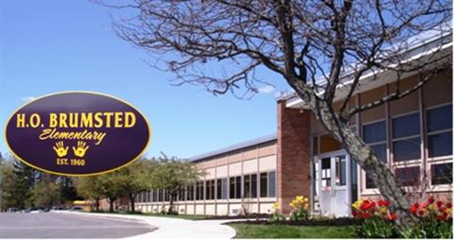 | Hallways  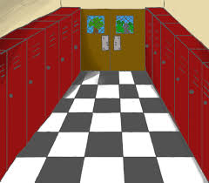 | Bathroom  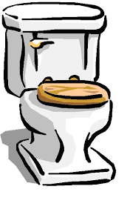 | Bus  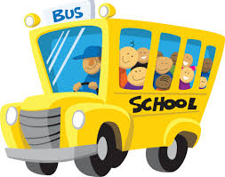 | Cafeteria  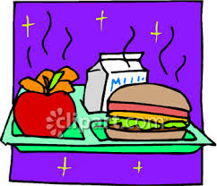 |  | Playground  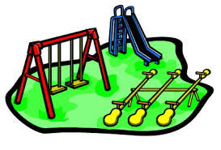
I am  Respectful.  I will: | - use kind words  - raise my hand  - be polite  - wait my turn  - keep my hands and feet to myself  - walk  - respect personal space | - use good manners  - watch where I am going  - walk on the right side of the hallway | - do only what I need to do and return to class quickly  - not write on walls | - go directly to my seat  - sit in my seat | - talk only to the people at my table  - use table manners  - sit appropriately on my chair  - stay seated  - touch only my food or tray |  | - show good sportsmanship  - take turns  - use equipment properly
I am  Responsible.  I will: | - follow directions given by any adult  - use my time appropriately  - do my best job and be proud of what I have done  - help others  - use positive statements  - own my behavior  - remind peers to follow the rules | - go only where I need to go  - do only what I need to do  - have the supplies I need for class | - keep the bathroom clean  - tell my teacher of any problems or messes in the bathroom | - keep my materials in my backpack  - follow the bus rules  - share my seat  - know my bus stop | - clean up after myself  - raise my hand to ask questions  - remember to take lunch/money to the cafeteria  - wait patiently in the lunch line |  | - gather up my belongings  - follow team rules  - ask permission to leave the playground  - share equipment  - include others in activities
I am  Safe.  I will: | - be in my seat  - follow directions and routines  - have my materials ready  - have eyes on the speaker | - face forward  - have my hands at my side | - wash my hands before leaving the bathroom  - not engage in horseplay in the bathroom  - not play in the sink or with paper towels | - not eat or drink on the bus  - wait my turn to walk on and off of the bus  - have my coat and all materials ready  - keep the aisle clear | - sit quietly and wait for directions  - walk to throw out my garbage  - be considerate of those with food allergies |  | - line up when asked to line up  - stay in line  - enter building silently

