

Be a Leader
at YMCA Camp Campbell’s
Outdoor Science School

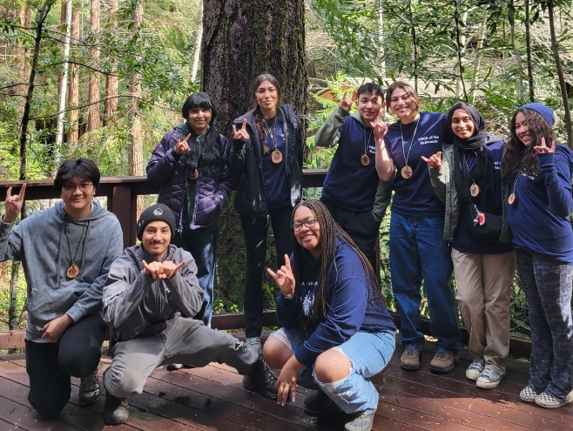
In the Heart of the Redwoods

Boulder Creek, CA
Come experience the week of a lifetime as a volunteer cabin leader at YMCA Camp Campbell's Outdoor Science School! 5th and 6th graders from all over the Bay Area come to our beautiful camp in the redwoods each week, and they need leaders like you to ensure they have an amazing experience!
You will:
- Gain invaluable leadership experience along with 87 hours of community service- and have a great time doing it
- Be in charge of a cabin of 5th and 6th grade students, along with support from the staff at YMCA Camp Campbell, who are onsite 24 hours a day.
- Attend field study along with your students and their field teacher- field study time includes picnic hikes, night hikes, river studies, forest ecology, Swimming pool, and more!
Looks great on a resume and a college application!

Candidates must be at least 15 years old, a sophomore in high school, and in good academic standing. School permission required when applicable. Fingerprinting is required for volunteers 18 and older.
Contact:
Manager of Volunteer Services
cabinleader@ymcasv.org
Website & Online application form:
https://www.ymcasv.org/ymca-camp-campbell/outdoor-education/cabin-leaders/ymca-camp-campbell-cabin-leader-application

YMCA Camp Campbell Outdoor Science School: Cabin Leader Program
High School Authorization Sheet

______________________________________________________________________________
Student’s Name School
______________________________________________________________________________
Week number (1 to 35) and dates of volunteer service
TEACHERS: PLEASE READ THIS CAREPULLY BEFOORE SIGNING
The student named will be reasonable for supervising elementary school-age children overtight in a cabin and assisting in behavior management during outdoor science classes.
Please sign if you have confidence that this student can:
Serve as a mature and positive role model for 10-12 year old students • Consistently show respect and a positive attitude towards peers and adults • Show good judgment and an ability to resolve conflict in an effective manner • Receive constructive feedback and follow through on directions • Put others' needs ahead of his/her own
It is the student’s responsibility to clear his/her absences with class instructors and to confirm such with the Attendance Office. The student named above requests to be excused from attendance to all regularly scheduled classes for all school days (typically Monday through Friday) of the week named above so that he/she can participate as a volunteer Cabin Leader in the YMCA Camp Campbell Outdoor Sciene School Cabin Leader Program.
Period | Class | Teacher’s Signature | Comments (optional)

______________________________________________________________________________
Attendance Officer’s signature Date Comments (optional)
______________________________________________________________________________
High School Coordinator’s signature Date Comments (optional)

Questions of comments can be directed to the Cabin Leader program office at
cabinleader@ymcasv.org. Thank you!

