

Emergency Procedures & Disaster Plan

INTRODUCTION
Maintaining a safe school environment is a priority of the North Clackamas School District. Many factors are critical to fostering a safe school climate. We collaborate with our community partners to review and enhance the District’s safety practices, emergency readiness, and response. As such, this document should be revisited for updates/changes and it should not be expected that information provided at any given point in time will continue to reflect current practices or procedures. As changes are made, the date and reason for the revision will be noted under “Version Control” below.
This plan provides details as to the above-mentioned practices, in accordance with board policy EBC, of the same title. While the following highlights protocols to be implemented to ensure the safety of students and employees, it is up to each individual employee to execute on the protocols to ensure the safety of themselves and those around them.

VERSION CONTROL
The North Clackamas School District Risk Management Department should coordinate review and revision of this plan every two years or when changes occur, such as lessons learned from exercises or events.

All updates and revisions to this plan should be tracked and recorded in the following table to ensure the most recent version of the plan is available and implemented by the District.
Date Reason for Revision
July 15, 2020 | Initial document creation
Aug 16, 2021 | Update Communicable Disease Management Plan to reflect the District is conducting contact tracing consistent with protocols set by CCPH and following all requirements under OAR 333-019-0010.
Aug 10, 2022 | Update to reflect revision to SRP to include actions of “Hold” and “Secure”  Remove reference to physical distancing, isolation and quarantine when conducting contact tracing for COVID-19 response, allowing this document to be more general and flexible as OHA or CCPH update required protocols.
Nov 7, 2022 | Add section on “Area of Refuge/Rescue” and the need to develop personal emergency plan for individuals needing assistance.
June 5, 2023 | Remove reference to COVID-19 based on OHA move to general protocols for communicable disease.

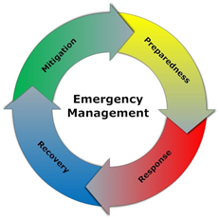
ACTIVITIES BY PHASES OF EMERGENCY MANAGEMENT
This plan is based on the emergency management principle of all-hazards planning and addressing emergency actions that are conducted during all phases of emergency management:

MITIGATION
Mitigation activities seek to eliminate or reduce a disaster’s likelihood and/or consequences. They involve actions to protect lives and property from threats, as well as long-term activities that lessen the undesirable effect of unavoidable hazards. The District has implemented a wide range of mitigation actions. A few examples include implementation of Crime Prevention Through Environmental Design (CPTED), Student Threat Assessment Protocol, seismic retrofit of buildings, retrofit of older buildings to include fire suppression systems and cyber security.

PREPAREDNESS
Preparedness activities serve to develop and/or enhance the response capabilities that will be needed should an emergency arise. Planning, equipping, training and exercises are the major activities that support preparedness. The District has implemented preparedness activities such as coordination of emergency plans with first responders, developing emergency communications plans, developing training programs and conducting drills.

RESPONSE
Response is the provision of emergency services during a crisis. These activities help reduce the risk of injury to individuals, damage to property and increase the speed of recovery.

The District’s planned response may include, but is not limited to the following components:
- Activation of the Standard Response Protocol
- Activation of the Standard Reunification Method
- Deployment of the District’s Incident Command System
- Implementation of District’s communication protocols
- Deployment of the District’s Crisis Management Team

RECOVERY
The goal of recovery is to return to the business of teaching and learning as soon as possible. Recovery can be both a short-term and long-term process. Short-term operations seek to restore vital services to the school community and provide for the basic/immediate needs. Long-term recovery focuses on the restoration of the school community to a normal or improved state.

Recovery can include the following components:
- Activate community resources such as emergency shelters.
- Implement continuity of operations plans.
- Locate displaced students and school personnel.
- Outline short- and long-term counseling needs for students and school personnel.
- Recover academically from setbacks related to lost instruction time.
- Recover the operation of systems, including human resources and financial operations, etc.
- Support the physical, psychological, and emotional healing of students and staff.
- Recover from physical damage to facilities.

EMERGENCY PROTOCOLS

STANDARD RESPONSE PROTOCOL
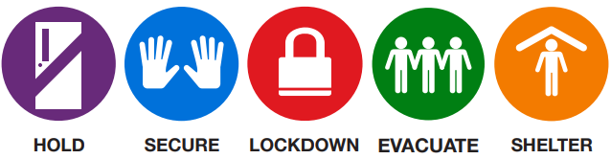
North Clackamas School District, in collaboration with the Clackamas County Sheriff’s Office (CCSO), Milwaukie Police (MPD), and Clackamas Fire, has implemented the Standard Response Protocol (SRP) developed by the I Love U Guys Foundation (www.iloveuguys.org).

The SRP is not based on one individual possible scenario but on the response to any given scenario. One large benefit of the SRP is the standard language used by all responders; this includes students, parents, employees, and first responders. The protocol also allows for a predictable series of actions as an event unfolds.

The SRP is based upon four actions: Lockout, Lockdown, Evacuate and Shelter. Each has specific staff and student directives that are unique to the action. Those directives may be found under the District’s web page for Emergency Protocols. (If printing a copy of this “plan” for future reference, you will need to also include a printed copy of the Emergency Protocols contained in this link.)

Designating an Area of Rescue/Refuge for Evacuation
An “area of refuge” is essential when it comes to emergency preparedness.. This area is used in lieu of a safe escape route, for instance, a stairwell. These spaces may also be called “areas of rescue.” Students and/or staff may need to wait in an area of refuge if evacuation is not a safe or possible option in the case of fires and multiple other emergencies. A common example of a need for use, is that of a person with a disability who may be unable to descend stairs (even with the assistance of staff) and need to wait for the fire department or first responders in a safe place.

An area of refuge should contain the following:
- A location near an emergency exit
- A fire barrier
- Wheelchair accessibility
- A space located in a spot that doesn’t block others who are trying to escape.

If a student or staff member is in need of an “area of refuge” the school shall develop a personal emergency plan that includes specific evacuation procedures, sheltering procedures, and means of communication in the event of an emergency. The use of an “area of refuge” would be considered a “last resort” only after considering all alternative resources such as use of additional staff to help mobilize, etc.

This plan shall include:
- Identifying the safest area located on each floor within the building to which a person with disabilities can be moved or directed to await assistance from emergency response personnel; and
- Designating a means to inform emergency response personnel (e.g., police, fire) of the locations of any person(s) requiring assistance.
A copy of all personal emergency plans shall be located in the Fire Department Information Center (FDIC) for the building and/or in the building’s emergency binder used for evacuation.

Earthquake
A seismic event may be unique in that the initial response may involve more than one action under the SRP. Specifically, when the shaking starts, students and staff should “Drop, Cover, and Hold On” as described below. This falls under the SRP directive of Shelter. Depending on the severity of the seismic event, it is possible that the next step of the response would be to Evacuate, and after that point, potentially even Shelter in place for an extended period of time.

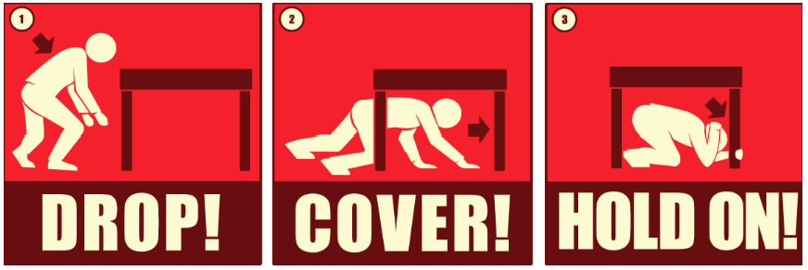

What to do When the Earth Shakes
DROP where you are, onto your hands and knees. This position protects you from being knocked down and also allows you to stay low and crawl to shelter if nearby.

COVER your head and neck with one arm and hand.
- If a sturdy table or desk is nearby, crawl underneath it for shelter.
- If no shelter is nearby, crawl next to an interior wall (away from windows).
- Stay on your knees; bend over to protect vital organs.

HOLD ON until shaking stops.
- Under shelter: hold on to it with one hand; be ready to move with your shelter if it shifts
- No shelter: hold on to your head and neck with both arms and hands.

Bomb Threat
A Bomb Threat may result from the discovery of a suspicious package on or near school grounds or receipt of a threat in writing or via a phone call indicating the risk of an explosion. While some steps contained in the SRP may be appropriate, employees should follow the District’s Bomb Threat Procedures.(If printing a copy of this “plan” for future reference, you will need to also include a printed copy of the procedures contained in this link.)

School Bus Accident or Fire
In the event of a serious accident or bus fire, it is important to note that drivers may need to make spontaneous, independent decisions based on the nature of the emergency, age of the children, location of the bus, and other unique circumstances to ensure children’s safety.

Initial steps to ensure the safety of students, staff and others may include the following:
- The bus driver will park the bus in a safe location with the emergency brake set and the ignition off.
- In the event of a fire, students and the driver should evacuate the bus immediately and move to a safe location away from the bus and traffic using available barricades (e.g., trees, cars) when available.
- The bus driver will immediately call 9-1-1 and provide the exact location of the bus and wait for the arrival of emergency response personnel.
- The bus driver should check students for injuries and provide appropriate first aid.
- The bus driver should call District Transportation to report the location and condition of students.
- The bus driver is responsible for accounting for all students throughout the emergency.

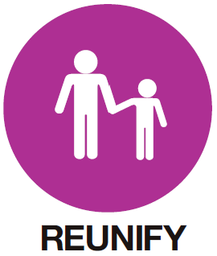
PARENT REUNIFICATION
Events may occur at school that require parents to pick up their students in a controlled release. The process of controlled release is called a reunification and may be necessary due to weather, a power outage, a hazmat issue, or if a crisis occurs at the school.

North Clackamas School District has implemented the Standard Reunification Method to make this process more predictable and less chaotic for all involved. Each school has a reunification kit, including printed copies of their individual reunification plan (which for security purposes is not included in this document).

COMMUNICABLE DISEASES MANAGEMENT PLAN
North Clackamas School District has board policies related to communicable diseases and students (JHCC and Administrative Rule JHCC-AR) as well as communicable diseases and staff (GBEB and Administrative Rule GBEB-AR). These policies and administrative rules provide an outline as to procedures to be followed to ensure compliance with all reporting measures and with all rules set forth by Oregon Health Authority, Public Health Division in the published Communicable Disease Guidelines, as well as those provided by Clackamas County Public Health. Additionally, each school building shall have a designated health care space(s) that is appropriately supervised and adequately equipped for providing first aid, and isolates the sick or injured child from other students and staff.

INCIDENT COMMAND SYSTEM (ICS)
ICS is a component of FEMA’s National Incident Management System (NIMS), which allows the District to coordinate the management of incidents with emergency responders across all jurisdictions and functions. North Clackamas School District has developed a District level ICS team. The basic ICS structure is depicted in this diagram:

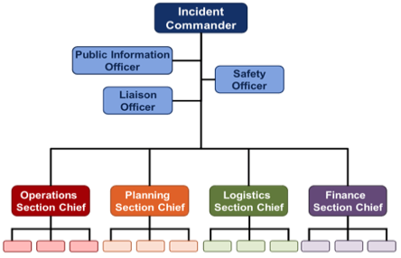

Should a school or small group of schools have a need, members of the District level ICS team are available to support and supplement the school’s response to the event. For larger, district-wide events, the ICS team may be activated in a District “Emergency Operations Center” (EOC) that will provide a common location from which to coordinate support for large-scale events and support the individual schools and facility response activities. It is important to note that the ICS team may be activated in any phase of emergency management (mitigation, preparedness, response or recovery) as appropriate.

