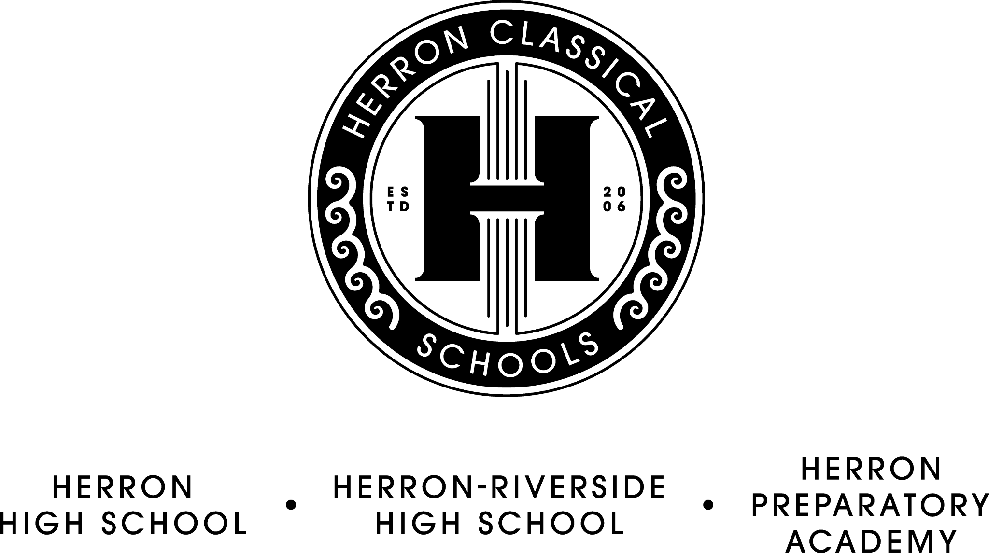

Herron Classical Schools Board Meeting Agenda
August 20, 2024, 7:30am
HCS Admin building 1715 N. Meridian

7:30 Board Meeting Agenda

- Call meeting to order (Roy)

- Approve minutes (Roy)

- Treasurer’s report/Fiduciary Committee report (Miller)
- Financials
- Vouchers
- Sept. and Oct. Budget Constraints

- Development Committee report (Sternberg)
- Annual Fund
- Campaign update
- Back to School Fundraiser
- Classical Cocktails

- Executive Committee report (Roy)
- OEI Board Assurance Form Accountability Reports
- Separation agreement
- Health insurance roll-out (McNeal)

- Education Committee Report (McNeal)
- Summer Academy completion data (Dorsey)
- Working Groups
7). President’s Report (McNeal)
- Start of school year report
- Enrollment
- Faculty

Adjourn

Executive Session
- staff evaluation

The next board meeting will be on October 15, 7:30 AM.

