
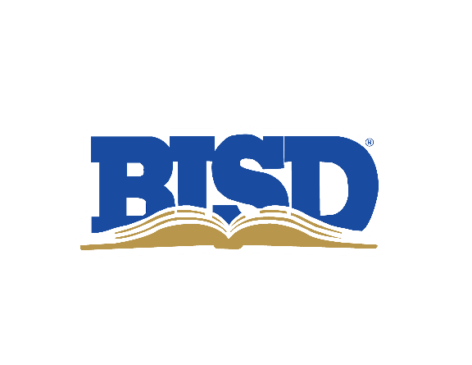

2022 Bond Oversight Committee

Monday, July 17 | 4:30–5:45 p.m.

Location: PLC – Blanco/Frio Rooms

Welcome/Introductions
Review where we are today
- Financials/Bond Sale
- Current Projects in Planning
- Bus Update
- Technology Update
- Website/Bond questions to bond22@birdvilleschools.net

2023–24 Meeting Dates/Times
- Monday, April 17 | 4:30–5:45 p.m.
- Monday, July 17 | 4:30–5:45 p.m.
- Monday, Oct. 16 | 4:30–5:45 p.m.
- Tuesday, Jan. 16 (Jan. 15 is MLK Day) | 4:30–5:45 p.m.

2023–24 Quarterly Reports to the Board – Presentation Dates (Mark)
- Thursday, April 27 (No Report)
- Thursday, July 27
- Thursday, Oct. 26
- Thursday, Jan. 25, 2024

Questions/Comments contact:
Mark Thomas
mark.thomas@birdvilleschools.net
817-547-5792 (Office)

