Menifee County School District
New Employees

Employee Records
- All employee personnel files will be maintained through Employee Records.
How to Login
Here are the steps for you to login for the first time.
- To begin the login process please go here:
https://menifee.tedk12.com/sso/Account/Login
  - This is a screen shot of what you will see:
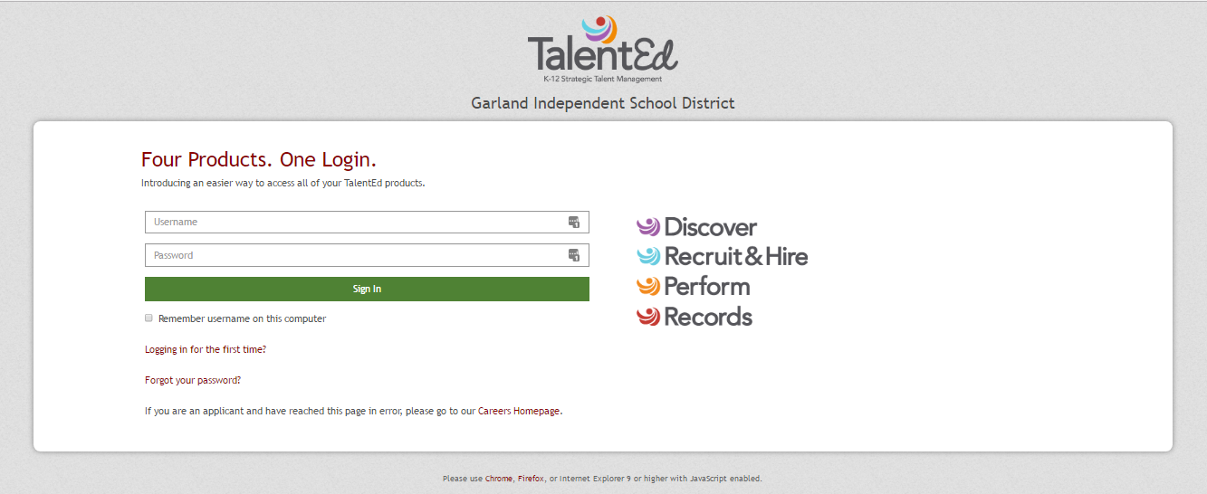
- You will need to choose Logging in for the first time
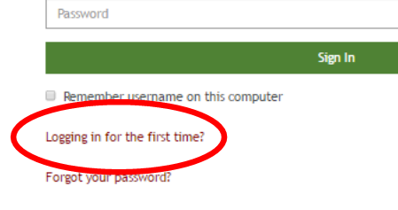
- You will be then brought to this screen where you will input your school email address:
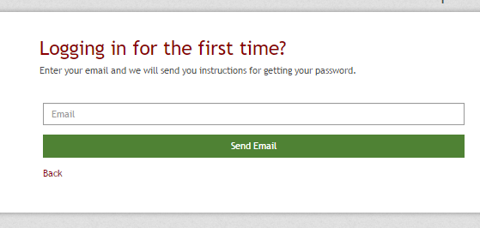
- You will then get an email to be able to login and create your own password.
- Follow those steps and you will then be logged into Records.

- Employee Records will log into my tasks page. All of your items that need to be completed will be available to you there.
- Employee Address changes, Name Change Requests, K-4s, W-4s, Payroll Direct Deposit Forms, Transfer Forms, Separation Forms are on Employee Records and should be completed there.
- Your salary/placement letters and contracts will also be completed in Employee Records.

Timesheets
- Absolutely no overtime will be granted without prior approval. You must fill out a pre-approved overtime request form.
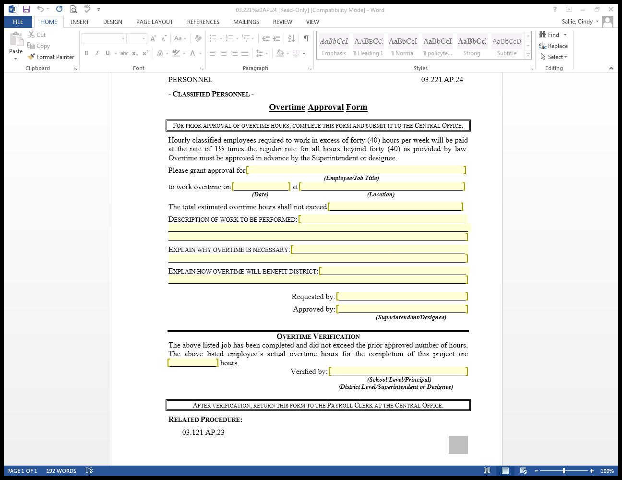

Coach Records
For coach’s pay and extra service positions. Page 1 must be signed and turned in to Hannah Ferguson immediately.
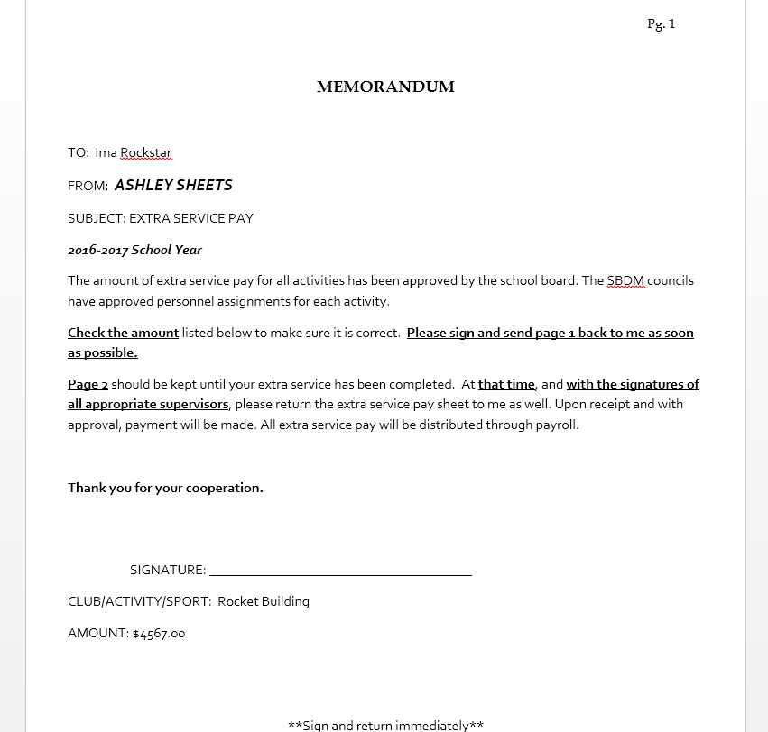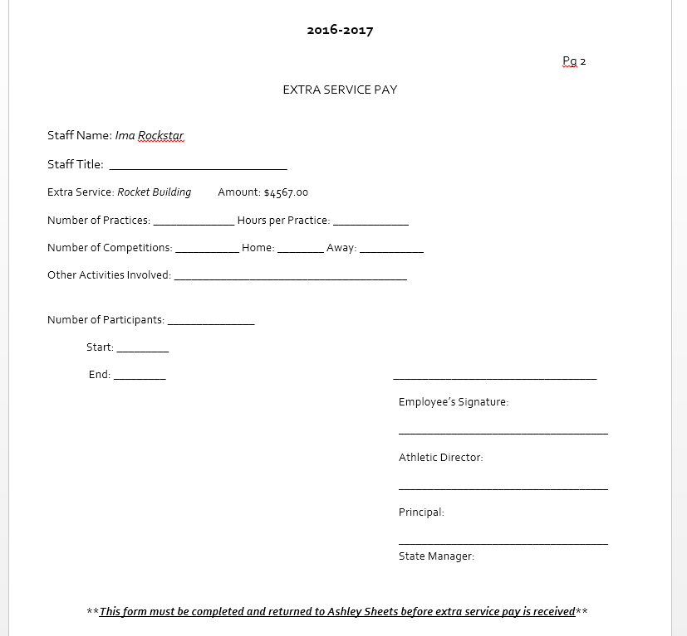

Instruction for Employee Self-Serve
The following will be how you can review all your pay information.
All employees will have access to Employee Self-Serve. This is where all employee information is held and includes the following:
check stubs, leave amounts
https://menifeectsdky.munisselfservice.com/ess/

In the right corner, you will see this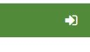
This is the log in button. Click this to log in.

User ID – your employee ID number.
Password – is the last 4 digits of your social security number.
You will immediately be prompted to change your password.
When you log in you will see the following options:
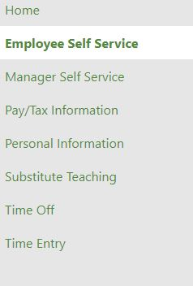
You should be able to see your information, leave you have used and details of all your paychecks on the home page.
From there you can look at Pay/Tax Information:
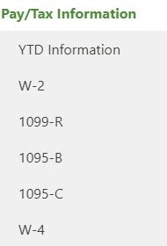

You can also request time off and review leave you have taken:
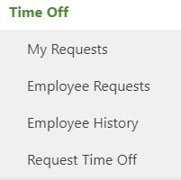
Please look through some of these options. It is very informative.

Insurance
State Insurance
All full-time employees are eligible to receive state insurance.
An insurance handbook will be provided to those employees.
An employee can choose between single, family, self+spouse and self+children. In addition, also can choose the level of coverage needed.
Any questions can be answered by the Finance department.
Insurance must be completed 30 days from your hire date. Changes can be made to your insurance for qualifying events. This must be done within 30 days of the event.
The state also provides an option to purchase vision and dental insurance in addition.

American Fidelity_ option – Cafeteria Plan
Cafeteria Plan consists of the option to purchase additional insurance options including vision, dental, life, cancer and various other insurances.
Representative - Beth Wyatt – beth.wyatt@americanfidelity.com 859-338-4905

Ky Deferred Compensation
This is highly recommended for employees.
Deferred Comp is an additional retirement plan to help employees to save money for retirement.
This is a way to deferred tax liability from current taxes to retirement taxes.

Leave
All full-time employees receive 10 sick leave, 3 personal days and 4 paid holidays a year. This is for all employees that work 185 days.
Personal leave can only be taken with two week advance notice.
Emergency leave of 3 days are allowed for the death of an immediate family member.
Additional sick days and paid holidays are given to employees working more than 185 days:
220-234 days get 6 paid Holidays.
235 days or more get 7 paid Holidays.
220 days-234 days – receive 12 sick days in total
235 days or more – receive 13 sick days in total
220-234 days – receive 2 vacation days
235-240 days – receive 4 vacation days
Vacation days will not accumulate
For any employee over 220 days a year, you can take 3 non-contract days when school is in session meaning, students are at school.

Pay Dates
Payroll is paid on the 15th or 30th of each month. With the exception that the pay date falls on a weekend, payroll will on the Friday before the weekend.
The board approves pay dates each year.

Work Hours
Work Hours – could change based on supervisor needs
  - Teachers – 7:25am- 3:25pm
  - Instructional Aide – 7 hours 2 paid 10-minute breaks and 30-minute unpaid lunch
  - Cook- 7 hours 2 paid 10-minute breaks and 30-minute unpaid lunch
  - Custodians/ Maintenance staff – 8 hours 2 paid 10-minute breaks and 30 minute unpaid lunch
  - Bus Drivers/Bus Monitors – 4 hours
Beginning and ending time for each position will be determined by your supervisor.
Classified staff are entitled to an unpaid 30-minute lunch break as well as a paid 10 minute break for each 4 hours of consecutive work. However, breaks cannot be taken at the same time as lunch breaks.
Certified staff is paid for their lunch break and are required to stay on the school premises during that time. This is a safety issue.

Employment Changes
Resignation
If you plan to terminate your employment, you must sign the separation form and notify central staff in writing. Please fill out separation form anytime leaving employment.
Retirement
If you plan to retire, please contact the payroll officer as soon as possible. She will need at least 3 weeks to fill out all appropriate forms to submit to retirement.
ALL REQUIRED FORMS CAN BE FOUND ON OUR WEBSITE UNDER QUICK LINKS CALLED FORMS AND LINKS
Requisitions
Verify that the company is a district vendor. Finance Office will give you the vendor number at this time.
If the company is not a district vendor verify they will accept purchase orders and obtain a W-9 from the company.
Contact the Finance Office and the company will be added as a vendor.
Fill out a requisition.
Vendor #
Name and contact # of person requesting to make purchase
Account Code – Contact the Lorri Bartley if you need the code.
Date
Address - for new vendors only.
Sign, have your supervisor to sign and email to Cindy Sallie.
Once approved by Mr. Spencer the purchase order will be processed.
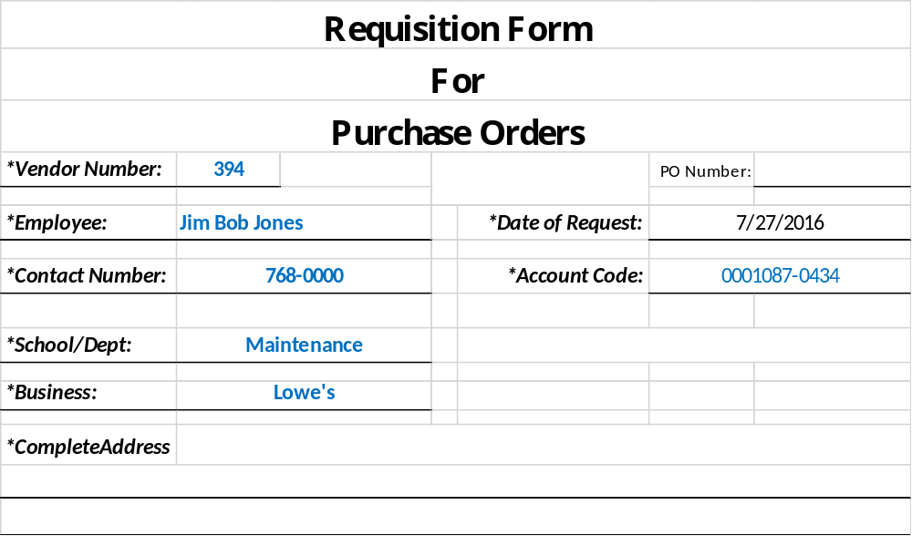
You will receive a copy of the purchase order via email and school mail.
Place your order.
When the product is received, or services rendered sign and date the invoice and return to AP CLERK and CHIEF FINANCIAL OFFICER. BLUE ink only.
If the invoice comes to you sign and date it as well – send to AP CLERK and CHIEF FINANCIAL OFFICER.. BLUE ink only.

Student Activity Monies
Maintained at the central office
Account for in Fund 25
To access funds
- Staff prepare requisition
- Staff and principal sign and give to the accounts payable clerk
- The requisition is input into MUNIS and handled through workflows. The MUNIS immediately lets you know if the budget is overspent.
- Requisition approved by principal in MUNIS,
- Requisition is approved by Finance Officer/ designee. Then converted into Purchase Order. Any requisition over $1,000 is approved by the superintendent.
- Purchase order is printed and signed by Finance Officer/designee.
- Requestor is scanned a copy of the purchase order.
- The requestor can make the purchase after the purchase order is received.
- After receipt of goods, send in the signed invoice to the finance department for payment.
- All payments must have a purchase order.
Additional Guidance for Student Activity Funds in the Red Book see our website site – Menifee.kyschools.us Finance Department / Red Book
Highlights:
Spending is restricted to allowable costs. See power point.
District Activity Funds
Maintained at the central office
These are accounted for in Find 21
The student activity accounts sweep funds to the District
District activity expenditures are not as restricted as student activity funds.
All payments must have a purchase order. Complete the normal purchasing procedures.

General
District Dress Code – Certified Staff
All employees are expected to dress as role models for students.
- Employee dress/grooming needs to meet or exceed student standards. All clothing should be neat, clean and in good repair. Faded, worn clothing, or clothing with holes, rips or tears is not acceptable. Appropriate items include khaki style pants or slacks, polo shirts, button up shirts, blouses, skirts, Capris and dresses. On game days, faculty and staff are encouraged to show their school spirit.
- Unless approved by the Principal for activities or field trips, blue jeans may not be worn Monday – Thursday.
- Casual Fridays: Staff may wear nice jeans (not faded or torn) and casual shirts, this would include school t-shirts. Windbreaker type warm-ups are acceptable on Fridays only.
- Sweatpants or shorts may be worn only when participating in a sports activity or instructing physical education classes.
This policy applies only when students are in attendance and excludes custodians, general maintenance and technology, cooks and bus drivers.
Classified Staff
All employees are expected to dress as role models for students.
- Employee dress/grooming needs to meet or exceed student standards. All clothing should be neat, clean and in good repair. Faded, worn clothing, or clothing with holes, rips or tears is not acceptable. Appropriate items include khaki style pants or slacks, polo shirts, button up shirts, blouses, skirts, Capris and dresses. On game days, faculty and staff are encouraged to show their school spirit.
- Unless approved by the Principal for activities or field trips, blue jeans may not be worn Monday – Thursday.
- Casual Fridays: Staff may wear nice jeans (not faded or torn) and casual shirts, this would include school t-shirts. Windbreaker type warm-ups are acceptable on Fridays only.
- Sweatpants or shorts may be worn only when participating in a sports activity or instructing physical education classes.
This policy applies only when students are in attendance and excludes custodians, general maintenance and technology, cooks and bus drivers.

For Cafeteria Staff/Cooks Only
- Required smock/apron issued while on duty;
- Socks;
- Gym shoes, work boots, or shoes with non-slip rubber soles, no open toe shoes may be worn at any point;
- Long pants or jeans are allowed. Shorts or capri pants are not permitted. EXCEPTION: In extreme weather conditions and with the supervisor’s prior approval, employees may wear shorts of an appropriate length or capri pants.
- Hats or hairnets must be worn in the cafeteria. Long hair must be restrained;
- Required uniform shirt (supplied) worn under smock/apron. Only supplied uniform shirt will be permitted;
- Chef jackets will be kept clean and in good appearance;
- Required Menifee County School District ID card must be displayed while on duty.

Custodial and Maintenance Staff
- Required uniform shirt (supplied). Only supplied uniform shirt will be permitted;
- Socks;
- Gym shoes, work boots, or shoes with non-slip rubber soles, no open toe shoes may be worn at any point;
- Blue jeans or khaki pants are allowed. Shorts or capri pants are not permitted. EXCEPTION: In extreme weather conditions and with the supervisor’s prior approval, employees may wear shorts of an appropriate length or capri pants.
- Required Menifee County School District ID card must be displayed while on duty.
- Safety First – custodial and maintenance staff shall wear all appropriate/approved Personal Protective Equipment (PPE) when working with the need for such item(s) while on duty.

Ethics
Each student in elementary, middle, and high school shall receive essential workplace ethics instruction that includes but is not limited to the following characteristics:
- Adaptability, including an openness to learning and problem solving, an ability to embrace new ways of doing things, and a capability for critical thinking;
- Diligence, including seeing a task through to completion;
- Initiative, including taking appropriate action when needed without waiting for direct instruction;
- Knowledge, including exhibiting an understanding of work-related information, the ability to apply that understanding to a job, and effectively explain the concepts to colleagues in reading, writing, mathematics, science, and technology as required by the job;
- Reliability, including showing up on time, wearing appropriate attire, self-control, motivation, and ethical behavior;
- Remaining drug free; and
- Working well with others, including effective communication skills, respect for different points of view and diversity of coworkers, the ability to cooperate and collaborate, enthusiasm, and the ability to provide appropriate leadership to or support for colleagues.

Confidentiality
Personnel evaluation records, specifically the personnel evaluation folder and its contents, will be kept as a part of the employee’s personnel file and will be treated as confidential as required by law.

Social Media
Employees should restrict the use of personal technology and social media for personal purposes to non-work times or hours. Any duty-free use must occur during times and in places that the use will not interfere with job duties or otherwise be disruptive to the school or working environment or its operation.

Smart Find Express: (Teachers and Substitutes)

Before any features are available, you must register with the system and create a PIN and password. You will need your employee ID number. If you do not know it, please contact Rebecca Spencer.
Register in the following order:
- Register via Telephone – Call 606-212-2072
- Access the Web App – https://menifee.sfe.powerschool.com/
- Access the Mobile App District Code – DJTN – SmartFindExpress
Register via Telephone
You will use your access ID and PIN to interact with the telephone system. Your access ID will be your employee number.
- Call the main system number provided by the district (606-212-2072)
- Enter your access ID (Employee #), then press the star key.
- When prompted for your PIN, enter your access ID again, then press the star key.
- Record your name, then press the star key.
- You will hear the primary location and classification set up in your profile. (If this information is incorrect, continue with the registration process, then contact your system operator to correct the information.)
- When prompted, enter the PIN you want to use, then press the star key. The PIN must be numeric, must meet the minimum length requirements for your system, and cannot be more than nine digits.
Access the Web App
You will use your access ID and password to interact with the web app.
- Enter the web address provided by the district - https://menifee.sfe.powerschool.com/
- Enter your access ID and PIN.
- When prompted, enter the password you want to use.
- Log in with your access ID and password.
- Verify your email address.

Access the Mobile App
You will use your access ID and password to interact with the mobile app. Each district using the mobile app will provide you instructions and an unlock code. (DJTN)

- Install the app.
- Open the app and enter the district unlock code.
- Select the district
- Log in with your access ID and password.

