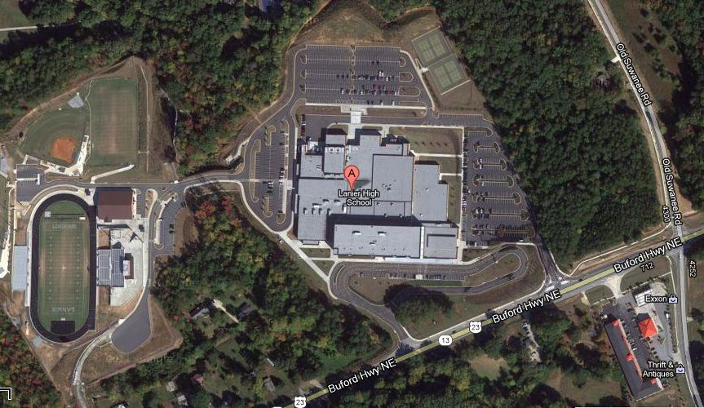
Buses Enter Here-
Pass “Do Not Enter” Sign

Visitor Parking
Bus Parking
(Along Curb)

All Patrons
Enter Here
Gym Entrance

