

Direct Report Quick Start Guide
Unified Talent Perform

Direct Report
My Folder
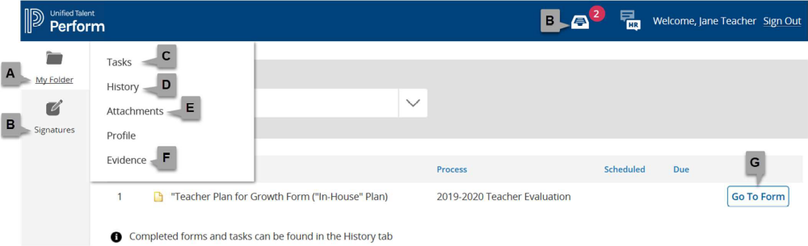
A. My Folder: View your tasks and evidence here.
B. Signatures: Electronically review, sign, or approve forms.
C. Tasks: Review the tasks assigned to you that need to be completed.
D. History: Review your completed tasks and forms.
E. Attachments: View documents shared by supervisors.
F. Evidence: Access the list of artifacts that you have attached to your forms, as well as notes shared with you by supervisors.
G. Go To Form: Click to open and complete the form.

Forms
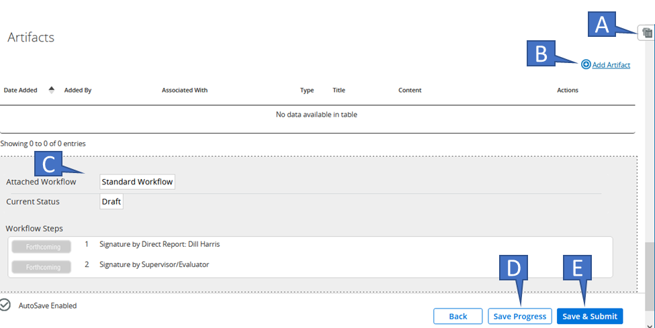
A. Rubric/Form Review Tool: Access a slide-out tool to view any rubric associated with this process, as well as any completed forms in the process.
B. Artifacts: Add any number of artifacts/attachments up to 10mb in size. May not be present on all forms. See next page for more details on adding artifacts.
C. Workflow: View the signature, approval, or review steps that must be completed once the form is
submitted. May not be present on all forms.
D. Save Progress: While the form does auto-save, it is always a good idea to Save Progress prior to exiting the form to be sure your changes are saved.
E. Save & Submit: Save the form, lock it from further edits, and begin the workflow defined for the form. Click this only when you have completed all of your edits.

Evidence
Add an Artifact
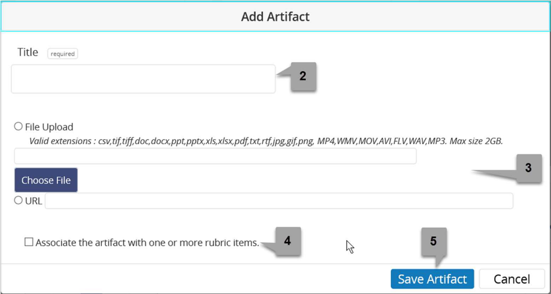
1. Click Add Artifact at the bottom of the form.
2. Enter the Title.
3. Select File to Upload or URL.
4. If enabled by HR, associate the artifact with rubric items. Note that the rubric selected for the process is the rubric to which artifacts can be associated.
5. Click Save Artifact.
Signatures and Approvals
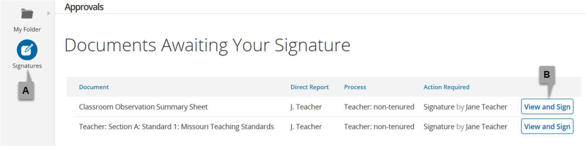
A. Signatures: Review and electronically sign or approve forms.
B. View and Sign: This button name changes depending on whether you are signing, approving, or
reviewing a form. Click to view the completed form, then scroll to the bottom to complete the assigned
step.

