Using the Home Access Center (HAC) to Check Grades and Attendance

The eSchoolPlus Home Access Center is where students and parents can check official grades and attendance at any time. HAC will be the most accurate reflection of grades as opposed to Canvas or Google Classroom because not all grades may appear in Canvas or Classroom.

How do I access the Home Access Center?
You can find the Home Access Center (hac) button at the top of every school web page under the menus Students and Parents menus.
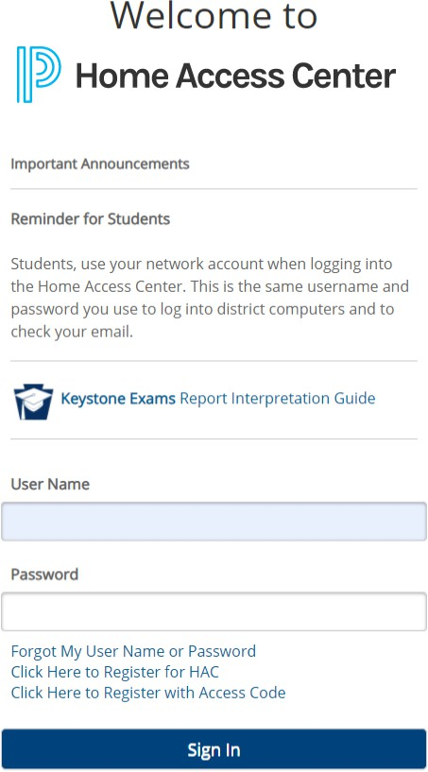

At the Home Access Center login screen, students should use their district user name and password to access HAC. Parents can create their own account using the “Click Here to Register for HAC” option at the bottom of the screen.

Follow the on-screen instruction to create an account. You must be in the school’s system as a parent in order to complete the registration process. After completing registration through an email you will receive, you will have access to view your
child’s information and grades.
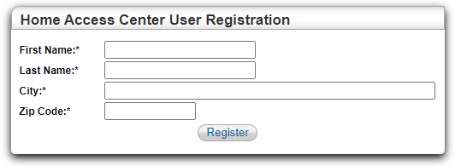

In Home Access Center, you can view important information such as registration information, current classroom grades and assginments, attendance records, report card grades, and standardized test grades. If at any time you find incorrect information, please contact your school building office to make corrections.

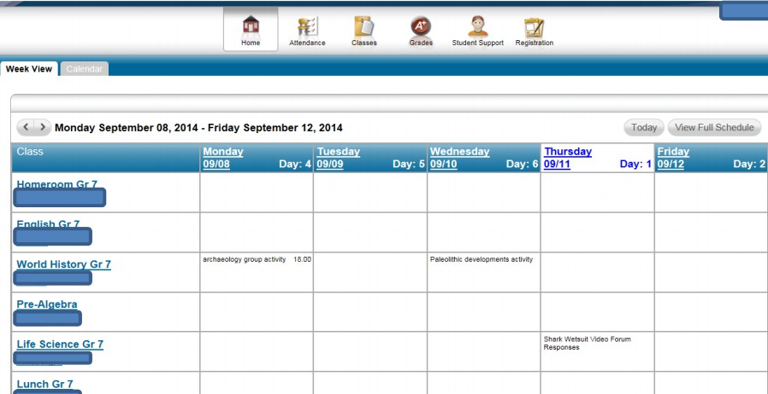
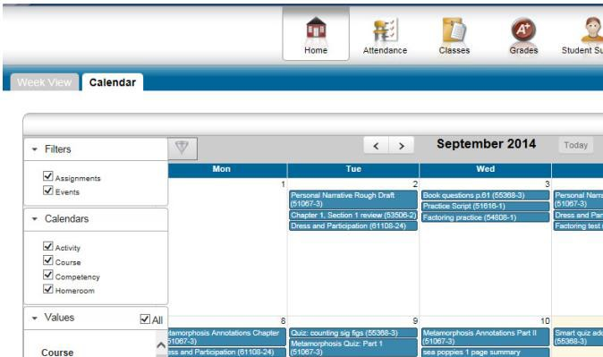
Home Tab: 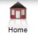
View posted information by week or monthly calander. Please note that only assignments posted to TAC will be displayed and many teachers only post the assignments to HAC after the due dates. For a more accurate listing of assignments, refer to your child’s Canvas or Google Classroom courses or contact the teacher.

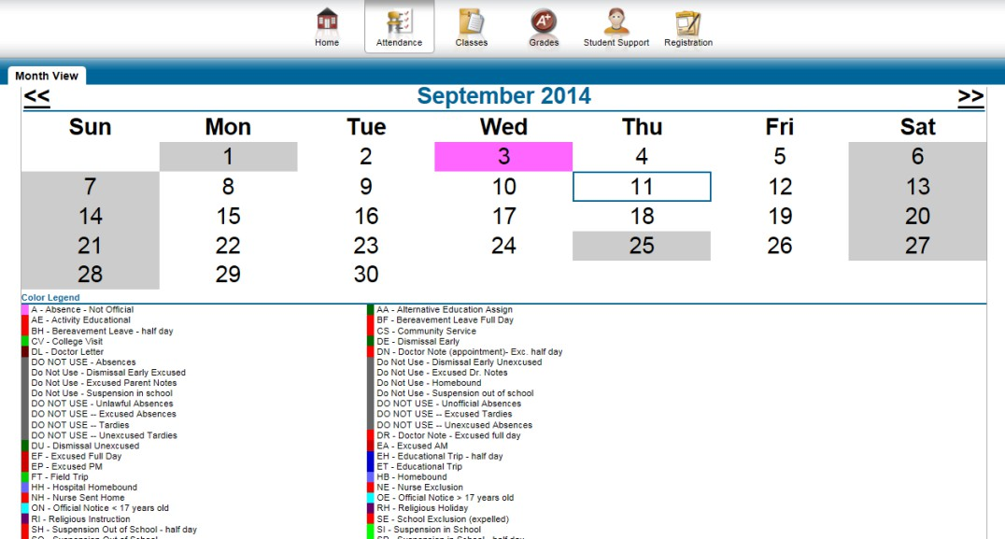
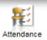
Attendance Tab:

In the attendance page, you can view all absences for the year and cross-check them to the attendance codes at the bottom.

Checking attendance often is recommended so errors can be corrected immediately.

Classes Tab: 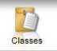
The classes page is the most often visited page in the system. This is where you check current grades for all classes. You can even set email alerts to notify you of failing grades (some reports are weekly while others are monthly). Please review the notes below regarding important settings:
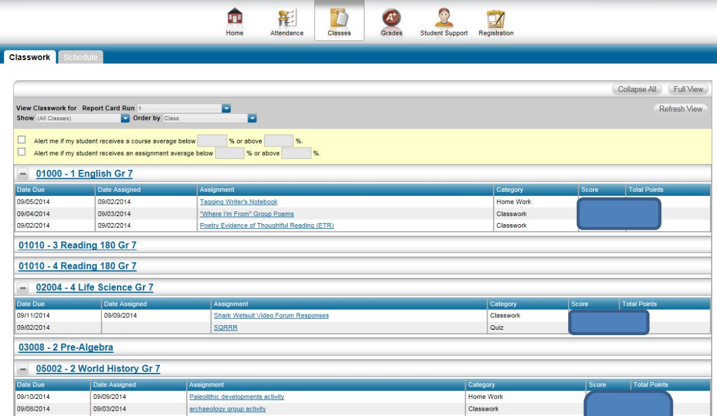
Assignment dates, descriptions, and grading categories
Full View: Show all assignment details and grading
Schedule:
Review the current class schedule
Classwork:
Review the current grades for all
Score and Total Point. If you use the Full View option, you will also see percentages and class averages.
Refresh View:
Press this after making any changes to these settings
Report Card Run:
Make sure the current marking period is selected, hit Refresh View

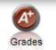
Grades Tab:

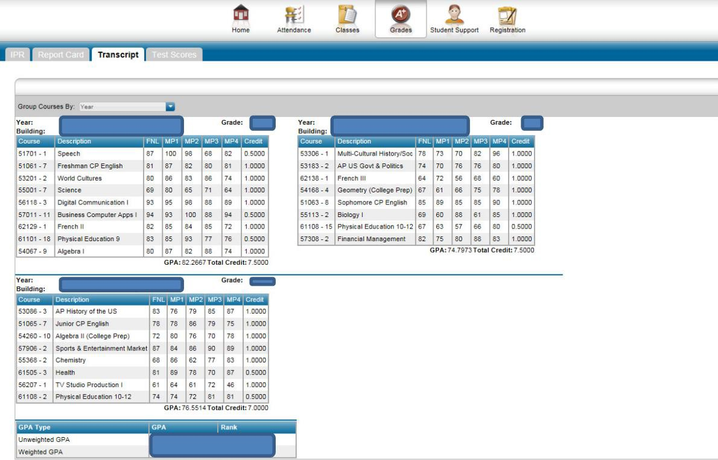
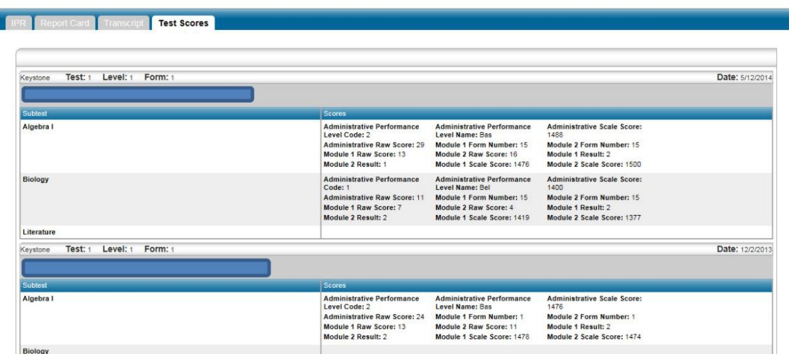
On the Grades page, you can access weekly (IPR) progress reports and report card grades. You can even select the option to receive an email when the reports become available. You can also review transcripts, and standardized test scores.

Student Support: 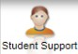
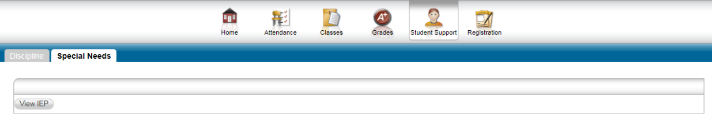
Under Student Support, if your child has any special needs or discipline reports, they can be accessed from this page.

Registration Tab: 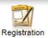
The registration page provides you with important information such as student and parent demographics, bus stops, emergency information, and contact information. If at any time you notice incorrect information, please contact your school building to make corrections.
